Higher Ed Dashboard App Functional Specification

July 5, 2012

Document Version History
Version | Date | Author(s) | Notes
1.0 | 4/17/12 | Craig Marcus | Initial version of Android MML Dashboard FS
1.1 | 5/16/12 | Craig Marcus | Updated images
1.2 | 5/23/12 | Chris Melton | Added new sections and Open Issue items.
1.3 | 5/25/12 | Craig Marcus | Updated strapline behavior. Added list view groupings.
1.4 | 5/31/12 | Craig Marcus | Updated behavior of status bar.
1.5 | 6/13/12 | Craig Marcus | Added License Agreement text, updated filtering section, closed open issue #1
1.6 | 6/14/12 | Craig Marcus | Updated Mastering Assignment time limit functionality. Removed Next from XL assignments. Updated Forgot Username section.
1.7 | 6/19/12 | Craig Marcus | Corrected error messages for Forgot Password screen.
1.8 | 6/20/12 | Craig Marcus | Added file upload info to List View section.
1.9 | 6/28/12 | Craig Marcus | Add Mastering passphrase-protected detail view
2.0 | 7/5/12 | Craig Marcus | Updated XL Results in list view, added global behaviors
2.1 | 7/16/12 | Megan Higginbotham | Updated White List information
2.2 | 7/26/12 | Chris Melton | Updated remove profile messaging.  Changed “Forgot username and password?” to use “or”: “Forgot username of password?”

Open Questions/Issues
ID | Status | Question/Issue | Resolution
1 | Closed | Do we want to consider a maximum number of courses this app can support? | The UI allows for a total of 19- 20 courses when a handheld device is in portrait mode.
2 | Open | How do we handle course lifecycle? What happens to a course when it reaches its end date? | Here is one possible UI solution:  http://onyxdev.pearsoncmg.com/mobile/MML-Dashboard/Kindle/Course-Completed.png
3. | Closed | Can we display the course ID for all platforms in the course detail header? | All platforms will display a course ID with the exception of EPIC.
4 | Closed | Do we truncate course titles at the end or in the middle? Or do we use a marquee approach where the title will scroll to the left? | We’ll use the marquee approach.
5 | Closed | Does a student that is exempt from an assignment receive a result? | Yes. The status of that assignment will read: Exempt.
6 | Closed | How do we display the “Terms of Use” for iOS and Android | See Terms of Use section.
7 | Open | For Assignment status in XL can we display “Completed”?
8 | Open | For Results in XL can we display the overall score?
9 | Open | For Results Status in XL can we display “Completed” or “Incomplete”?
10 | Open | How do we present compressed files (sit, sitx, zip) and flz file on a mobile device? | Deferred
11 | Open | If a user logs into the app with a valid subscription, but their MyLab/Mastering course is not supported by the app – what do we display?
1.0: Overview
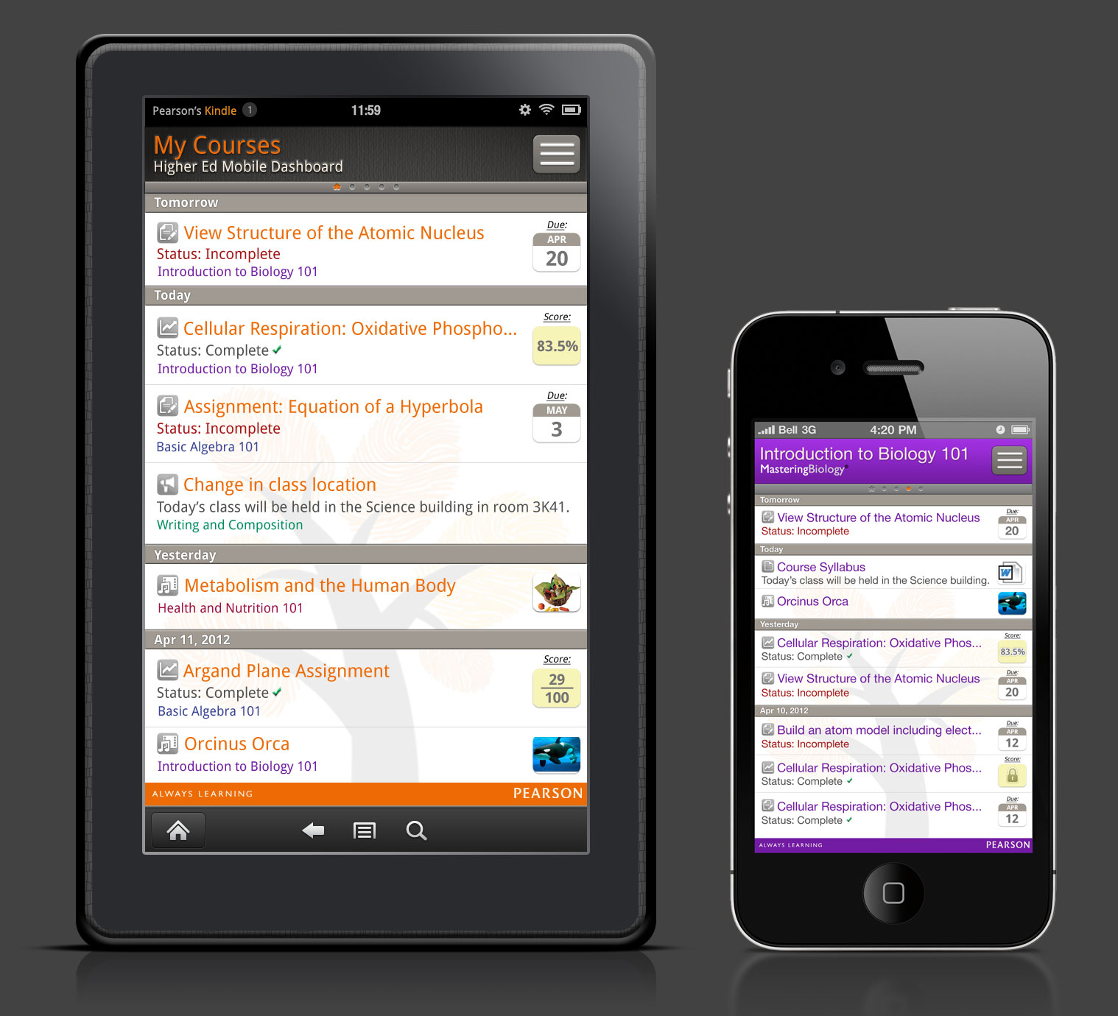

The Higher Ed Mobile Dashboard app is designed to be a dashboard for students using Pearson higher education courses, allowing them to clearly see course activity at a glance. The app is build around the concept of “Today, tomorrow and yesterday”. This concept allows students to clearly see when assignments are due, if they have not completed an assignment, and what the result (grade) of that assignment is. The HEMD app is an adaptive design that supports the ability to display content based on the device it is installed on (i.e., tablet vs. handheld) and the device’s orientation (profile or landscape). The HEMD app also has the ability to display media based on Pearson’s file upload services and Kaltura integration (deferred until October). This app will be available for Android devices and iOS devices (excluding the iPad).

On Android it’s a hybrid app, meaning it will work on both tablet and handheld. On iOS it is for iPhone and iPod Touch only.

General App Behaviors:

1. The app will support unlimited courses, but the user will receive a dialog message from the All Courses screen if they exceed 15 courses that states the following:
“You have exceeded the maximum number of courses this app can support. This may result in unexpected performance issues.”

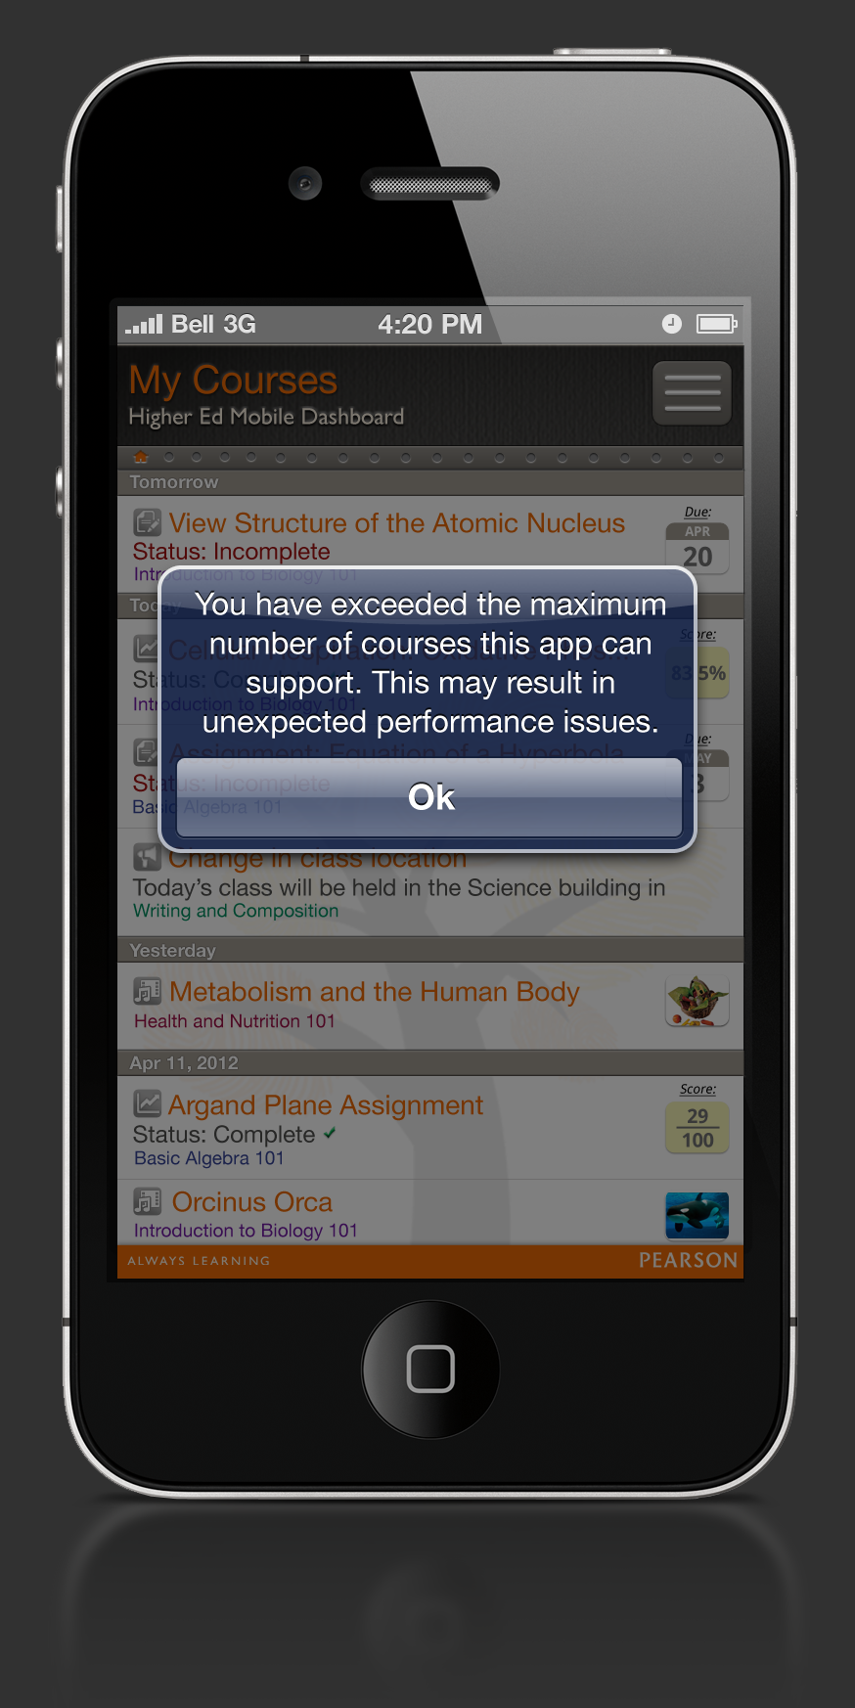

2. When a course has ended for a user… [See Open Issue #2]
3. When a user has a MyLab/course that is not supported by the app, they will receive the following dialog that states:
“This app does not currently support the MyXXLab course [course title].
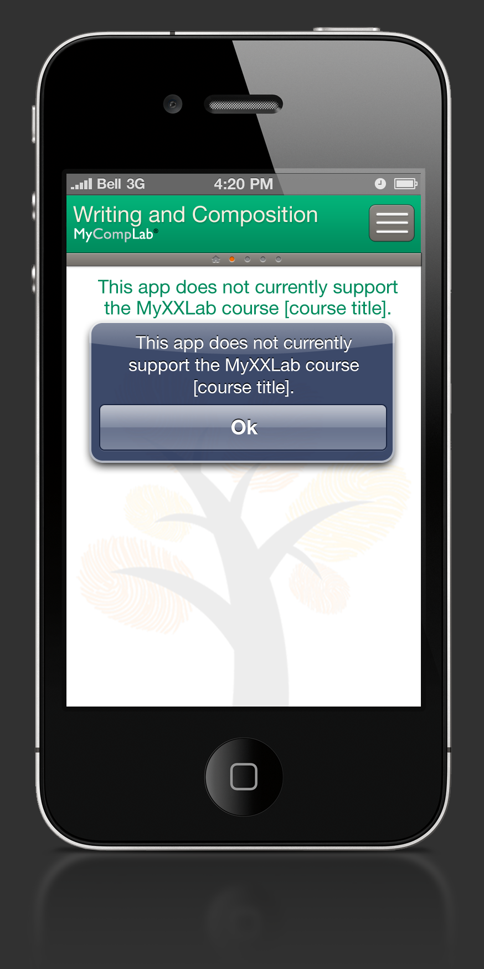

See Appendix 1: Supported Platforms and Series Titles
2.0: Launcher Icon
After installing the app, the HEMD Dashboard launcher icon will appear on the user’s home screen. On certain tablets, the launcher icon may appear under the “Apps” tab.


3.0: Terms of Use

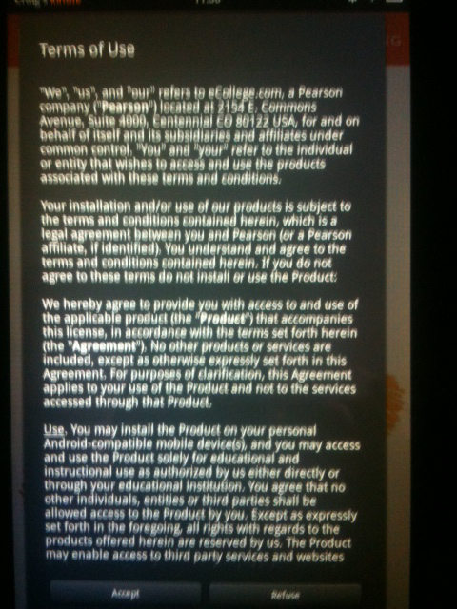

Description:
iOS: The Terms of Use do not display on the users’ device. The Terms of Use can only be accessed via the product page in the iTunes/App Store.

Android: The Terms of Use will display only once when the user launches the app on their device for the first time. If the user accepts the Terms of Use by tapping the Accept button, the app will display the sign in screen. If a user declines the Terms of Use by tapping the Refuse button, the app will close and the user will not be able to access the sign in screen. The OS of the users device will determine the look and feel of the Terms of Use screen.

Legal Notice

Terms of Use
Unless otherwise indicated, this Web site and its contents are the property of Pearson Education, Inc. and/or its subsidiaries, affiliates, or assigns (collectively “Pearson Education”), and are protected, without limitations, pursuant to U.S. and foreign copyright and trademark laws. By accessing this Web site, you agree to the following terms and conditions. If you do not agree, you have no right or license to access this Web site and you should not do so.

General Terms
You are authorized to download one copy of the material on this Web site on one computer for your personal, non-commercial use only. In doing so, you may not remove or in any way alter any trademark, copyright, or other proprietary notice. Except as allowed in the preceding sentence, you may not modify, copy, distribute, republish, commercially exploit, or upload any of the material on the Web site without the prior written consent of Pearson Education. No intellectual property or other rights in and to this Web site or its contents, other than the limited right to use set forth above, are transferred to you.
PEARSON EDUCATION MAKES NO REPRESENTATIONS OR WARRANTIES WITH RESPECT TO THIS WEB SITE OR ITS CONTENTS, WHICH ARE PROVIDED FOR USE “AS IS.” PEARSON EDUCATION DISCLAIMS ALL WARRANTIES, EXPRESS OR IMPLIED, INCLUDING WITHOUT LIMITATION THE IMPLIED WARRANTIES OF TITLE, NON-INFRINGEMENT, MERCHANTABILITY AND FITNESS FOR A PARTICULAR PURPOSE, WITH RESPECT TO THE WEB SITE AND ANY WEB SITE WITH WHICH IT IS LINKED. PEARSON EDUCATION ALSO MAKES NO REPRESENTATIONS OR WARRANTIES AS TO WHETHER THE INFORMATION ACCESSIBLE VIA THIS WEB SITE, OR ANY WEB SITE WITH WHICH IT IS LINKED, IS ACCURATE, COMPLETE, OR CURRENT.
It is your responsibility to evaluate the accuracy and completeness of all information, opinions, and other material on this Web site or any Web site with which it is linked. Price information is subject to change without notice.
To the fullest extent permitted by applicable laws, Pearson Education and its employees, agents, suppliers, and contractors shall in no event be liable for any claims, charges, and contractors damages, liabilities, losses, and expenses of whatever nature and howsoever arising, including, without limitation any compensatory, incidental, direct, indirect, special, punitive, or consequential damages, loss of use, loss of data, loss caused by a computer or electronic virus, loss of income or profit, loss of or damage to property, claims of third parties, or other losses of any kind of character, even if Pearson Education has been advised of the possibility of such damages or losses, arising out of or in connection with the use of this Web site, or any Web site with which it is linked. You assume total responsibility for establishing such procedures for data back up and virus checking as you consider necessary.

Postings
To the extent that portions of this Web site (such as “chat rooms” or “bulletin boards”) provide users an opportunity to post and exchange information, ideas and opinions (“Posting”), BE ADVISED THAT PEARSON EDUCATION HAS NO OBLIGATION TO SCREEN, EDIT, OR REVIEW POSTINGS PRIOR TO THEIR APPEARANCE ON THIS WEB SITE, and Postings do not necessarily reflect the views of Pearson Education. To the fullest extent permitted by applicable law, Pearson Education shall in no event have any responsibility or liability for the Postings or for any claims, damages, or losses resulting from their use and/or appearance on this Site.
Pearson Education reserves the right to monitor all Postings and to remove any which it considers in its absolute discretion to be offensive or otherwise in breach of these terms and conditions.
You hereby represent and warrant that you have all necessary rights in and to all Postings you provide and all material they contain; that your Postings shall not infringe any proprietary or other rights of third parties; that your Postings shall not contain any viruses or other contaminating or destructive devices or features; that your Postings shall not contain any defamatory, indecent, offensive, tortious, or otherwise unlawful material or content; and that your Postings shall not be used to carry out or solicit any unlawful activity and/or be used to make commercial solicitations. You hereby authorize Pearson Education to use and/or authorize others to use all or part of your Postings in any manner, format, or medium that Pearson Education or such other parties see fit. You shall have no claim or other recourse against Pearson Education for infringement of any proprietary right in Postings.

Indemnification
You hereby agree to indemnify and hold harmless Pearson Education from and against any and all claims, charges, demands, damages, liabilities, losses, expenses, and liabilities of whatever nature and howsoever arising (including but not limited to any legal or other professional fees and the costs of defending or prosecuting any claim and any loss of profit, goodwill, and any other direct or consequential loss) incurred or suffered by Pearson Education directly or indirectly by reason of any act or omission which you commit in breach of these terms and conditions and the obligations and warranties contained in them.

Digital Millennium Copyright Act Compliance
If you have any copyright concerns about any materials posted on this site (” Pearson Site”) by others, please let us know. We comply with the provisions of the Digital Millennium Copyright Act applicable to Internet service providers (17 U.S.C. :§ 512). Please provide us with written notice (“Notice”) by contacting our Designated Agent at the following address:
Designated Agent
Pearson Education, Inc.
200 Old Tappan Road
Old Tappan, NJ 07675
Facsimile: 201-785-2721
E-mail: dmca.agent@pearsoned.com

4.0: Sign In Screen

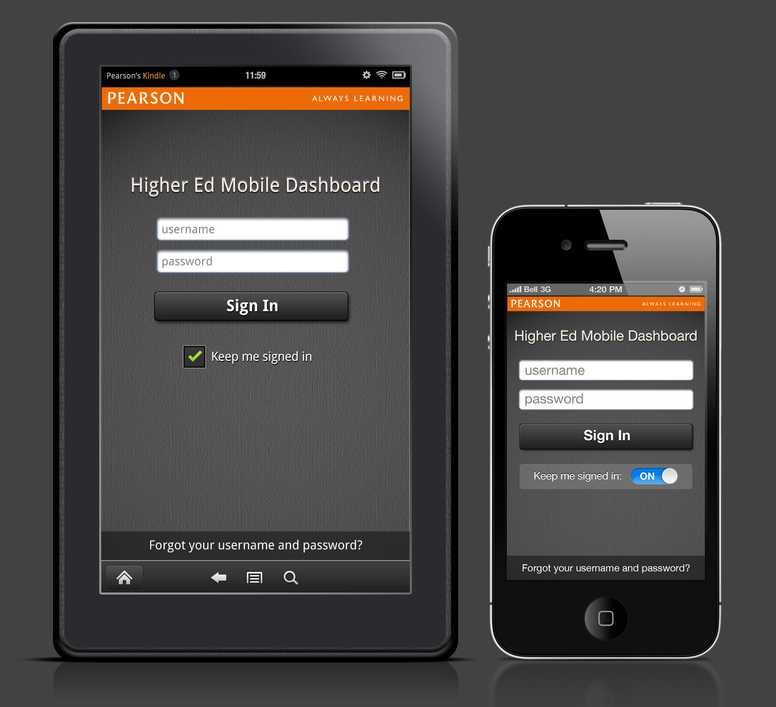

Description:
When a user launches the app, they will be presented with the sign in screen. The sign in screen consists of the Pearson strap line, the app tile, username and password fields, a sign in button, a “keep me signed in” checkbox and the ability to retrieve a username and password.

Behaviors:
- Tapping in the Username field will bring up keyboard and allow text input. The field will be case sensitive.

- Tapping in the Password field will bring up keyboard and allow text input. The field will be case sensitive.

- When Keep me signed in is selected, the username and password will be saved and the user will bypass the login screen next time the app is launched. The default setting of the checkbox is on. If the user signs out from the Profile screen, they’ll need to sign in again here next time they’re on the device.

- When Keep me signed in is not selected, the user will need to enter their username and password to sign in again.

- When the sign in button is tapped, the app will verify the username and password is correct using the Viking SMS service, which will return a valid SMS User ID.

- The app will use the SMS User ID with the User Summary service to get a list of the user’s subscriptions.

- The app will use the list of user’s subscriptions to connect to the necessary subscriptions.

- If the user has multiple courses, they will land on the “All courses” view. Users with a single course will land on that specific course screen.

Error Messages:

1 | If a user taps the “Sign In’ button without entering one or both credentials, the following error message will appear: | You must provide a username and password
2 | If a user enters an incorrect username and/or password, the following error message will appear: | Incorrect username and/or password
3 | If a user does not have a WiFi, 3G, 4G or Edge connection, the following error message will appear: | No network connections available
4 | What if the user has expired subscriptions? | TBD

Forgot Your Username or Password:

On iOS devices, when the user taps the “Forgot your username and password” bar, the screen will flip left over right to reveal the following screen. On Android devices, the screen will slide into position.

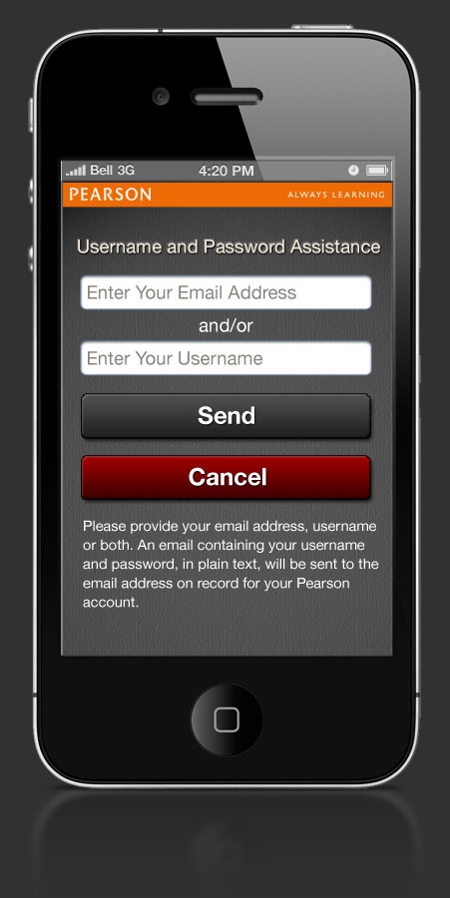

On-screen Text:

Please provide your email address, username or both. An email containing your username and password, in plain text, will be sent to the email address on record for your Pearson account.

Button Behaviors:
Behaviors for Send button:

Success Messages
“Your Password Was Sent”

“An email containing your login name and password, in plain text, has been sent to the email address on record for your Pearson account.
Buttons: OK.

OK button returns user to Sign-in screen.

Error Messages:

1 | If a user taps the “Send” button without entering any credentials (both fields blank), the following error message will appear: | You must enter an email address or username. | OK
2 | If a user enters an incorrect email address, the following error message will appear: | The email address you entered was not recognized. | OK
3 | If a user enters an incorrect username, the following error message will appear: | The username you entered was not recognized. | OK
4 | If a user enters both an incorrect email address and/or username, the following error message will appear: | The email address and username you entered were not recognized. | OK
5 | If a user does not have a WiFi, 3G, 4G or Edge connection, the following error message will appear: | No network connections available. | OK
6 | If SMS does not recognize email address | The email address you entered was not recognized. | OK
7 | If SMS does not recognize username | The username you entered was not recognized. | OK
8 | SMS does recognize either the username or email address but if there are expired subscriptions, does SMS throw an error message? | TBD | TBD

Cancel button:
On iOS devices, tapping the “Cancel” button will flip the screen, right over left, returning the user to the Sign In screen. On Android devices, the screen will slide away displaying the Sign In screen.
5.0: Course Header

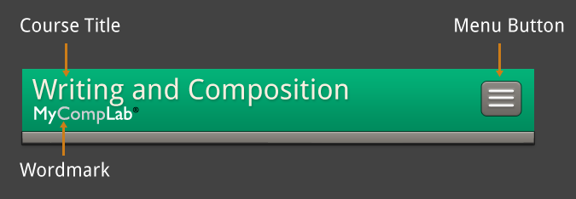

Description:
The course header resides at the top-most area of the app and contains the (1) course title, (2) MyLab/Mastering wordmark and (3) the menu button. The height of the course header will vary from handheld device to tablet.

Behaviors:

1. Course Title: The end of longer course titles will fade based on the width and orientation of the device. For longer course titles, the title will appear on screen for 5 seconds, then begin to scroll to the left, revealing the entire course title (this is known as marquee) It will continue to scroll until the first character of the title has returned to the far left position, then pause again. This process will repeat again after 5 seconds.

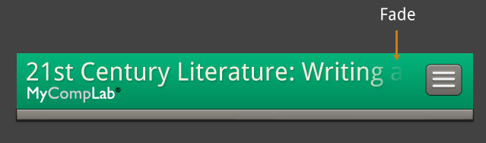

2. Wordmarks: For courses with associated wordmarks, the appropriate wordmark will display beneath the course title. When a course appears that does not have an associated wordmark, the app will display a generic “MyLab/Mastering” wordmark.

3. Menu button: When a user taps on the menu button, the menu will slide onto the screen from the right. The menu button size will vary from handheld device to tablet.

Gestures:

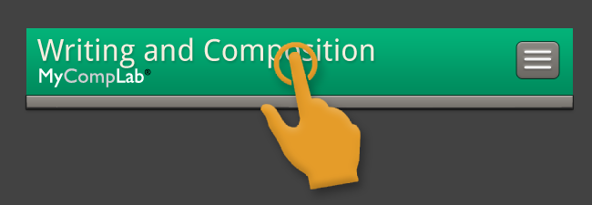

- A user can access the “course details” view by tapping anywhere on the course header. The course header will flip forwards to reveal the “course details” header. Tapping anywhere within the course detail header or the back arrow button will return the user back to the course header with the same flipping animation.

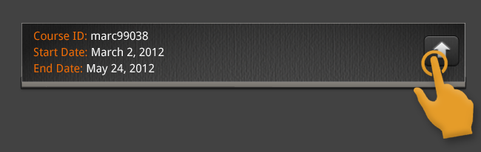

Note: When a user is on the “All Courses View”, the course header bar cannot be tapped to reveal any course details.

Animation Example:
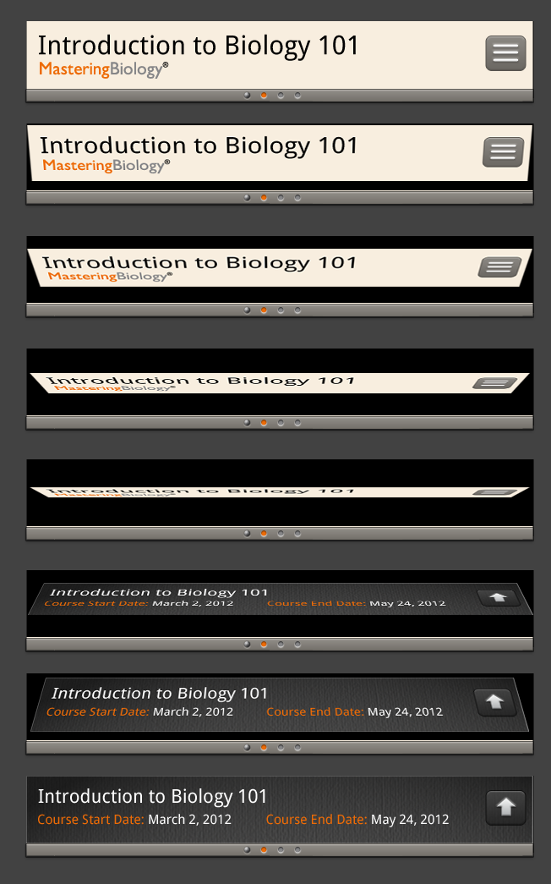

2. For users with more than one course, the user can swipe left and right on the course header or anywhere on the screen with one finger to navigate between courses. See Course Indicator Bar section for more details.

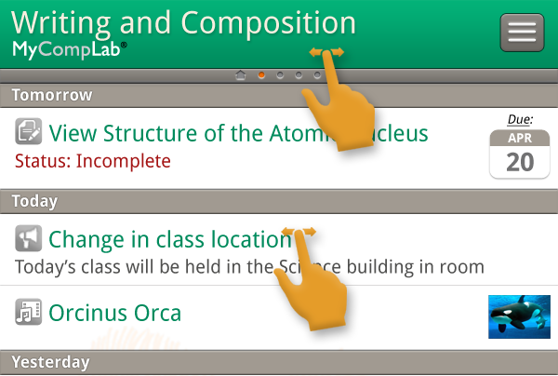

3. A user can access the menu by tapping on the menu button. See Menu section for more detail.



Color Variations:
A user with only one course will not see the “All Courses” view. The user will only see a single course with the green color palette with no course indicators dots.

Users with multiple courses will see different color palettes for each course. Courses will cycle through 4 color schemes, which will follow these rules:
Course 1 = Color 1 (Green)
Course 2 = Color 2 (Blue)
Course 3 = Color 3 (Purple)
Course 4 = Color 4 (Red)
Course 5 = Color 1 (Green)
Course 6 = Color 2, etc…

The “All Course” view will have the dark background.

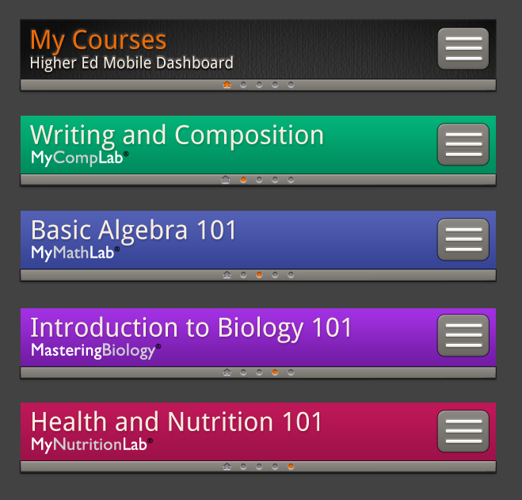

6.0: Course Details Header

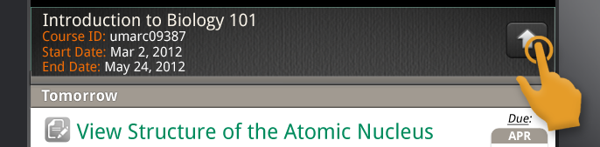

Description:

The following information will be displayed on the Course Details header:
- Full course title (no marquee)
- Course ID or course code when available from platform. If neither is available, nothing will be displayed.
- Start Date using standard date format. (Apr 01, 2012)
- End Date using standard date format. (Apr 01, 2012)

Note: When a user is on the “All Courses View”, the course header bar cannot be tapped to reveal any course details.

Behaviors:

Tapping anywhere within the course detail header or the back arrow button will return the user back to the course header with the same flipping motion.

Gestures:

The user can tap the back button to return to the course header bar. User can continue to swipe left and right between courses in this view.
If user has 4 courses and user is on the second course, having already flipped all the headers, when the user swipes between all the courses, the app will continue to show the course details, but only one course to the left and one course to the right. The app remembers the state one course previous and one course after wherever user took the action.

7.0: Course Indicator Bar

Description:
When a user has more than one course, the course indicator bar will appear below the course header. The course indictor bar will consist of dots, each representing a course. The first dot (home icon) in the row indicates the “all courses” view.

Behaviors:
Each dot represents a course, with courses appearing alphabetically. The highlighted dot indicates the course currently being displayed. Non-highlighted dots indicate course not currently being viewed. The first dot in the row indicates the “all courses” view.

Gestures:
The user can navigate between courses by swiping left and right on the course header or anywhere on the screen with one finger. As the user swipes, the entire screen will slide left or right to reveal the previous or next course. The highlighted dot will also follow the users’ gesture to indicate where they are in the list of courses. When the user reaches the last course in the app, they will no longer be able to swipe left.

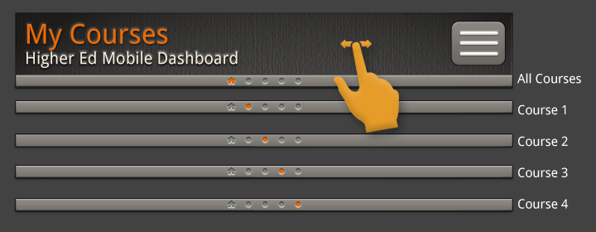

8.0: Status Bar and Page Refresh

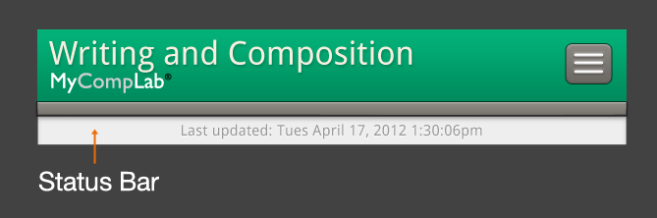

Description:
The status bar is used to indicate to the user the time the content of the app was last updated. The status bar resides beneath the course header bar and the course indicator bar (when multiple courses are present). The status/refresh option is not available on the Profile screens, Sign-in screen, and Forgot Username or Password screen.

Behaviors:
If a user chooses to refresh the screen (by pulling the screen downwards), the refresh arrow and message will appear above the status bar until the user releases the screen. Once released, the status bar will move upwards hiding the status bar entirely.

Gestures:
To refresh a course activity list, the user will tap and pull downward, then release. The refresh arrow, which initially will point downwards, will rotate counter-clockwise as the user pulls downward.

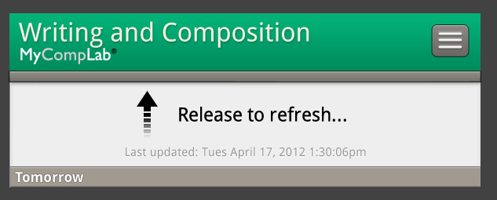
9.0: Course Activity List View
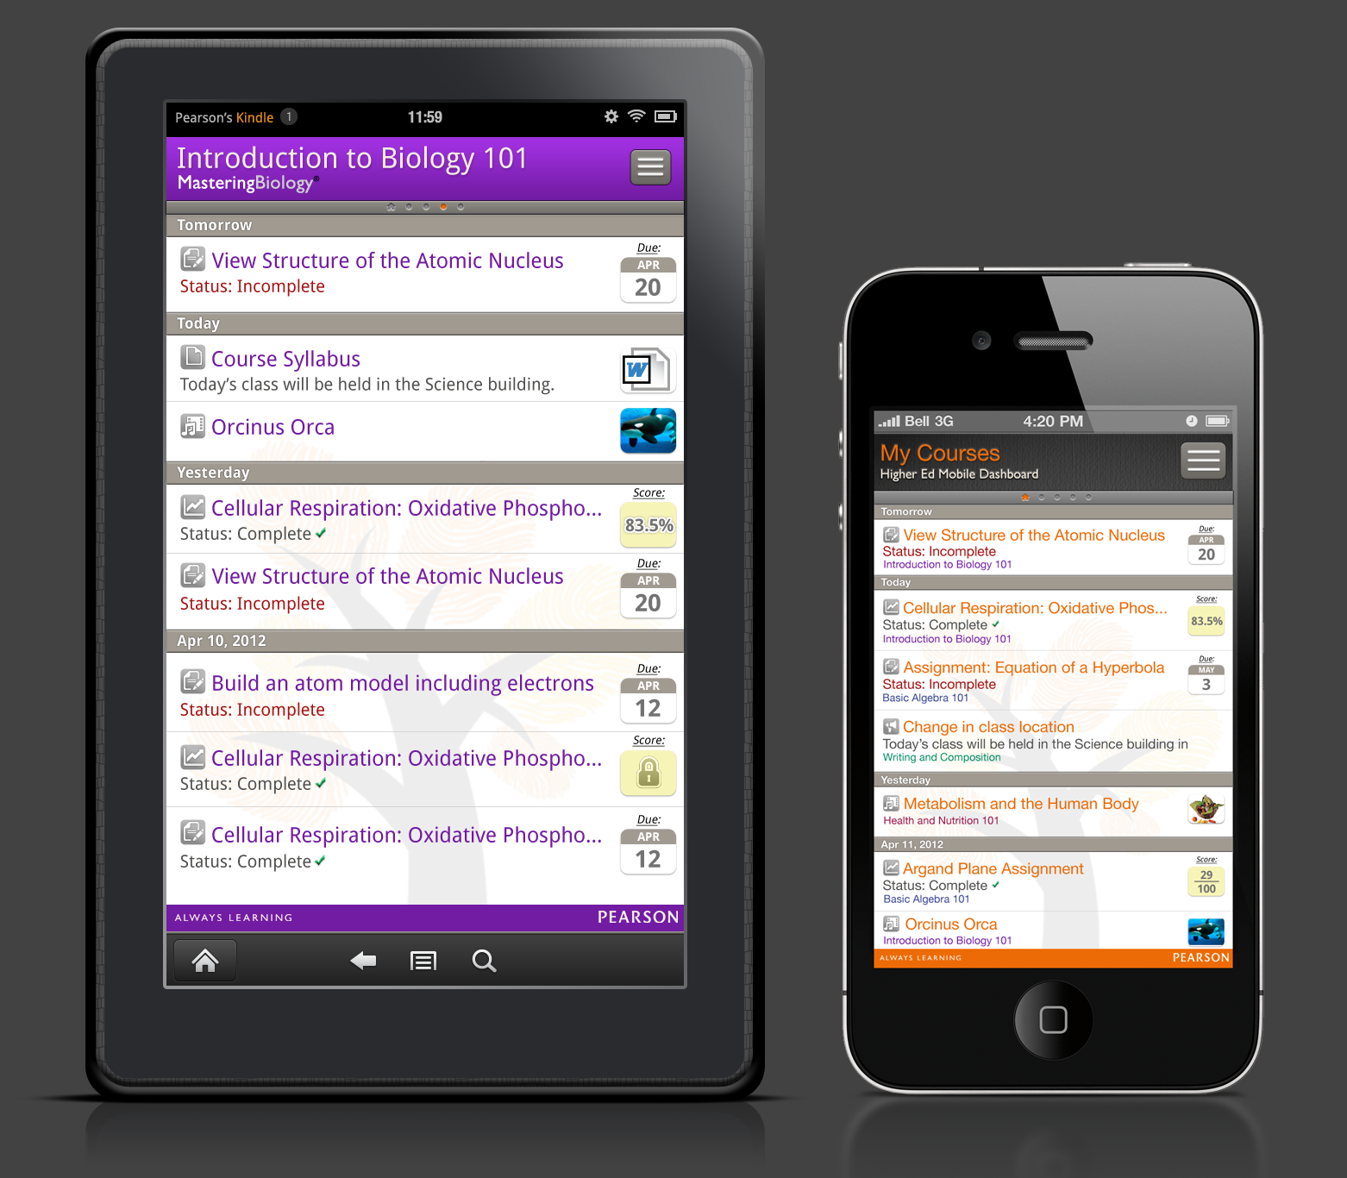

Description:
When a user is viewing their course in list view, the following items will appear on the screen below the course header and course indicator bar:

- Date Bars
- Icons
- Announcements
- Assignments
- Documents (deferred)
- Media (deferred)
- Notes (Epic only)
- Results
- Due Dates
- Assignment Results/Scores
- Assignment Status
- File Upload iconography (deferred)
- Pearson Strapline

Activity list data will appear in the list grouped in the following order:
By Date → By Course (alphabetically) → By Type (announcements, assignments, notes, results) → By Title (alphabetically)

Date Bars:
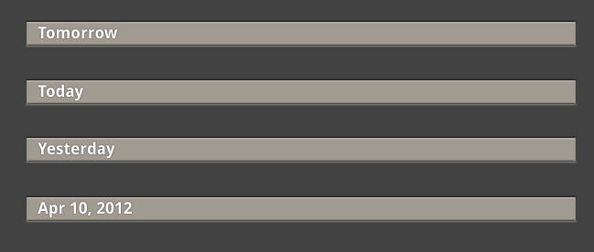

Date bars help the user understand the sense of time as it relates to the activities of their course. The top-most date bar will always read “Tomorrow” and the second-most date bar will always read “Today. The third bar will always read “Yesterday”. All subsequent date bars will display the full date in Month (3 letter abbreviation), Day (2 number), Year (4 number) format. Only dates that have activities associated with them will appear. For instance, if no activities happened on Mar 15, 2012, then no date bar will appear.

For the Mastering platform (all assignments), and the EPIC platform (seven days of assignments), the user can also scroll upwards to see assignments that are posted in the future. The date bars will follow the same date format as dates that are shown in the past.

If there are no activities available under the “Tomorrow,” “Today” and “Yesterday” date bars will display the following messages:

Tomorrow: “There are no course activities for tomorrow.”
Today: “There are no course activities today.”
Yesterday: “There were no course activities yesterday.”

NOTE: When there are no activities, these items cannot be tapped in the Course Activities list.

NOTE: The only time when Tomorrow, Today and Yesterday will NOT appear in the list is when a user filters a specific data type and that data type is not available for those 3 days.

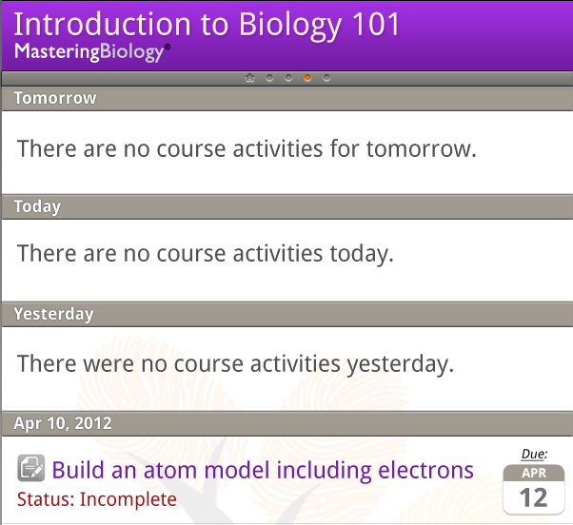

Icons:
Each activity type has an associated icon. The icons that appear in the list view are the same icons that appear under the filtering section of the menu:

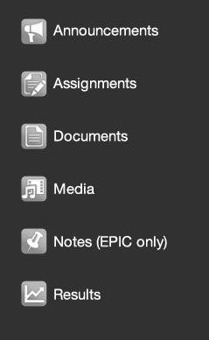

Announcements:


Epic – Announcements received from the Epic platform will display the following:
- Announcement icon.
- Announcement Title, truncated with ellipsis based upon device’s screen width.
- Two lines of announcement text, truncated with ellipsis based upon device’s screen width.

Mastering – Announcements received from the Mastering platform will display the following:
- Announcement icon.
- Announcement Title, truncated with ellipsis based upon device’s screen width.
- Two lines of announcement text, truncated with ellipsis based upon device’s screen width.

MMND – Announcements received from the MMND platform will display the following:
- Announcement icon.
- Announcement Title, truncated with ellipsis based upon device’s screen width.
- Two lines of announcement text, truncated with ellipsis based upon device’s screen width.

XL – Announcements received from the XL platform will display the following:
- Announcement icon
- Announcement Title, truncated with ellipsis based upon device’s screen width.
- Two lines of announcement text, truncated with ellipsis based upon device’s screen width.

Note: If no announcement text is present, only the Announcement title will display.
Note: No html will display in this view.

Assignments:

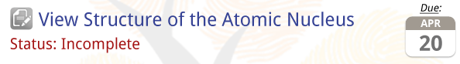

EPIC – Assignments received from the Epic platform will display the following:
- Assignments icon.
- Assignments Title, truncated with ellipsis based upon device’s screen width.
- Due Date (Displayed as calendar icon).
- Status (Completed, Not Started, In Progress, Rewrite Required.)

Mastering – Assignments received from the Mastering platform will display the following:
- Assignments icon.
- Assignments Title, truncated with ellipsis based upon device’s screen width.
- Due Date (Displayed as calendar icon).
- Status (Completed, Not Started, Exempt.)

MMND – Assignments received from the MMND platform will display the following:
- Assignments icon.
- Assignments Title, truncated with ellipsis based upon device’s screen width.
- Due Date (Displayed as calendar icon.)
- Status (Completed, Not Started.)

XL – Assignments received from the XL platform will display the following:
- Assignments icon.
- Assignments Title, truncated with ellipsis based upon device’s screen width.
- Due Date (Displayed as calendar icon.)
- Status (Completed or Incomplete.)

Documents: (Deferred Until October)

Instructor-generated documents received from the file upload services will display the following:
- Documents icon.
- Document Title, as set by the instructor.
- File name.
- Associated file type icon

Supported document formats include: bmp, doc, docx, flz, gif, html, jpg, jpeg, pdf, png, ppt, pptx, sit, sitx, swf, tif, txt, xls, xlsx, zip
Associated file type icons:

Icon Image | Icon File Name | Associated with:
 | icon-lv-compressed.png | zip, sit, sitx
 | icon-lv-excel.png | xls, xlsx
 | icon-lv-flash.png | swf
TBD | TBD | flz
 | icon-lv-graphic.png | bmp, gif, jpg, jpeg, png, tif
 | icon-lv-html.png | html
 | icon-lv-msword.png | doc, docx
 | icon-lv-pdf.png | pdf
 | icon-lv-powerpoint.png | ppt, pptx
 | icon-lv-txt.png | txt

Media: (Deferred Until October)

Instructor-generated media received from the file upload services will display the following:
- Media icon.
- Audio/Video Title, as set by the instructor.
- File name.
- Thumbnail of video. If no thumbnail is available or if it is an audio file, then display associated file type icon.

Supported media upload formats include:
- Audio: .flv, .asf, .qt, .mov, .mpg, .avi, .wmv, .mp4, .3gp, .mp3, .wav, .wma
- Video: V: .flv, .asf, .qt, .mov, .mpg, .avi, .wmv, .mp4, .3gp, .mpeg, .m4v

Note: Some formats support both audio and video. Since we wont be able to determine which the instructor has created, we will display a generic icon for these files.

Associated file type icons:

Icon Image | Icon File Name | Associated with:
 | icon-lv-audio.png | mp3, .wav, .wma,
 | icon-lv-media.png | .avi, .qt, .mov, .wmv, .mp4, .3gp, .mpg, .mpeg, .avi, .m4v
 | icon-lv-flash.png | .flv

EPIC Notes:



EPIC – Notes received from the Epic platform will display the following:
- Notes icon.
- Note Title, truncated with ellipsis based upon device’s screen width.
- Two lines of Note text, truncated with ellipsis based upon device’s screen width.

Note: If no Note text is present, only the Note title will display
Note: No html will display in this view.

Results:

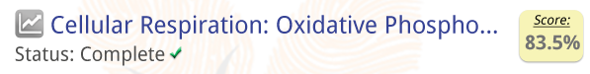

EPIC –Results received from the Epic platform will display the following:
- Results icon.
- Assignments Title, truncated with ellipsis based upon device’s screen width.
- Grade.
- Status (Completed.)

Mastering – Results received from the Mastering platform will display the following:
- Results icon.
- Assignments Title, truncated with ellipsis based upon device’s screen width.
- Grade, or n/a when an instructor does not make the grade available to the student.
- Lock icon – indicates pass phrase-protected results. Note: icon only appears when enabled by instructor.
- Status (Completed.)

MMND – Results received from the MMND platform will display the following:
- Results icon.
- Assignments Title, truncated with ellipsis based upon device’s screen width.
- Grade.
- Status (Completed.)

XL – Results received from the XL platform will always display under “Today” in the first position with the following:
- Results icon.
- The Title “My Results”
- Overall Score.
- % of assignments completed (displayed as: 18% of assignments done). When an instructor does not make the overall score available to students, then “n/a” should display in the score area.

Behaviors:
A user can tap anywhere within a specific activity line to view the detail view of that activity. The user can also scroll the activity list by swiping up and down with one finger. The course header and strapline will not scroll with the page.

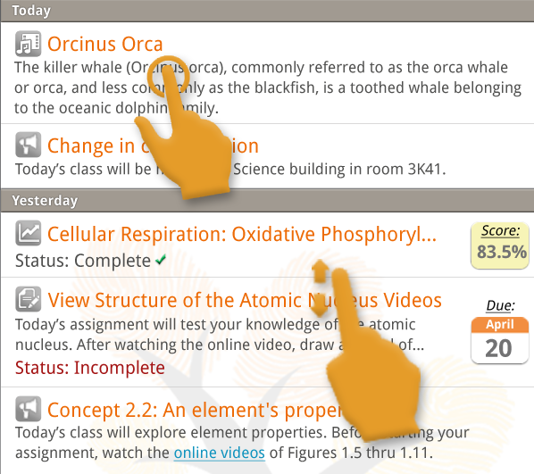

Variations:
In the “All Courses” view, the course title will also display for each item in the Activity list. The course title text color should match the course color as it appears in the app.

Example of “All Courses” when in list view”:
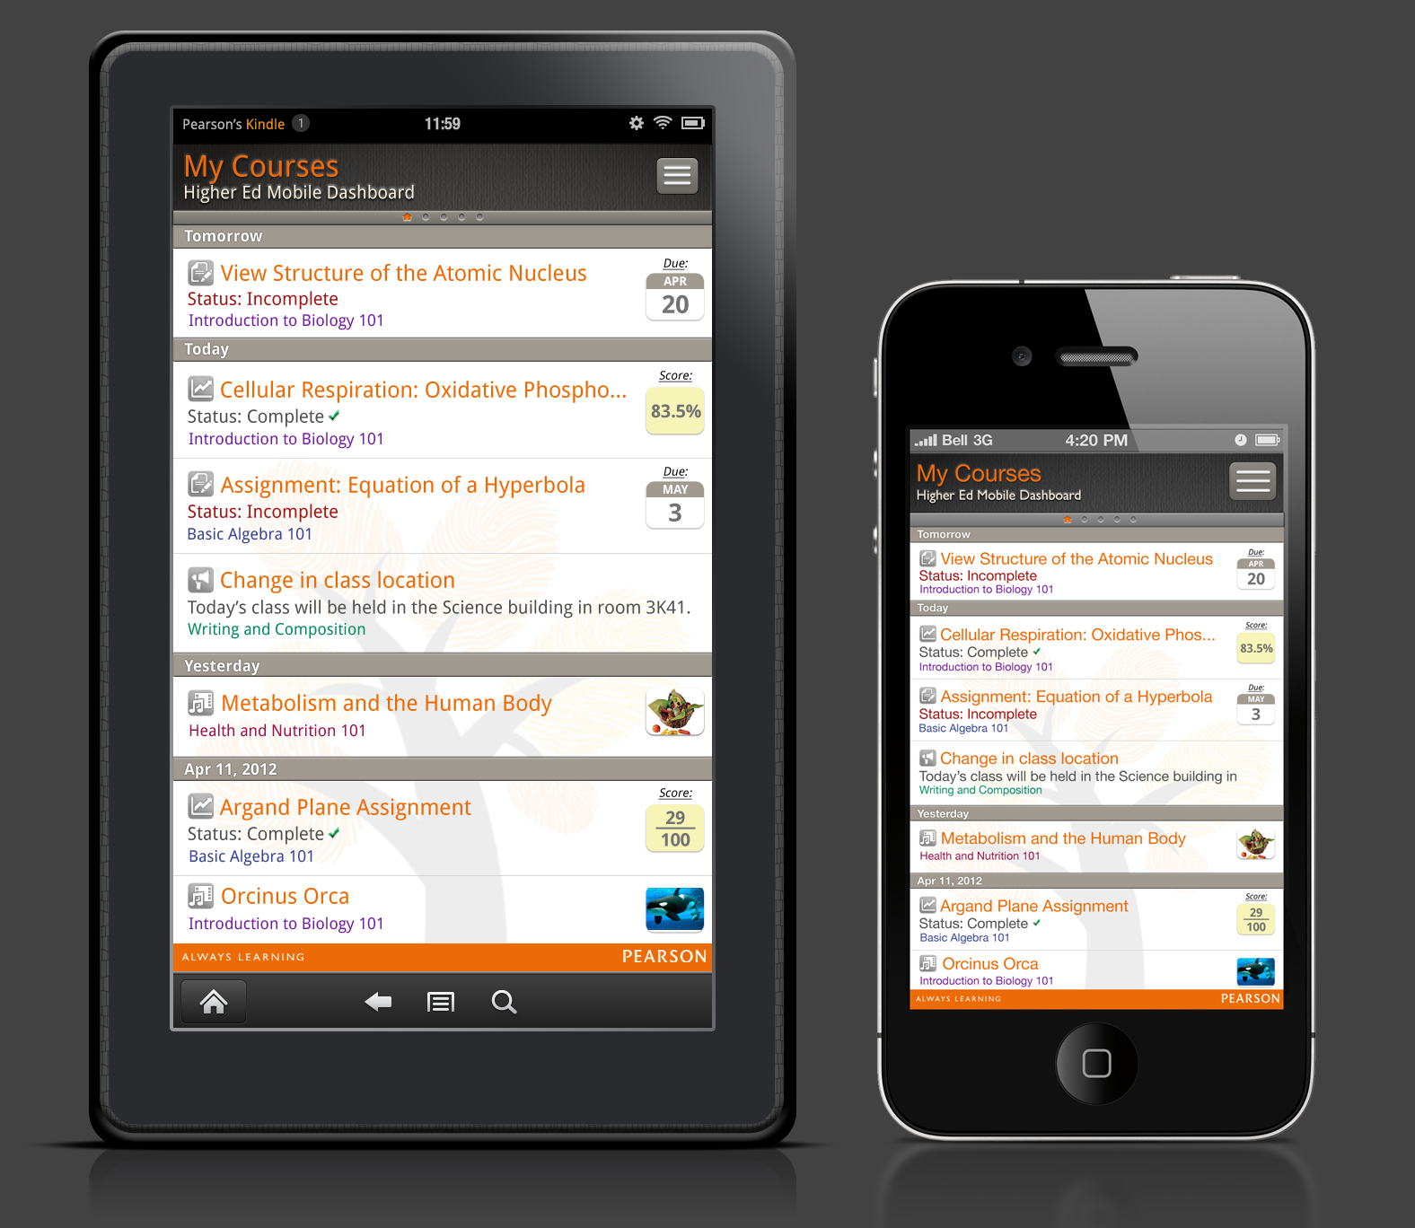

10.0: Detail Views

Description:
A Detail View opens a modal window over the course activity list. This allows the user to view more details on the activity they have selected. User cannot navigate from detail view to detail view. User must exit the detail view before being able to return to the activity list.

There are six types of details views:

- Announcements
- Assignments
- Documents
- Media
- Notes (EPIC only)
- Results

Announcements
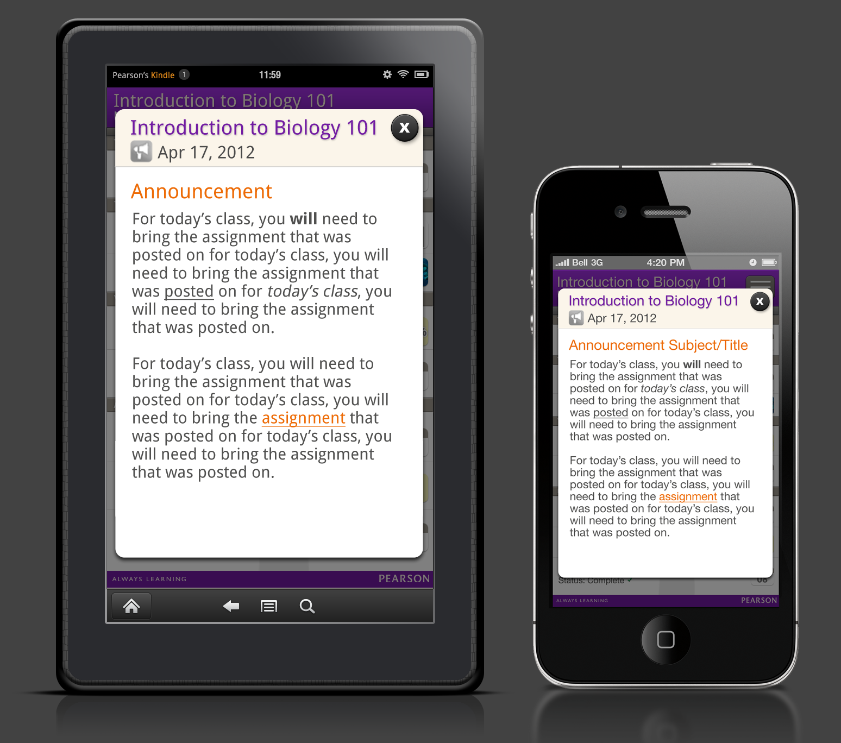

Epic – Announcements received from the Epic platform will display the following:
- Course title, truncated with ellipsis based upon device’s screen width.
- Announcement icon.
- Announcement date – (standard formatting: Apr xx, xxxx.)
- Announcement Title – full title (allow wrapping).
- Full Announcement body text, including accepted HTML formatting (See the HEMD App HTML White List section for more detail.)
- Close button (dismisses Detail view modal window.)

Mastering – Announcements received from the Mastering platform will display the following:
- Course title, truncated with ellipsis based upon device’s screen width.
- Announcement icon.
- Announcement date – (standard formatting: Apr xx, xxxx.)
- Announcement Title – full title (Allow wrapping).
- Full Announcement body text, including accepted HTML formatting (See the HEMD App HTML White List section for more detail.)
- Close button (dismisses Detail view modal window.)

MMND – Announcements received from the MMND platform will display the following:
- Course title, truncated with ellipsis based upon device’s screen width.
- Announcement icon.
- Announcement date – (standard formatting: Apr xx, xxxx.)
- Announcement Title – full title (Allow wrapping).
- Full Announcement body text, including accepted HTML formatting (See the HEMD App HTML White List section for more detail.)
- Close button (dismisses Detail view modal window.)

XL – Announcements received from the XL platform will display the following:
- Course title, truncated with ellipsis based upon device’s screen width.
- Announcement icon.
- Announcement date – (standard formatting: Apr xx, xxxx.)
- Announcement Title – full title (Allow wrapping).
- Full Announcement body text, including accepted HTML formatting (See the HEMD App HTML White List section for more detail.)
- Close button (dismisses Detail view modal window.)

Scrolling behavior:
When length of body text exceeds height of fixed modal window, the bottom row of text will fade to white. A scroll bar appears when user interacts with the screen.

Note (Android): If a user taps on a link from within an announcement that will launch their devices browser, returning to the app should place the user from where they left.

Note (iOS): If a user taps on a link from within an announcement, the iOS “Copy” dialog should appear. This will allow the user to copy the URL and paste it into the Safari browser.

Notes (EPIC only)
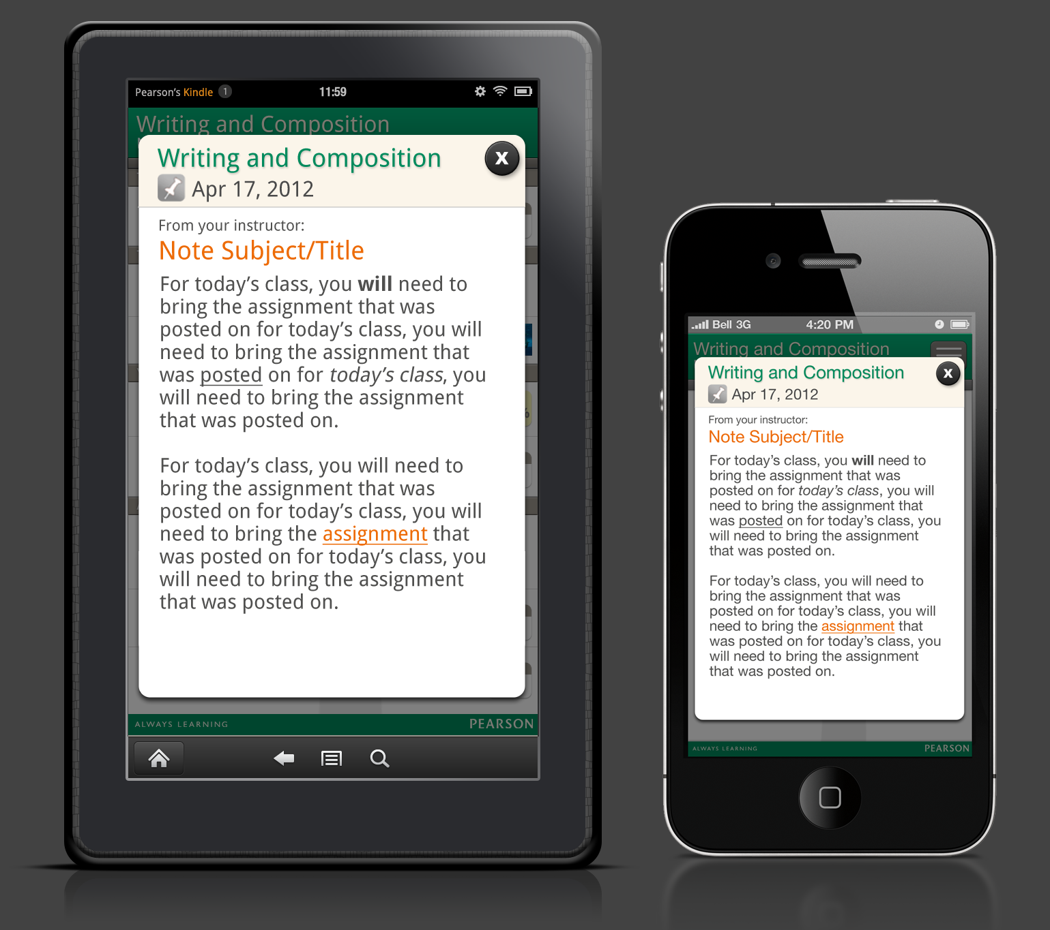

Epic – Notes received from the Epic platform will display the following:
- Course title, truncated with ellipsis based upon device’s screen width.
- Notes icon.
- Note date – (standard formatting: Apr xx, xxxx.)
- Note Title – full title (Allow wrapping).
- Full Note body text, including accepted HTML formatting (See the HEMD App HTML White List section for more detail.)
- Close button (dismisses Detail view modal window.)
- For Instructor-authored Notes: insert “From your instructor:”, placed above the Note title.
- For Student-authored Notes: nothing appears above Note title.

Scrolling behavior:
When length of body text exceeds height of fixed modal window, the bottom row of text will fade to white. Scroll bars appear when user interacts with the screen.

Assignments

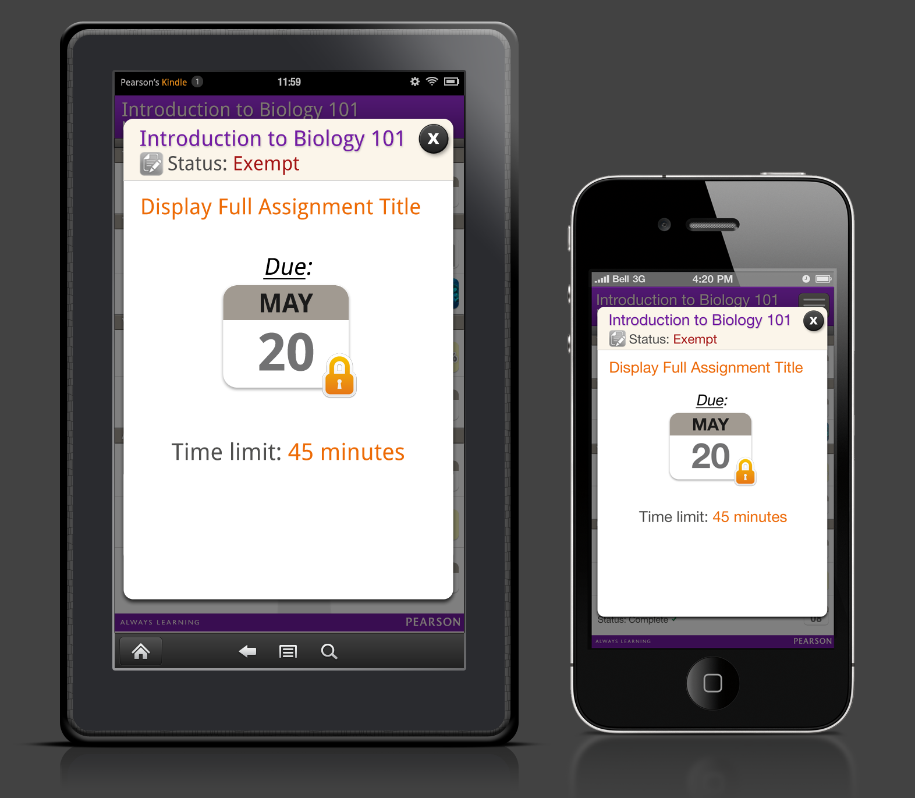

Epic – Assignments received from the Epic platform will display the following:
- Course title, truncated with ellipsis based upon device’s screen width.
- Assignment icon.
- Assignment Status – Completed, Not Started, In Progress, Rewrite Required.
- Assignment Title – full title (Allow wrapping).
- Due Date - Display “Due:” above calendar icon containing date.
- Type – Assignment, Resource.
- Sub-type - Composition, Portfolio, Peer Review, Collaboration, Diagnostic, Skill Building, HTML, Video, Audio, Exercise.
- Close button (dismisses Detail view modal window.)

Mastering – Assignments received from the Mastering platform will display the following:
- Course title, truncated with ellipsis based upon device’s screen width.
- Assignment icon.
- Assignment Status – Completed, Not Started, Exempt.
- Assignment Title – full title (Allow wrapping).
- Due Date - Display “Due:” above calendar icon containing date.
- Lock icon – indicates pass phrase-protected assignment. Note: icon only appears when enabled by instructor.
- Time Limit – Display as xx minutes (this is a static display – not a countdown timer.)
- Close button (dismisses Detail view modal window.)

MMND – Assignments received from the MMND platform will display the following:
- Course title, truncated with ellipsis based upon device’s screen width.
- Assignment icon.
- Assignment Status – Completed, Not Started.
- Assignment Title – full title (Allow wrapping).
- Due Date - Display “Due:” above calendar icon containing date.
- Close button (dismisses Detail view modal window.)

XL – Assignment received from the XL platform will display the following:
- Course title, truncated with ellipsis based upon device’s screen width.
- Assignment icon.
- Assignment Status – Completed, Incomplete.
- Assignment Title – full title (Allow wrapping).
- Due Date - Display “Due:” above calendar icon containing date.
- Due Time – Displayed as xx:xx AM or PM
- Types – Homework, Test, Quiz, Other.
- Next Assignment - Homework, Test, Quiz, Other.
- Close button (dismisses Detail view modal window.)

Results
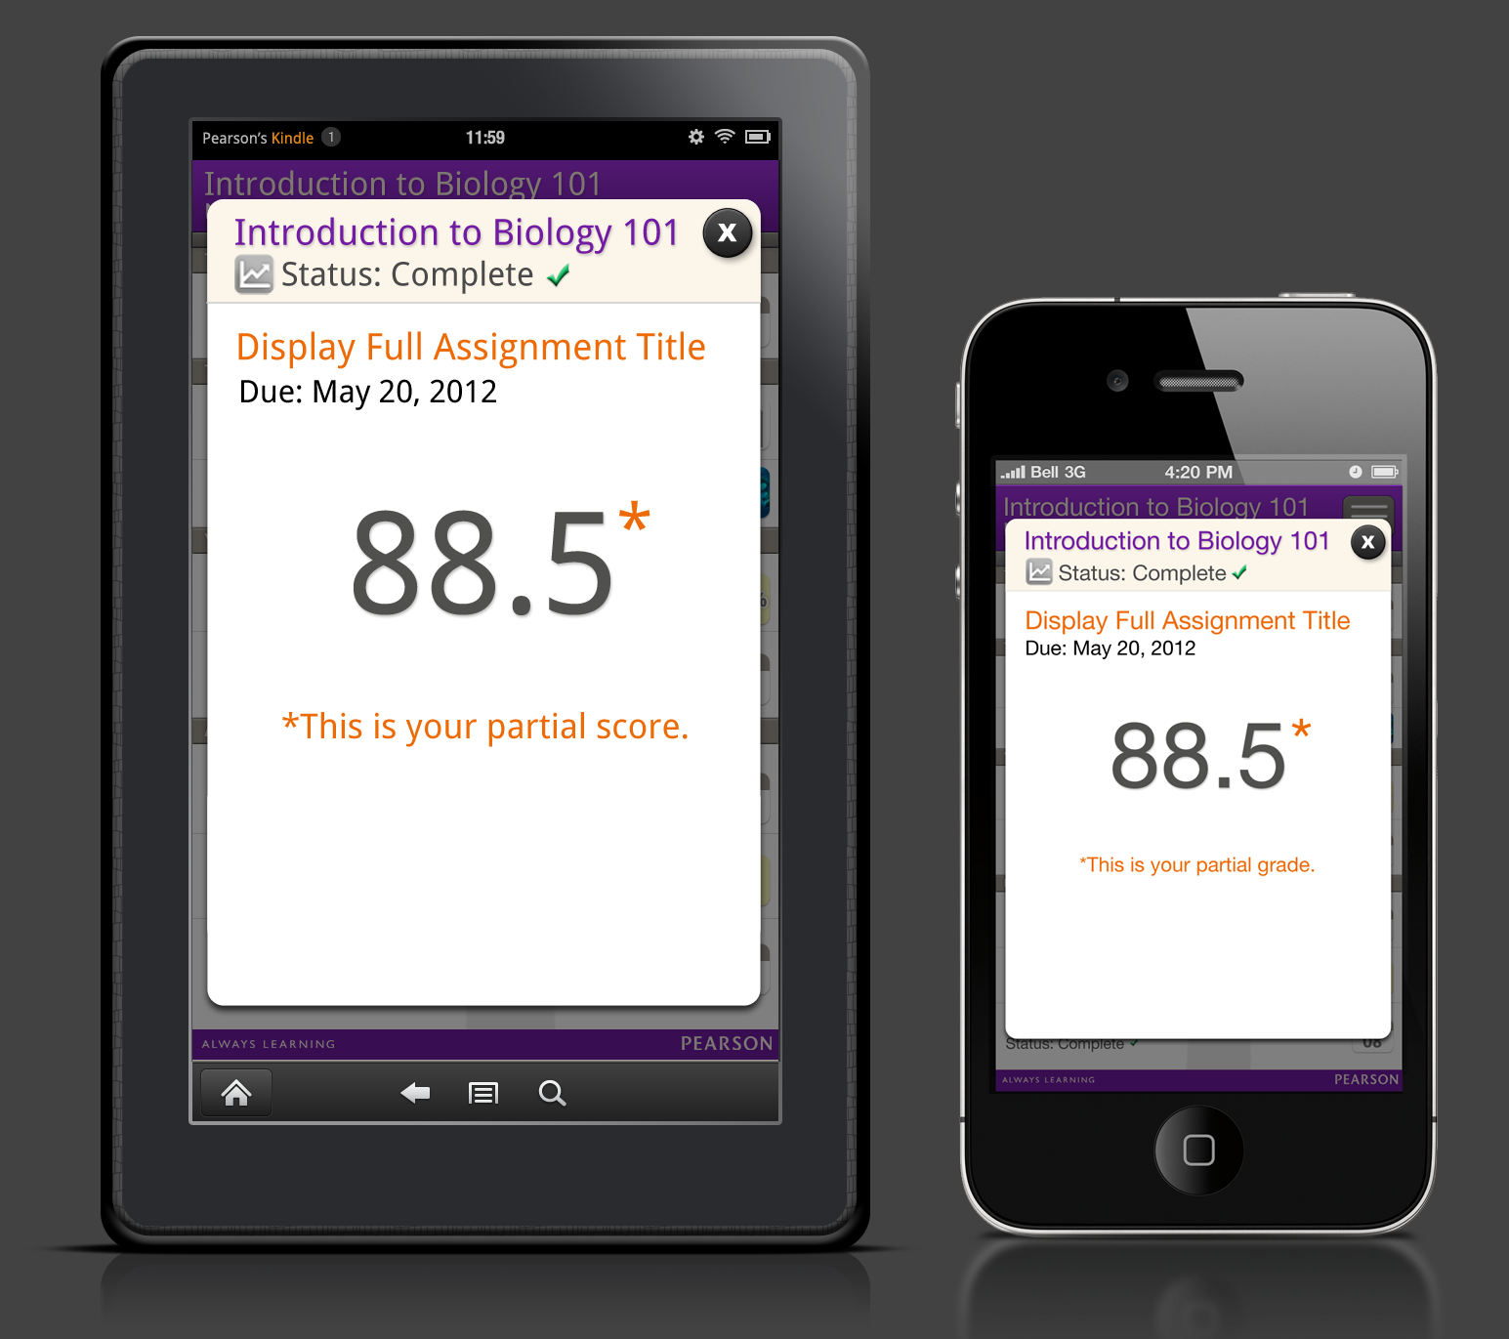

EPIC – Results received from the Epic platform will display the following:
- Course title, truncated with ellipsis based upon device’s screen width.
- Results icon.
- Status – Complete (with green checkmark).
- Assignment Title – full title (Allow wrapping).
- Due Date – Display “Due: Apr xx, xxxx” as text below assignment title).
- Score – Displayed as numeric with one decimal point and percent sign, e.g., 88.5.
- Max Grade Point – Displayed as “Max Grade Point: xxx%”
- Close button (dismisses Detail view modal window.)

Mastering – Results received from the Mastering platform will display the following:
- Course title, truncated with ellipsis based upon device’s screen width.
- Results icon.
- Status – Complete (with green checkmark).
- Assignment Title – full title (Allow wrapping).
- Due Date – Display “Due: Apr xx, xxxx” as text below assignment title).
- Score – Displayed as numeric with one decimal point and percent sign, e.g., 88.5%. When this is a partial score display asterisk ( 88.5%*) with asterisk text below reading “*This is your partial score” . If an instructor does not make a grade available to a student, then “n/a” will be displayed with asterisk text below reading “*Your instructor has not made this score available to you”.
- If an instructor has passphrase-protected a score, then a lock icon will appear with the following text: Your instructor has passphrase-protected your score. Sign in to your course from your computer to see your score.
- Close button (dismisses Detail view modal window.)

MMND – Results received from the MMND platform will display the following:
- Course title, truncated with ellipsis based upon device’s screen width.
- Results icon
- Status – Complete (with green checkmark).
- Assignment Title – full title (Allow wrapping).
- Due Date – Display “Due: Apr xx, xxxx” as text below assignment title).
- Score – Displayed as a letter.
- Close button (dismisses Detail view modal window.)

XL – Results received from the XL platform will display the following:
- Course title, truncated with ellipsis based upon device’s screen width.
- Results icon.
- Percentage of work done, e.g., “18% assigned work done”
- Overall Score.
- Score – Displayed as numeric with one decimal point and percent sign, e.g., 88.5%.
- Overall progress bar, with “Weight” text on right.
- Homework progress bar, with “Weight” text on right.
- Quiz progress bar, with “Weight” text on right.
- Test progress bar, with “Weight” text on right.
- Other progress bar, with “Weight” text on right. (TBD)
- Close button (dismisses Detail view modal window.)

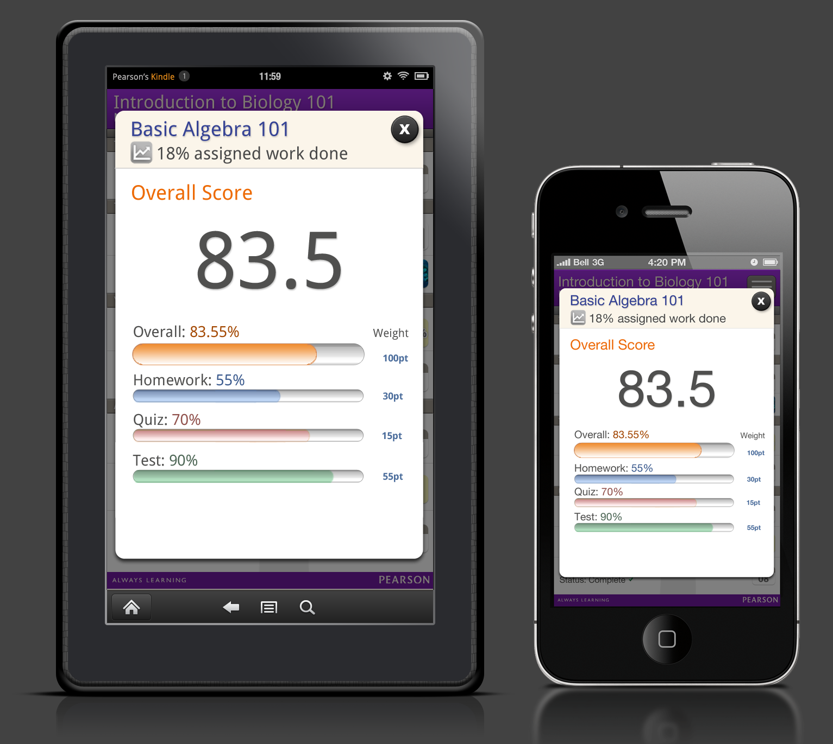

Documents (TBD)

- Course title, truncated with ellipsis based upon device’s screen width.
- Documents icon.
- Date – Date format Apr XX, XXXX.
- Document Title – full title (Allow wrapping).
- Full file name.
- File icon.
- View File button.
- Close button (dismisses Detail view modal window.)

Media (TBD)

- Course title, truncated with ellipsis based upon device’s screen width.
- Media icon.
- Date – Date format Apr XX, XXXX .
- Media Title – full title (Allow wrapping).
- Full file name.
- Thumbnail image.
- “View Video” or “Listen to Audio” button.
- Close button (dismisses Detail view modal window.)

11.0: Overdue View
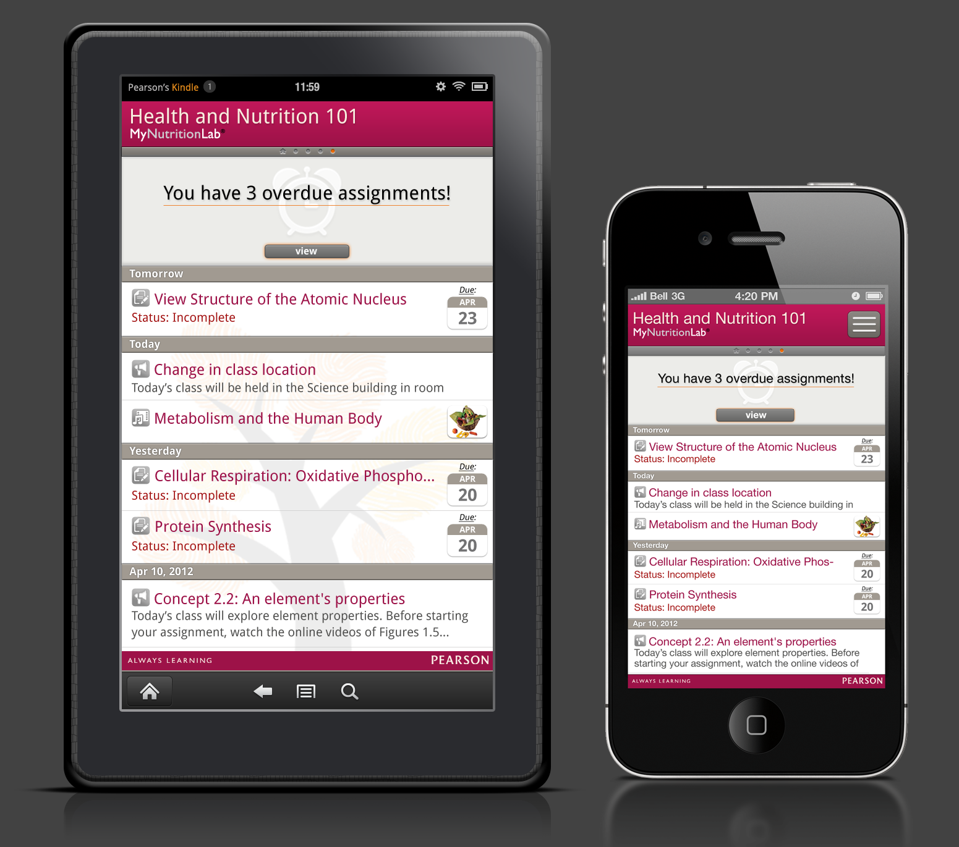

Description:
When a user has one or more assignments that have past their due dates and are not complete, the Over Due area displays just beneath the Course Indicator bar and above the Activity list. The Overdue Area will indicate how many assignments are past due, and will contain a View button.

When a user is on a specific course screen, the Overdue area will show only overdue assignments for that specific course.

When a user is on the All Courses screen, the Overdue area will show overdue assignments for all courses in the app.

The Overdue area contains the following elements:

- Overdue messages
- Alarm clock icon
- View or Dismiss button

Message for single overdue assignment: “You have one overdue assignment!”
Message for multiple overdue assignments: “You have x overdue assignments!”

Behaviors:
When user taps the View button, the Activity list will filter to show only those assignments that are overdue, and the View button will change to Dismiss.

Tapping on an overdue assignment in the Activity list will call the detail view for that assignment.

When user taps the Dismiss button, the Overdue area will slide upwards underneath the Course Indicator bar and out of sight. The Activity list will refresh to show all activities.

If a user navigates to other courses, the Overdue area will retain its state unless it has been dismissed by the user.

If a user navigates to more than one course to the left or to the right, the Overdue area will return to its default state.

When the Overdue area appears on the All Courses screen, it will display all overdue assignments for every course in the app.

When the Overdue area is present, it will remain stationary under the Course Indicator bar and the user will have the ability to scroll the Activity list.

When the user completes all overdue assignments, the Overdue area will no longer display.

12.0: Menu
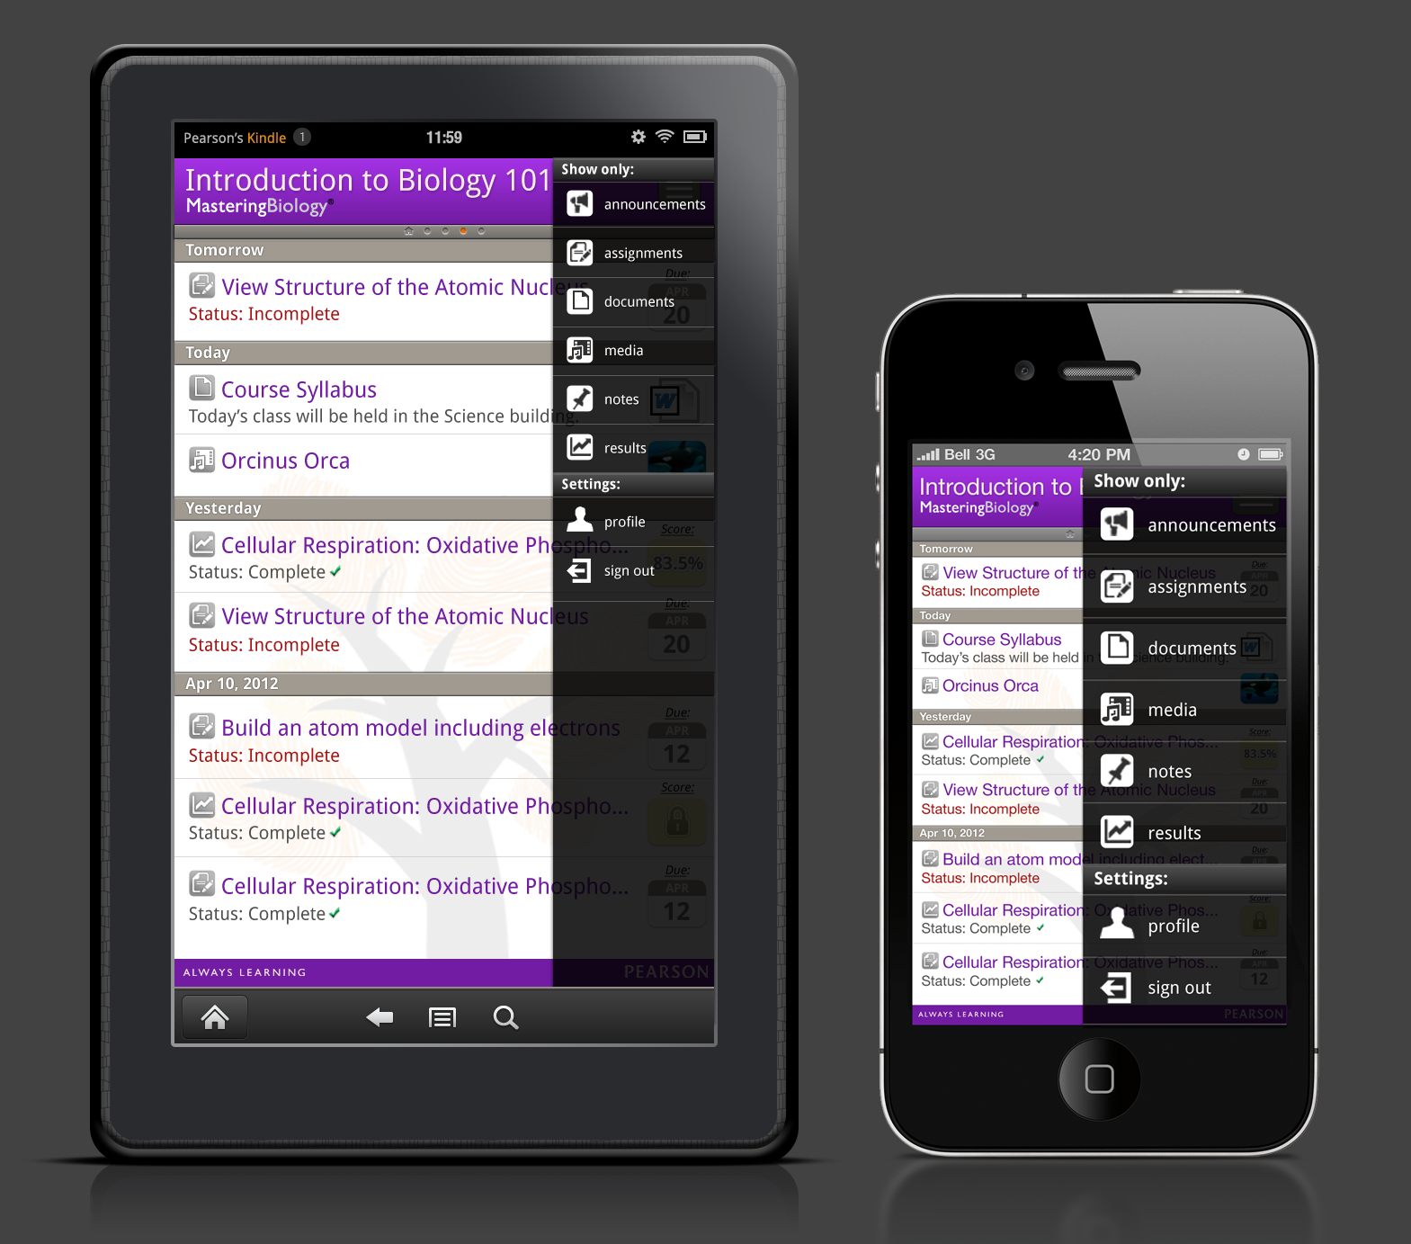

Description:
The menu is activated when a user taps the menu button in the course header. When the button is tapped, the menu will slide out from the right side of the screen. A user can hide the menu at any time by tapping anywhere outside of the menu or by tapping the Profile or Sign out icons.

The menu consists of two areas:
- Show only – this area provides filtering of the content displayed on the screen.
- Settings – Profile and Sign out.

Show only:
When the user opens the menu, all icons in the show area will be in their default states (white icon and white text). The icons act as filter buttons for the content displayed on the screen. When a user taps a specific icon, say, announcements, the icon changes to the active state (icon and text with orange glow) and only announcement data will be show on the screen. The remaining icons in the Show Only area turn to the inactive state (gray icon and gray text). To return to the full view of activities, the user would tap the icon again. The icon will return to the default state.

A user can continue to “show” data by tapping any of the icons.

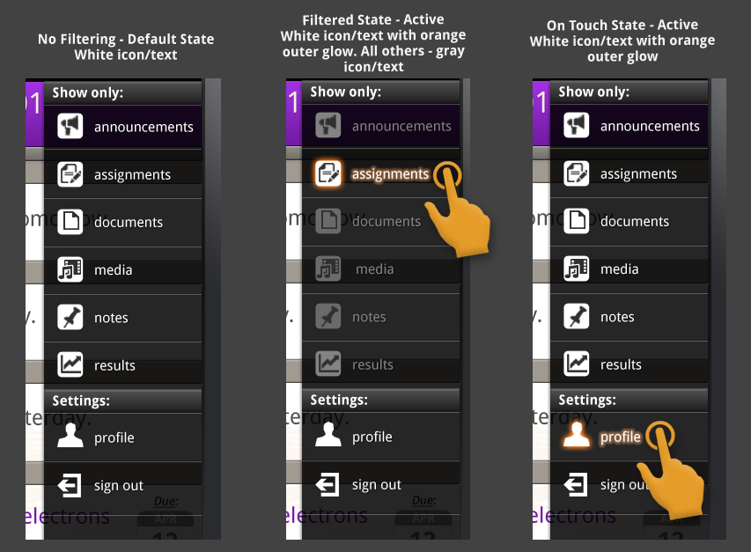

The following icons will appear in the Show only area:
- Announcements
- Assignments
- Documents
- Media
- Notes
- Results

Data types that are unique to a platform (Notes for the Epic platform) will be conditionally displayed if the user has a course hosted on that platform.

Since the Menu is a “global” item, filtering applied from a specific course or the All Courses screen will apply to all courses.

Note: All filtering will return to the default state (all filters off) when a user leaves the app by signing out, quitting the app, or placing the app in an inactive state.

If a user filters a specific type of data that is not present in the Activity List, the following “zero state” will display:

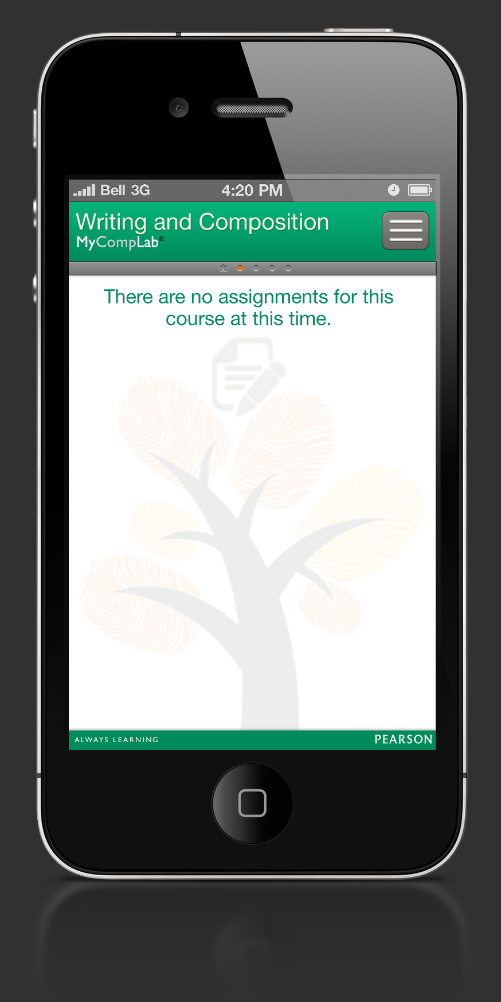

Settings:

Profile – When a user taps the Profile icon, the menu will close and the profile screen will appear. See the Profile section for more detail.

Sign Out – when a user taps the Sign Out icon, the menu will close and they will be prompted with the following message:

Are you sure you want to sign out?

This message will also contain OK and Cancel buttons.
See the Sign Out section for more detail.

13.0: Strapline

Strapline in Profile View
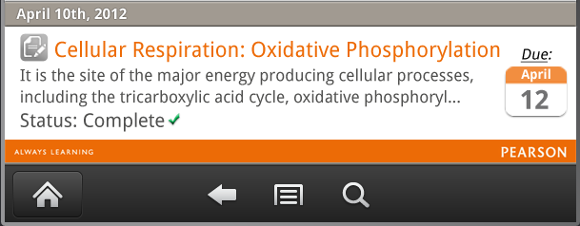

Strapline in Landscape View
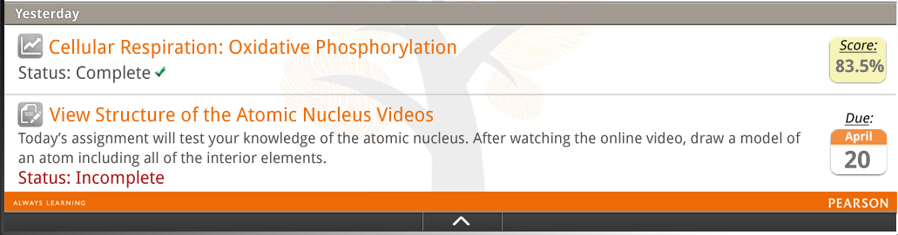

Description:
The Pearson Strapline will appear at the very bottom of the list view. The Strapline should be present even when no content is available.

The strapline in not interactive on iOS devices. Tapping on the strapline will not do anything.
On Android devices, when a user taps on the strapline, the following URL will launch in the device’s browser:
http://pearsonmylabandmastering.com/
14.0: Tree Watermark
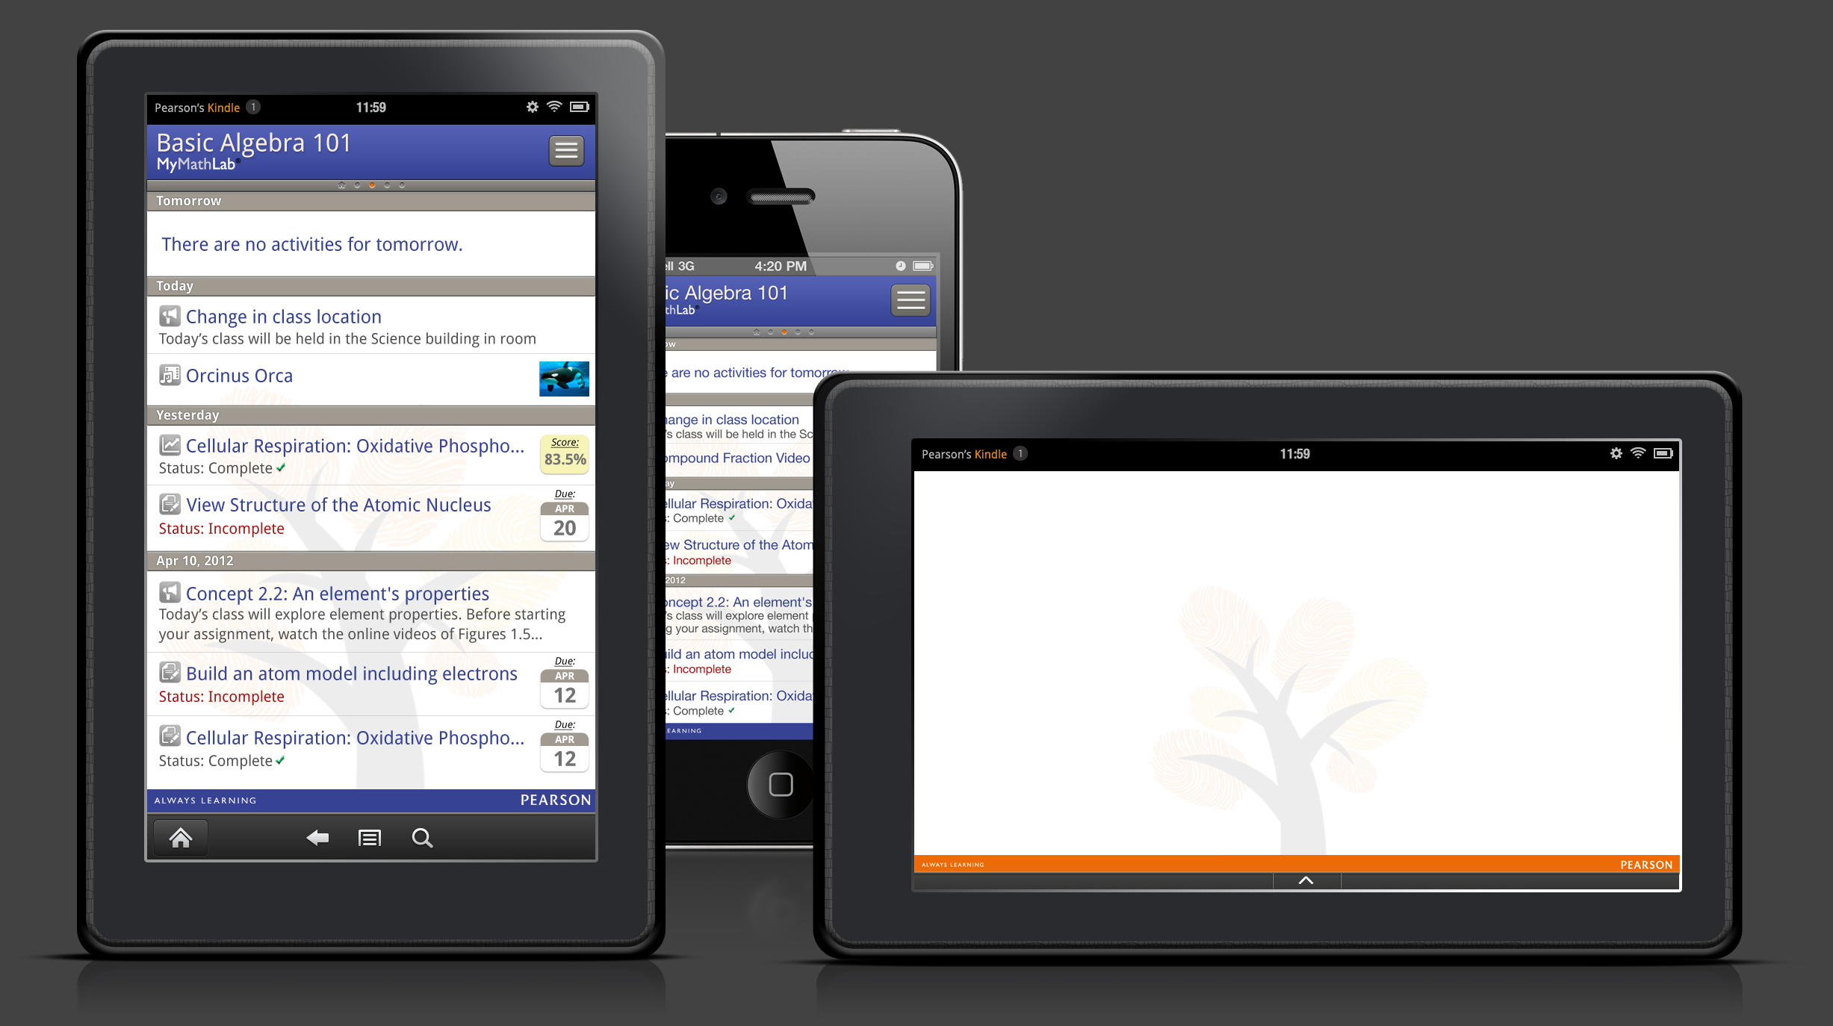

Description:
The Pearson “Tree of Learning” illustration watermark should appear on all screens (except Sign In) in a fixed position at the bottom of the screen.

15.0: Profile
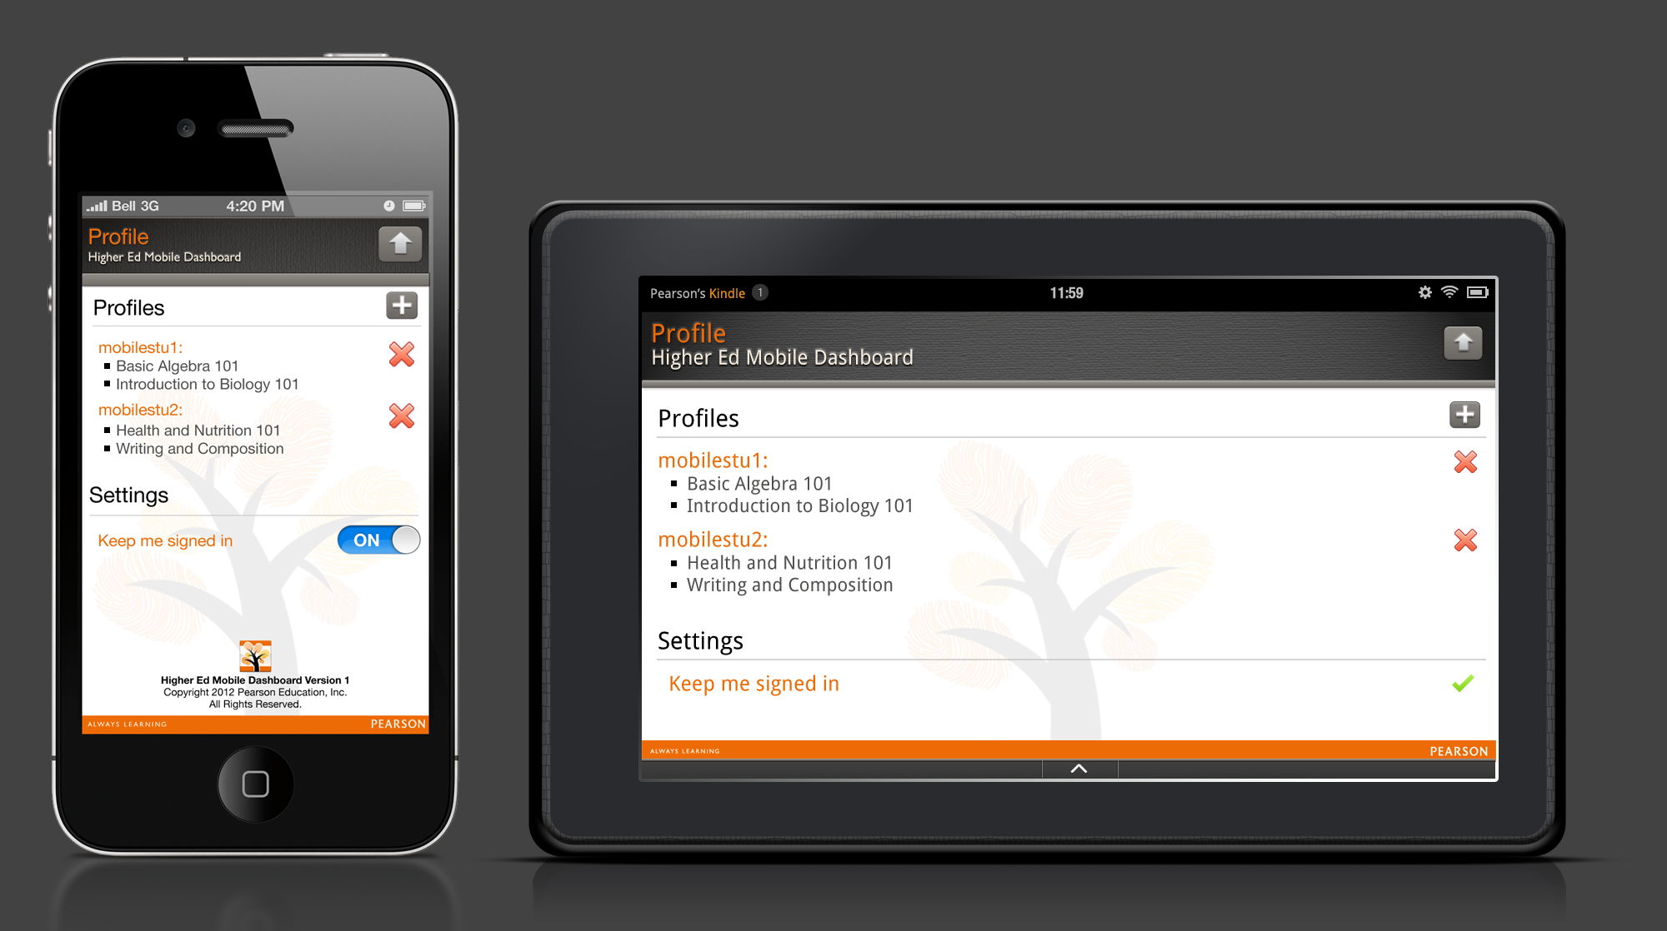

Description:
When a user taps the Profile icon from the menu, the menu will close and the Profile screen will appear. The Profile screen consists of 3 sections: Profiles, Settings and the footer.

Profiles:
Under the Profiles, the user will see the username that they originally signed into the app with. There is an “add” icon placed to the upper right-hand corner of the Profile section. The “add” button allows users to add additional Pearson accounts to the app. Under each Profile the user has listed, the course titles will appear that are associated with that Pearson account.

Add Profile:
A user can add additional Pearson accounts (profiles) by tapping the “+” icon in the Profile header area. The following screen will appear:

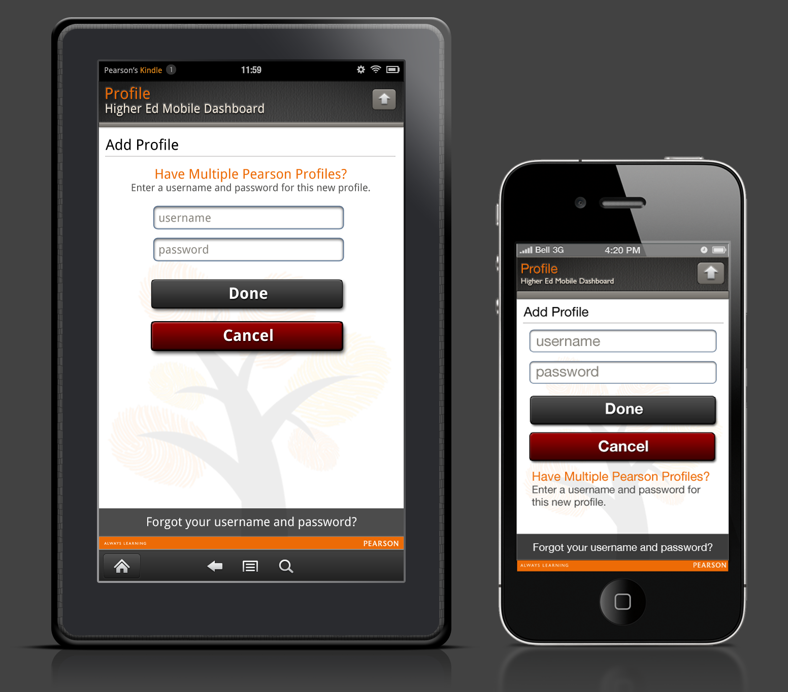

Behaviors:
- Tapping in the Username field will bring up keyboard and allow text input. The field will be case sensitive.

- Tapping in the Password field will bring up keyboard and allow text input. The field will be case sensitive.

- When the Done button is tapped, the app will verify the username and password is correct using the Viking SMS service, which will return a valid SMS User ID.

- The app will use the SMS User ID with the User Summary service to get a list of the user’s subscriptions.

- The app will use the list of user’s subscriptions to connect to the necessary subscriptions.

- If the user taps Cancel button they will return to the Profile screen.

Onscreen Text:
“Have Multiple Pearson Profiles?”
“Enter a username and password for this new profile”

Error Messages:

1 | If a user taps the “Done” button without entering one or both credentials, the following error message will appear: | You must provide a username and password | OK
2 | If a user enters an incorrect username and/or password, the following error message will appear: | Incorrect username and/or password | OK
3 | If a user does not have a WiFi, 3G, 4G or Edge connection, the following error message will appear: | No network connections available | OK
4 | What if the user has expired subscriptions? | TBD | TBD

Success Messages:
Header: “Profile Added”
“[username] has been added” with OK button.

“Forgot your username or password?”
See previous section under Forgot Your Username or Password:.
Remove Profile:

The user can remove Profiles from the app by tapping the “delete” icon. This action will only remove courses and their associated data from the app. It will not delete their Pearson account.

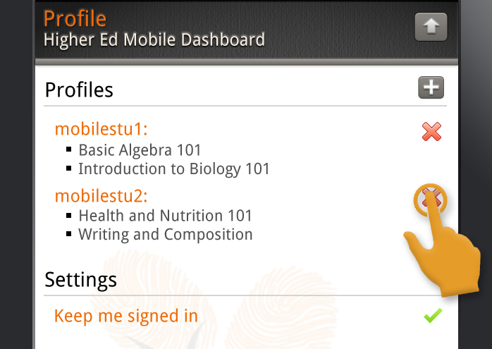

Note: We are never deleting a Pearson account via this app!!! We need to message that clearly to our users.

When removing a profile from the app, the user will be prompted with the following message:

“Are you sure you want to remove your [mobilestu2] profile?
While this will not affect your Pearson account, it will remove this course and all of its data from this app. You can add this profile back to the app at any time."
Buttons:
“Remove” - returns user to the Profile screen; Profile screen refreshes to remove the profile from the screen.
“Cancel” – returns user to the Profile screen
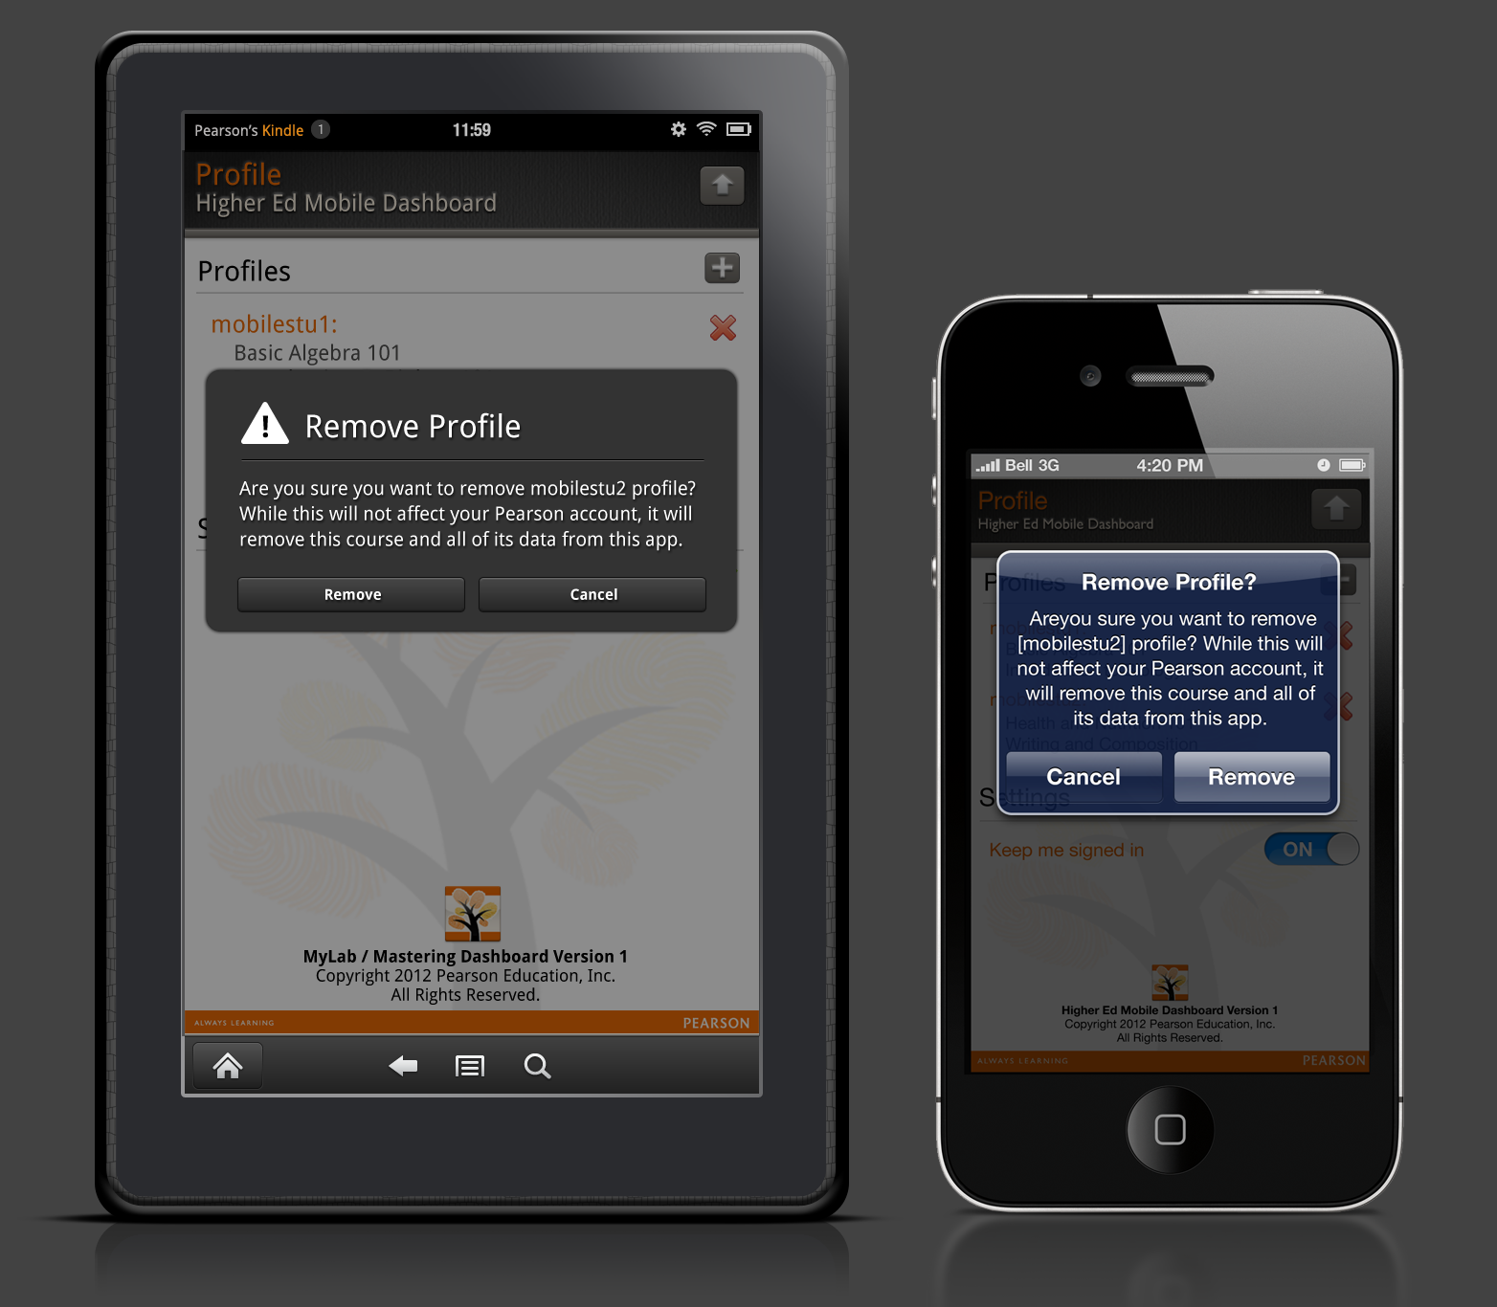

Settings:
Under the Settings area, the user has the ability to change the “Keep me signed in” setting. On Android devices, a green checkmark indicates on and the gray checkmark indicates off. On iOS devices, the standard on/off slider control will appear.
Note: Action here is reflected in the Sign-in screen.

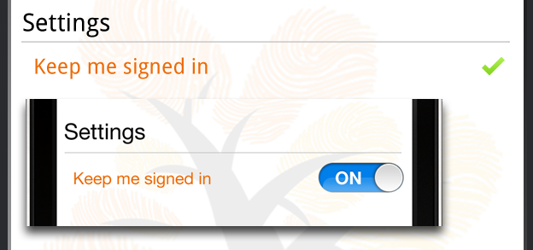

16.0: Sign Out
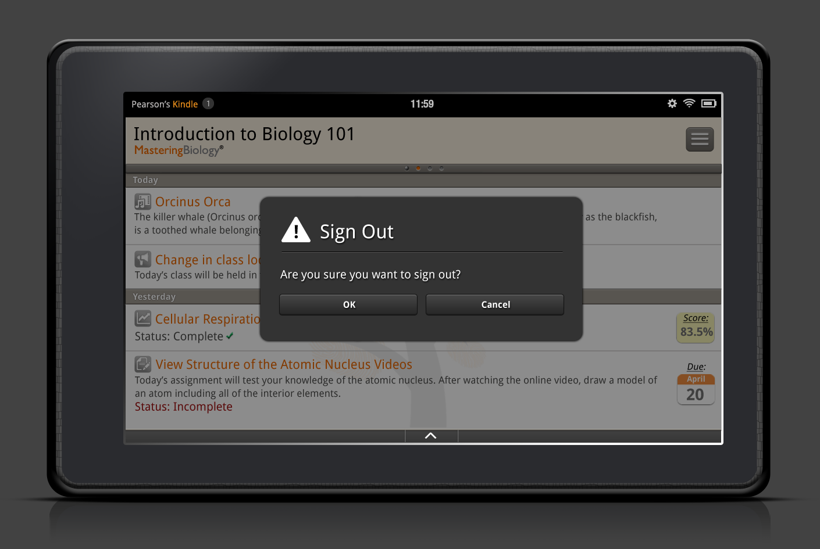

Description:
When a user taps the Sign Out icon from the menu, the menu will close and they will be prompted with the following message:

Are you sure you want to sign out?

This message will also contain OK and Cancel buttons.

Behavior:
When a user taps the OK button, the Sign Out message will disappear and the user will be returned to the Sign In screen.

When a user taps the Cancel button, the Sign Out message will disappear, revealing the screen the user was previously on.

Appendix 1: Supported Platforms and Series Titles
As of May 16, 2012, the follow platforms and series titles are supported:

MMND Mastering & Mastering Standalone (same list for both platforms)
- Mastering A&P
- Mastering Astronomy
- Mastering Biology
- Mastering Chemistry
- Mastering Engineering
- Mastering Environmental Science
- Mastering Genetics
- Mastering Geography
- Mastering Geology
- Mastering Microbiology
- Mastering Physics

MMND XL
- MyAccountingLab
- MyEconLab
- MyFinanceLab
- MyFoundationsLab
- MyMathLab
- MyOMLab
- MyReadingLab
- MySkillsLab
- MyStatLab
- MyStudentSuccessLab
- MyWritingLab
- MyEngineeringLab

XL Standalone
- MathXL
- MyAccountingLab
- MyEconLab
- MyFinanceLab
- MyFoundationsLab
- MyOMLab

Appendix 2: HEMD App HTML White List

Bold <b>
Strong Emphasis <strong>
Italic <i>
Underline <u>
List <li>
Ordered List <ol>
Unordered List <ul>
Strike-Through <strike>
Blockquote <blockquote>
Table Elements <table>, <tr>, <th>, <td>
Align: Left, Center, Right, Justified <align>
Paragraph <p>
Horizontal Rule <hr>
Non-breaking Space “&nbsp;”
Break <br>
Image <img>
Anchor <a>
Subscript <sub>
Superscript <sup>
All MathML tags

