Communities Pattern Library

Table of Contents

Design Patterns for Navigation 3
Action Buttons 4
Breadcrumbs 6
Pagination 8
Design Patterns for Forms 10
Add Attachment 11
Error Messaging 13
Input Hints 15
Design Patterns for Searching 17
Advanced Search 18
Search Box 20
Search Results 21
Design Patterns for Displaying Information 23
Display Grid 24
Expand & Collapse 26
Portlet 28
Sortable Tables 30
Design Patterns for User Messaging 31
Messaging – Popup 32
Server Down 34
Design Patterns for Miscellaneous Elements 36
Footer 37
Hello Object 38
Help 39

Design Patterns for Navigation

The following design patterns are meant to assist users with traveling from one page within the site to another.
Action Buttons

Problem: The user needs to complete an action and needs a mechanism for traveling to a different page.

Use When: The user is submitting, or deciding not to submit, information, or is in the midst of completing a process within the site.

Solution: Display rounded buttons allowing the user to cancel their action or move forward to the next step. When completing a search, the terminology of “Go” should be used for the action button. When changes to previously submitted information are being made, the terminology of “Save” should be used for the action button, even though “Save Changes” is also used as terminology within the setting button on the Portal landing page. For situations where “Go” or “Save” are not applicable, other action words may be used such as “Create course now” or “Submit”.

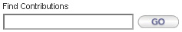

Cancelling follows a more standard process with a “Cancel” button which should always be displayed to the left of other buttons. When a user clicks this button, a pop-up window will always occur asking the user if they are sure if they would like to cancel their previously selected action. The text to this confirmation is reliant on the situation and action being cancelled.

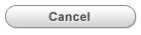

A final constant button seen to users is the “Log Out” button. This button should be placed on the top right of all pages within the site.

Rationale: Using rounded buttons provides the website with a more comfortable feel to it, but more importantly, distinguishes these buttons from any other information or links on the page. These buttons help users achieve results such as completing a search, submitting a form, or other important tasks, so it is important that they are highly visible to users at all times.

The placement of the buttons is fairly standard across the web. Log Out buttons are traditionally found in the top right corner, so this will allow the user to easily find this function should they need it. Additionally, the right side is often associated with a “next step”, and since logging out could be interpreted as moving forward, this right side location is logical.

Cancel buttons are always necessary because users do make mistakes, and cancel buttons allow them an easy way out. However, it is also important that a confirmation is provided because should a user have been working on something within the site and accidently click the cancel button, the work would be lost. A confirmation screen prevents this from happening.

Known Exceptions: Action buttons within portlets have rounded corners, but do no follow the traditional model and are more rectangular in design. These buttons face space constraints within the portlet, thus requiring them to have a different appearance. Additionally, less important actions within Portal do not have their own rounded button. One primary example is the “Print This” button.

This button is placed near the top of pages containing important information which the user may wish to print. However, as this action is not quite as important as cancelling or saving, it does not have its own rounded button.

Usability Findings:

Accessibility Notes:

External Examples: The following example is from Amazon:

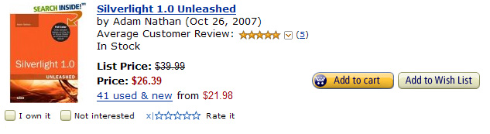
Breadcrumbs

Problem: Users need a method for determining where they are within a website and have an easy way to navigate back to higher levels within the website hierarchy.

Use When: A user is on level 2 or higher within the website.

Solution: Near the top of the page, display breadcrumbs which explain to a user their current location within the greater hierarchy of the website. The page titles should be displayed in order from left to right, with the left most being the highest level page of the hierarchy. The pages should be separated by > signs. All page titles should be links to allow the user to quickly return to that page.

Rationale: Breadcrumbs provide users with a better sense of where they are within the website and how the website is structured. By showing breadcrumbs, users not only are less prone to getting lost, but can more quickly learn the entire hierarchy of a website.

Through using the approach listed as the solution, the hierarchy is not only clear and easy to understand, but takes up minimal space and fits nicely near the top regardless of how the page has been designed.

Known Exceptions: If there are no use cases where a user would need links to pages earlier in the path to get to that page, then breadcrumbs are unnecessary.

Usability Findings:

Accessibility Notes:

External Examples: The following examples are from Sun and Apple:

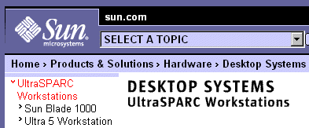

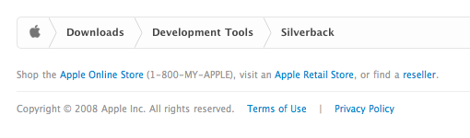
Pagination

Problem: Users need to browse through a large list of items looking for the item that interests them the most.

Use When: The list of items is greater than a pre-determined amount that is able to fit comfortably on a page.

Solution: Break the large list of items into pages, and use pagination to allow the user to switch between the many pages of items. In the solution, the user may see the current page they are on, the two other nearest pages, a link to go to the next page, and >> arrows to transport the user to the late page. All pages are separated by a | symbol and the current page the user is on carries the traits of not being clickable and is shown as a different color. The solution should be placed at the very bottom below all search results.

Rationale: Pagination prevents the scenario of a search returning so many results that the page takes an inordinate amount of time to load.

Placing pagination at the bottom makes sense as per the user’s mental model. They create a search, review the results, and if they have yet to find their desired match on the first page, they can then travel to the next. If pagination was placed on the top and users were allowed to go to the next page before they have seen everything on the current page, it would not be logical. Additionally, the size of the navigation bar can serve as an additional aide to the user in telling them how much further they have to scroll until they get to the end of the page. This may help them get a better sense of the amount of search results and whether traveling to another page may be necessary for them to find their desired result.

Known Exceptions: If all of the information may be displayed comfortably within one page, pagination is obviously unnecessary.

Usability Findings:

Accessibility Notes:

External Examples: The following examples are from Google and Live.com:

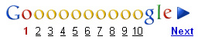

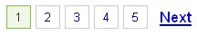

Design Patterns for Forms

The following design patterns are found within forms to prevent any potential submission problems.
Add Attachment

Problem: Users may need to add attachments to varying submission forms.

Use When: A scenario exists within a form where the user may want to attach a file.

Solution: Allow the user to attach files to the form. By default, show one upload box where the user can browse for the file they would like to upload. After clicking a “Browse” button, the user will see a view of their hard drive and have the ability to select a file they would like to upload.

After the user has chosen the file they would like to upload, they will see the path to that file. The file will be submitted with the rest of the form using a submit button at the bottom of the form. Should the user wish to add additional files to the form, they can click an “Add Files” button. Clicking this button will add another browse box below the original which the user may click to add the additional file. Users may attach up to five files before being given an error message that they may not upload any more files.

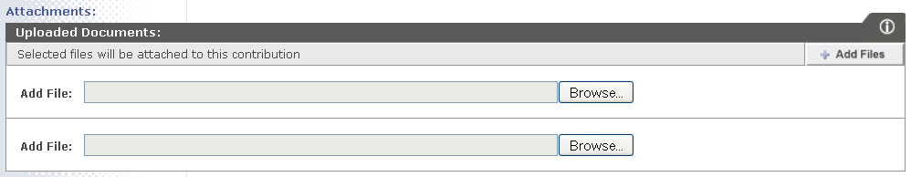

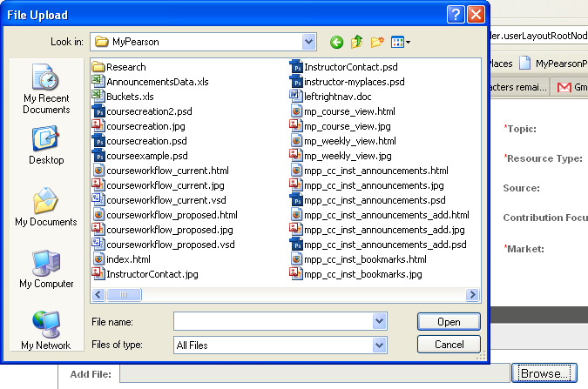

Rationale: By default, one browse box is already displayed for users to ready the form for a user to upload a file. While users may choose to upload any number of files, the majority of users tend to upload only one file, and due to space constraints, it makes little sense to display more than one browse box by default. However, if the user needs to upload more files, with only one additional click, they are able to do so.

After uploading their desired file, the user will still need to submit the form to submit the attachment. This process is logical because if the attachment was uploaded before-hand, other changes to the form would be erased and the user would need to complete those sections again.

Known Exceptions: None, assuming that the user may wish to upload an attachment to the form.

Usability Findings:

Accessibility Notes:

External Examples: The following example is of adding attachments in Gmail:

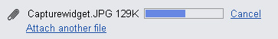

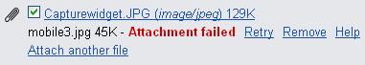

Error Messaging

Problem: Users need to be informed when they have made a mistaken.

Use When: A user attempts to submit a form in which they have forgotten a required field, or input data which is not valid for the field.

Solution: Display an error message to the user. When submitting a search or a form, if an error has occurred, text which describes this error should be displayed in an alert box. The text should tell the user that an error has occurred, where the error has occurred, and how the problem can be fixed. After the user clicks “OK”, they may re-try the search.

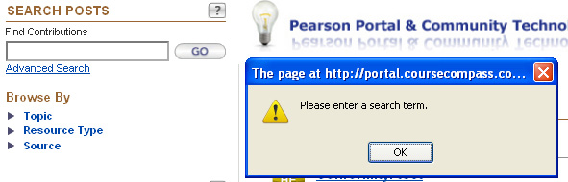

Rationale: Using an alert box for error messaging is not pretty, but it is a sure fire way to ensure that the user sees the error message because the pop-up takes a forefront to the screen. After the user has read about the problem, the pop-up conveniently goes away.

Known Exceptions: If the user is submitting form data which includes more than one input box, and more than one error could have possibly been made, users instead see error messaging embedded within the original page which highlights all mistakes.

After making the submission, the user is directed to the top of the page so the error message is highly visible to them.

Usability Findings:

Accessibility Notes:

External Examples: The following example is from Amazon:

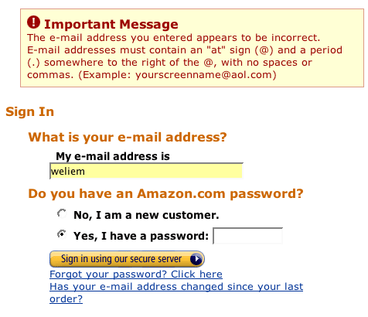
Input Hints

Problem: Users may encounter a field within a form where it is not initially clear what the desired input into the system is.

Use When: A text box for input is provided that may be slightly confusing, or if other textboxes on the same page have used the solution provided within this pattern.

Solution: Display at most a sentence below the text box that more clearly explains the desired user input. This sentence should have parenthesis around it and be in a lightly colored font so it attracts minimal attention.

Rationale: Wording can sometimes be confusing, and input hints provide users with additional explanation as to the desired input to the system. This ensures that data collected into the system will be fairly accurate. By placing the explanation text directly below the input box, it is unlikely to be missed by the user.

Known Exceptions: If the desired input is obvious enough that no user could ever be confused, then input hints are unnecessary. However, when in doubt, they should be used.

For situations where even much further explanation is needed to explain a situation, a question mark arrow should be used to link the user to a help section.

Usability Findings:

Accessibility Notes:

External Examples: VersionsApp.com follows a similar format:
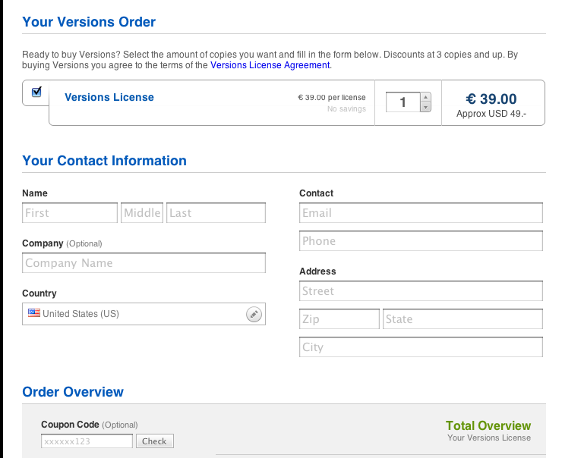

Google uses a different approach to the problem:
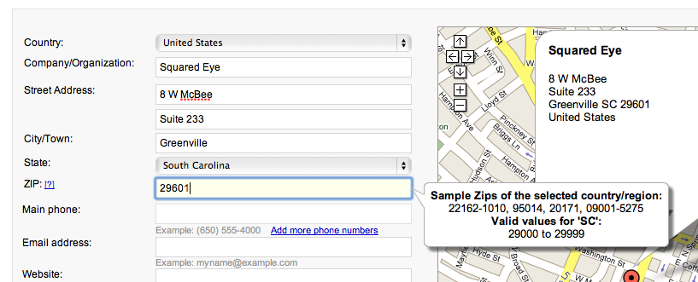
Design Patterns for Searching

The following design patterns assist users with searching for information.
Advanced Search

Problem: Users may want to more enter more specific criteria into their search.

Use When: Multiple data fields exist which the user may want to create a search by, and it is logical to want to search by those fields at the same time.

Solution: By default, offer only a basic search, but allow the user to enter an “Advanced Search” within relevant situations through a link. This advanced search should provide a combo box or open text box for relevant searchable fields. Combo boxes should be chosen when there are a limited number of finite searchable terms. By default, it should be assumed that a user is searching for “All” of each field unless they select otherwise. This will ensure users do not have to make a selection about fields they are not interested in.

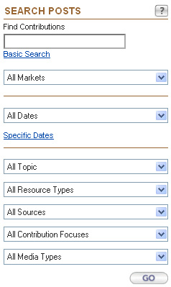

Rationale: Providing advanced search capabilities allows users to narrow their search to more easily access the content they are seeking. Without it, they are forced to sift through much more information which may not be relevant to them.

In the design, users are given many options and can simply choose the ones which are most pertinent to them.

Known Exceptions: If there are not multiple fields which the user may want to search by, having the ability to create an advanced search is not necessary.

Usability Findings:

Accessibility Notes:

External Examples: The following example of advanced search is from Google:

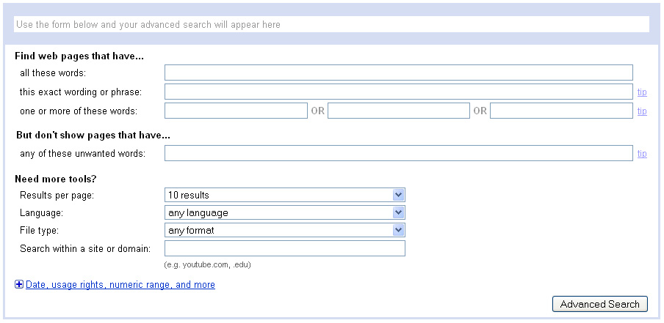

Search Box

Problem: Users are by nature, impatient, and sometimes have a need to quickly find specific information.

Use When: The site already has other navigational methods, but has so much information that the user may want to perform a search to more quickly find specifically what they are looking for.

Solution: Offer a search box which allows the user to submit terms for their search. This box should be long enough to submit most search terms, but should not waste too much space on the page. A very short description of what the user should use the search box to look for should be placed near the box. On the right side of the search box should be a “Go” button which submits the search to the search engine.

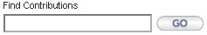

Rationale: Users hoping to enter a quick search may certainly achieve their goals through this simple solution. It only requires the user to enter one search term before they may see the rewards of their search through seeing the results.

Known Exceptions: Should users wish to narrow their search, they may instead complete an advanced search. An advanced search allows the user to run a query using at least two search terms. This pattern is detailed earlier in the document.

Usability Findings:

Accessibility Notes:

External Examples: The following example is from Powerset

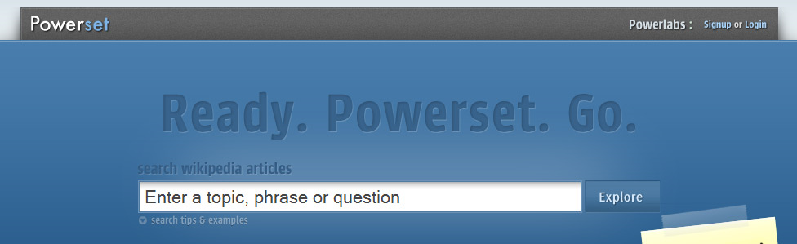
Search Results

Problem: Users need to be able to view the results of their search.

Use When: A search has been previously input by users.

Solution: Present sorted results to the query by the user and offer relevant details of all returned results. Offer the user the ability to sort their search results should another logical field exist which the user may wish to sort by. All results should be separated by a line. Should too many results be returned to fit reasonably within a page, split the results into multiple pages and offer users with a way to switch between the pages. Finally, offer users the ability to begin an additional search as often users are unable to find their desired result on an original search.

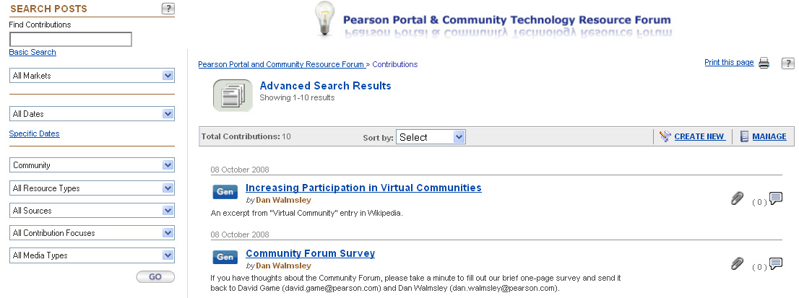

Rationale: The object of search results is to help the user find their desired information or product as quickly as possible. Users tend to scan search results quickly, so the format of the results should visually make this user behavior as easily achievable as possible. Sorting is provided to help users find their desired result more quickly. As users often are not completely sure what they are looking for, the search again box provides a means for users to search again should they have not typed the correct search terms during their first try.

Known Exceptions: If a user enters a search which returns no results, rather than seeing results, they will receive a messaging telling them that no results were found.

Usability Findings:

Accessibility Notes:

External Examples: The following is an example of search results on Amazon.com:

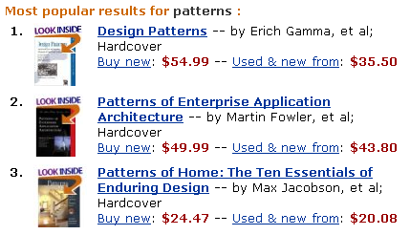

The following is an example of search results returned by Google:

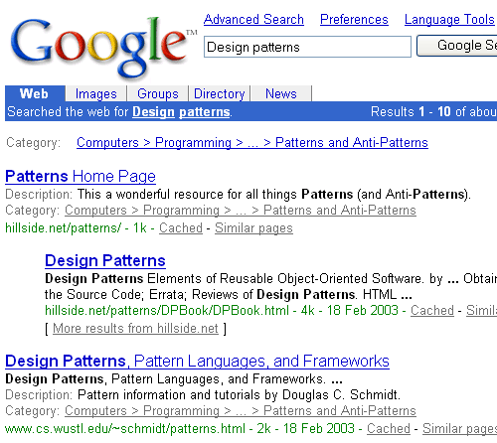
Design Patterns for Displaying Information

The following design patterns either allow the user to control, or use another mechanism, to organize information shown on a page which will be most efficient to the user.
Display Grid

Problem: Users like to customize displays of data so it is shown in a manner which is most efficient to them.

Use When: There is more than one logical method for displaying information within a table.

Solution: Use a display grid which allows the user to customize how their information is seen. All possible relevant options should be given to the user within a combo box. This combo box should be placed near the top of the grid so it is highly visible to the user. After the user changes their selection, the results from the table should automatically update to match the user’s selection.

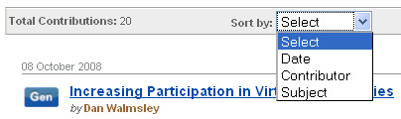

Rationale: Display grids provide for customization options which make data more helpful to users. Without them, a system would merely be guessing which view is best for each specific user.

Known Exceptions: If there are no other ways to sort information called from a database, then a display grid would not be applicable.

Usability Findings:

Accessibility Notes:

External Examples: The following example is from Zapatec.com:

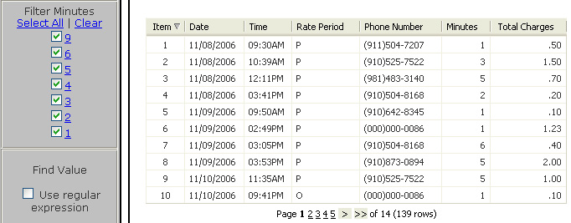
Expand & Collapse

Problem: Users need to access specific information or functionality, but they only need it under certain circumstances.

Use When: There is a copious amount of information available on the page. Pages with limited amounts of information do not need the ability to expand and collapse because the space is available to permanently display all information with no negative side effect to the user.

Solution: Separate information or functionality into groups that can be opened or closed independently of each other. Use arrows to indicate to the user whether the information has been expanded or collapsed. Clicking the arrow toggles the state of the information. Collapsed is the default state, but the user may choose to collapse all, expand all, or create any combination that they choose at any one time.

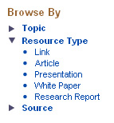

Rationale: Through using expanding and collapsible panels, page real estate is able to be conserved except in the circumstances where the hidden information is desired by the user. When the information is desired, it is displayed in a method that is clean and undisruptive to other elements within the page. Additionally, through using these panels, a hierarchy of the importance of varying information is created. Through placing specific information in panels, this is another way of telling the user that the information seen in those panels is worth seeing, but not overly important, and that the focus should be on the rest of the information displayed on the page.

The method of using arrows is easy to rationalize. It is a very standard method for this pattern as seen on many other websites, and users are often familiar with the pattern. If they have not seen it before, it is still intuitive enough because the arrow is pointing in the direction that the information is displayed.

Known Exceptions: Collapsible panels are excellent in situations where the user may not need some of the information within the panel. Within situations where there is no scenario where the user should want to hide information, or the designers determine that information is so important that it should never been hidden from users, collapsible panels are unnecessary. Also, collapsible panels should not be used as a navigational solution. However, if collapsible panels are being used plentifully within a specific page, that page should remain consistent with its elements.

Usability Findings:

Accessibility Notes:

External Examples: The following examples are from Google and Sothink.com:

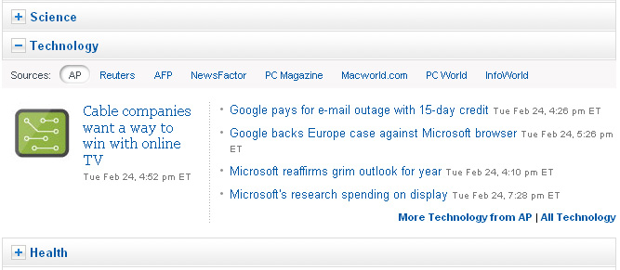

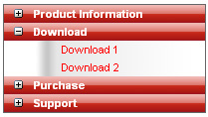
Portlet

Problem: The user needs a way to organize their information.

Use When: Data can be more easily organized under a section or if there is a small function that would like to be performed without needing to refresh an entire page.

Solution: Use portlets to organize sets of information together. All portlets should be titled and have their own help function.

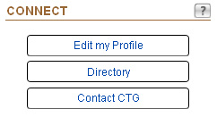

Rationale: Portlets provide a visually easing way for users to separate information. Through their appearance, it is very clear what data pertains to which sections, and should a user only be interested in one thing, portlets make it easier for the user to find this information. The greater benefit of portlets is the ability to provide users with the power to perform limited actions without refreshing a page. For example, if a user is typing into a search portlet and performs the search, the search results may be updated into the portlet without refreshing any other part of the page. This allows users to save time and not need to be bothered to take the time to learn new interfaces or page designs.

Known Exceptions: Portlets should not be used on landing pages that are not on level 1 within the website or where the information displayed falls within one category.

Usability Findings:

Accessibility Notes:

External Examples: The following examples are from iGoogle.com and Netvibes.com:
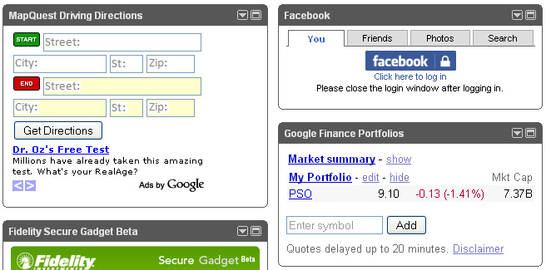

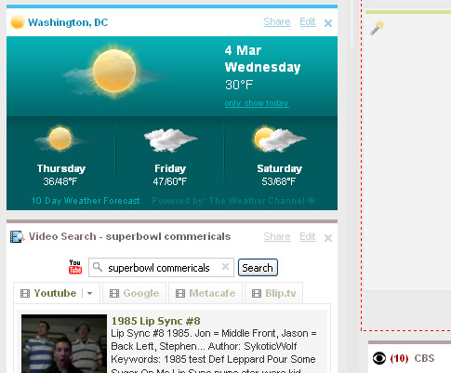

Sortable Tables

Problem: Users may want to sort data within a table in a different manner that is more pertinent to their needs.

Use When: A table has multiple fields which a user could logically sort by.

Solution: The column which is currently being sort should be shown in a color which contrasts the color of other columns. Next to the name of the column will appear an arrow which explains to the user the direction of the sort. By default, the left-most column will be sorted alphabetically. When users click a title on another column, that column will be sorted alphabetically by default, and a user will need to click the title again to change the direction of the sort.

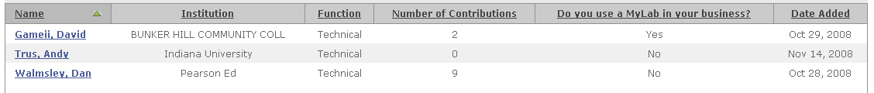

Rationale: Tables may many items, and it is impossible to always be able to predict how the user will want to sort the information, so having the ability to sort columns is extremely important. Through using many other websites and software applications, users should be familiar with the control that one click will change the order or object of a sort. By initially showing one column as being highlighted with an arrow next to it, the user is being told that it is possible to sort the rows within the website. They can then use that knowledge to sort in the manner which is most helpful to them.

Known Exceptions: If there is no possible use case where the user would want to sort by other fields than the default, providing sortable tables are unnecessary.

Usability Findings:

Accessibility Notes:

External Examples: The following example is from Microsoft Exchange:

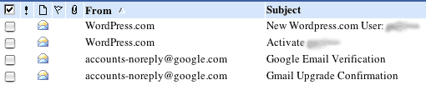
Design Patterns for User Messaging

The following design patterns display information to users that is of such high importance, that when displayed, it should be the most visible thing on the screen.
Messaging – Popup

Problem: Users sometimes miss important notices on a screen.

Use When: Users need to be informed of a message, and it is highly important that the message is immediately seen by the user.

Solution: Display an alert box to the user. This message should include text, and also at least one action button they may click so they can make a decision about the message being displayed to them. This solution is always used in situations where the user has decided to cancel, but may also be used in other important scenarios.

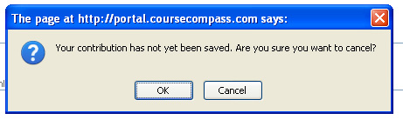

Rationale: Alert boxes are effective because they capture the attention of the user. Pop-ups are displayed on top of the current browser screen, so they are very difficult to ignore. These pop-ups are especially effective because they allow the user to make a choice in situations where the system is not positive about a user’s intentions, such as if they really want to cancel a form they may have just spent awhile completing.

Known Exceptions: Messages which are of lesser importance and not as urgent to the user do not need to be displayed within pop-up windows. However, when a session times out, something that is not the direct result of an action taken by a user, a light box message is used.

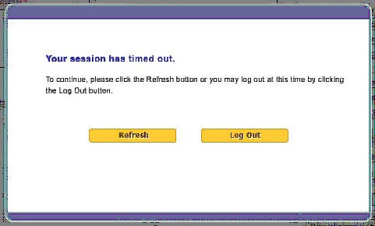

Usability Findings:

Accessibility Notes:

External Examples: The following example from FrostNixon.com is a different type of pop-up window:


Server Down

Problem: Users become frustrated when websites do not work.

Use When: A website, or even a small part of a website, is down for maintenance or any other reason.

Solution: Create a standardized server down page to be displayed to users. This message should thoroughly explain the situation and why the server is down, when it will be back up, and any alternatives for the user while the server is down.

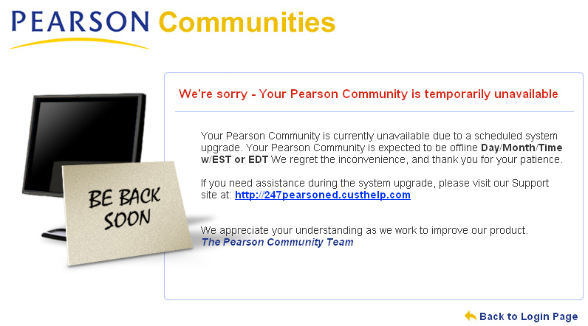

Rationale: Users do not respond favorably to broken technology, but are more accepting when they are properly warned of the situation and can work around the problems. Through explaining to the user the approximate amount of down time, they can properly adjust their schedule to return to the page at a later time and only be minimally inconvenienced.

Known Exceptions: None, a server down page should always be displayed in times when the website is not functional to users.

Usability Findings:

Accessibility Notes:

External Examples: The following are examples from some very popular websites:

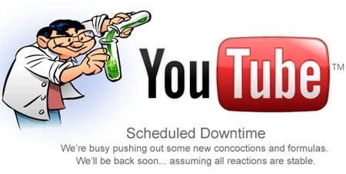
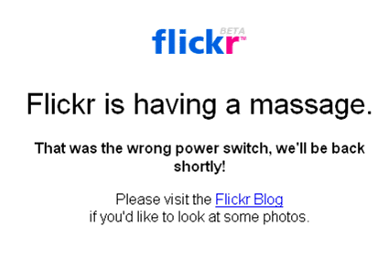

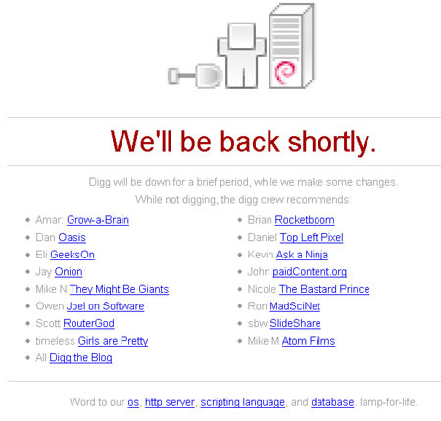

Design Patterns for Miscellaneous Elements

The following design patterns did not fit under any other category.
Footer

Problem: Users need to be able to view legal information regarding usage of the site.

Use When: The site contains material that is copyrighted or keeps personal data of customers.

Solution: At the very bottom of all applicable pages, display a Copyright notice. A link to the legal notice and privacy policy should also be available.

Rationale: Legal and privacy information is required for certain situations. Within these situations, sufficient information is required to prevent law suits. While this information is important, it should be placed at the very bottom of the page. This is a standard placement of legal information so most users have an expectation that should they be interested in reading it, that they should go to the bottom to find it. Additionally, by placing this information at the bottom, it does not distract from content on the rest of the page.

Known Exceptions: None, unless the site does not contain material that copyrighted or any personal data of customers.

Usability Findings:

Accessibility Notes:

External Examples: Below are examples of footers from other websites:



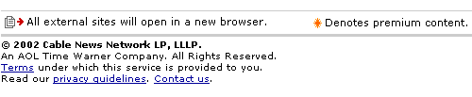

Hello Object

Problem: Personalization is a sure-fire method for improving user experience. The system needs a way to convey to the user that it knows who they are.

Use When: A user is on any logged in page within the system.

Solution: Display near the top left a message welcoming the user the website with their name included. As a natural extension, should the name be incorrect, provide the user with the ability to log out and log back in with their own username. This object should be displayed on every page within Portal.

Rationale: Through using a Hello object, the system is conveying to the user that it knows who they are and generally, sends the signal that it will tailor its contents to that user. This action drives confidence from the user into the system and increases the probability that they will be satisfied.

Known Exceptions: Hello objects may not be displayed for users from Canada due to legal restrictions. This is the only situation where this object should not be displayed unless the user is not already logged into the system.

Usability Findings:

Accessibility Notes:

External Examples: The following examples are from Amazon and Yahoo:

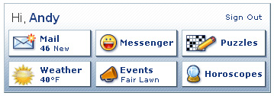
Help

Problem: There always exists the possibility that users may need further clarification regarding information displayed or a function, and will attempt to seek an answer to their question.

Use When: Usability testing, a heuristic analysis, or analysis through another method has determined that a specific part of the page may be confusing to users.

Solution: Near potentially confusing information, display a help icon which will link specifically to the help section most relevant to the user within the larger help database. This icon should be placed on the top right corner of the section which is potentially confusing. When clicked, this icon will open a new pop-up window. This pop-up window displays an index of the help section and other relevant topics on the left side, and the actual help content on the right side.

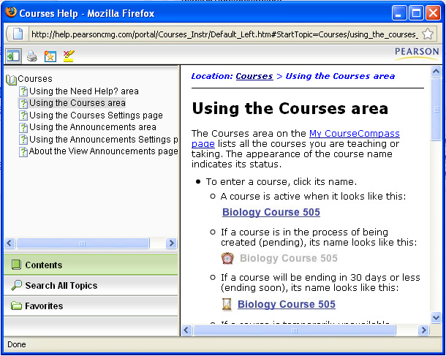

Two different icon solutions were found within Portal. The square icon is used within portlets, and the circular icon with the word help next to it is associated with an entire page. However, regardless of the difference in the icon, their behavior is similar.

Rationale: Through using a small, yet effective icon, users have a way to gain information when needed, but when it is unneeded, is unobtrusive and does not disrupt the overall viewing experience. Through using a standard icon across the platform, the hope is that it becomes more recognizable to users regardless of the current page they are viewing, and by building familiarity with the icon, users will be able to locate it more quickly when it is needed. The question mark should be easily associated with the concept of asking a question, and therefore, universally understood by users.

Known Exceptions: All portlets should have help icons. The lone exceptions are pages which so limited in scope or self-explanatory, that do not include portlets.

Usability Findings:

Accessibility Notes:

External Examples:

