Differences Between the Coordinator and Member Course Creation Process

The course creation process for coordinator and member courses are very similar. The following are the only variances in the process for the two different types of courses.

- Create vs. Join a Course

Coordinators have the ability to create a new course, or copy a course that they themselves have created or from another instructor. Member’s have the ability to join a coordinator course that they themselves have created or from another instructor, but may not create another course.

Coordinator Option
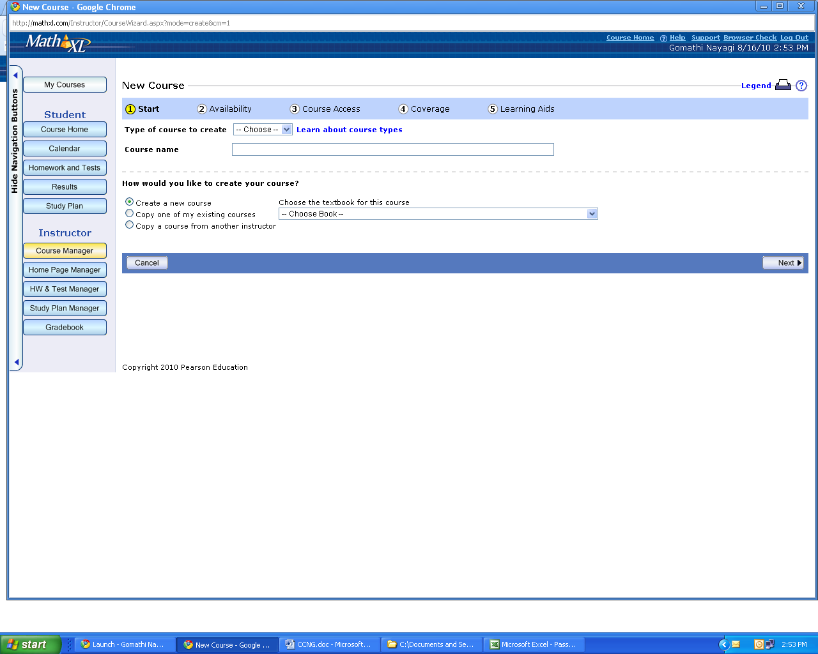

Member Option
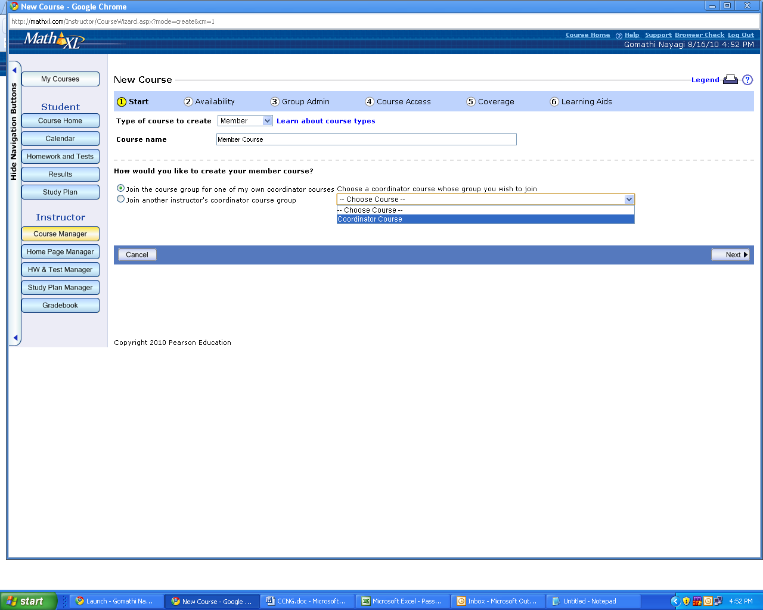

- Course Availability

Coordinators do not have the option on whether to make a course available for students. Members have this option. Despite this section being grayed out, the course start date and course end date are active for both coordinators and members.

Coordinator Option
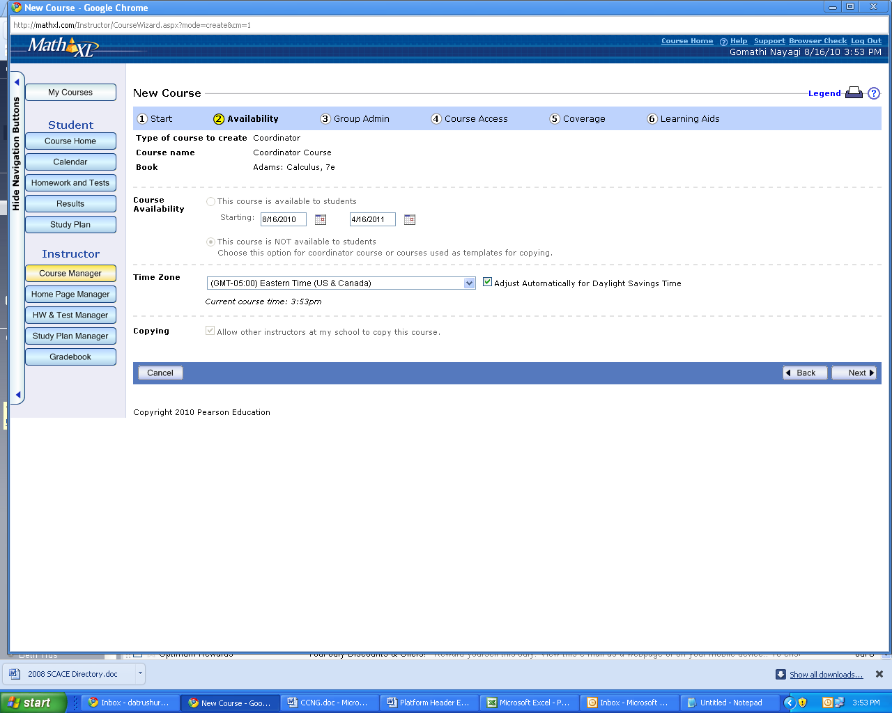

Member Option
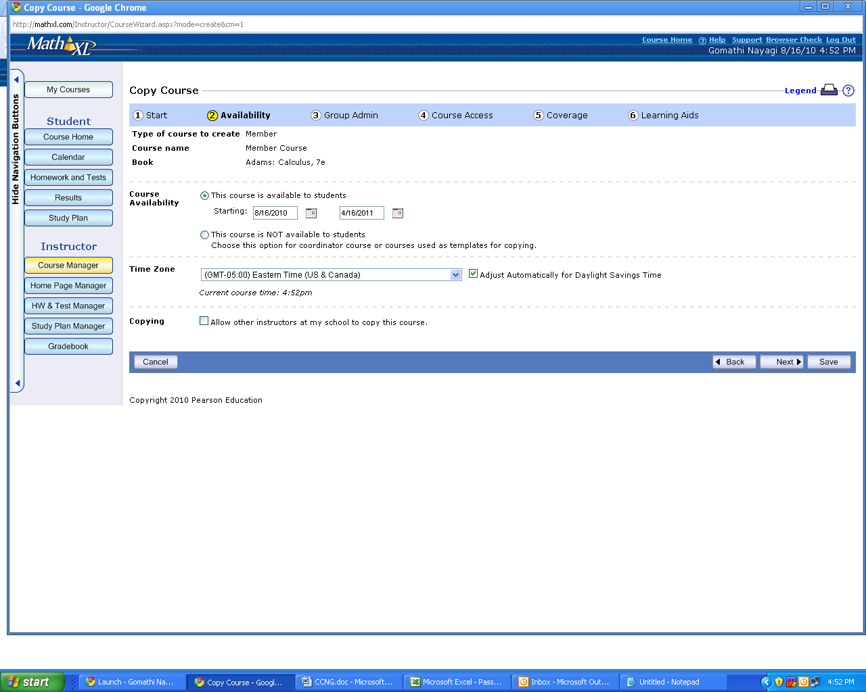

- Ability to Copy the Course

Members are given the option of whether to allow other instructors to copy a course. Coordinators are not given this option.

Coordinator Option

Member Option

- Remove Member Courses from Group

Coordinator courses allow the option for member courses to remove themselves from the group. This checkbox is not available for member courses.

Coordinator Option
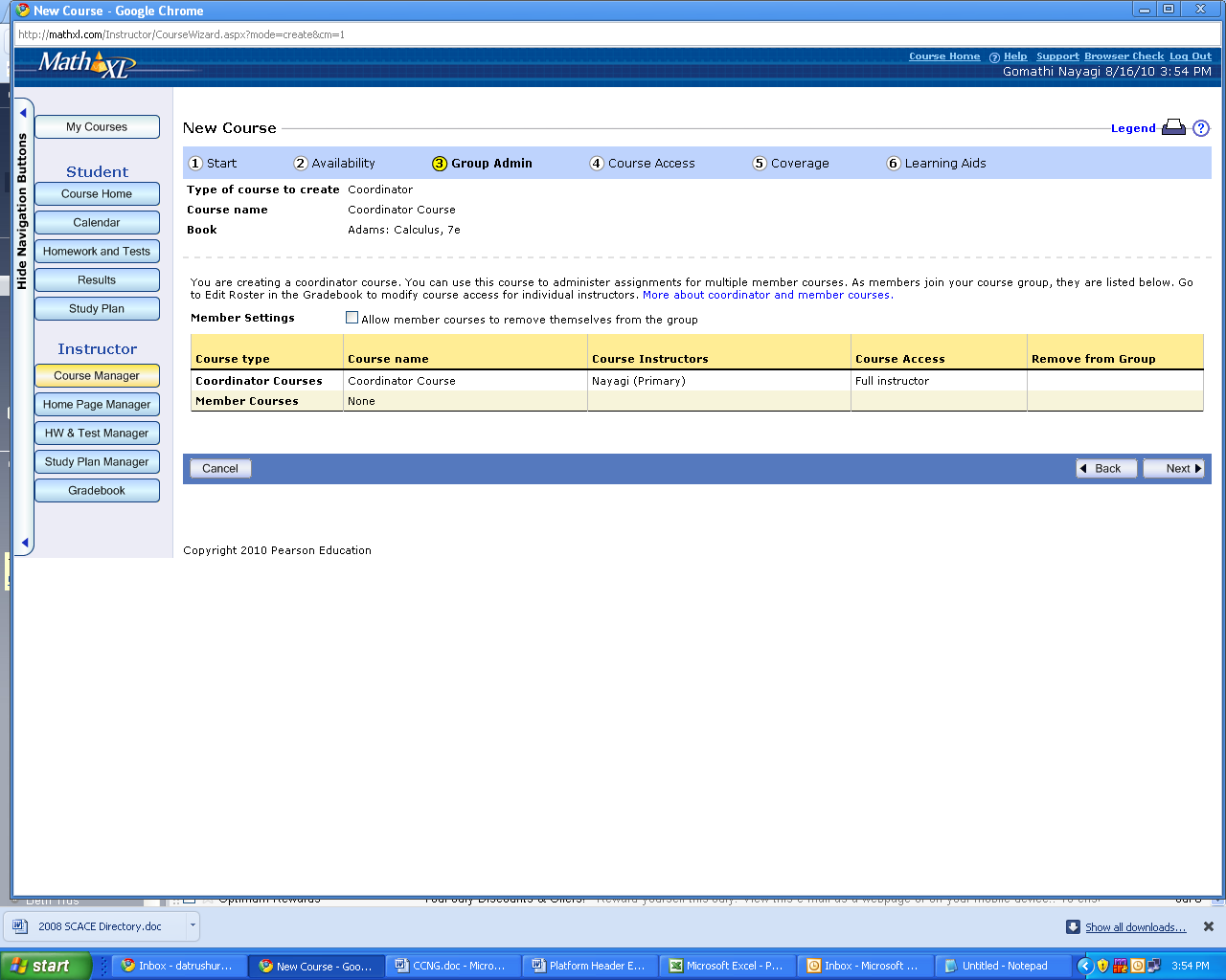

Member Option
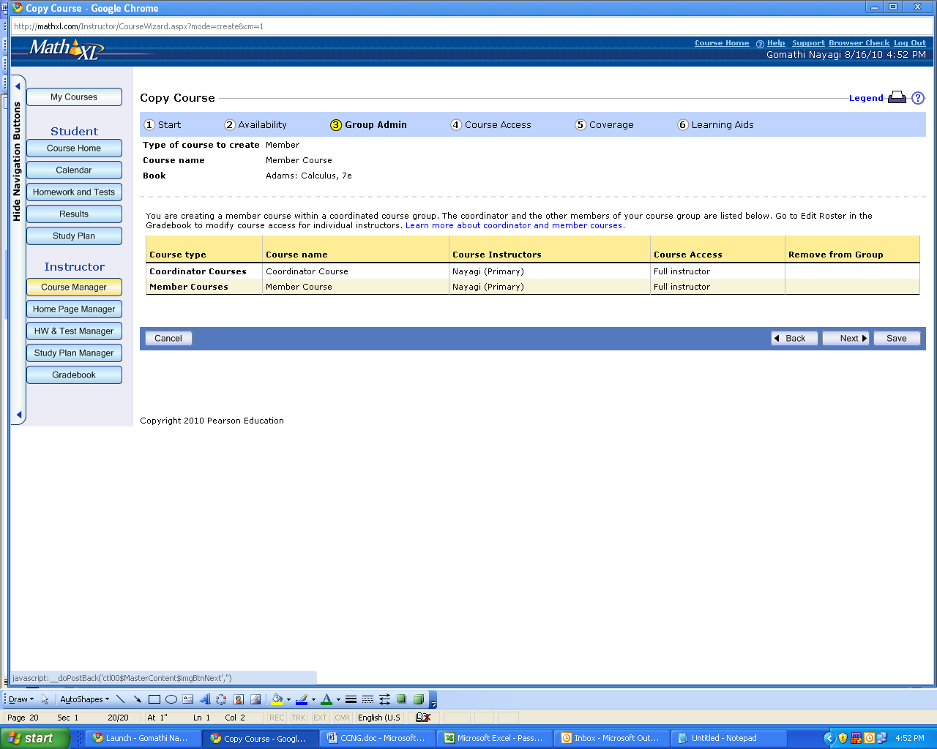
Course Creation Process Fields

This is an all-inclusive list of all options and fields included in XL’s course creation process.

Page 1 - Start

- Course Type
- Course Name
- Coordinator ONLY - Option to Create a New Course, Copy Existing Course, Copy Existing Course from Another Instructor
- Member ONLY – Option to Join Existing Course or Join Existing Course from Another Instructor

Page 2 – Availability

- Member ONLY - Course Available / Not Available to Students
- Course Start Date
- Course End Date
- Time Zone
- Member ONLY - Allow Other Instructors to Copy Course

Page 3 – Group Admin

- Coordinator ONLY - Allow Member Courses to Remove Themselves From Group

Page 4 – Group Access

- Grant or Restrict Access to Member Courses
  - Full Access
  - Section Instructor Access
  - Read-Only Access
  - Custom Access
    - Manage Student Results
    - Change Individual Student Assignment Settings
    - Add Announcements
    - Change Class Assignment Settings
    - Create and Edit Own Assignments
    - Edit All Assignments in Course
- Grant or Restrict Access to Edit Course Roster
- Grant or Restrict Access to Ask My Instructor Email Address

Page 5 – Coverage

- Listing of All Chapters

Part 6 – Learning Aids

- Help Me Solve This
- View an Example
- Textbook
- Calculator
- Ask My Instructor

Page 7 – Confirmation page

- Course ID
- Course Type
- Course Name
- Book Name
- Coordinator ONLY - Course Available / Not Available to Students
- Member ONLY – Course Start & End Date
- Time Zone
- Allow Other Instructors to Copy Course
- Coordinator Course Name
- Coordinator ONLY - Remove Member Courses From Group
- Primary Instructor
- Member/Section Instructor Access
- Other Restricted Access Privileges
- Chapters Included
- Sections Included
- Objectives Included
- Learning Aids Included
Screenshots of Course Creation Process for Coordinator Course
Login/Pass: vnayago/goms2gomes

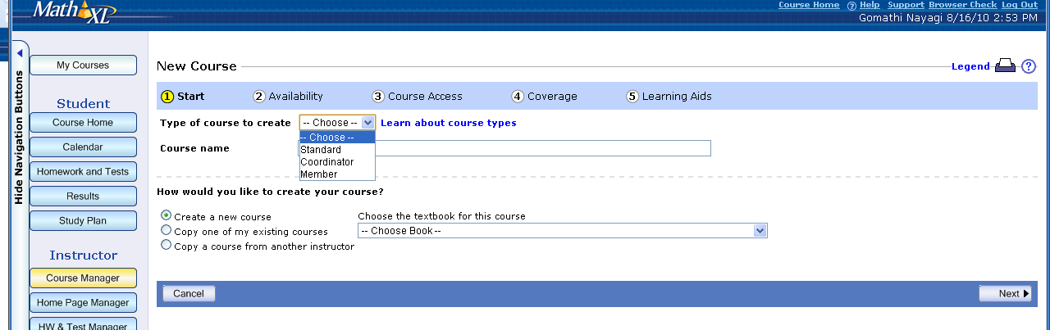

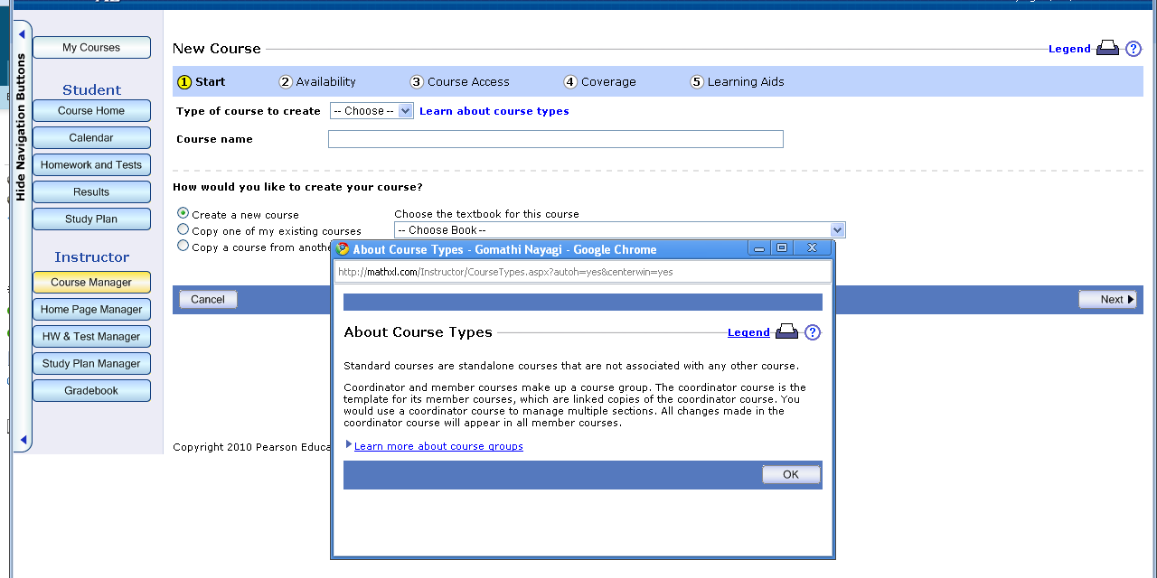

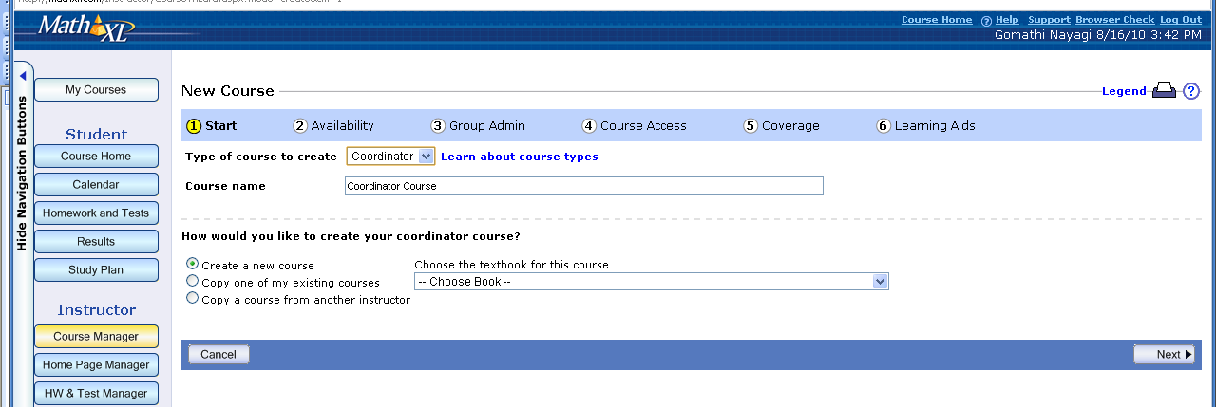

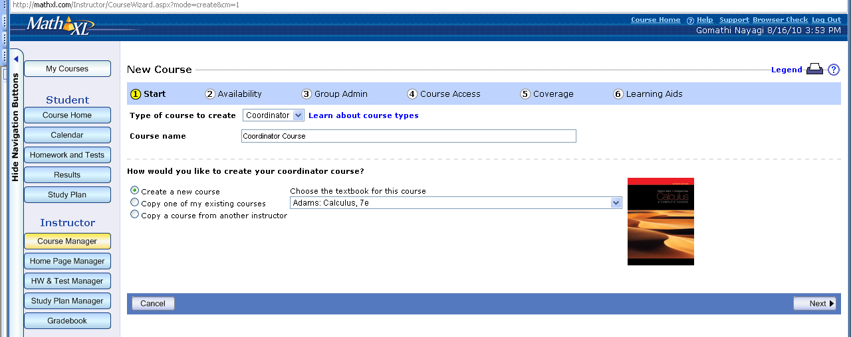

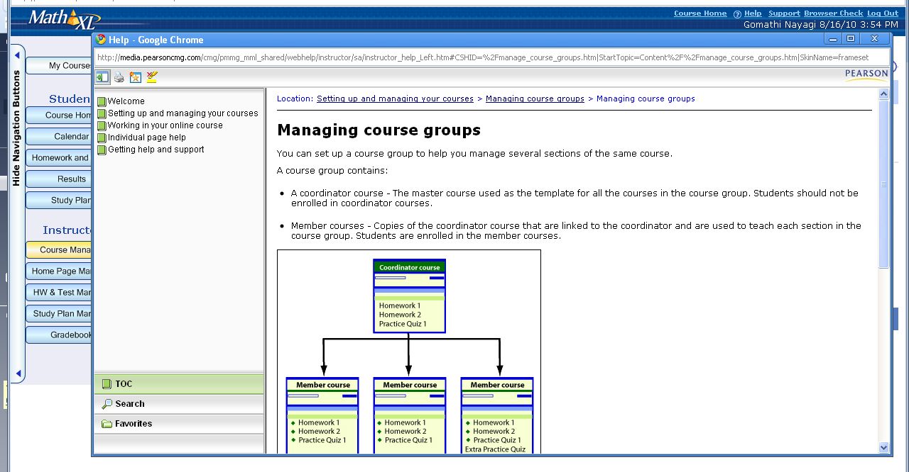

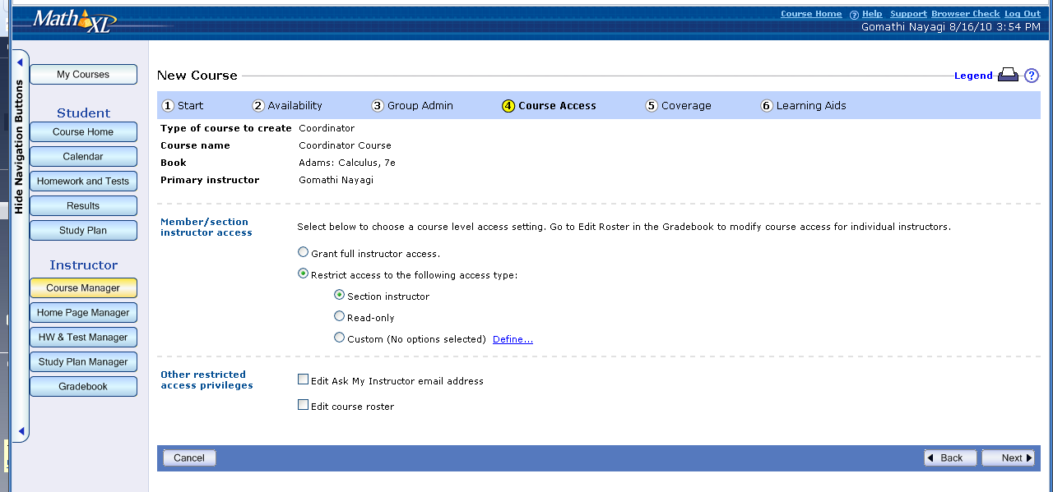

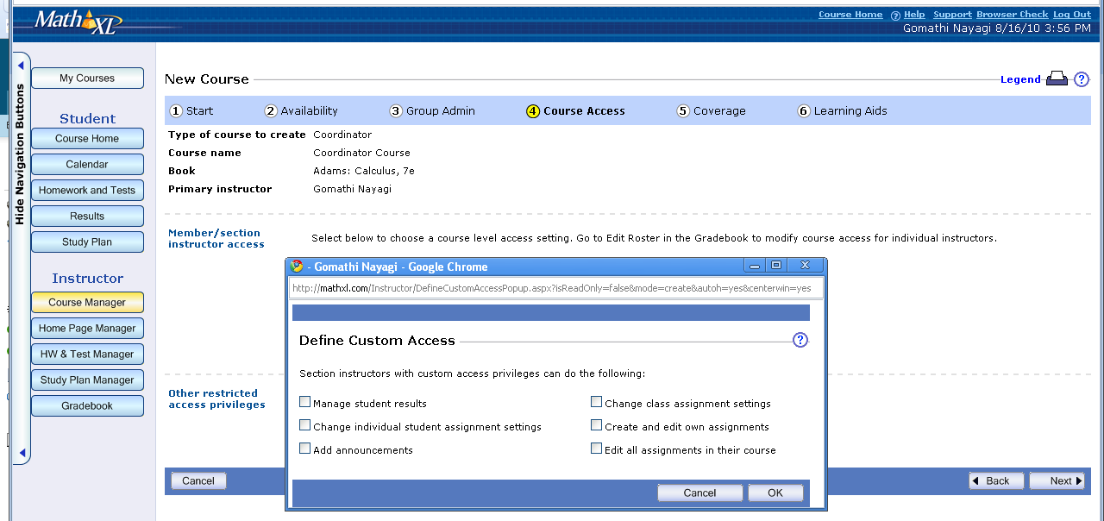

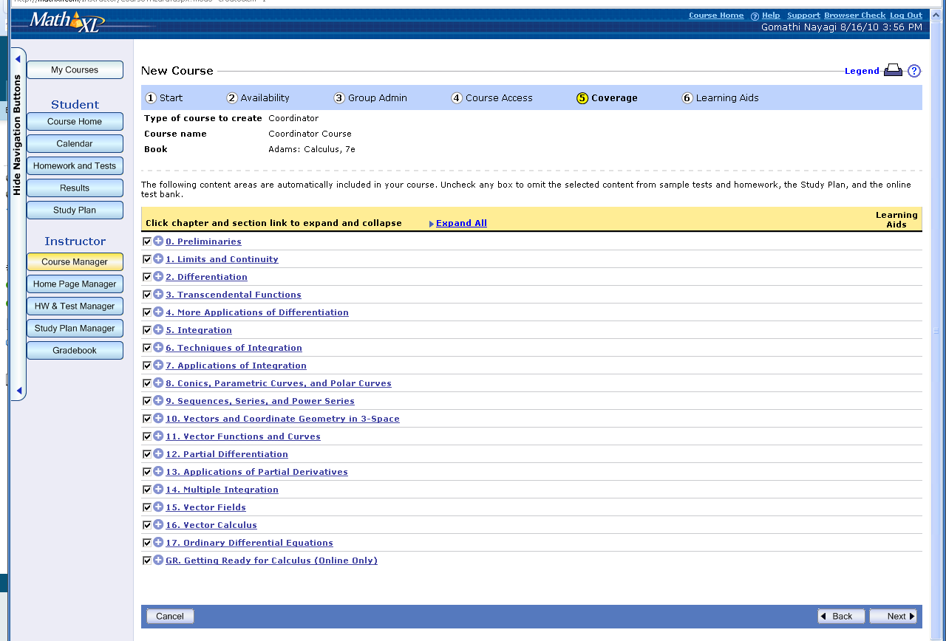

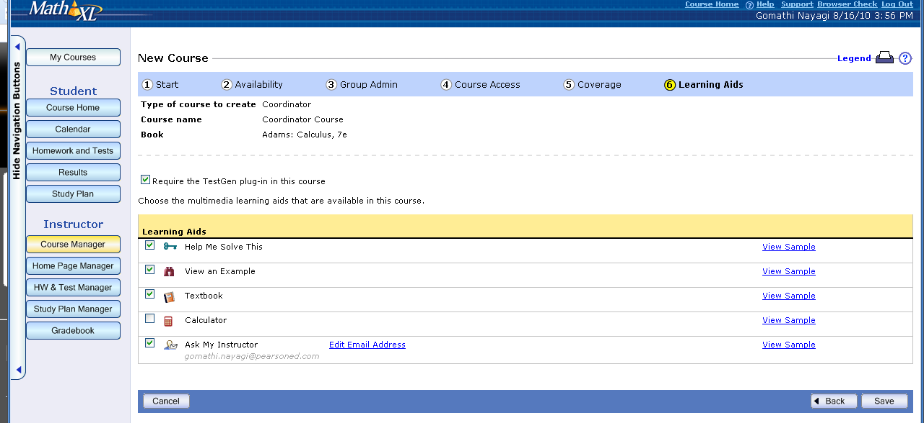

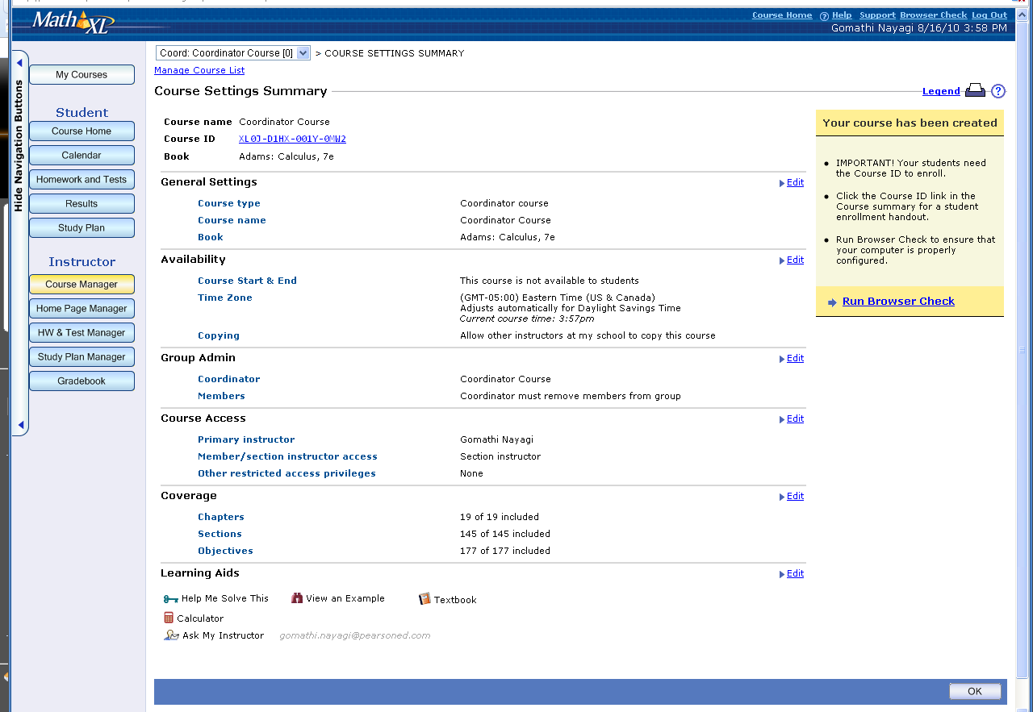

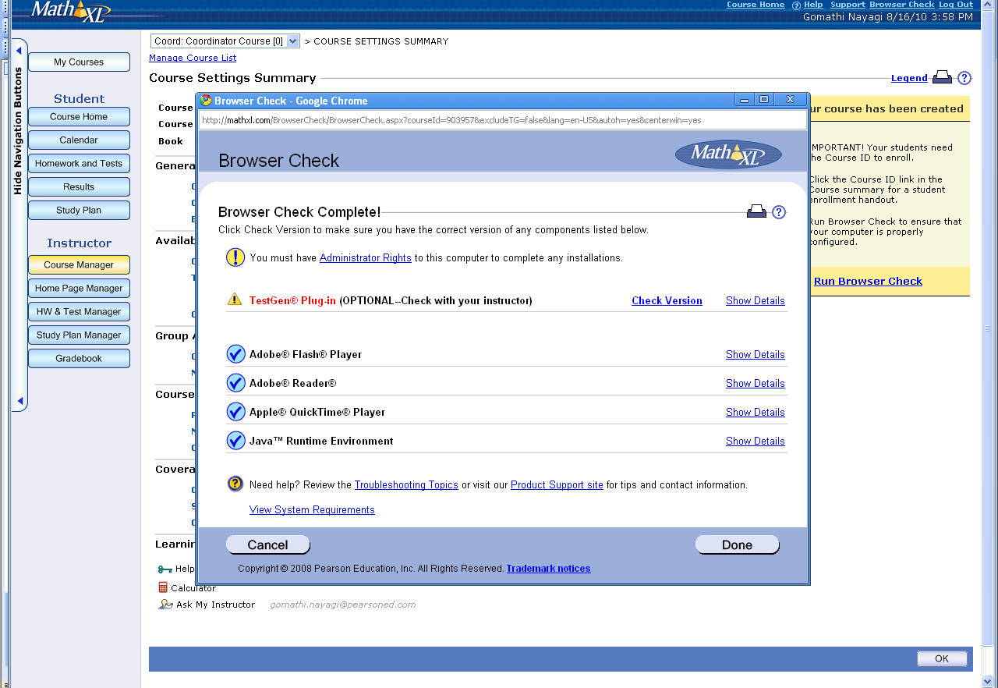

Screenshots of Course Creation Process for Member Course – Same Instructor
Login/Pass: vnayago/goms2gomes

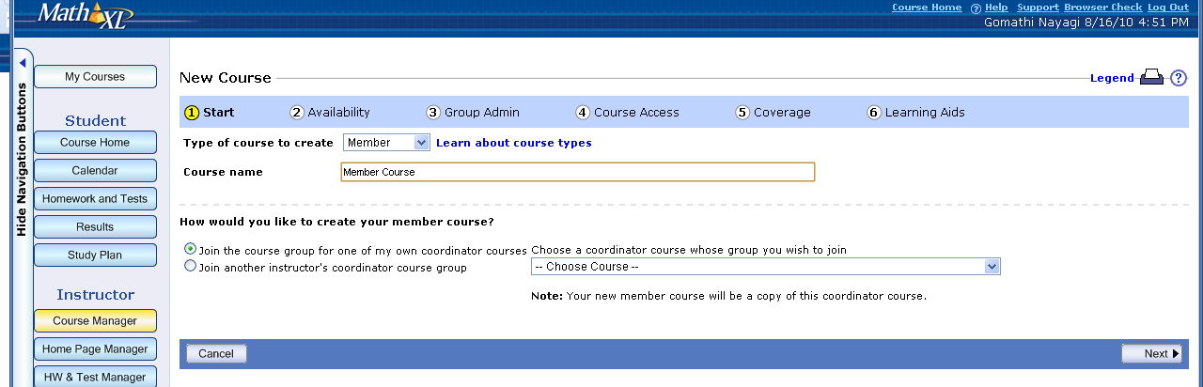

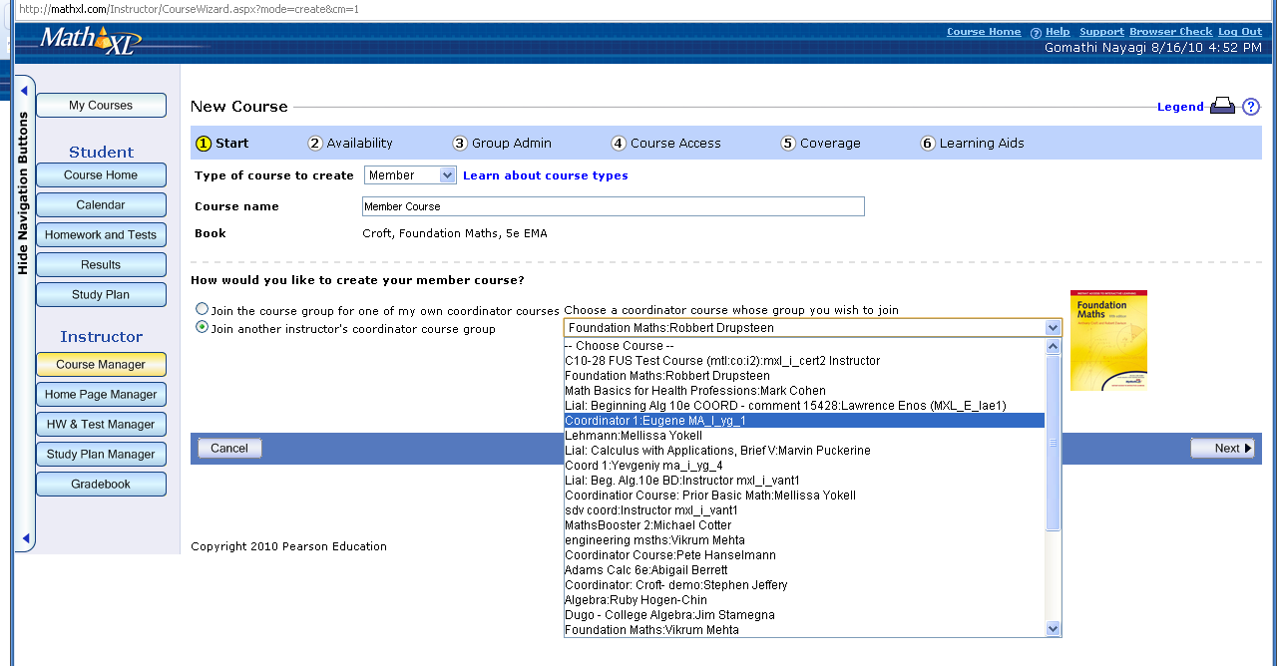

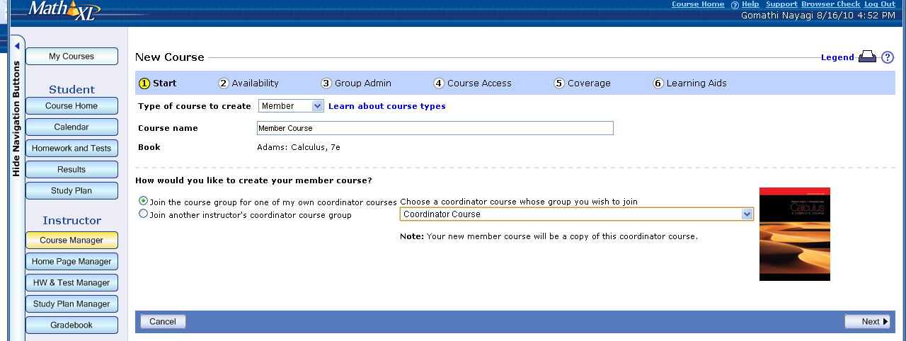

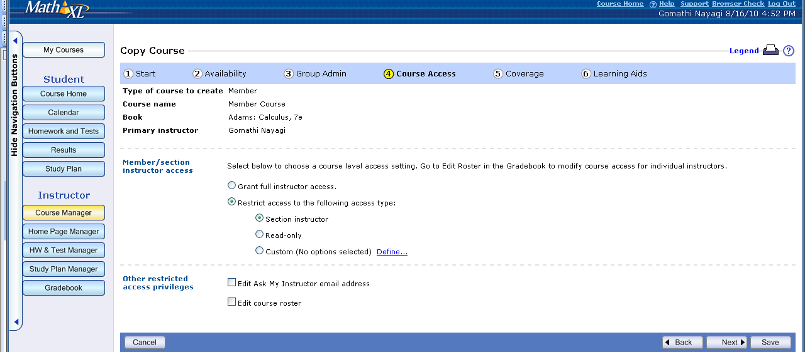

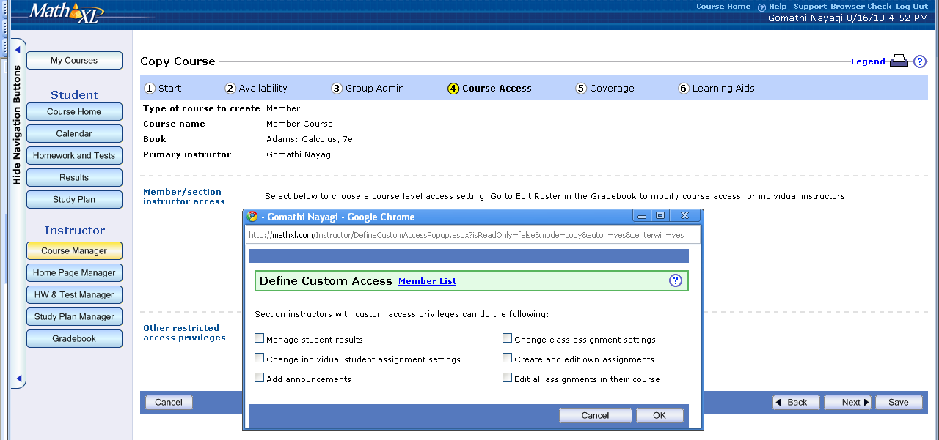

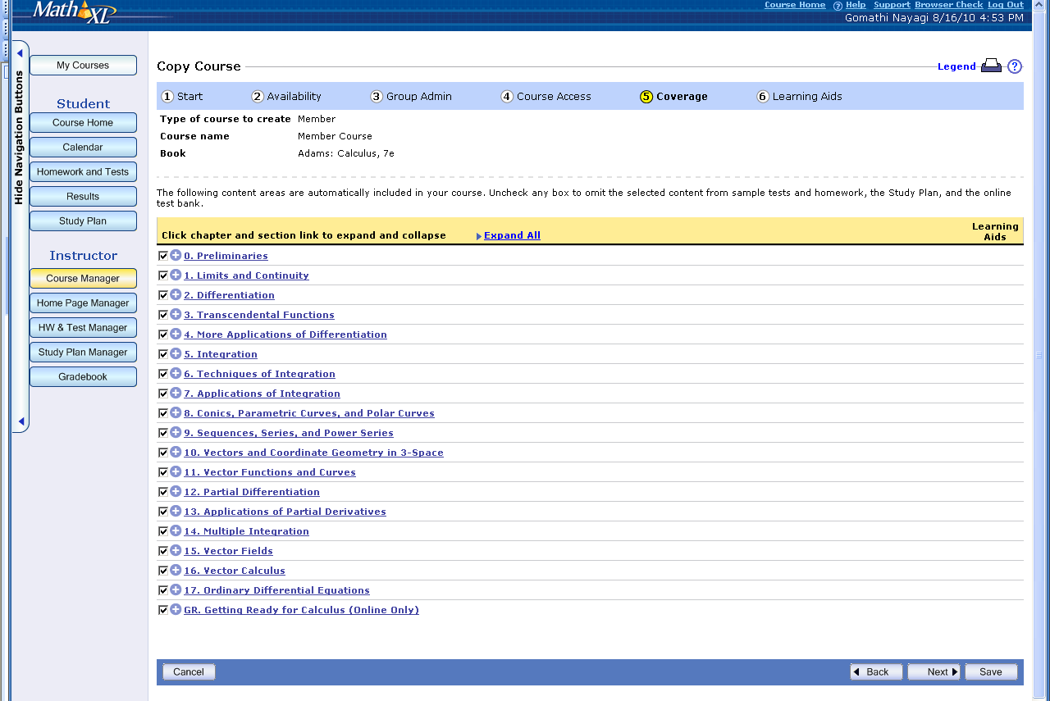

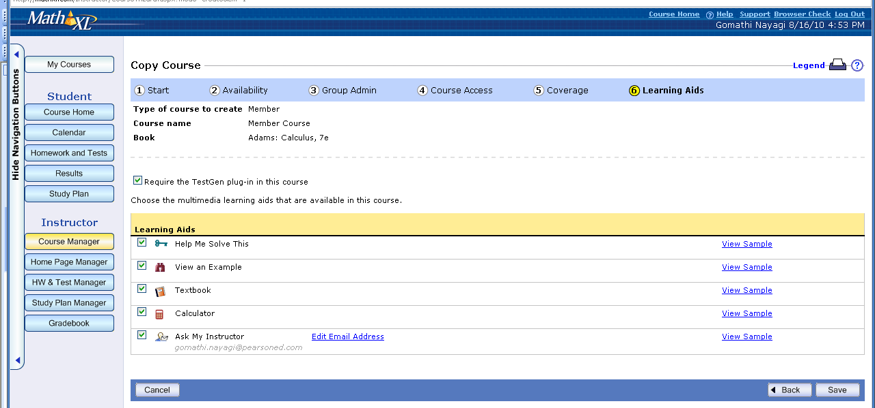

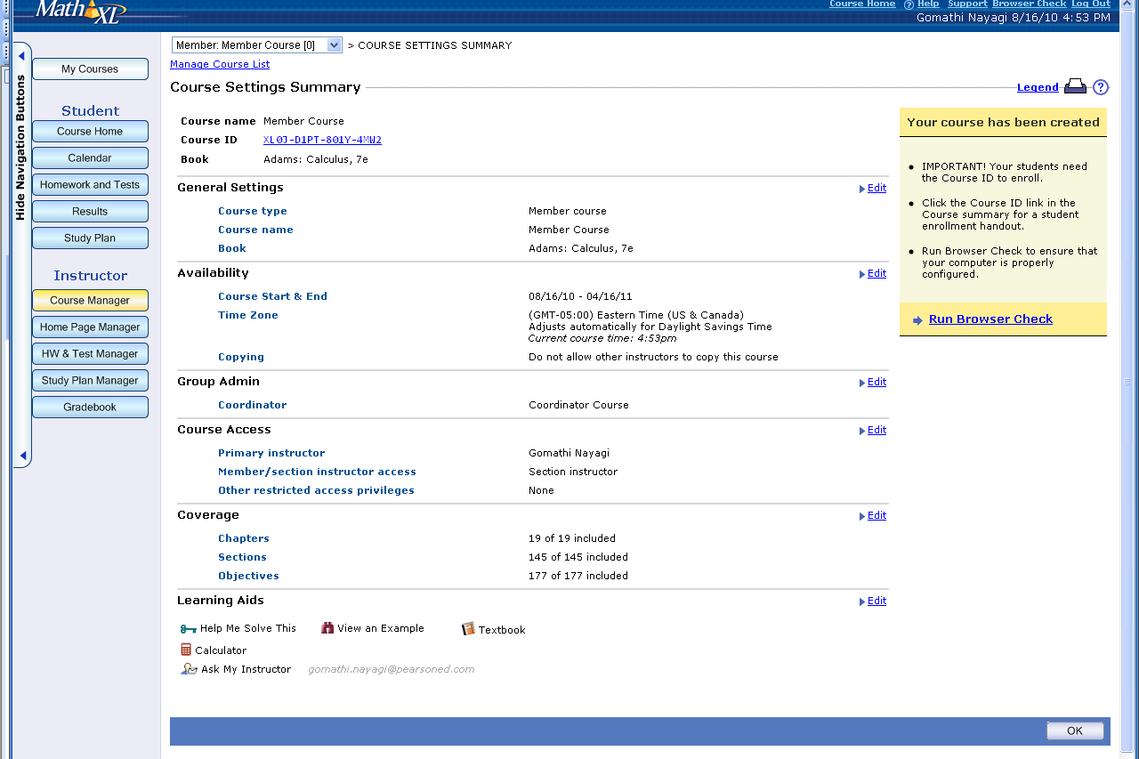

Screenshots of Course Creation Process for Member Course – Different Instructor
Login/Pass: alfred.low/alfred.low



