General Announcements – Functional Specification

June 15, 2011

Document Version/History
Version | Date | Author(s) | Notes
1.0 | 6/6/11 | Craig Marcus | Initial version of General Announcements
1.1 | 6/8/11 | Craig Marcus | Reviewed by Chris Reynolds and
1.2 | 6/14/11 |  | Updated based on feedback from CR and SEM

Open Questions/Issues
ID | Status | Question/Issue | Resolution
1 | Closed | In the Create/Edit screen, is choosing a Tool Provider required? | No, selecting a Tool Provider is not required.
2 | Closed | Should we remove the circled X from the lightbox, as to not confuse the user into thinking they are dismissing the announcement (not just closing the lightbox). | I removed the X until we can do user testing on this.
3 | Closed | Will portal retain the users state of the expand/collapse arrow in the Announcements portlet and View Announcements leftnav? | No, portal will not retain the state of the arrow. The default state of the arrows will be expanded.
4 | Open | For admin users, will the Broadcast channel be implemented above or below the tabs? Also, will it appear on all tabs, or just the myPearson/Home tab.

General Announcements – Functional Specification 1
1.0 General Announcements Overview 2
2.0 The Broadcast Channel 3
3.0 Formatting, Positioning and Styling 3
3.1 Font Formatting: 4
4.0 Behaviors 5
4.1 Display Rules 5
4.2 Stacking Order 5
4.3 Show/Hide More Announcements UI Controller 7
4.4 Dismiss General Announcement UI Controller 8
5.0 Viewing General Announcements 9
5.1 Viewing a General Announcement from the Broadcast Channel: 9
5.2 Viewing a General Announcement from the Announcements Portlet or the View Announcements page: 10
6.0 The Announcements Portlet 12
7.0 The View Announcements Page 13
8.0 Manage General Announcements 14
8.1 Tool Provider Column 14
8.2 Preview Link 15
9.0 Create/Edit General Announcements 16

1.0 General Announcements Overview
Although General Announcements exists today in HE Portal, this project allows users to easily view and dismiss General Announcements in the Broadcast channel. All prototypes can be viewed at the following location:
http://onyxdev.pearsoncmg.com/he_portal/portal_summer_2011/index.html - General-Announcements

2.0 The Broadcast Channel
The “Broadcast channel” can be described as the horizontal area that is just below the Pearson strap line (or Portal header) and just above the portlets.

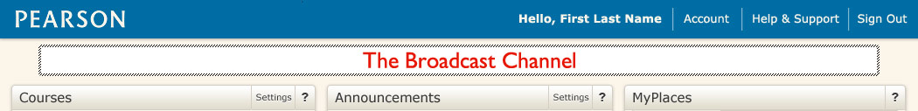

For Portal Administrators, the “Broadcast channel” is located directly below the tab bar and just above the portlets. The Broadcast channel should appear only on the myPearson (Home) tab. See open issue #4.

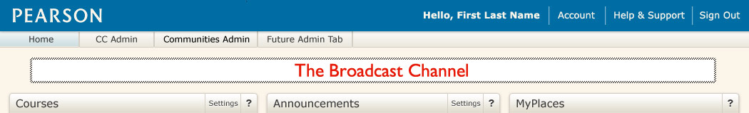

When no General Announcements are available, or the user has dismissed all General Announcement targeted to them, the Broadcast channel should not take up any vertical space. The portlets should be at their normal distance below the Pearson strap line (Portal Header): Make note of loading order: Broadcast channel should load first, then portlets.

3.0 Formatting, Positioning and Styling
When a General Announcements is present, it should appear 15px below the Pearson strapline and 15px above the portlet titlebars. It should be left aligned with the portlets in the left column. The General Announcement block should have a white background (hex#ffffff) with a blue border (hex# 006da4) and a subtle drop shadow. The width of the General Announcement block should be fluid, increasing in width as the user increases the width of their browser. The right border of the General Announcement block should align with the right side of the right hand column of portlets:

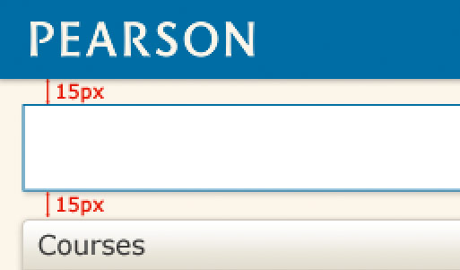

3.1 Font Formatting:
The General Announcement block will contain the following information:
- Date posted
- Announcement Subject Line
- The first line of the announcement body, truncated to 115 characters Note: amount of characters could change if browser window changes
- A “read more” link
- A UI controller to dismiss the announcement (conditional)

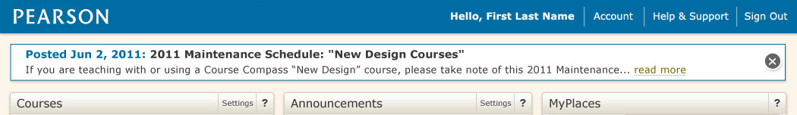

The date posted should appear before the subject line, followed by a colon (:). It should display in 14pt Verdana bold (or equivalent font percentage) and have a hex value of #006da4. The date format should be the same format we use in the Announcements portlet today.

The announcement subject line should appear in 14pt Verdana bold (or equivalent font percentage) and have a hex value of #393939. The entire subject line should be displayed (no truncation). These font settings should overwrite any font customization the announcement author has set. Open Issue? If a subject line exceeds the width of the General Announcements block, the subject line should wrap.

The announcement body text should appear in 13pt Verdana normal (or equivalent font percentage) and have a hex value of #393939. These font settings should overwrite any font customization the announcement author has set. The body text should be truncated after 115 characters and be followed by an ellipses (…). If the body text in its entirety does not exceed 115 characters, then the entire body text should appear with no truncation, ellipses or “read more” link.

The read more link should appear after the truncated body text and ellipses. This link should display in 13pt Verdana normal (or equivalent font percentage), have a hex value of #766b00 and a bottom dotted border with a hex value of #999999. As the user hovers over this link, the bottom border should change to solid, with a hex value of #766b00. When a user clicks on this link, a lightbox window should open over the Portal homepage and the entire General Announcement should appear.

The dismiss announcement UI controller is a conditionally displayed small circle with an X. It should be centered vertically along the right edge of the announcement block. When a user clicks this controller, the General Announcement will fade while collapsing upwards, and the content of Portal homepage will move upwards back into its normal positioning.

4.0 Behaviors

4.1 Display Rules
- Announcement is active for the current/date time
AND
- Announcement is targeted to the user’s role (Student, Instructor, Admin)
AND
- If a Course Instance is specified, user must have one or more active courses for that course provider instance to view the announcement (If no course instance selected, all users meeting other criteria should be able to see announcement – allows users with no courses to get announcements)
AND
- If a Tool Provider is specified, user must have one or more active courses associated to that tool provider. This is new

4.2 Stacking Order
When there are three or more General Announcements with an active status present in the Broadcast channel at any time, the following will apply:
- Announcements will stack in date descending order, with the most recently posted announcement at the top.
- If a user has chosen not to dismiss an announcement and it still has an active status, it will retain its date posted position in the list.
- If there are 4 or more active general announcements present, a show more/hide more UI controller will appear. See following images:

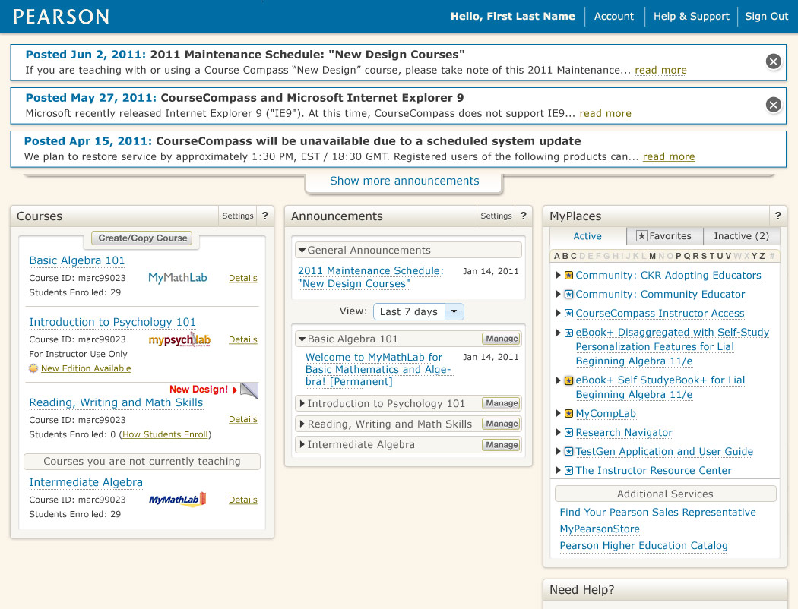

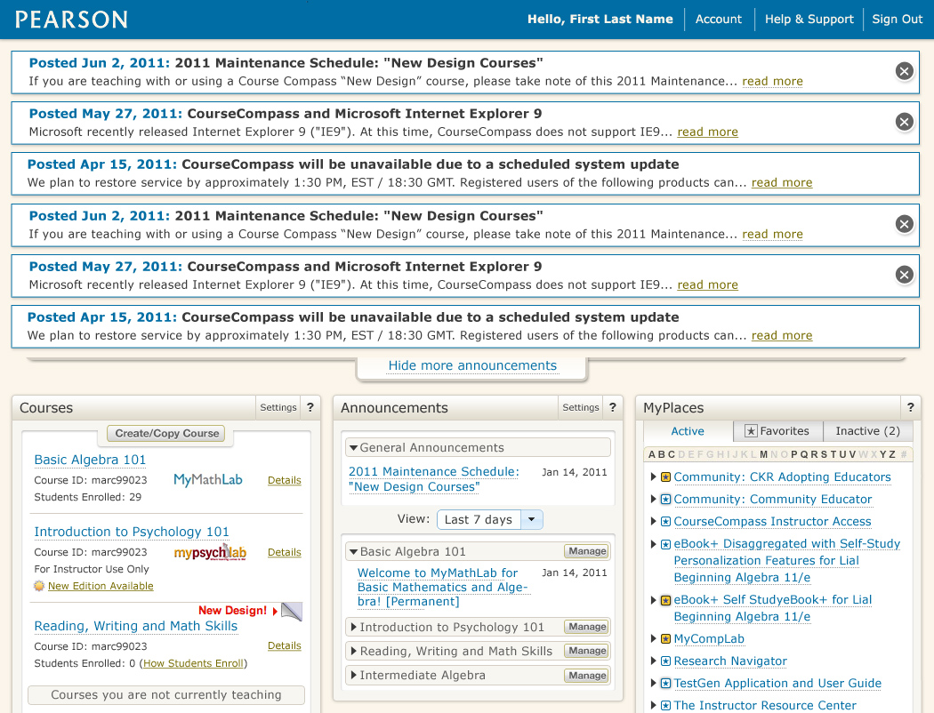
Full-sized clickthru prototype can be viewed at:
http://onyxdev.pearsoncmg.com/he_portal/portal_summer_2011/Rebranding/General-Announcements/GA-Homepage-Four-Closed.html

4.3 Show/Hide More Announcements UI Controller
The show/hide controller will only appear when a user has 4 or more active General Announcements.


When a user clicks on the “Show more announcements” link, the Broadcast channel will expand downwards (animated) to reveal the entire list of General Announcement blocks, and will push the contents the homepage downwards. The text on the controller will change to “Hide more announcements”.

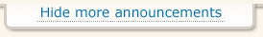

When a user clicks on the “Hide more announcements” link, the Broadcast channel will collapse upwards (animated) to only display 3 General Announcement blocks, and the contents the homepage will move upwards. The text on the controller will then change back to “Show more announcements”.

If while in the expanded view, a user chooses to dismiss messages and the total number of General Announcements becomes less than 4, the Show/Hide control will fade from the screen. This also applies if the user dismisses announcements while the controller is in the collapsed state.

4.4 Dismiss General Announcement UI Controller
The dismiss announcement UI controller is a conditionally displayed small circle with an X. When a user clicks this controller, the General Announcement will fade while collapsing upwards. The controller is conditionally displayed based on setting in the Create/Edit Announcement page.

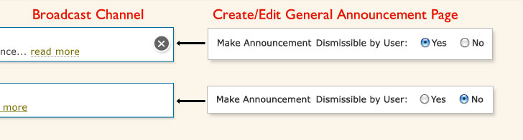

When the “Make Announcement Dismissible by User” radio button is set to “Yes”, the then controller appears to the end user. “Yes” will be the default setting in the Create/Edit Announcement page.

When the “Make Announcement Dismissible by User” radio button is set to “No”, the then controller does not appear to the end user.

When a user dismisses a General Announcement, it will be removed from the Broadcast channel only. All General Announcements will continue to be displayed in both the Announcements portlet (under the General Announcements header) and on the View Announcements page (under the General Announcements header).

5.0 Viewing General Announcements
A user can view General Announcement in three ways:
- By clicking on the “read more” link in the Announcement block in the Broadcast Channel (Announcement opens in lightbox).
- By clicking on the subject line of the General Announcement from the homepage Announcements portlet (this brings user to the View Announcement page).
- By clicking on the subject line of the General Announcement in the leftnav on the View Announcements page.

5.1 Viewing a General Announcement from the Broadcast Channel:
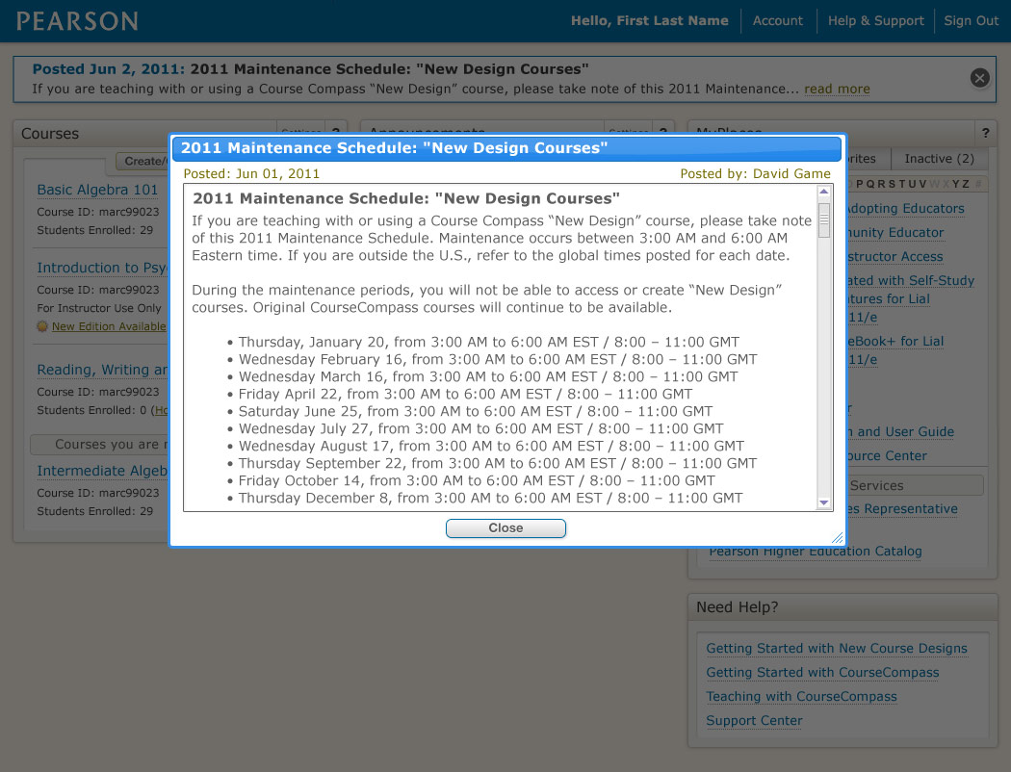
Full-sized prototype can be viewed at:
http://onyxdev.pearsoncmg.com/he_portal/portal_summer_2011/Rebranding/General-Announcements/GA-Lightbox.html

When a user clicks the “read more” link from the announcement block within the Broadcast channel, a lightbox will appear over the portal homepage displaying the General Announcement. This lightbox should include the following:
- The announcement subject displayed in the titlebar of the lightbox window
- Announcement post date
- Announcement posting author name
- Announcement subject line
- Announcement body text
- A “Close” button that closes the lightbox window, but does not dismiss the announcement from the Broadcast channel.
- A scrollbar if the announcement body exceeds the height of the lightbox window.

5.2 Viewing a General Announcement from the Announcements Portlet or the View Announcements page:

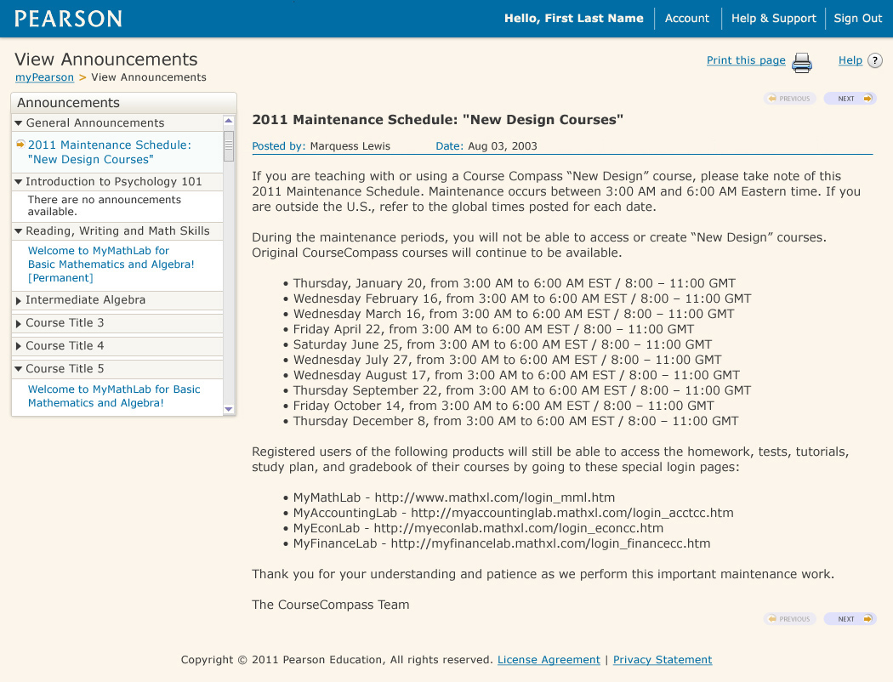
Full-sized prototype can be viewed at:
http://onyxdev.pearsoncmg.com/he_portal/portal_summer_2011/Rebranding/General-Announcements/View-Announcements.html

6.0 The Announcements Portlet
There will be no UI changes to the homepage Announcements portlet, with the exception of the following:

An expand collapse arrow will be places in the left corner of the General Announcements header. Clicking on the arrow, or anywhere within the General Announcements header area will trigger the expand/collapse functionality. We will not retain the user’s state of this expand/collapse arrow. The default state of the arrow will be expanded.

General Announcements expanded:
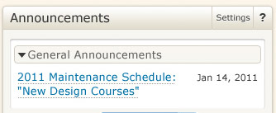

General Announcements collapsed:
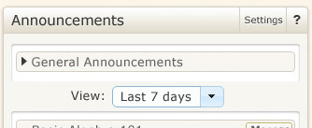

7.0 The View Announcements Page
There will be no UI changes to the View Announcements page, with the exception of the following:

An expand collapse arrow will be places in the left corner of the General Announcements header in the leftnav. Clicking on the arrow, or anywhere within the General Announcements header in the leftnav will trigger the expand/collapse functionality. We will not retain the user’s state of this expand/collapse arrow. The default state of the arrow will be expanded.

General Announcements expanded:

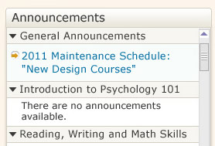

General Announcements collapsed:

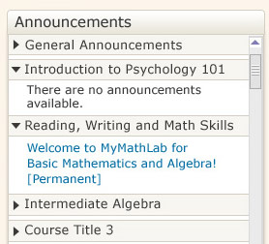

8.0 Manage General Announcements
There will be two UI changes to the Manage Announcements page:

8.1 Tool Provider Column
We will be adding one new column of data immediately to the right of the “Role” column. The column header should read “Tool Provider”. Within that column, the following info may appear based on the settings of the Create/Edit General Announcements of that row: XL, Mastering, EPIC, Pegasus, All and None. When several Tool Providers are listed, wrapping may occur. When no Tool Providers are selected, then the word “None” should display.

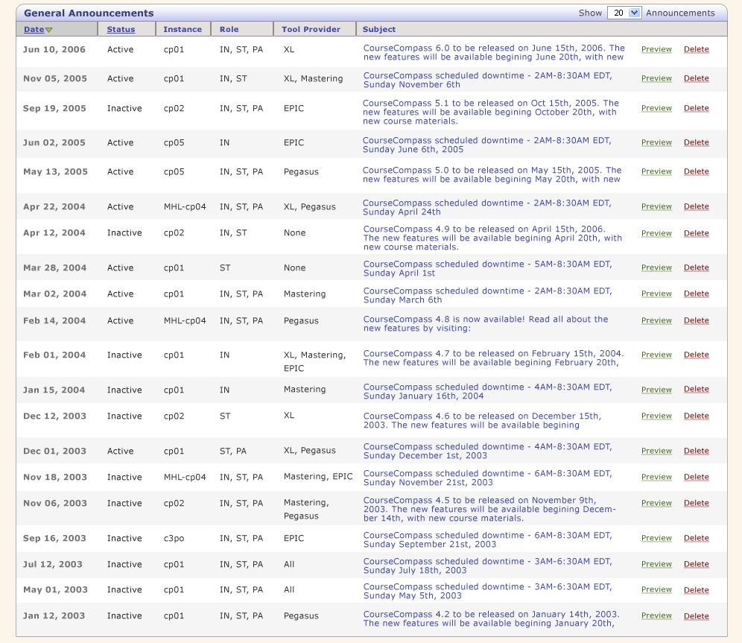
Full-sized prototype can be viewed at:
http://onyxdev.pearsoncmg.com/he_portal/portal_summer_2011/Rebranding/General-Announcements/Manage-Announcements.html

8.2 Preview Link
The Preview link for each announcement will now display the entire announcement in a lightbox.

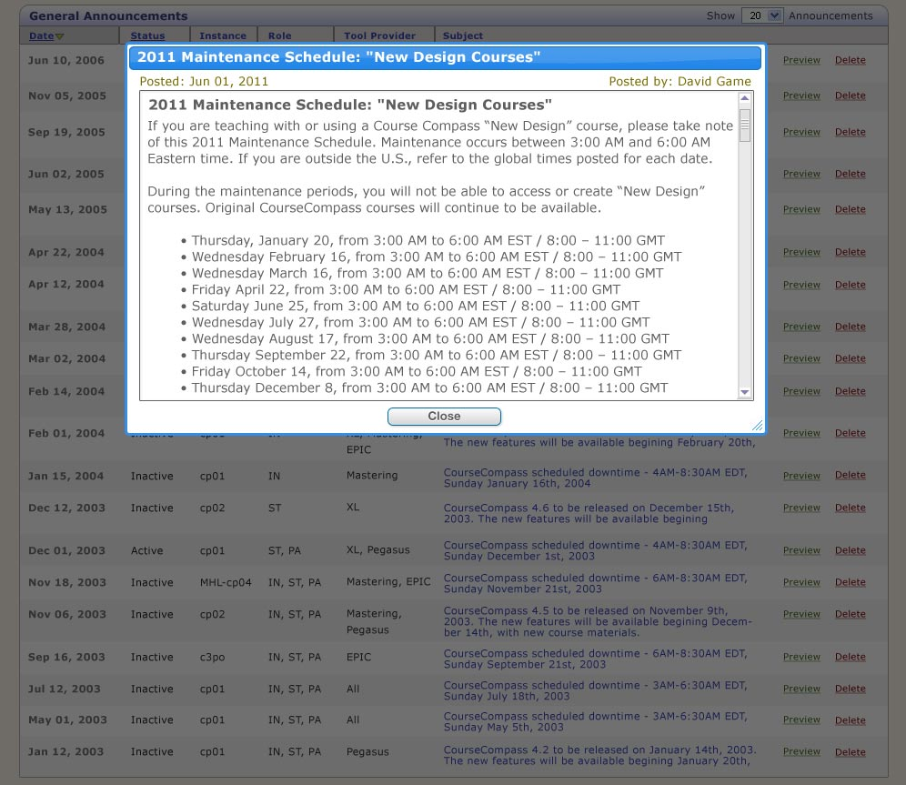

9.0 Create/Edit General Announcements

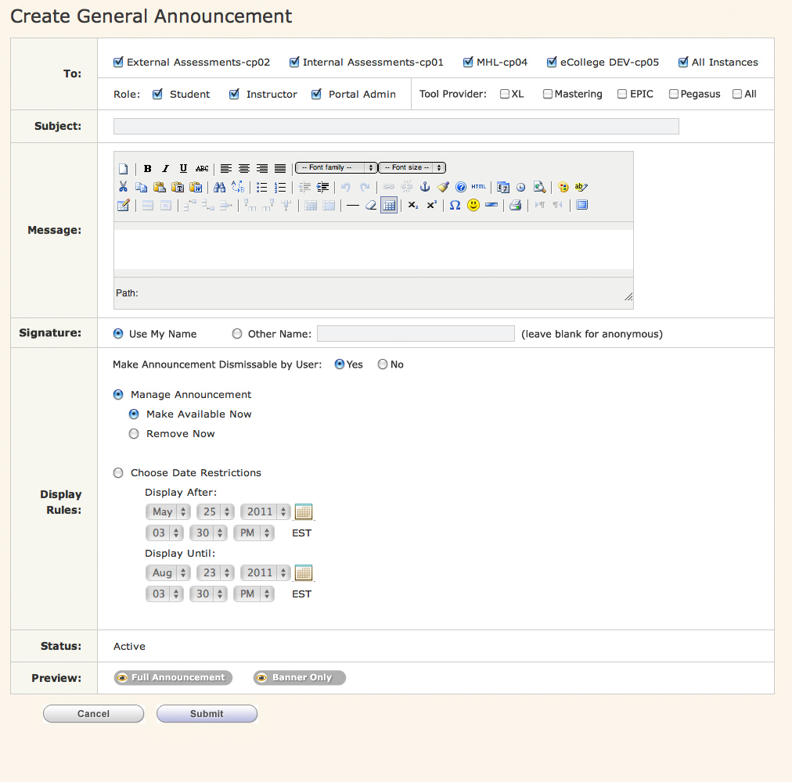
Full-sized prototype can be viewed at:
http://onyxdev.pearsoncmg.com/he_portal/portal_summer_2011/Rebranding/General-Announcements/Create-General-Announcements.html

There will be several additions to the Create/Edit Announcements page:
- In the “To:” row, under “Role”, we will be changing the words “Portal Administrator” to “Portal Admin”. This is to allow more space for the new Tool Provider area.
- In the “To:” row, we will be adding a new section called “Tool Providers”. It will consist of 5 checkboxes: XL, Mastering, EPIC, Pegasus and All. Selecting the “All” checkbox toggles all of the other checkboxes on or off, even if you have one or more already selected. These fields are not required.
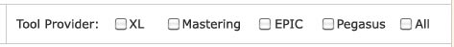
- We will be adding a new row, directly beneath the “Message” row, titled: “Signature”. It will consist of 2 radio buttons: Use My Name and Other Name. If the announcement author selects the “Other Name” radio button and leaves the text field blank, the announcement will be posted as “anonymous”. The radio button for “Use My Name” should be the default setting.This is stored in one field
- We will be adding new functionality to the top of the “Display Rules” area. These radio buttons determine whether the dismiss General Announcements UI controller appears in the announcement block. The default button should be “Yes”.

- We will be adding an additional button to the “Preview” row.

Clicking on the Full Announcement button will display the announcement in a lightbox window exactly as the user would see it.

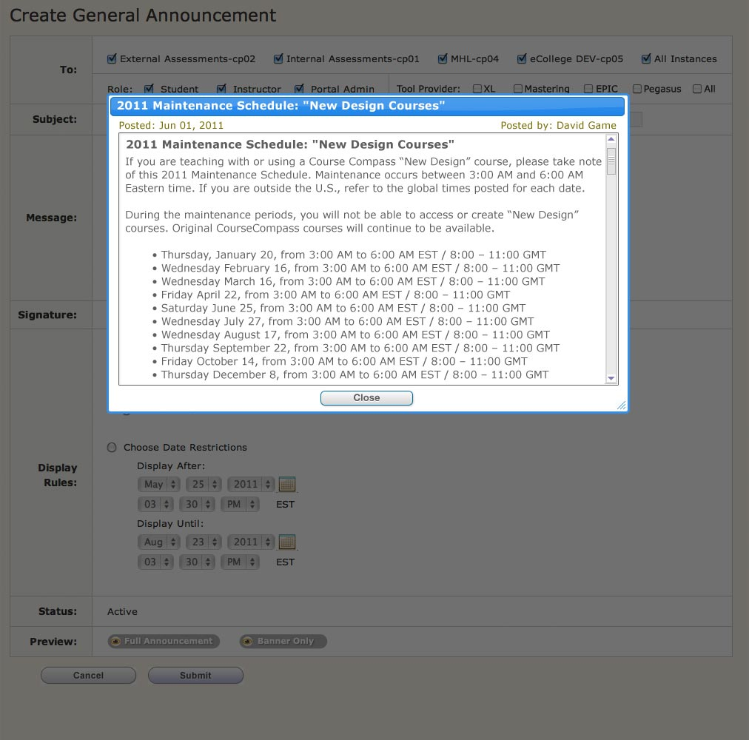
Full-sized prototype can be viewed at:
http://onyxdev.pearsoncmg.com/he_portal/portal_summer_2011/Rebranding/General-Announcements/Preview-Full-Announcement.html

Clicking on the “Banner Only” button will display exactly what the users sees in the Broadcast channel.

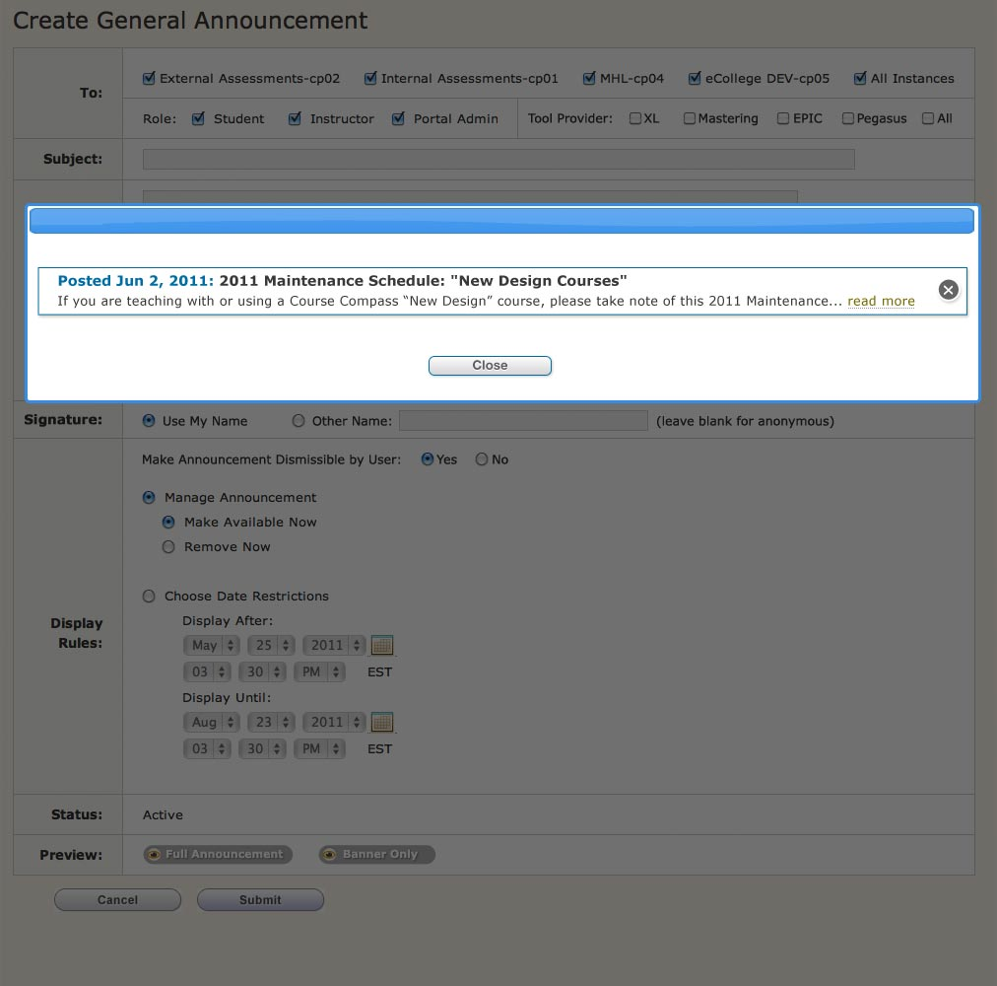
Full-sized prototype can be viewed at:
http://onyxdev.pearsoncmg.com/he_portal/portal_summer_2011/Rebranding/General-Announcements/Preview-Banner-Only.html

