Modal Window Design Functional Spec

Version 1.2

Document Version History
Version | Date | Author(s) | Notes
1.0 | 5/13/10 | Andy Trus | Initial Draft
1.1 | 5/14/10 | Andy Trus | Added header titles and resizing mechanism
1.2 | 6/24/10 | Andy Trus | Updated table of contents headers

Table of Contents

1. Overview 4
2. Performing an Action Modal Window 5
2.1. Overview 5
2.2. New Modal Window Design 5
2.2.1. New Modal Window Design for License Agreement 6
2.2.2. New Modal Window Design for Privacy Policy 6
2.3. Old Prototypes to Translate to New Modal Window Design 7
2.3.1. License Agreement 7
2.3.2. Privacy Policy 8
2.3.3. Create a Search and Bookmark Project – Coming from Homepage 9
2.3.4. Create a Search and Bookmark Project – Coming from Manage Page 9
2.3.5. Add a Bookmark 10
2.3.6. Copy a Bookmark 11
2.3.7. Course Copy History 11
2.3.8. Preview an Announcement 12
3. Confirmation and Error Messaging Modal Window 13
3.1. Overview 13
3.2. New Modal Window Design 13
3.3. Old Prototypes to Translate to New Modal Window Design 14
3.3.1. Session Timed Out 14
3.3.2. Course Lifecycle Invalid Dates 15
3.3.3. Courses Portlet – Course is Ending Soon 15
3.3.4. Courses Portlet – Course is Unavailable 16
3.3.5. Delete a Course 16
3.3.6. Delete an Announcement 16
3.3.7. Save Changes to an Announcement 17
3.3.8. Delete a Search and Bookmark Folder 17
3.3.9. Delete a Bookmark 18
3.3.10. Save Changes to Search and Bookmark 18
3.3.11. Adding and Removing Favorites from MyPlaces 19
4. Urgent Alert Messaging Modal Window 20
4.1. Overview 20
4.2. New Modal Window Design 20
4.3. Old Prototypes to Translate to New Modal Window Design 21
4.3.1. CourseCompass Subscription Expired – Coming From CourseCompass 21
4.3.2. CourseCompass Subscription Expired – Coming From myPearson 21
4.3.3. No CourseCompass Subscription 22
4.3.4. Course Update Error – Coming from CourseCompass 22
4.3.5. Course Update Error – Coming from myPearson 23
5. CSS Values 24
5.1. Values 24

Overview

We are transitioning over to uPortal 3.x, and with that transition, we are moving towards using the jQuery UI library for various widgets. With that transition, we are now able to use jQuery UI themes which allow us to have a unified look and feel across all of the jQuery UI widgets within the various Pearson portal applications.

This document outlines three different scenarios for modal window design. Included in each scenario is a prototype of how the modal window should look, and examples of how modal windows and pop-ups are currently displayed for that scenario across Portal and Communities. It is our goal to eventually convert all of the old modal windows and pop-ups into the new ones. This can be completed by using a standardized theme generated by ThemeRoller that can be downloaded here:

http://onyxdev.pearsoncmg.com/he_portal/portal_spring_2010/Lightbox-Redesign/jquery-ui-1.8.1.custom.zip

Additional information about using the theme roller application can be found here: http://jqueryui.com/docs/Theming/Themeroller

Performing an Action Modal Window

Overview

This modal window is used in scenarios where the modal window is allowing the user to take an action as part of the website beyond simply answering a confirmation or error message. It is also used in scenarios where an extensive amount of text is available that the user would like to read. For this modal window, an X should be available on the top right corner and users should be able to resize or move the box to cater to their needs.

New Modal Window Design

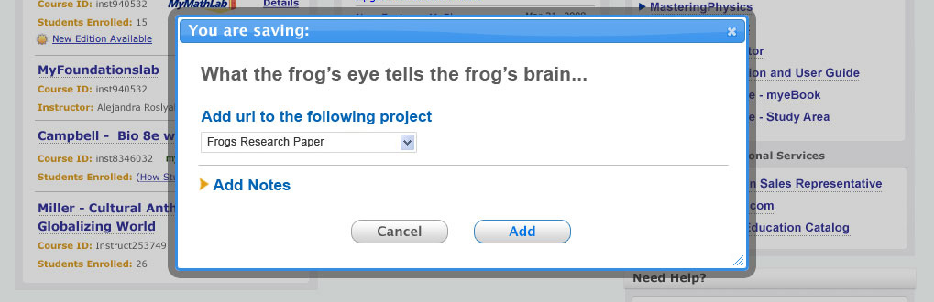

New Modal Window Design for License Agreement
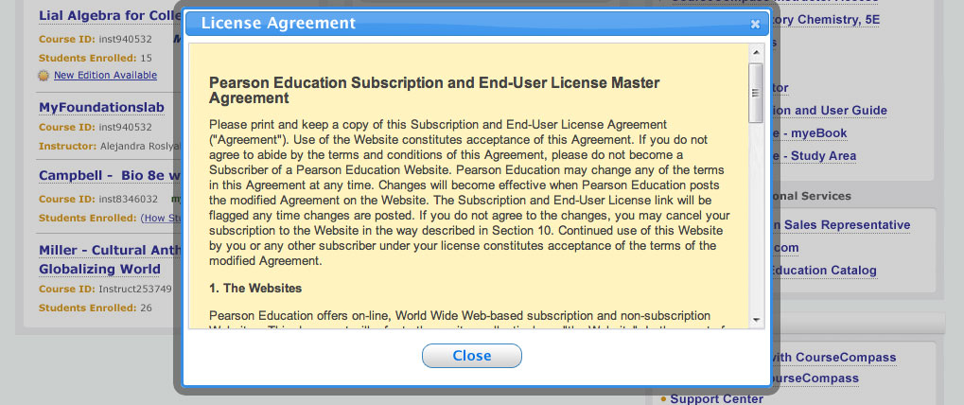

New Modal Window Design for Privacy Policy
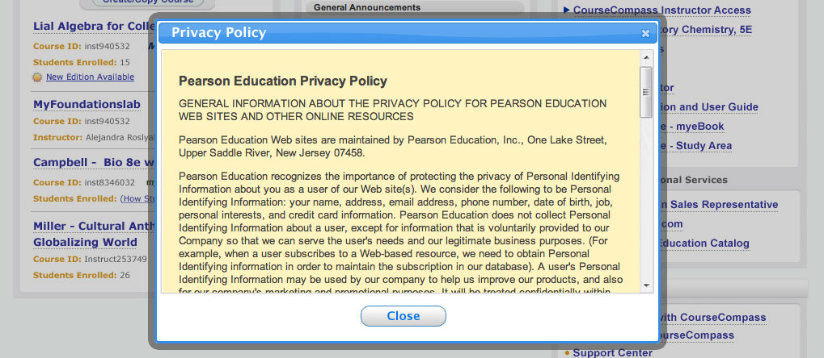

Old Prototypes to Translate to New Modal Window Design

License Agreement

Header Title: License Agreement
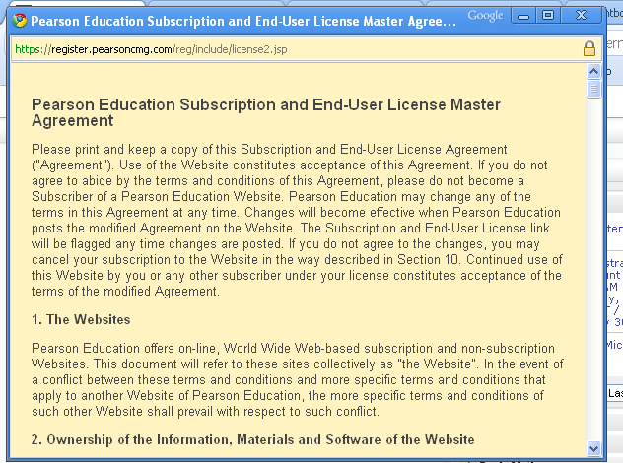

Privacy Policy

Header Title: Privacy Policy
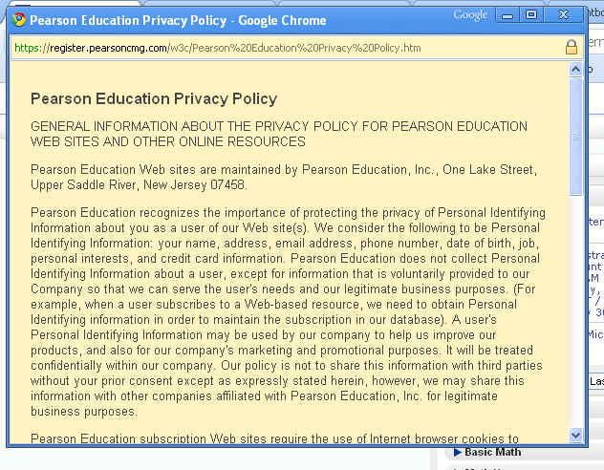

Create a Search and Bookmark Project – Coming from Homepage

Header Title: Create New Project
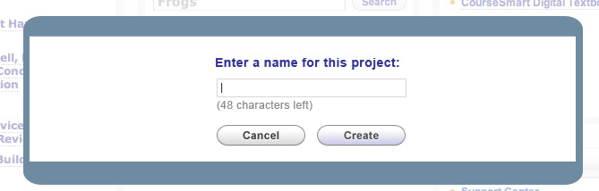

Create a Search and Bookmark Project – Coming from Manage Page

Header Title: Create New Project
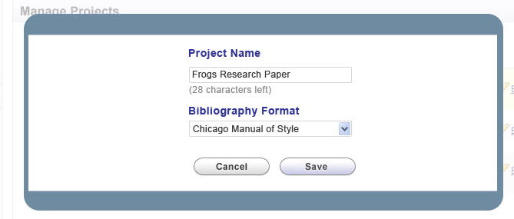

Add a Bookmark

Header Title: You are saving: (Note: remove “You are saving” text inside of box)
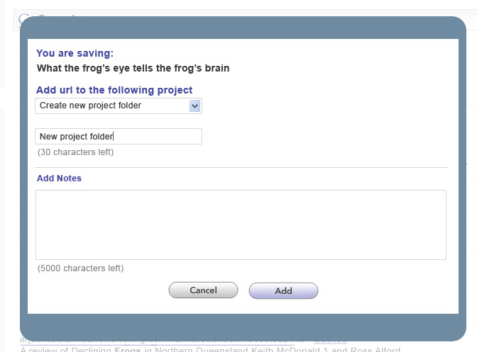

Copy a Bookmark

Header Title: You are copying: (Note: remove “Copy” text inside of box)
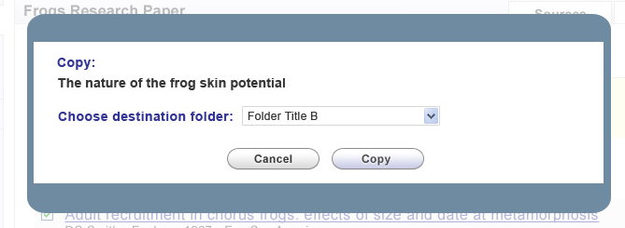

Course Copy History

Header Title: Copy History (Note: remove “Copy History” text inside of box)
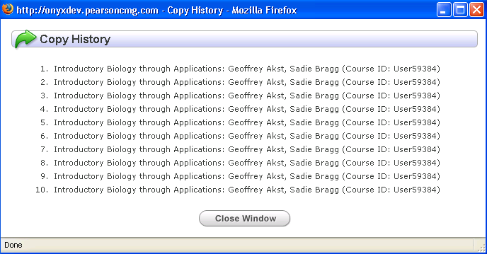

Preview an Announcement

Header Title: Announcement Preview (Note: remove “Preview” text inside of box)
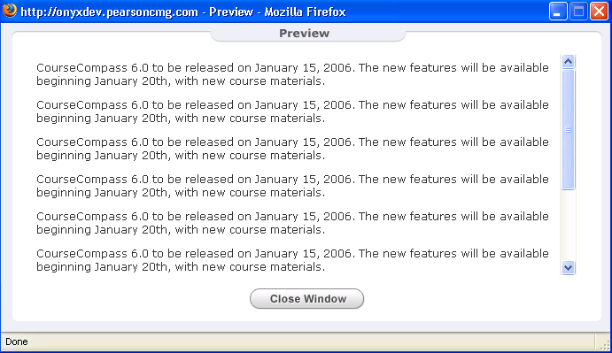

Confirmation and Error Messaging Modal Window

Overview

This modal window is used in scenarios where a confirmation or error message needs to be displayed to the user, but the opacity isn’t as dark so the user can still see the contents of the background. The user should be able to drag this modal window to another location, but should not have an X on the top right corner and cannot be resized.

New Modal Window Design

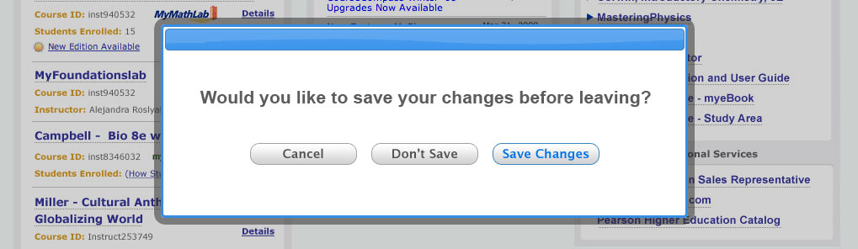

Old Prototypes to Translate to New Modal Window Design

Session Timed Out

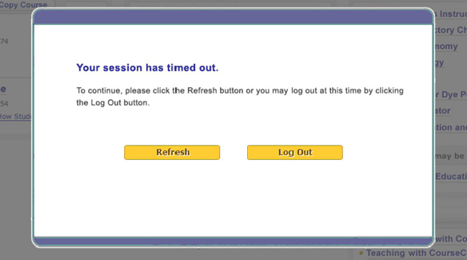

Course Lifecycle Invalid Dates
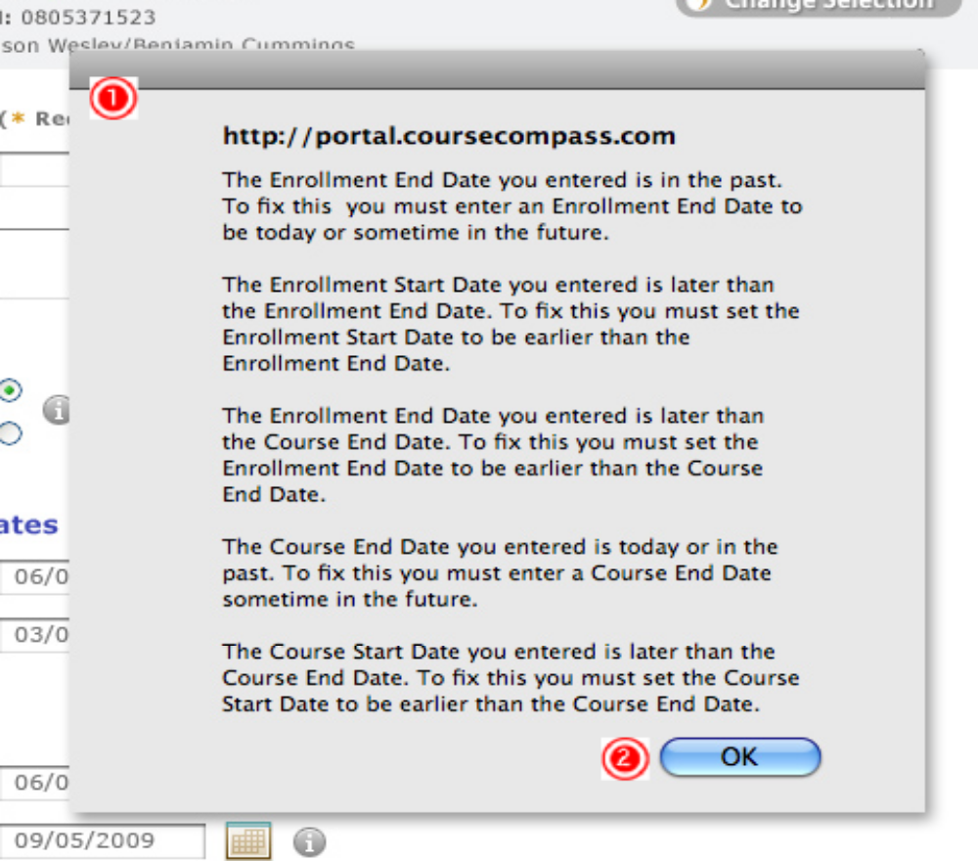

Courses Portlet – Course is Ending Soon
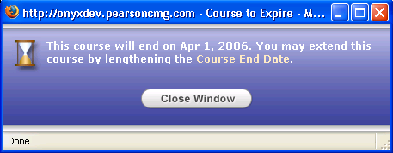

Courses Portlet – Course is Unavailable

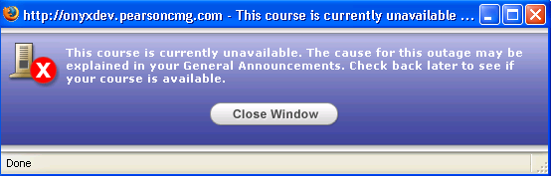

Delete a Course

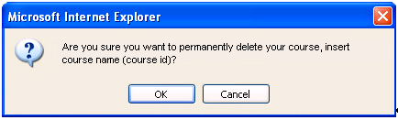

Delete an Announcement

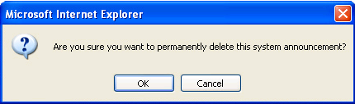

Save Changes to an Announcement

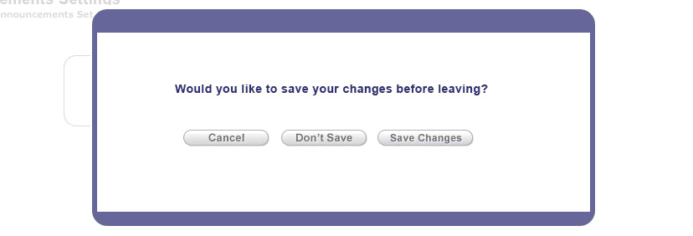

Delete a Search and Bookmark Folder

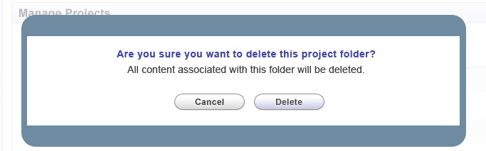

Delete a Bookmark

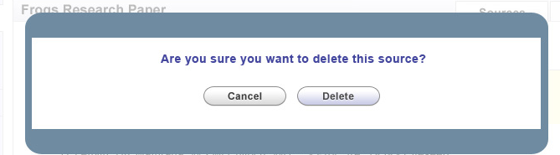

Save Changes to Search and Bookmark

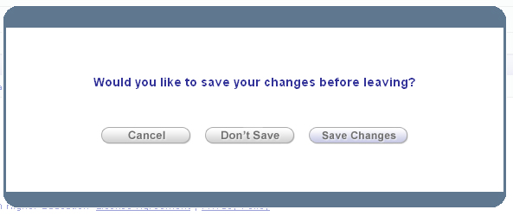

Adding and Removing Favorites from MyPlaces

Note: Remove from Favorites box should be converted to the new modal window, but Add to Favorites box should be removed all together.

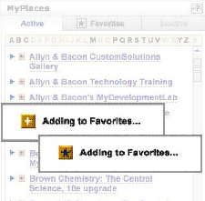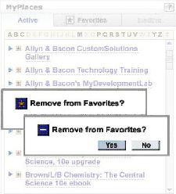

Urgent Alert Messaging Modal Window

Overview

This modal window is used in scenarios where an urgent message needs to be displayed to the user, such as the case of a subscription having expired. The user should not be able to drag this modal window to another location or resize the window. There also should not be an X on the top right corner.

New Modal Window Design

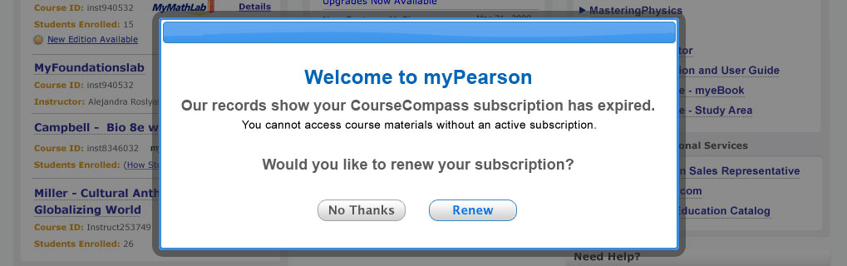

Old Prototypes to Translate to New Modal Window Design

CourseCompass Subscription Expired – Coming From CourseCompass

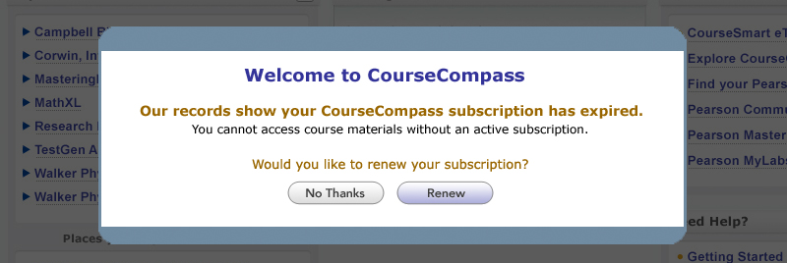

CourseCompass Subscription Expired – Coming From myPearson

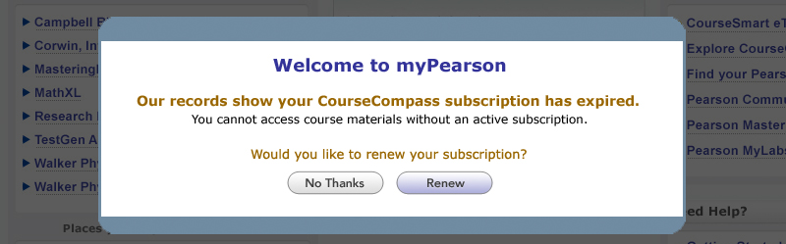

No CourseCompass Subscription

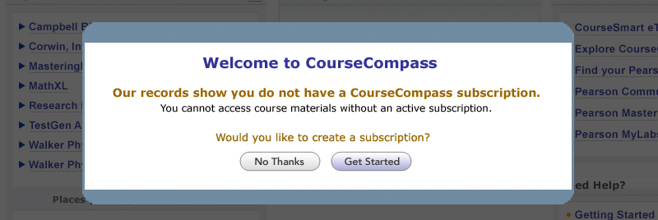

Course Update Error – Coming from CourseCompass

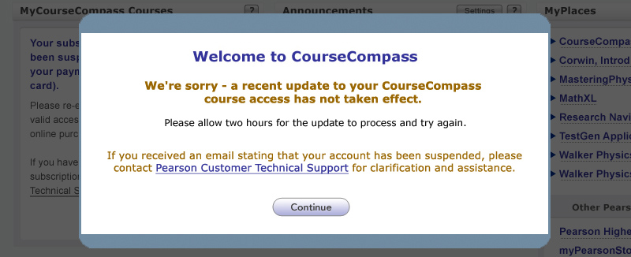

Course Update Error – Coming from myPearson

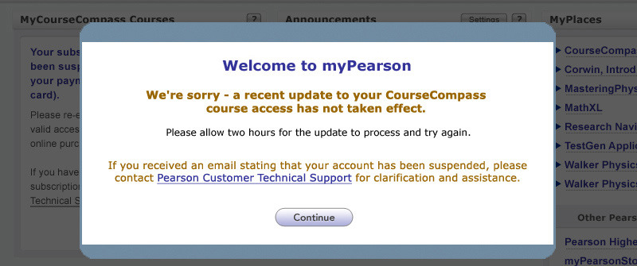

CSS Values

Values



