Course Information Page (Course Lifecycle) Functional Spec

Version 1.6.1

RED = Open Issue
BLUE = Modification

Document Version History
Version | Date | Author(s) | Notes
1.0 | 5/20/08 | Matt Hofmann
1.5 | 5/29/08 | Matt Hofmann/ Craig Marcus
1.6 | 6/05/08 | Craig Marcus
1.6.1 | 6/26/08 | Matt Hofmann | Changed email links.

Questions/Issues
ID | Status | Question/Issue | Resolution
01 | Closed | Where do the “What is this” links in emails go? | “What is this?” for course create date links to http://info.coursecompass.com/website/course_create_date.html  “What is this?” for course expiry date links to  http://info.coursecompass.com/website/course_expiry_date.html
02 | Closed | Need URL for course creation confirmation page help link. | This button shall link to http://info.coursecompass.com/help/WebHelp/confirmation_request_received_page.htm  in a secondary browser window constrained to 600x400.
03 | Closed | Need info text for Course Type icon | Select For Student enrollment if you intend to enroll students in this course. Select For Instructor use only if you do not intend to enroll students in this course. This course can be used as a model to copy other courses.
04 | Open | Need content for “What is this?” pages to be hosted on info.coursecompass.com | David/Peter/Clare?
05 | Open | “What is this” pages need to be posted on infodev.pearsoncmg.com and deployed to production | Craig
Table of Contents

1. Course Information Page Standard Layout 4
1.1. Requirements 4
1.2. Interaction Diagram 4
2. Prototypes 5
2.1. Enter Course Information Page, Standard Layout Prototype 5
2.2. Course Information Page, For Instructor use only 6
2.3. Course Information Page, Calendar View 7
2.4. Course Information Page, Error State 8
2.4.1. Error Conditions 9
2.5. Course Creation Confirmation Page 11
2.6. Course Details Page, For Student Enrollment 12
2.7. Edit Course Dates Page, For Student Enrollment 13
2.7.1. Edit Course Dates Page, For Instructor Use Only 14
2.7.2. Edit Course Details Error Conditions 15
2.8. Course Creation Confirmation Email (For Student Enrollment) 16
2.9. Course Creation Confirmation Email(For Instructor Use Only) 17

Course Information Page Standard Layout

Requirements
This technical specification meets detailed requirement PRR00357: Course Lifecycle UI.

This is the standard layout for the Course Catalog page in My CourseCompass. It contains the listing of information related to the selected course, and the ability to change the course type, enrollment dates, and duration.

Interaction Diagram
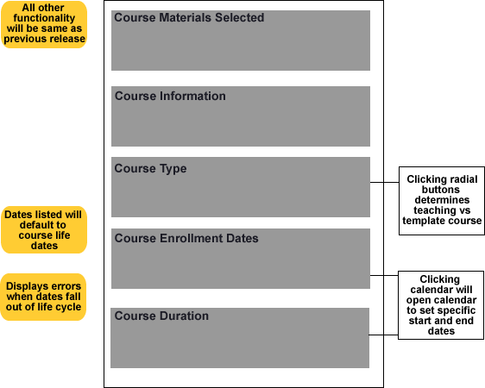

Prototypes

Enter Course Information Page, Standard Layout Prototype
The following user types will see this My CourseCompass Course Catalog page layout – Users with CourseCompass Educator and Admin Subscriptions.
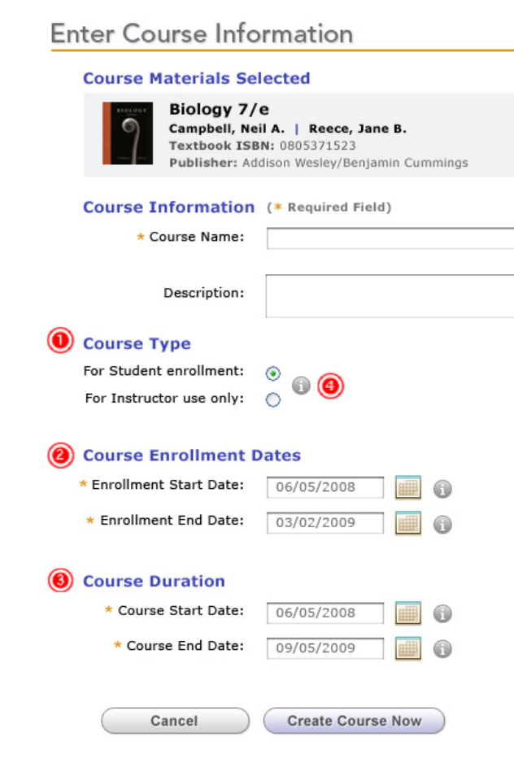
Course type radio buttons will default to For Student enrollment course versus For Instructor use only (template) course. This will allow an instructor to optionally flag a course as instructor only.
The Course Enrollment Dates section allows the user to select the dates for student enrollment, and clicking in the box or calendar icon opens the calendar to set dates. Please see DRD for business rules. This section will be disabled if user selects For Instructor use only. See 2.2
The Course Duration section allows the user to select the overall length of the course, and clicking in the box or calendar icon opens the calendar to set dates. Please see DRD for business rules.
Clicking information symbol opens info box in same window stating:
Select For Student enrollment if you intend to enroll students in this course. Select For Instructor use only if you do not intend to enroll students in this course. This course can be used as a model to copy other courses.
NOTE: All other functionality has not changed from previous release.

Enter Course Information Page with Course Type set to For Instructor use only
The following user types will see this My CourseCompass Course Catalog page layout – Users with CourseCompass Educator and Admin Subscriptions.
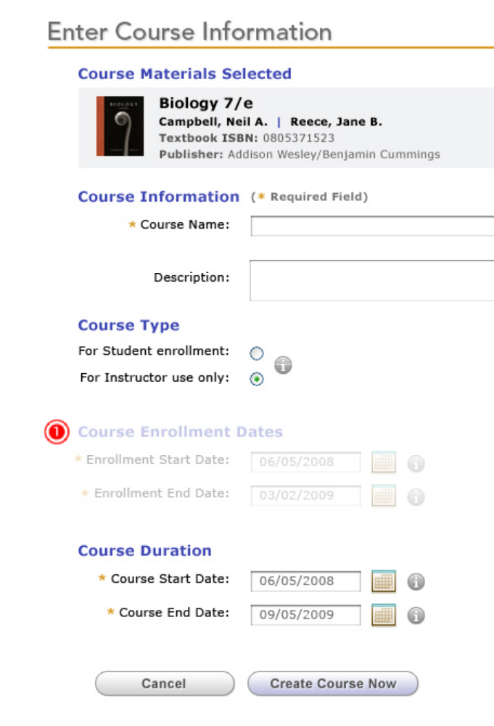
If the Course type radio buttons is set to For Instructor use only, the Course Enrollment Date area will be disabled. Clicking the text field, calendar icon and info icon will yield no results. If user toggles back to For Student enrollment, the Course Enrollment Date area will become enabled.

Course Information Page, Calendar View
The following user types will see this My CourseCompass Course Catalog page layout – Users with CourseCompass Educator and Admin Subscriptions.
.
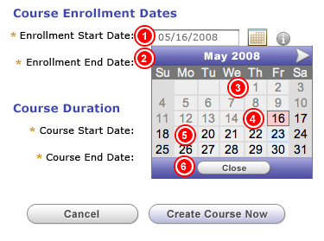
Clicking the date box or calendar icon will open calendar. Field will not be manipulable via text insertion.
Calendar will display one month, with the month being viewed displayed in the line with the arrows. Clicking on the arrows will move to the previous or next month depending. A lack of arrow means that the user cannot go back or forward any further due to business rules.
Dates that are not permissible will be grayed out. User will not be able to select any date prior to the course create date or any date 15 months (450 days) after the Course Create date or 15 months (450 days) after the Feature Implementation Date if editing an existing course - created prior to the lifecycle implementation
A selected date.
Available dates will be displayed in black. Clicking on an available date will display it in the text box in the format mm/dd/yyyy and close the calendar.
Clicking close button closes the calendar.

Course Information Page, Error State
The following user types will see this My CourseCompass Course Catalog page layout – Users with CourseCompass Educator and Admin Subscriptions.

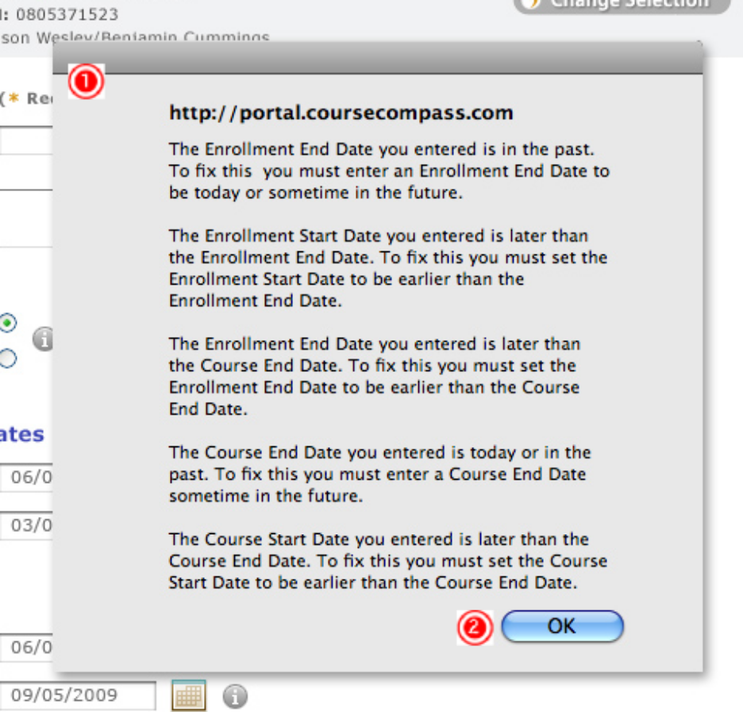
If the user has made errors, an error message will be displayed after the user clicks Create Course Now stating the error that has been made. NOTE: User will only see relevant error message(s).
Clicking OK will return user to the Enter Course Information page.

Error Conditions – Fields marked in yellow are no longer applicable.
Course Creation Date Validatons | Message Displayed (in a JavaScript pop-up with “OK” button to close.)
If the “Course Name” field is blank. | You forgot to enter the Course Name. To fix this, enter a course name.
If the “Description” field exceeds 512 characters. | Your Course Description cannot exceed 512 characters.
If the “Enrollment Start Date” is before the current date. | The Enrollment Start Date you entered is in the past. To fix this you must enter an Enrollment Start Date to be today or sometime in the future.
If the “Enrollment End Date” is before the current date | The Enrollment End Date you entered is in the past. To fix this you must enter an Enrollment End Date to be today or sometime in the future.
If the “Enrollment Start Date” is later than the “Enrollment End Date” | The Enrollment Start Date you entered is later than the Enrollment End Date. To fix this you must set the Enrollment Start Date to be earlier than the Enrollment End Date.
If the “Enrollment Start Date” is later than the “Course Start Date” | The Enrollment Start Date you entered is later than the Course Start Date. To fix this you must set the Enrollment Start Date to be earlier than the Course Start Date.
If the “Enrollment End Date” is later than the “Course End Date” | The Enrollment End Date you entered is later than the Course End Date. To fix this you must set the Enrollment End Date to be earlier than the Course End Date.
If the “Course Start Date” is the before the current date. | The Course Start Date you entered is in the past. To fix this you must enter a Course Start Date to be today or sometime in the future.
If the “Course End Date” is the same day or before the current date. | The Course End Date you entered is today. To fix this you must enter a Course End Date sometime in the future.
If the “Course End Date” is before the “Course Start Date” | The Course Start Date you entered is later than the Course End Date. To fix this you must set the Course Start Date to be earlier than the Course End Date.
If the “Course Start Date” is an invalid date | The Course Start Date you entered isn’t a real date. To fix this, go back and enter a valid date, or use the calendar to find a valid date.
If the “Course End Date” is an invalid date | The Course End Date you entered isn’t a real date. To fix this, go back and enter a valid date, or use the calendar to find a valid date.
If the “Enrollment Start Date” is an invalid date | The Course Enrollment Start Date you entered isn’t a real date. To fix this, go back and enter a valid date, or use the calendar to find a valid date.
If the “Enrollment End Date” is an invalid date | The Course Enrollment End Date you entered isn’t a real date. To fix this, go back and enter a valid date, or use the calendar to find a valid date.

Course Creation Confirmation Page
The following user types will see this My CourseCompass Course Catalog page layout – Users with CourseCompass Educator and Admin Subscriptions.
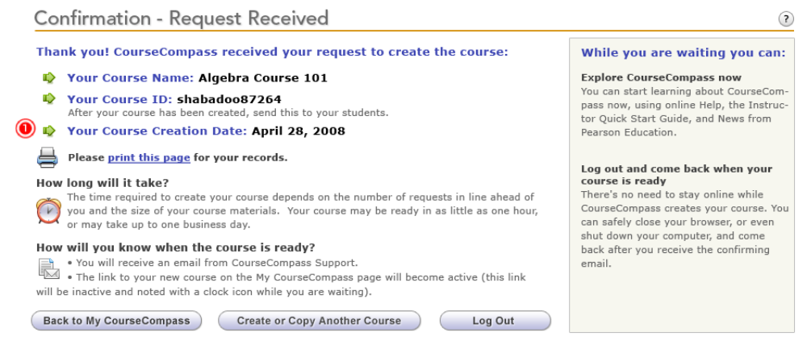

Course creation date will be displayed.

Course Details Page – For Student Enrollment Course Type
The following user types will see this My CourseCompass Course Catalog page layout – Users with CourseCompass Educator and Admin Subscriptions.
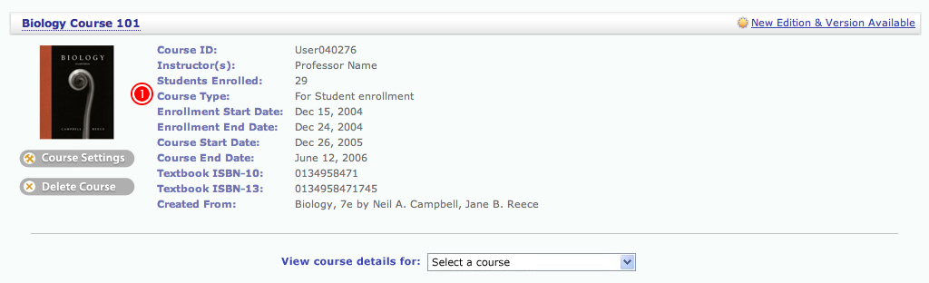
Course type will be displayed according to the descriptions on the course information page—For Student enrollment or For Instructor use only. If the course type is For Student enrollment, the enrollment start and end dates will appear. If the course type is set to For Instructor use only, the enrollment start and end dates will not appear.
NOTE: All other functionality has not changed from previous release.

Edit Course Dates Page– For Student Enrollment Course Type
The following user types will see this My CourseCompass Course Catalog page layout – Users with CourseCompass Educator and Admin Subscriptions.

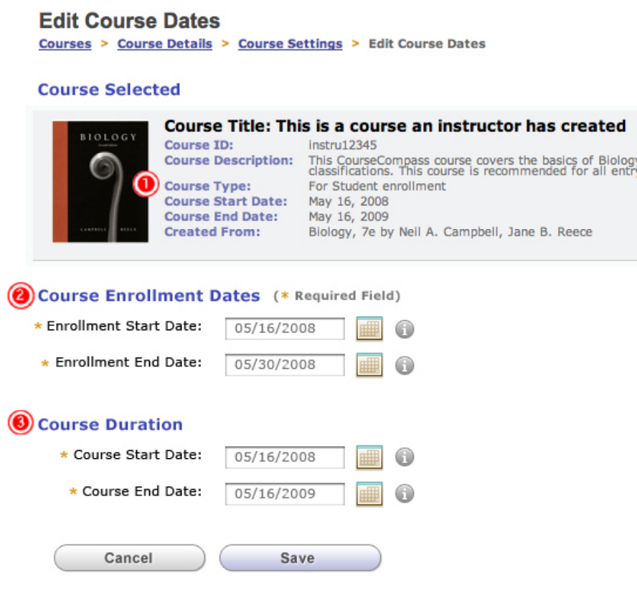
Course type will be displayed according to the descriptions on the course information page—For Student enrollment or For Instructor use only. NOTE: The addition of “Course Type” to the Course Details area must be made to all instances of this area, including but not limited to all instances in Course Settings and Course Catalog.
Course Enrollment Dates section functions the same as 1.3. NOTE: End date cannot exceed 15 months (450 days) from course creation date or 15 months (450 days) from the feature implementation date if the course was created before the lifecycle functionality was added. If the course type is For Instructor use only, the Course Enrollment Dates section will not be displayed. (See 2.7.1)
Course Duration section functions the same as 1.3. NOTE: End date cannot exceed 15 months (450 days) from course creation date or 15 months (450 days) from the feature implementation date if the course was created before the lifecycle functionality was added.
NOTE: All other functionality has not changed from previous release.

Edit Course Dates Page– For Instructor Use Only Course Type
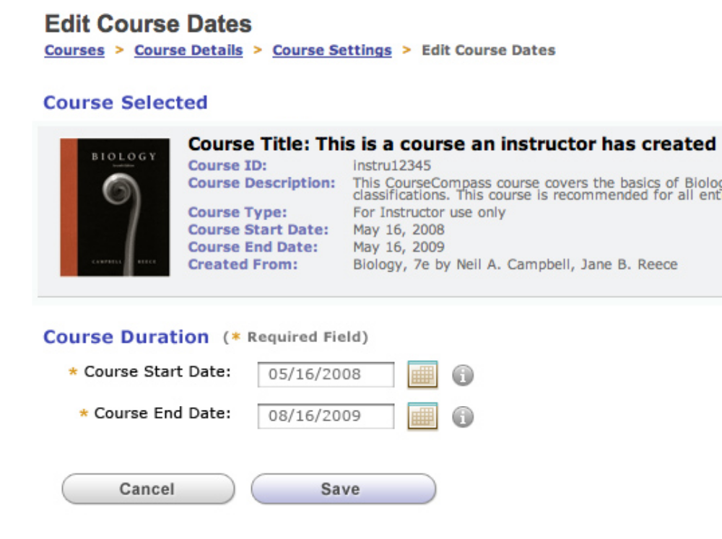

2.7.2 Edit Course Details Error Conditions - Fields marked in yellow are no longer applicable.
Course Detail Error Condition | Message Displayed (in a JavaScript pop-up with “OK” button to close.)
If the “Enrollment Start Date” is later than the “Enrollment End Date” | The Enrollment Start Date you entered is later than the Enrollment End Date. To fix this you must set the Enrollment Start Date to be later than the Enrollment End Date.
If the “Enrollment Start Date” is later than the “Course Start Date” | The Enrollment Start Date you entered is later than the Course Start Date. To fix this you must set the Enrollment Start Date to be earlier than the Course Start Date.
If the “Enrollment End Date” is later than the “Course End Date” | The Enrollment End Date you entered is later than the Course End Date. To fix this you must set the Enrollment End Date to be earlier than the Course End Date.
If the “Course End Date” is before the “Course Start Date” | The Course End Date you entered is later than the Course Start Date. To fix this you must set the Course End Date to be earlier than the Course Start Date.
If the “Course Start Date” is an invalid date | The Course Start Date you entered isn’t a real date. To fix this, go back and enter a valid date, or use the calendar to find a valid date.
If the “Course End Date” is an invalid date | The Course End Date you entered isn’t a real date. To fix this, go back and enter a valid date, or use the calendar to find a valid date.
If the “Enrollment Start Date” is an invalid date | The Course Enrollment Start Date you entered isn’t a real date. To fix this, go back and enter a valid date, or use the calendar to find a valid date.
If the “Enrollment End Date” is an invalid date | The Course Enrollment End Date you entered isn’t a real date. To fix this, go back and enter a valid date, or use the calendar to find a valid date.

Course Creation Confirmation Email – For Student Enrollment Course Type
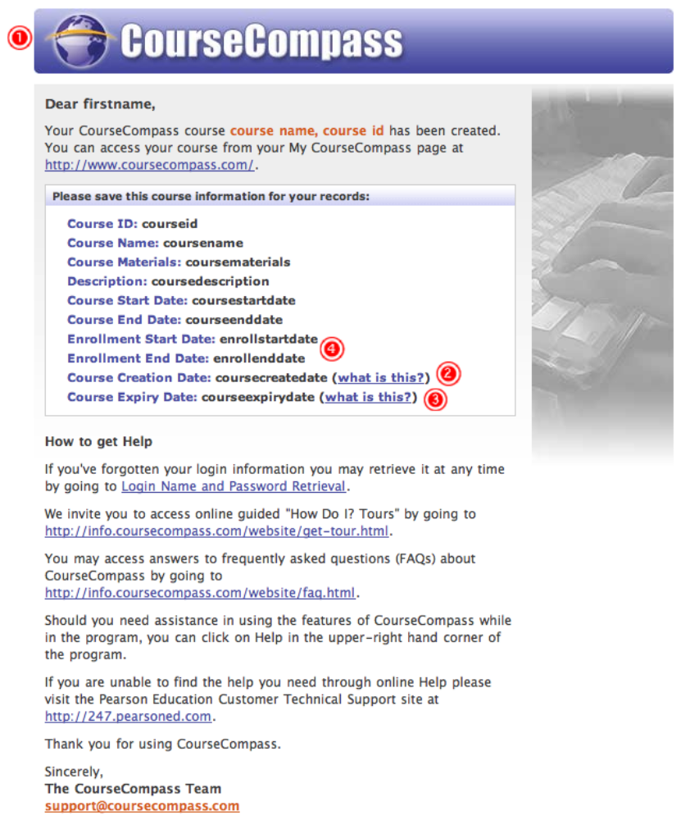
When a course has been successfully created, this email will be sent to the user, which lists the course ID, name, materials, description, course start and end dates, enrollment start and end dates, and course creation and expiry dates. NOTE: Error message will stay the same as current version.
“What is this?” links to http://info.coursecompass.com/html/course_create_date.html
“What is this?” links to http://info.coursecompass.com/html/course_expiry_date.html
The Enrollment Start and End Dates will appear in this email.

Course Creation Confirmation Email – For Instructor use only Course Type
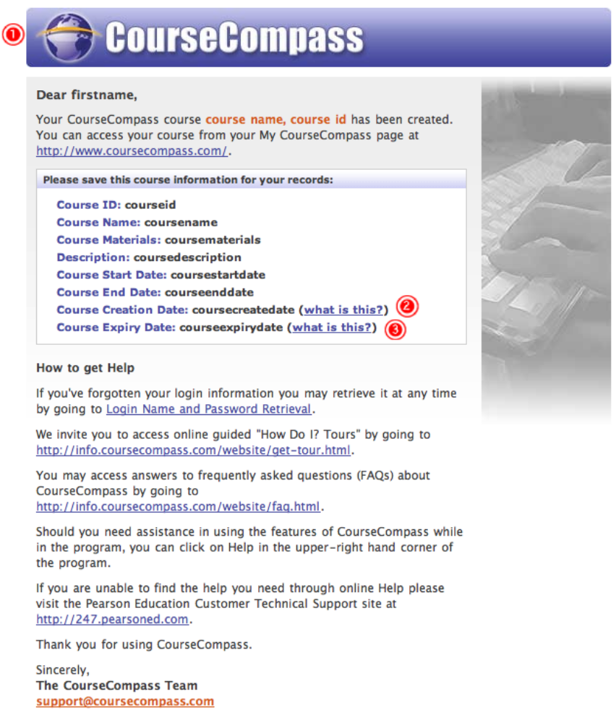
When a course has been successfully created, this email will be sent to the user, which lists the course ID, name, materials, description, course start and end dates, and course creation and expiry dates. NOTE: Error message will stay the same as current version. NOTE: This version of the email DOES NOT contain the Enrollment Start and End Dates.
“What is this?” links to http://info.coursecompass.com/html/course_create_date.html
“What is this?” links to http://info.coursecompass.com/html/course_expiry_date.html

