Portal Usability Summary
Version 2 - 10/20/05 - Prepared by Chatree Campiranon, Jim Chalex, and Brent Mundy

The purpose of this document is to summarize of the usability findings to date regarding the Portal project.
The findings in this document come from 6 sources:
- uPortal/Academus Usability Test and Review
- 3rd party portal sites Usability Test and Web Standards Review
- CourseCompass Course Creation Usability Test and Review

Table of Contents
Portal Usability Summary 1
Table of Contents 1
uPortal/Academus Usability Test and Review Findings 2
Browser “Back” Button Doesn’t Operate Properly 2
Intra-Portal Navigation Disorientation 3
Unconventional Portlet “Edit” Design = Too Many Clicks and Unfamiliar Interaction Model 5
Page Title Should Reflect Current Location 6
Add Content Page is Difficult to Use 6
Save Settings Button on “Edit” pages 7
Module Controls Confusing 8
Lack of Confirmation Messages 8
Fixed-Width Design Causes Horizontal Scrolling 8
Repositioning Portlets/Channels is Cumbersome 9
Minimizing Portlets Causes Page Refresh 10
Adding New Tabs Difficult to Locate 10
Naming Newly Created Tabs is Difficult 11
Terminology Improvements 11
“Detaching” Portlets/Channels not Useful 11
Manually “Focusing” Portlets not Useful 11
Portlet Sub-Tab Design 12
Iconic Representation of Layout Options Unclear 12
Parts of Left Navigation Redundant with Portlets/Channels 12
Dropdown Menus Useful, but Potentially Troublesome 13
Portlet Help Implemented Effectively 13
3rd Party Portal Sites Usability Test and Review Findings 14
Moving Modules 14
Adding & Editing Modules 15
“Focusing” on a Module 17
Module Icons and Options 18
Course Creation Usability Findings 19
Course Creation Process 19
General Recommendation: Implement a stepped process 19
Create a Course Page 21
Browse Course Materials 22
Create Course Confirmation 24
Adopting a Course 24
Appendix A – Leading Task Interaction Design Options for Web Applications 25
Hub-and-spoke 25
Wizard 26
Guide 26
(Modal) Secondary Window 26
In-line 26
Pros and Cons to Interaction Models 26

uPortal/Academus Usability Test and Review Findings
Academus has been used as a proxy for uPortal because there doesn’t appear to be a “standard” uPortal implementation. As such, in some cases the findings in this document pertain to Academus’ customizations of the uPortal platform. However, many of Academus’ customizations appear to be workarounds to remedy some of uPortal’s negative usability characteristics, so it is thought that by analyzing these customizations we are actually reviewing a “best-case” design of uPortal.
The findings in this section rely upon a usability test and review.

Browser “Back” Button Doesn’t Operate Properly

Problem
In certain circumstances, the browser’s “Back” button does not take the user back one page. Rather, it refreshes the current page exactly as it was displayed before. This is a significant usability issue: the “Back” button is the bedrock of a user’s browsing experience, and to have it rendered inoperable will cause serious usage issues.

Solution
Ensure that the browser’s “back” button operates properly.
Academus has implemented a “Return Home” navigation bar, available from all of their “focus” and “task spoke” pages to overcome this limitation. This is a valiant effort to mitigate the issue – and proved to be an somewhat effective stopgap in user testing – but still falls short of the expected and preferred approach from a user’s perspective, especially for the “focus” view. One of the problems with this approach is that the terminology “return home” is actually inaccurate because this link takes the user back to the tab from which they came, which may or may not be the “home” tab.
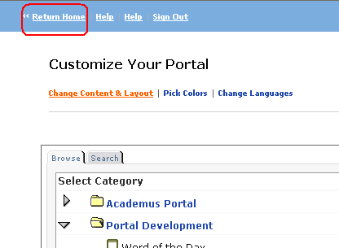

Intra-Portal Navigation Disorientation

Problem
The “focus view” – that is, when a user clicks into a portlet and is still on the Portal site – removes the global navigation (including tabs) and replaces it with a new navigational bar at the top of the page, on which the “Return Home” link is displayed that takes users back to the tab from which they came. (See previous issue regarding “Back” button.) The following screenshots illustrate this.
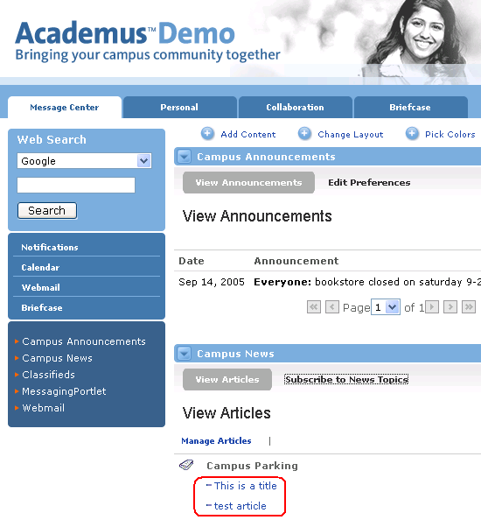 | 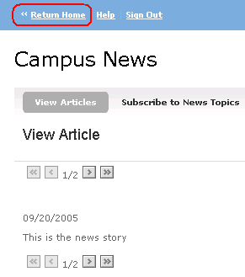
The “portal tab” view, in the Message Center Tab. When either of the two highlighted links is clicked, the user goes to… | …a “focus view” in which the portal navigation is removed and replaced with a “Return Home” link back to the portal view.

There are two problems with this approach:
- The user is disoriented, and forced to comprehend a new navigational concept for no apparent reason. Sites very seldom remove their global navigation like this; global navigation is one of a handful of visual and conceptual anchors that help users know where are in a web site.
- The user cannot easily navigate to other areas of the portal via global navigation. This is actually desirable when the user is completing a task (see appendix A) but for normal navigational links like the ones shown above, this is not desirable as it limits navigational flexibility. (For example, the user would need to click “Return Home” and then click a tab to go to another section of the site.)

Solution
Maintain the global navigation when the user clicks a link that spawns a “focus view.”

Unconventional Portlet “Edit” Design = Too Many Clicks and Unfamiliar Interaction Model

Problem
When the user attempts to edit a setting for a portlet from a tab page, the conventional interaction design choices used for most portal and non-portal web applications (see appendix A) are generally not followed. The following interaction diagram illustrates an example of this for the “Subscribe to News Topics” setting available from the “Message Center” tab.
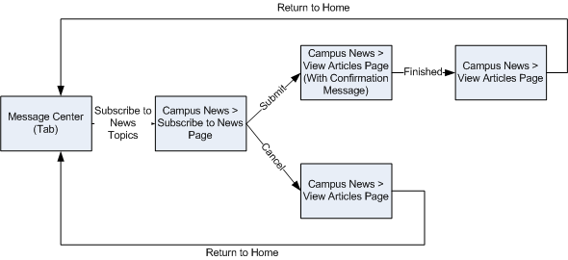
It should be noted that not all portlet settings are implemented in the fashion shown above. Some are modified “hub-and-spoke” (Add Content, for example) and others are “in-page interfaces” (Campus Announcements, for example).

Solution
In the abstract, there is no single best interaction design for editing portlet settings. The best approach for any given task must take into account the details of the task, which is to say that “it depends.” (See Appendix A for more discussion on this topic.)
The following options would all be preferable to the current behavior. It would also be ideal to choose one option so that the interaction design for editing portlet settings was consistent throughout the site.
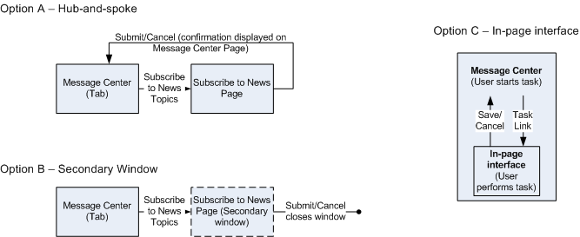

Page Title Should Reflect Current Location

Problem
There are no page titles implemented in Academus for the tab navigation pages. One of the most common visual anchors found on websites is a prominent page title in the top-left region of the page.

Solution
All pages on the portal should have a prominent page title. The browser window’s title should also include the page title.

Add Content Page is Difficult to Use

Problem
The interface for adding content was found to be difficult to use during user testing. Reasons for this include:
- Poor terminology used at the top-most directory (users didn’t know what would be “underneath” each category).
- Search was difficult to find and use (results are displayed in the category hierarchy instead of simply showing individual results).
- After clicking “subscribe to channel” users expected to go back to the tab page from which they came, but instead were taken back to the “Customize Your Portal” page.
- The “Save Settings” button was missed by most users.
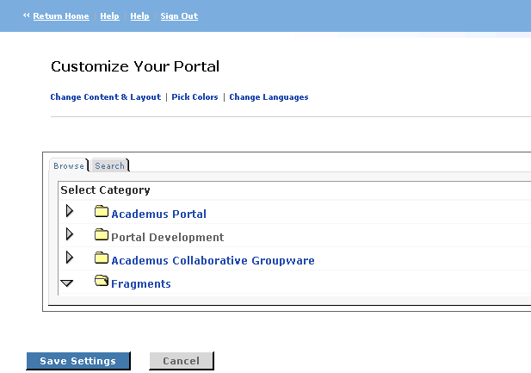

Solution
- Improve terminology for categories of content. Perform a “card sort” usability test to ensure that the terminology and directory structure matches user expectation.
- Increase prominence of search, and change the results interface so that instead of seeing the entire list of channels (with results highlighted) only results are displayed.
- When user clicks “Subscribe to channel” take the user back to the tab page (ideally with a confirmation message).
- Use a term other than “Subscribe to channel”, such as “Add to my page.”
- Make the “Save Settings” button more prominent (or possibly remove it) so that users are not required to find it in the first place (make all changes automatically saved upon returning to the tab page.)
- More generally, it may make sense to put this entire interface in a pop-up window. Results from several studies indicate that a large majority of users prefer this approach.

Save Settings Button on “Edit” pages

Problem
In general, users either missed or were bothered by the fact that they had to remember to save changes. If users don’t perform this action, their changes are lost and they must redo the change.

Solution
- Put “Save Settings” and “Cancel” buttons at the top and bottom of the page.
- Make these buttons more prominent.
- Avoid this problem altogether by implementing “edit” pages using another design, e.g. secondary window or in-page interface.

Module Controls Confusing

Problem
The module controls used in Academus were confusing to users, and all users tested in the Academus study preferred to see “windows-style” icons. This is consistent with the 3rd party portal study.

Solution
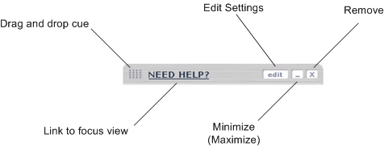
Note that there is some evidence to suggest that the entire bar (excluding links and buttons) should be made “hot” in order to allow users to drag-and-drop the module.

Lack of Confirmation Messages

Problem
With Academus’ interaction design approaches, the user generally does not receive notification when changes were made. When confirmation messages are provided, they are typically not prominent enough.

Solution
A confirmation message is an important aspect of any web applications’ interaction model: it tells the user, in effect, that “the task you just attempted to complete was successful, and you may go on to perform another task.”
It is worth noting that Google’s Portal (covered in the 3rd party usability section of this document) includes an undo option. Usability findings were mixed on the value of this functionality, but this is potentially useful and should be tested further.

Fixed-Width Design Causes Horizontal Scrolling

Problem
A fixed width design is employed for certain sections of the Academus site. This causes horizontal scrolling to occur in (a) the main browser window (as shown below) and (b) in iFrames under certain circumstances. Both of these problems occur at common screen resolutions of 800x600 and 1024x768 (accounting for approximately 85% of Internet users).
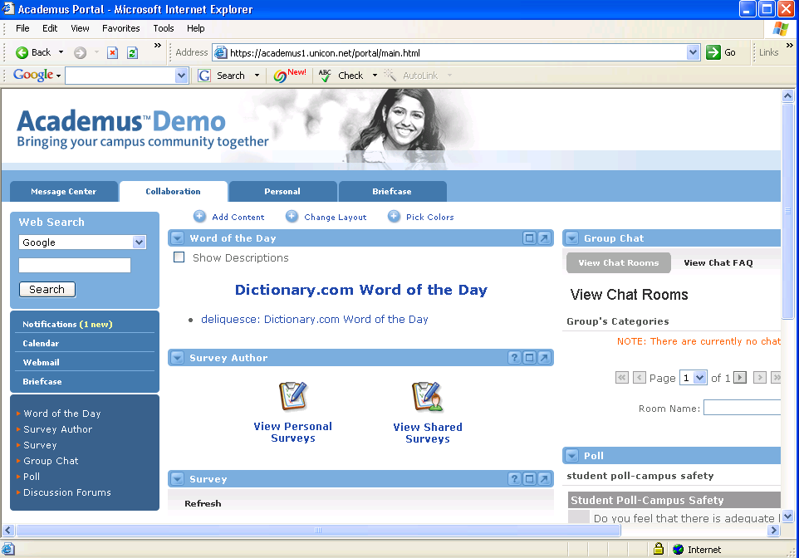
More research is required to determine if this is the result of the way in which Academus is designed, or some kind of underlying uPortal limitation.

Solution
Don’t design portlets that are fixed width; always design portlets as “liquid” so that they wrap gracefully irrespective of the browser window’s dimensions.

Repositioning Portlets/Channels is Cumbersome

Problem
In order to move a portlet, the user must (a) click the “Change Layout” button, (b) go to a secondary interface to move the module, (c) save the changes, and (d) return to the tab. Some users in the usability study had difficulty even finding this option.

Solution
A better approach would be to provide controls on the module itself to allow repositioning. These could include drag-and-drop, “layer menus”, etc. A layer menu approach (as implemented on My MSN) is shown below.
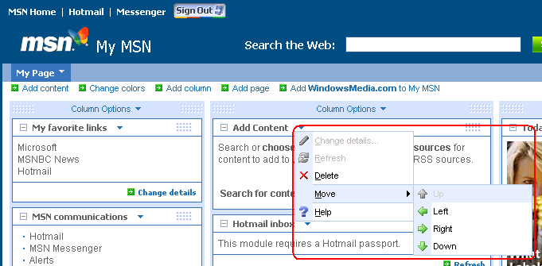

Minimizing Portlets Causes Page Refresh

Problem
When a portlet is minimized, the entire tab page refreshes to show the change. This causes two problems:
- This page refresh causes the user to lose their focus, causing momentary disorientation.
- If a minimized channel/portlet is “below the fold” then the page refresh jumps to the top, which is an annoyance (the user must scroll down to find the affected channel/portlet).

Solution
Refresh only the channel/portlet in question and have the page maintain its position.

Adding New Tabs Difficult to Locate

Problem
Some users had trouble finding the “Add New Tab” option, which is accessed by clicking on the “Change Layout” link.
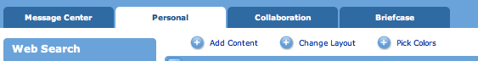

Solution
Add a more explicit link to “Add a Tab” on the main interface in line with the other options (Add Content, Change Layout, and Pick Colors).

Naming Newly Created Tabs is Difficult

Problem
Users had little or no trouble adding a new tab to their portal in the Academus study, but they did have problems renaming the tab. The reason for this appears to be the proximity of the tab to the rename link.
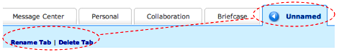

Solution
- When a user creates a tab, force them to provide a name immediately.
- Move the “rename tab” closer to the unnamed tab.

Terminology Improvements
- 7 out of 7 users did not like “Focus.” They preferred “Maximize” or “Full screen.”
- 7 out of 7 users did not like “Channel.” They preferred “Content” or “Section.” One user suggested “Topic.”
- 7 out of 7 users did not like “Subscribe.” They preferred “Add.”
- 6 out of 7 users did not like “Detach.” They preferred “New windows” or something similar.

“Detaching” Portlets/Channels not Useful

Problem
The detach function — which shows the respective channel/portlet in a new browser window — is not thought to be especially useful.

Solution
There may be little harm in displaying this feature, but to minimize information clutter, it is recommended that we do not implement this feature.

Manually “Focusing” Portlets not Useful

Problem
The focus link — which shows the respective portlet in the same browser window, but in the “focus” interface — is not thought to be especially useful.

Solution
It is recommended that focus not be made an option at the top of the portlet/channel simply to replicate the content in a focus view. Focusing is something that should happen more naturally and transparently in the context of a particular portlet/channel.

Portlet Sub-Tab Design

Problem
The Academus design for selected sub-tabs was not intuitive to many users.
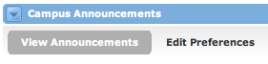

Solution
Make sub-tabs actually look like tabs to clarify their function.

Iconic Representation of Layout Options Unclear

Problem
Most users did not understand the column layout option icons. Some users preferred to be able to click and drag to resize column (as in My MSN). Some users commented that there should be a clearer caption for these icons rather than just the ALT text. See the picture below for current implementation in Academus:


Solution
Each icon should be redesigned, and there should be a clearer explanation near each option. Also, the “currently selected” state should be made more obvious.

Parts of Left Navigation Redundant with Portlets/Channels

Problem
6 out of 7 users commented that the portlet list in the left column is redundant with the contents of the page. The “Web Search” was thought to be useful by most users.
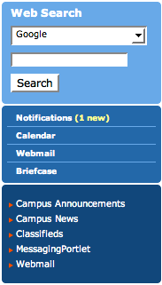

Solution
Remove left navigation, and include search functionality as an individual portlet, if desired.

Dropdown Menus Useful, but Potentially Troublesome

Problem
Most users liked the dropdown menus on each tab because they took them directly to a portlet without accessing the tab. But the dropdown bothered some users when they accidentally moved the mouse over the tab and the dropdown obscured the link that they actually wanted to click.
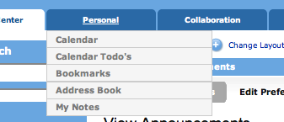

Solution
Ensure that the design of the tabs, dropdowns, and links avoid this problem by moving the links over to the right, or elsewhere where they don’t conflict with the tab and dropdown.

Portlet Help Implemented Effectively
The help icon available at the top right of all channels/portlets opens a secondary browser window (without browser controls) and jumps to the appropriate help section within the help documentation for the site. The aesthetic design of the help system mirrors that of the portal itself. All of these things are well done, and we should strive to follow this approach for our own portal online help functionality.
One minor improvement would be to add a “Close this window” button to the secondary window.

3rd Party Portal Sites Usability Test and Review Findings
The findings in this section rely upon a usability test and review.

Moving Modules
When asked to move a module, all users tried to drag-and-drop first. Most users preferred the drag-and-drop approach because it is similar to Windows OS manipulation. If drag-and-drop is implemented, the following design guidelines should be considered:
- Use a darker/different color bar at the top of module.
- On mouse-over, the cursor’s shape should change to a hand or move sign so that users will know that the module can be dragged.
- When something is being dragged, a silhouette or lightened version of the module should persist beneath the cursor.
- When the module being dragged is in a location where it can be dropped, the potential destination should be highlighted. Ideally, a lighter version of the module should be dragged visibly, and “snap” into place before the user unclicks in order to show how the module would look in its new location. Google’s portal uses this approach:
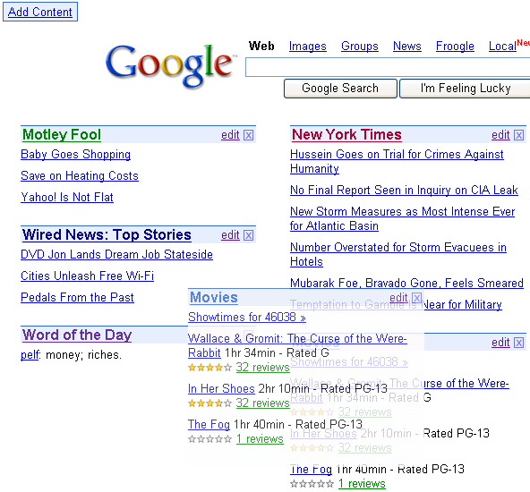
It should be noted that some users preferred not to use drag-and-drop because it does not work well when they want to drag a module up or down on a scrolling page. For example, one user had to perform this action in multiple steps: (a) drop the module, (b) scroll down the scroll bar, (c) drag the module again, and (d) drop it to a designated area. Another user used the mouse’s scrolling wheel to scroll the page while dragging a module.
Also, the portal standards research found that:
- 4 of 7 sites used drag-and-drop (2 from primary page, 2 from secondary page)
- 3 of 7 sites didn’t use drag and drop.

Adding & Editing Modules
When asked to add or edit a module, no users preferred to go to a separate page (e.g. My Yahoo and My Excite). Four out of six users preferred using a secondary window (e.g. My MSN), and two out of six users preferred in-line editing (e.g. Google).
Generally speaking, secondary windows are not a preferred choice for interaction designs for a number of reasons, but for this task it seemed to work well. My MSN uses secondary windows to add or edit modules, and most users liked this approach because they could see their current page behind a smaller secondary window. When the secondary window was shown, users could not click and activate the current page; they could only interact with the secondary window. In all of the usability sessions, no users noticed or had problems with this and they knew that they had to interact with the secondary window first before going back to the portal page. See picture below for an example of My MSN’s pop up windows:
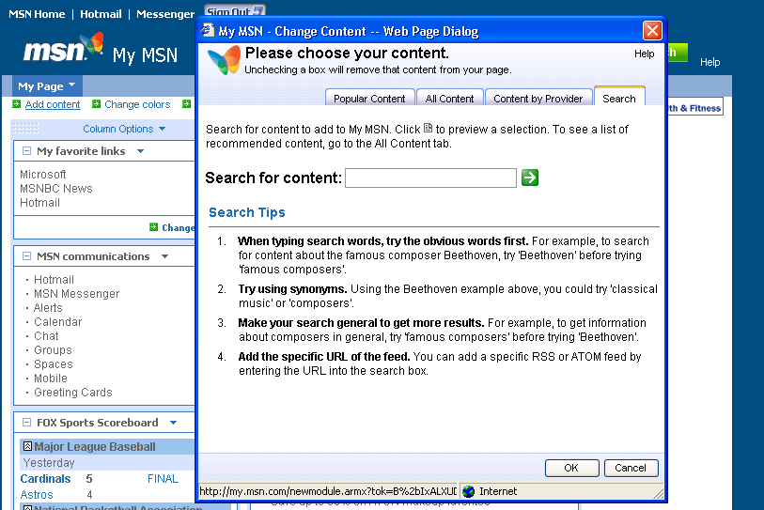
Google’s portal provides an alternative to the secondary window approach by allowing users to add or edit contents from within the current page, i.e. “in-line” editing. Some users liked the way Google slides available contents from the left side of the screen, but some users did not like this. One user mentioned that it is “too interactive” for the Web. Another disadvantage of putting add or edit options in the current page is that there are inherent space restrictions.
The following screenshot illustrates the “Add Content” design:

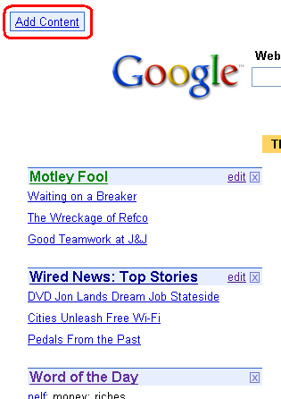 | 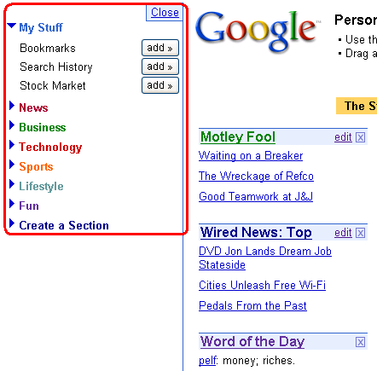
The Google main page. If a user clicks the “Add Content” link… | …an in-line “editing pane” slides open from the left-hand side of the screen. Multiple modules can be added, and the editing pane can be closed manually.

Many users had problems finding a module when it is placed in a category that they did not expect. For example, Google’s “My Stocks” module is under the “My Stuff” category, but some users expected it to be under the “Business” category. This was similar to the problem noted in the Academus section of this document. A good idea to help prevent this issue is to provide a duplicative list of popular modules so users have a better chance of finding and selecting some of them right away.
Another example of Google’s “in-line” editing approach is shown in the following screenshot, which illustrates Google’s “edit module” design:

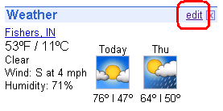 | 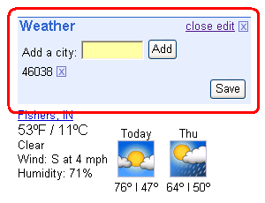
A module on Google. When the “edit” button is clicked… | …the page does not refresh, and an in-line ”editing pane” opens up.

Once users successfully added a module, most of them tried to find the added module; in general users had a hard time figuring out which column the module would be added to. One way to combat this problem is to follow an approach similar to what My MSN and My Yahoo have done: provide extra “Add content” buttons at the bottom of each column. In this approach, a module is added to the respective column for which the “Add content” link has been clicked. See picture below:
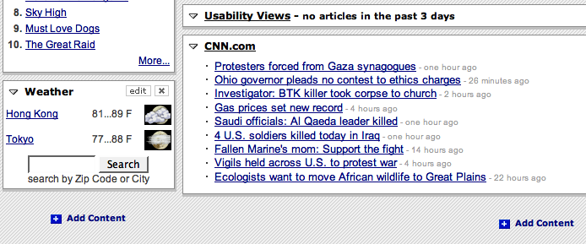

“Focusing” on a Module
Before the day of user testing, Google changed the way that users could “focus” on a particular module: previously, they had a “Go to…” link at the bottom right of the module, but they changed to linking the title of the module. See differences below:
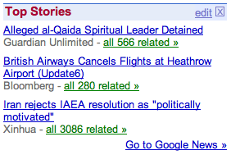← Before 8/16/05
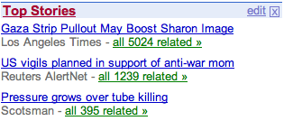 ← Since 8/16/05
Four of six users completed this task right away by clicking the module title. Two users could not find a link to focus on the module. The problem appears to be that the module title’s name is not self-explanatory. For example, “My News” or “Top Stories” were thought to be customized pages of news or headlines, but in fact these actually link to the entire news section of Google’s site, which was not expected.
Two out of six users preferred a “more…” link at the bottom of the module because they were confused by the misleading title and they did not realize that the title could be clicked. A “more…” link would work fine with modules like “News” or “Announcements” but it might not work for other complicated modules like “My Courses.”
Overall, linking the title appears to be the best choice to focus on a module, but it is important to avoid misleading titles that could confuse users. Also, underlining the title will assist users to understand that it is a link. Finally, it may be best to employ both options to ensure that users can focus on a module easily.

Module Icons and Options
Five out of six users liked module options such as minimize/maximize/close that are exactly the same as Windows OS icons, and those icons should be placed at the top-right of the module. Many users spent a longer time trying to minimize a module when the icon was at the top-left of the module. The My Excite interface was preferred overall. See picture below:
Most portals placed an “edit” button next to a minimize button, and most of them use the word “edit” instead of an icon. The word “edit” and the “Windows-like” minimize and close buttons in the picture above from Excite were effective and self-explanatory, and all users could perform tasks related to these buttons easily. An example of the preferred approach for module icons is also explained in the Academus section of this document.

Course Creation Usability Findings
The findings in this section rely upon a usability test and review.

Course Creation Process
The current course creation process (in CourseCompass) is shown below:
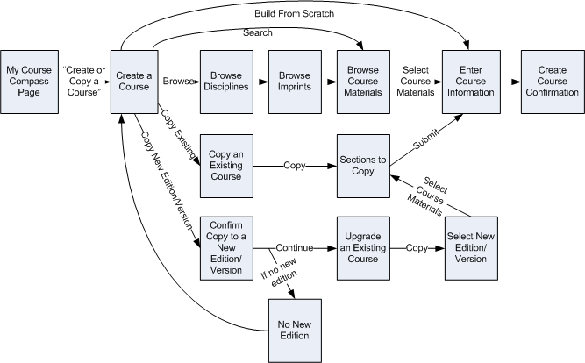

General Recommendation: Implement a stepped process
Stepped processes help users maintain focus on the task at hand, and provide a sense for how long a process is and much farther they have to go. It is recommended that the course creation process become a stepped process.
The first page, “Create a Course,” would not be counted as a step. After the user has selected one of the course creation options, the stepped process will start. The various processes based on current pages are shown below:
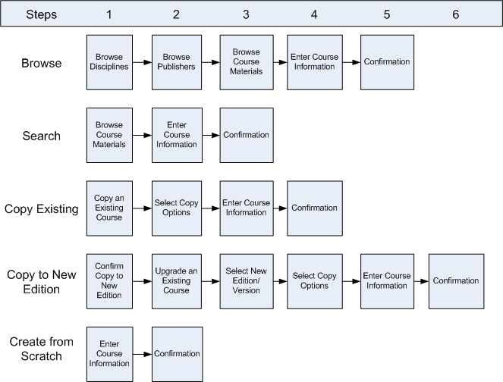
The following factors should be taken into account as we go about designing a new stepped process:
- Add progress bar. This should show all of the steps in the process, indicating where the user is, and how far she has to go. (Note that the crumbtrail should be removed from these pages.) The progress bar should be navigable, allowing the user to go to any previously viewed step in the process at any time.
- Consistent action buttons. The button to proceed to the next step should be consistent in format, more prominent, and always above the fold at a screen resolution of 800x600, if possible.
- Going backwards. There will not be an explicit “Back” button provided in the UI, but the user must be able to use the browser “Back” button and the progress bar to go back to a previous page.
- Remove global navigation. Global navigation can effectively act as a “cancel” button if the user is in the middle of creating a course, and clicks on global navigation before finishing the task. For this reason, the removal of the global navigation of Portal should be considered. Further user testing should be conducted to determine if the removal of global navigation is noticed by users, and if it is perceived to be a problem. If the removal is thought to be a problem, it may be possible to include an “are you sure…” secondary window if the user attempts to click on the global navigation from these pages.
- Going forwards. The user will be forced to select an “action button” to go to the next step in the process. The progress bar will not allow the user to move forward in the process.
- Remove as many steps as possible. Processes should contain the fewest number of steps possible. It is thought that several processes can have steps removed. For example: The “Copy to a new edition” process may not need the initial confirmation page; The “Browse” process may not need the “Imprint” selection page.
- Simplify information on each page. The goal of these processes is to move the user through as fast as possible with the fewest number of errors. To this end, superfluous information should be removed. Two examples of this are the “Browse Course Materials” page, and the “Enter Course Information” page, which both have non-essential information.
- Conditionally display “Copy to a new edition” from the “Create a Course” page. We should show this option only if the user has at least one course with a new edition available. This would remove the need for a “No New Edition” page in the process.

Create a Course Page
The design for this page is clever (incorporating a compass metaphor into the navigation) but comes at the expense of a clear prioritization of course creation methods, and the ability to scan the page efficiently.
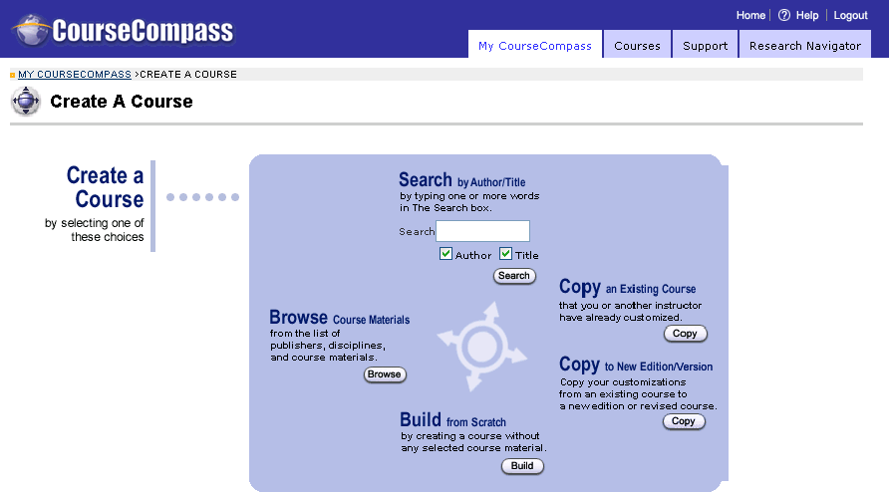
- It is recommended that we group the four main methods into distinct visual categories that are evenly aligned:
  - Search
  - Browse
  - Copy
  - Build
- The search operation should allow the user to find courses based on the ISBNs associated with courses materials.

Browse Course Materials
The following recommendations apply to this page, which is used when the user either (a) searches for a course, or (b) browses for a course:
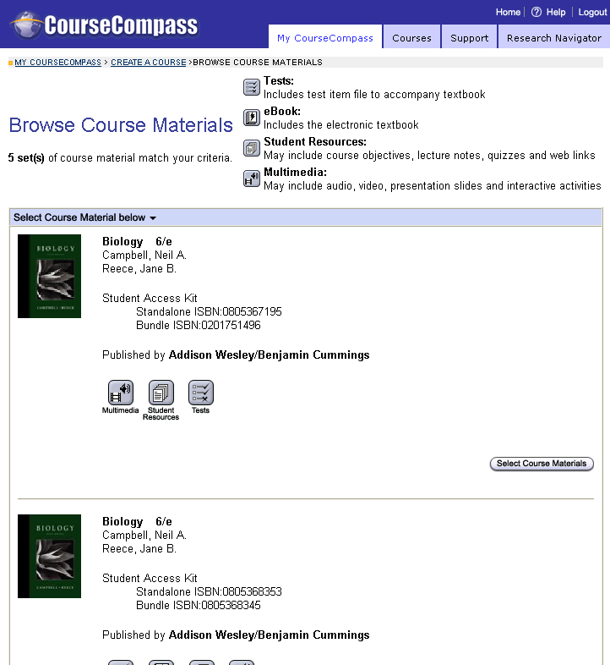
- Combine multiple courses with the same textbook. A serious usability issue currently exists regarding courses materials that have the same textbook, and are similarly named (e.g. e-book editions.) A fair number of users select the wrong course materials, resulting in access code mismatches. (The screenshot above shows an example of this problem: scrolling down the page, most users would likely select the first book that matches their title and/or cover. If the user actually saw both versions, it would not be immediately clear how they differ from one another.)
- Customize pages between “Search” and “Browse”. Presently the search and browse paths both use the same template. A better approach would be to customize each template. For example, search should include another search textbox at the top of the page to allow users to search again, or refine their search, if necessary.
- “Select Course Materials” button prominence. The primary action on the page is to select the course materials. Because of this, it is recommended that this button be larger and placed closer to the course information.
- Content icons. Most of the internal stakeholders and usability test participants interviewed felt that the content icons had little or no value. Assuming that further usability testing confirms this, it will be recommended that the content icons be removed.
Note: If this recommendation is followed, the “E-book” icon MUST be retained if the previous recommendation regarding combining course materials is not followed.
- Use of vertical space. The current design uses screen real-estate inefficiently, resulting in more vertical scrolling than would otherwise be necessary. A new design of this page should strive to conserve vertical page space as much as possible.
- Include sorting options. If the user is confronted with a long list of courses (e.g. from the “browse” path), it would be helpful to allow the user to (a) know the current sort order and (b) re-sort the courses based on their preference.
- Include contextual help links for “Standalone ISBN” and “Bundle ISBN”. These ISBNs are important to the success of student enrollment, but some users may not understand their importance or meaning.

Create Course Confirmation
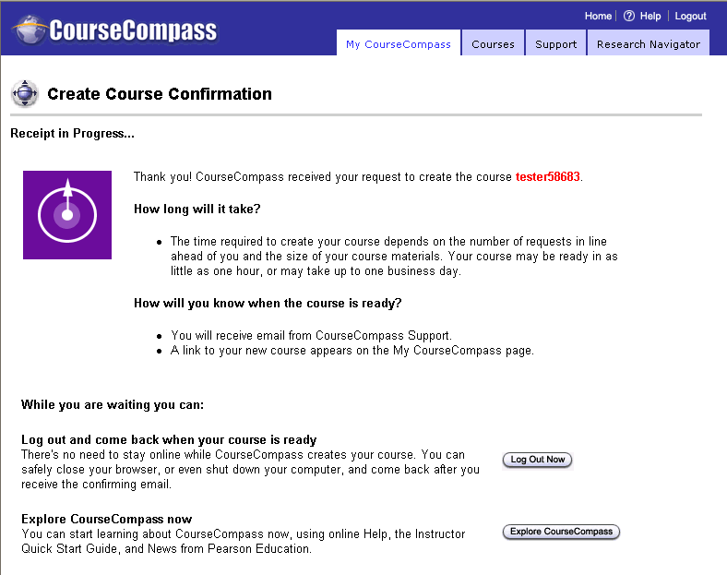
- Clarify what “Receipt In Progress” means. The wording on this page should be changed to make this “soft-creation” more understandable.
- Tell users at the beginning of the course creation process that course won’t be created right away. Users who have gone through this process have expressed surprise that their courses wouldn’t be available right away. Given this reality, it would be best to inform users up-front (e.g. on the “Create a Course” page) so that the proper user expectation is established.

Adopting a Course

Problem
None of the users tested elected to “Adopt” their course after they finished building it. When they clicked back to their main account page from the course creation confirmation page they were presented the “My Courses” box. Universally, they would click on the title of the course to see what was contained within it. Only one user went back and noticed that an additional step was needed in order to make their course available to their students.
There could be two reasons for this oversight:
- Most of the users had some sort of Blackboard experience. Blackboard does not include an “Adopt” step. As a result, it is possible that users thought that CourseCompass was more like Blackboard in this regard than it actually is.
- When the user returns to this page after creating their course, they are presented with the same “My Courses” module, but this time it has an additional element appended to it, the “Courses you are previewing” section. Within this section are the directions regarding the next step to make the course available to students, but the most dominant item is the title of the course. This title is something the user determines on their own, so it is immediately recognizable (and likely more desirable to click).
Solution
Remove the preview option entirely. This would mean that after creating a course, it would be displayed in the “courses you are teaching” section, and the “courses you are previewing” would simply go away. In order to make the course available to students, the instructors must communicate the course ID. This key task could be communicated to instructors in multiple places to ensure compliance: on the module, the course creation confirmation page, the confirmation e-mail, etc.

Appendix A – Leading Task Interaction Design Options for Web Applications
There are five leading approaches for how to let users to perform tasks in a web application. These five approaches are actually all variations on the first approach, which is called a “hub-and-spoke.”
In light of the examples shown below, in Academus, the “Hubs” are the various portal tab pages (Message Center, Personal, Collaboration, Briefcase) and the “Spokes” are the various portlet editing pages.

Hub-and-spoke
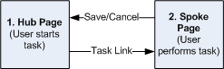

Wizard
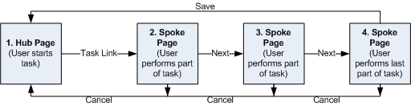

Guide
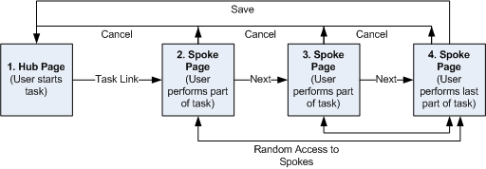

(Modal) Secondary Window
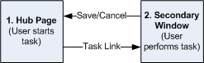

In-line
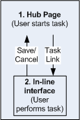

Pros and Cons to Interaction Models
These five approaches have some positive and negative aspects:
Interaction Model | Positives | Negatives
Hub-and-spoke | - Provides more space on secondary page in the same browser window, making more complex task interfaces easier to design/display. | - Removes user from the hub to which they are making a change, reducing contextualization.  - Difficult to implement modally, i.e. forcing the user to complete the action or cancel, because of “back” button and global site navigation, if made present. This increases the risk of users losing changes.  - More time on task because of separate page loading, reorientation, etc.
Wizard | - Provides a sequential path, which helps users visualize process  - Steps can follow a pre-determined decision tree  - Breaks up complex tasks into smaller, more manageable parts. | - Doesn’t allow the user the ability to complete a task in a non-sequential way.  - Requires more page-loads and clicks, which increase time on task, and further separate it from the hub.
Guide | - Provides a sequential path  - Allows the user more flexibility to complete in a non-sequential way. | - Too much flexibility can cause confusion, and make completing tasks more difficult.  - Requires more page-loads and clicks, which increase time on task, and further separate it from the hub.
(Modal) secondary window | - Maintains the context of the hub while allowing user to perform task in secondary window.  - Modality is more possible (albeit imperfect on some browsers) thus forcing user to interact with secondary window before returning to the hub.  - Familiar mental model consistent with how many desktop applications behave. | - Opening secondary windows is not a user-specified event, which can cause disorientation/confusion.  - While unlikely, default settings for pop-up blockers may prevent from functioning properly. User-defined settings for pop-up blockers could easily prevent from functioning properly.  - If not made modal, user can navigate away from secondary window without completing the task.  - Hard to control where secondary window will open with respect to the primary window.  - Hard to predict size of secondary window with respect to size of primary window.
In-page Interface | - Maintains the context of the hub effectively. | - Limited amount of space can make presentation of content more difficult.  - If page must refresh to show in-line view, disorientation is likely.

