File Upload - Functional Specification

August 25, 2011

Document Version History
Version | Date | Author(s) | Notes
1.0 | 1/20/10 | Andy Trus | Initial version of File Upload
1.1 | 2/3/10 | Andy Trus | Updated prototypes to include progress bar, show and hide, and other functionality.
1.2 | 2/25/10 | Andy Trus | Includes changes to the show/hide feature, properties, location of lightboxes, and many other changes to the interface.
1.3 | 4/1/10 | Andy Trus | Returned to lightbox design, added legal, and made many other changes
1.4 | 4/12/10 | Andy Trus | Updated character limit from 48 to 42 on all files and folders
1.5 | 4/23/10 | Andy Trus | Updated legal box within file upload form and replace file conditions.
1.6 | 4/28/10 | Andy Trus | Added exact legal text
1.7 | 5/7/10 | Andy Trus | Included minor changes to the upload screen, coordinator icons, and copy functionality
1.8 | 5/12/10 | Andy Trus | Copy file/folder tree updated.
1.9 | 5/18/10 | Andy Trus | Copy language and lightbox size and location
2.0 | 5/28/10 | Andy Trus | Added Help URLs and changed help behavior
2.1 | 6/8/10 | Andy Trus | Duplicate folder text changes
2.2 | 6/15/10 | Craig Marcus | Updated image 2.1.4, and text changes in B-1 and C-2
2.3 | 6/22/10 | Andy Trus | Added in links to down pages
2.4 | 8/10/2011 | Megan Higginbotham | Specs updated per US38565; Need to update mock-ups to remove tab-based design to the new drop-down menu design, add new file type icons, add updated icons for New Folder, Upload File & updated context menu
2.5 | 8/12/2011 | Katie Daggett | Updated Student View and made changes to 8/10/11 version
2.6 | 8/25/2011 | M. Higginbotham | Formatting updates

Open Questions/Issues
ID | Status | Question/Issue | Resolution
1 | Open | How will we handle scenarios where we have too many tabs to fit across the lightbox? | Per update to specs in version 2.4, we will switch from tabs to a drop-down menu to alleviate this issue.
Table of Contents

1. File Upload Overview 5
1.1. File Upload Description 5
1.2. General Layout and Behavior 5
1.3. Down Pages 5
2. Folders and Drop-down Menu 6
2.1. Prototypes 6
2.1.1. MathXL – Logged In, but Not Within Course Documents 6
2.1.2. Platform Folder – Member, Media not enabled 7
2.1.3. Platform Folder – Coordinator, Media not enabled 7
2.1.4. Initial State, Media not enabled 8
2.1.5. Course Folder 8
2.1.6. File or Folder Commands cMenu – Read/Write Access, Media not enabled 10
2.1.7. File or Folder Commands cMenu – Read Only Access, Media not enabled 10
2.1.8. Read Only Course Files, Media not enabled 11
2.1.9. Subscription to Only 1 Platform, Media not enabled 11
2.2. Elements 12
3. Upload Document File 19
3.1. Prototypes 19
3.1.1. Initial State: Documents 19
3.1.2. Uploading Progress Bar: Documents 19
3.2. Elements 20
4. File and Folder Management 25
4.1. Prototypes 25
4.1.1. New Folder 25
4.1.2. Delete a Folder 25
4.1.3. Delete a File 26
4.1.4. Copy a File or Folder 26
4.1.5. File Properties – Full Access 27
4.1.6. File Properties – Read Only Access 28
4.1.7. Folder Properties – Full Access 29
4.1.8. Folder Properties – Read-Only Access 29
4.2. Elements 30
5. Media File Management 36
5.1. Prototype 36
5.1.1. Initial State 36
5.2. Elements 37
6. Upload Media File 42
6.1. Prototypes 42
6.1.1. Initial State: Media 42
6.1.2. Uploading Progress Bar: Media RON – New Image with messaging for Large File Upload 43
6.2. Elements 43
7. Record File 44
7.1. Prototype 44
7.1.1. Initial State 44
7.2. Elements 45
8. Student View 48
8.1. Prototype 48
8.1.1. View Documents 48
8.1.2. View Media 49
8.2. Elements [RON – Images needed for 2 items here] 50

File Upload Overview

File Upload Description
The file upload service will provide an opportunity for instructors to upload files to share with their students. Within the service, they’ll be able to upload files, manage files, and more. Students will not have access to any of the management features, but will be able to view the files once the instructor makes them available. This document outlines all functionality contained in MathXL, and will outline all functionality contained in Portal in the future.

General Layout and Behavior
The design of the File Upload box should be in a lightbox and have a minimum width of 400 pixels and the ability to expand according to its content up to a maximum width of 800 pixels. The height of the box should have a minimum height of 300 pixels and the ability to expand according to its content up to a maximum height of 600 pixels. The position of the box should be 102 pixels from the top of the screen, and centered.

After 60 minutes of inactivity, the session for the File Upload service should time out. The user should receive the error message, “Your session has timed out because of inactivity. Click Course Documents to re-launch the Course Documents window.”

This box will contain a drop-down menu should the user have subscriptions to 2 or more different products. All prototypes below are presented as if the user has a subscription to MathXL and MyAccountingLab, but the design of the tool is explained should the user only have 1 subscription.

Down Pages
All service down pages should be called from the media server. Links to these pages can be found below:

Dev:
http://mediadev.pearsoncmg.com/cmg/offline/fileupload/planned.html
http://mediadev.pearsoncmg.com/cmg/offline/fileupload/unplanned.html
Production:
http://media.pearsoncmg.com/cmg/offline/fileupload/planned.html
http://media.pearsoncmg.com/cmg/offline/fileupload/unplanned.html

Folders and Drop-down Menu

Prototypes

MathXL – Logged In, but Not Within Course Documents
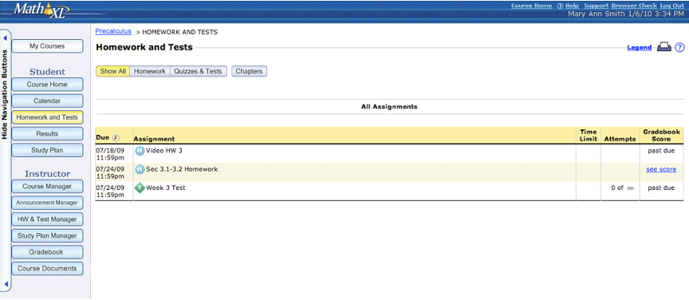

Platform Folder – Member, Media not enabled
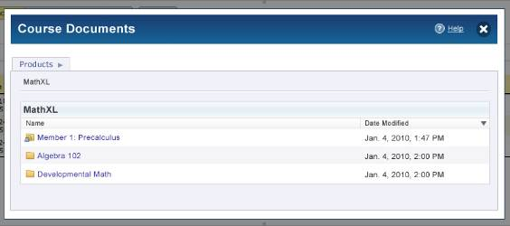

Platform Folder – Coordinator, Media not enabled
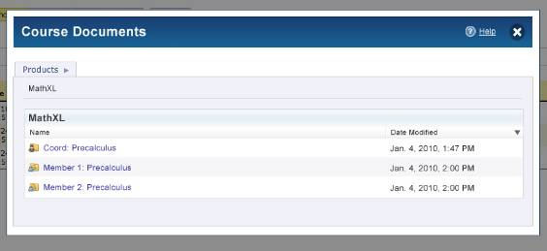

Initial State, Media not enabled
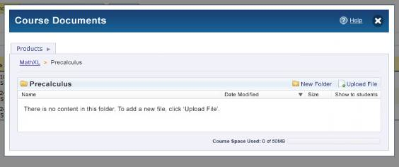

Course Folder

V1 (XL):
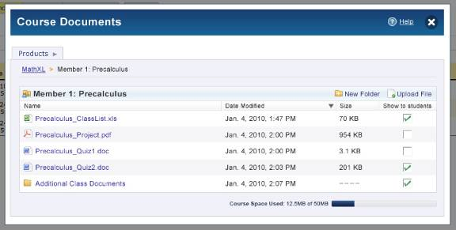

V2 (Mastering):
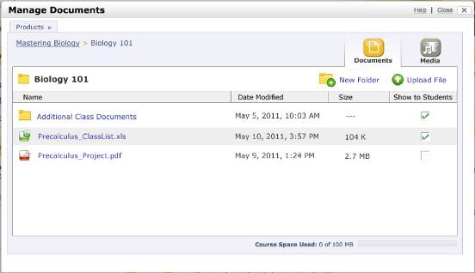

File or Folder Commands cMenu – Read/Write Access, Media not enabled
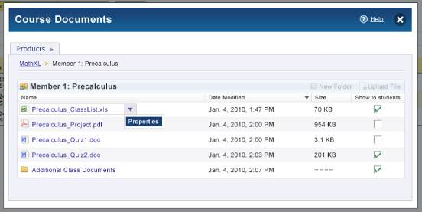

File or Folder Commands cMenu – Read Only Access, Media not enabled
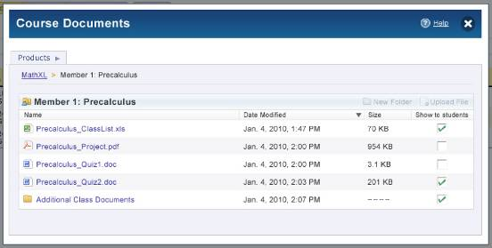

Read Only Course Files, Media not enabled
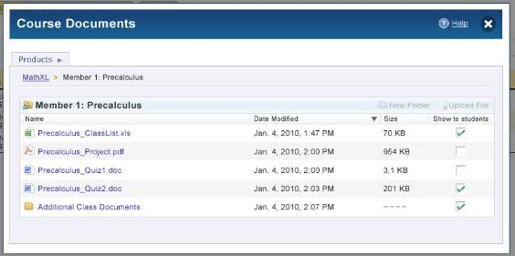

Subscription to Only 1 Platform, Media not enabled
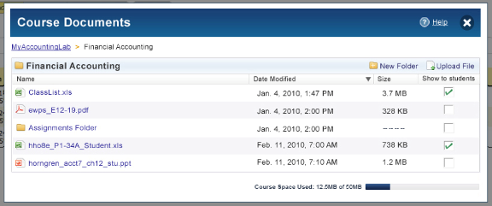

Elements
ID | Element | Behavior
B-1 | Platform Menu  Dropdown:  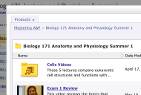  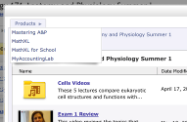  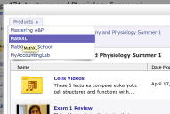 | - For instructors with subscriptions to at least 2 platforms, display a drop-down menu that lists each platform the user has at least one course in. Potential platforms to be included as menu names include:  - MathXL  - MathXL for School  - MyAccountingLab  - MyEconLab  - myomlab  - MyFinanceLab  - MyPlacementTest  - MyMathTest  - MyMathLab-Espanol  - MyMathLab-Brasil  - MyMathLab-Global  - MyFoundationsLab  - For instructors who only have a subscription to 1 platform, display the sans-menu version of the design shown in 2.1.9.  - Students will only see the course they are currently viewing and not any additional courses or platforms. Therefore, students should always see the sans-menu version of the design shown in 2.1.9.  - If an instructor selects a platform from the drop-down menu, it will link to the top level that shows all courses taught within the platform.  - Hover text is “Click here to view files for your <platform name variable> courses.”
B-4 | Path | - Display the path to the folder the user is currently located in. If the user is not at the top level, an arrow should be displayed between each level.  - Clicking a folder at a different level than the one being currently viewed should link the user to that location. The current level should not be clickable.  - By default, when the user opens the tool, they should be taken to the folder containing the associated files of the course they are currently viewing.
B-5 | New Folder  Active  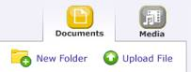  Inactive  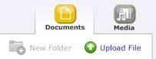 | - Clicking this button will launch the new folder feature described in section 4.1 in a lightbox.  - This button should not be visible at the top level showing all courses.  - If the user is a member of a coordinator course, and the coordinator has given the member read-only access, the button should be in the inactive state.  - This feature should not be visible to student users.  - Hover state of “Create a new folder”  - If the file upload service is unavailable, this button should appear in the inactive state.  - HOVER STATE: label will underline on hover.
B-6 | Upload File  Active  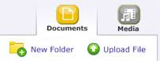  Inactive  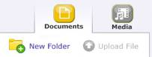 | - Clicking this button will launch the file upload box described in section 3 in a lightbox.  - This button should not be visible at the top level showing all courses.  - If the user is a member of a coordinator course, and the coordinator has given the member read-only access, the button should be in the inactive state.  - This feature should not be visible to student users.  - Hover text of “Upload a file to this folder”  - If the file upload service is unavailable, this button should appear in the inactive state.  - HOVER STATE: label will underline on hover.
B-7 | Folder Name  Coordinator  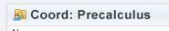  Member  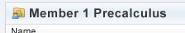  Standalone | - Display the name of the folder being viewed in this area. This should match the last level of the path displayed above.  - Before the course name, display either the Coordinator, Member, or Standalone icon depending on the course type.
B-8 | Course Level View  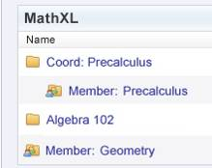 | - By default, an empty folder should be created for each course the user has for each platform within that platform’s section.  - Coordinators should see all coordinator and member courses. All member courses should be displayed directly below the coordinator course.  - Members should see member courses only and not the coordinator course.  - If the course is a coordinator course or a standalone course, display the top icon next to “Coord: Precalculus”. If the course is a member course that is part of a coordinator course, display the member icon and indent the course name in the file listing. If the course is a member course that is not part of a coordinator course, display the member icon and do not indent the course name.  - Display columns for Name, Date Modified and Size. Show to students should not be shown at this level.  - By default, folders should be sorted alphabetically by name. Allow the user to sort by name, date modified, and size by clicking the headers of the columns. Display an arrow pointing up or down next to the column being sorted.  - Folders remain at the top or the bottom of the view, depending on whether the filed is being sorted ascending (top) or descending (bottom).  - Sort settings for each folder remain sticky for the duration of the user’s session and for the next login.  - If the user is a coordinator, and has member and coordinator courses, the member courses should ignore sorting rules and always remain below the coordinator course. If the user is not a coordinator, and the course listing contains only member or standalone courses, normal sorting rules should apply.  - Students should not be able to get to this level. The root level for a student should be the individual course level.
B-9 | File and Folder Listing  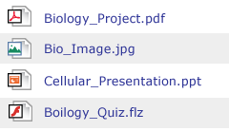  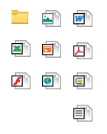 | - Display the name, date modified, size, and whether the file or folder is being shown to students or not.  - When a user hovers over the Name header, rollover text will appear: “The title of the file”  - If a folder is hidden from students, but files within that folder are set to be shown, the files should not be able to be seen by students until the instructor decides to show the folder.  - Allow the user to sort by name, date modified, size, and show to students by clicking the headers of the column. Display an arrow pointing up or down next to the column being sorted.  - By default, display any folders within the folder at the top of the list. These folders should be sorted alphabetically by name. If the user sorts by any of the available columns, folders should still remain on the top or bottom, depending on whether the field is being sorted ascending or descending.  - To the left of all files and folders, display an icon representing the type. .xls and .xlsx should display the Excel icon. .ppt and pptx should display the PowerPoint icon. .ai, .bmp, .gif, .jpg, .png, .psd, .tif should display the general image icon (top right corner). .pdf should display the acrobat icon. .flv, .fla, and .swf should display the flash icon. Folders should display the folder icon. .doc and .docx should display the word icon. All other supported file types (txt, avi, flv, rar, sit, sitx, tgz, zip, bok, vsd, dcr, accdb, html) should use the default icon on the bottom right. Movie file extensions will not be supported (mov, qt, rm, wmv)  - Clicking the file name will prompt the option to save or open the file.  - The “Show to students” column should not be visible to student users.  - If the user is an instructor of a read-only course, or is a student, and there are no files within the folder, display the message, “There is no content in this folder.”  - If the user is an instructor of a coordinator course, standalone course, or member course with read-write privileges, and there are no files within the folder, display the message, “There is no content in this folder. To add a new file, click 'Upload File'.”  - If the file upload service is unavailable, display the message, “This page is currently unavailable. Check back later to see if this page is available.”
B-10 | File and Folder Listing Hover Effect – Full Access  V2:  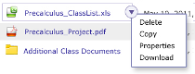  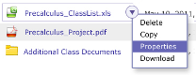 | - If the file or folder has been uploaded by a coordinator, and the coordinator is hovering over the file name or folder name, a cMenu should make available an arrow. Clicking this arrow should display the options to Delete, Copy, or view Properties about the file.  - If the file or folder has been uploaded by a member, and the member is hovering over the file name or folder name, , a cMenu should make available an arrow. Clicking this arrow should display the options to Delete, Copy, or view Properties about the file.  - If the file or folder is a part of a standalone course, and the instructor is hovering over the file name or folder name, a cMenu should make available an arrow. Clicking this arrow should display the options to Delete, Copy, or view Properties about the file.  - Functionality for the Delete, Copy, and Properties options are described in Section 4.  - Hovering over other data within the row such as size, date modified, and show to students should not activate the hover effect.  - The cMenu feature should not appear for student users.
B-11 | File and Folder Listing Hover Effect – Limited Access  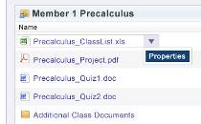 | - If the file or folder has been uploaded by a coordinator, and a member is hovering over the file name or folder name, a cMenu should make available an arrow. Clicking this arrow should display the options to view Properties about the file or folder.  - Functionality for the Delete, Copy, and Properties options are described in Section 4 and should load in a lightbox.  - Hovering over other data within the row such as size, date modified, and show to students should not activate the hover effect.  - The cMenu feature should not appear for student users.
B-12 | Space Used  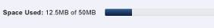 | - The amount of space available is configurable by program, and a course-specific override is possible.  - Allow the user to have 50mb of disk space per course by default.  - Display “Course Space Used: <mb used>MB of 50MB” (or whatever the configured total is)  - Round the Space Used value up to the nearest tenth of a decimal.  - The percent of the bar filled should match the percentage of space used.  - This feature should not be visible for student users.  - If the user is a member of a coordinator course, and the coordinator has given the member read-only access, this feature should not be visible  - Hover state of “You have used <mb used> of your allotted 50MB within the course.” (or whatever the configured total is)
B-13 | Show to students  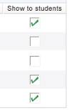 | - If the check is showing, the file or folder should be visible to students. If check is not showing, the file or folder should not be visible to students.  - Coordinators, members, and instructors with standalone courses all have access to select the Show or Hide feature for all files and folders, regardless of who uploaded them.  - If a coordinator changes the Show/Hide setting of a file or folder within the coordinator course, these changes should not affect the member course.  - By default, all files and folders should be hidden.  - Any changes to this setting should automatically be saved.  - This column should not be visible for student users.  - On the column header, hover state of “Click the checkbox to show or hide this file from your students.”
B-14 | Date Modified  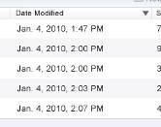 | - Include the date modified of the file or folder.  - The date modified for a folder should be the date the most recent file within the folder was modified.  - On the column header, hover state of “The date that the file or folder was last modified.”
B-15 | Size  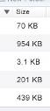 | - Include the size of the file.  - For folders, do not calculate the size and instead display “-- -- -- --“  - On the column header, hover state of “The size of the file.”
B-16 | Help  XL:  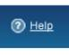  Mastering:  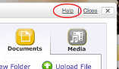 | - Display the help icon and the text “Help” to the left of the X to close the lightbox.  - Clicking either the icon or the text should launch a pop-up window that has a width and height of 600.  - The XL link to help for instructors is http://helpdev.pearsoncmg.com/modules/file-upload/instructor  - The XL link to help for students is http://helpdev.pearsoncmg.com/modules/file-upload/student  - The Mastering link to help for instructors is http://www.masteringsupport.com/product_help/help_professors/  - The Mastering link to help for students is http://www.masteringsupport.com/product_help/help_students/  - Hover state of “Get help about how to use the course documents service”
B-17 | Close  XL:    Mastering:  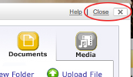 | - Clicking the X will close the lightbox and return the user to the page they were previously viewing inside of the platform.  - Hover state of “Close your course documents”  - THIS IS AN OUT-OF-THE-BOX LIGHTBOX TREATMENT. I WOULD LIKE TO RE-VISIT THIS.
B-18 | Header  XL:   | - Display a header containing a title. This header title should change as the user goes to the file upload, media area, and other auxiliary pages.  - XL Title: “Course Documents”  - Mastering Title: “Manage Documents”
B-19 | Switch to Media Upload – Media Enabled  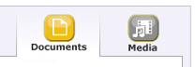  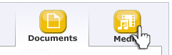 | - When a product does not have the Media area enabled, the “Documents” and “Media” toggle buttons do not appear  - When a product has the Media area enabled, instructors can toggle between Documents and Media.  - Documents element displays in “active” state  - Media Element displays in “Off” state.  - On hover, Media Element displays in “Over” state.  - When a user hovers over the Media button, rollover text will appear: “Browse and play media files”

Upload Document File

Prototypes

Initial State: Documents
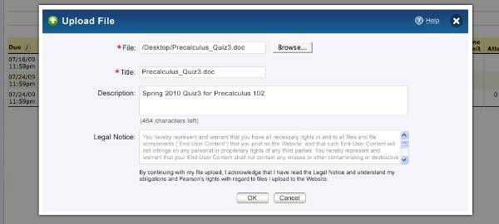

Uploading Progress Bar: Documents
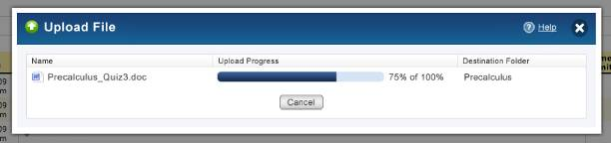

Elements
ID | Element | Behavior
C-2 | Browse  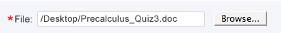 | - This field is required and should have a red asterisk next to it to indicate such.  - This text field will work in conjunction with the Browse button.  - Shall display the local path to selected attachment selected using the Attachment Browse button.  - By default, this field will be blank.  - Clicking the text field or the button will open a file-browser window showing files on the user’s computer.  - Selecting a file then affirming the selection will close the browse window. The uploaded file name should be displayed as the filename with extension, but without the entire path  - The presentation of the text field and associated browse button will visually differ on each browser. More on the visual difference by browser can be found here - http://www.456bereastreet.com/lab/styling-form-controls-revisited/file-select/  - Copy the name and extension of the file (not the entire path) to the Title field. Should the user browse for a different file, recopy the name to the title field and replace the existing title.
C-3 | Title  Active  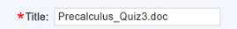 | - By default, this field will be blank, but will contain the name of the file after the user has browsed and selected one. This field will also be disabled for the document file upload areas until a file has been selected.  - The user may change the Title from the name of the file to a different name if they choose to.  - Title should have a character limit of 42. If the user uploads a file that is more than 42 characters, truncate the name at the character limit.  - This field is required and should have a red asterisk next to it to indicate such.
C-4 | Description  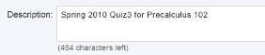 | - This field is not required.  - Users should not be able to save white space for a description. A description of only blank spaces will be deleted.  - The description field should not display the encoding of the text to users when the form is saved.  - Users should be able to enter and save 500 characters, including spaces, for a description for either a document or a media file. The number of characters left should decrease one by one after every character the user types.  - Default text appears in the description file, which disappears when the field becomes active and the user starts typing. The default text is as follows:  - "Click to enter a description of your file."  - Default Description text is gray. When users start typing text, the user-entered text is black.  - If users delete all text in the Description, the default text appears.  - The default Description text should not appear to users in conjunction with a saved file:  - It should not appear in the View Media Files list for instructors or students  - It should not appear in the Properties window for instructors  - The behavior of the description field for documents should be the same as the behavior of the description field for media.
C-5 | Okay and Cancel Buttons  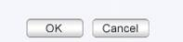 | - If the user clicks Cancel, and has not typed any characters into either field in the form or browsed for a file, the user should be returned to the folder they were previously viewing.  - If the user clicks Cancel, and has added at least 1 character into either field in the form or browsed for a file, they should be prompted, “Your file has not yet been uploaded. Are you sure you want to cancel?” in an alertbox.  - Clicking Ok will submit the form and begin uploading the file. They will be taken to the screen described in section 3.1.2  - The file should not be shown to students by default.  - If the user is uploading a file to a coordinator course, that file should also appear in the same destination location within all member courses.  - If the size of the file is greater than the amount of space remaining on the user’s account, prompt the error message “You do not have enough free disk space to upload this file. To create more disk space, click Cancel, zip the file or delete unwanted files or folders, and try again.” in an alertbox.  - The maximum file size allowed is configurable by product, and a course-level override is possible.  - The default maximum file size is 10MB. If the file is greater than 10mb, prompt the error message “The file you are uploading exceeds the size limit of 10mb. Please zip the file and try again.” in an alertbox.  - Valid file formats include: txt, doc, ppt, xls, pdf, ai, bmp, gif, jpg, png, psd, tif, avi, flv, rar, sit, sitx, tgz, zip, fla, swf, bok, vsd, dcr, docx, pptx, xlsx, accdb, html. Movie file extensions will not be supported (mov, qt, rm, wmv)  - If the file type is not a supported file type, prompt the error message “<file type variable> is not a supported attachment type.” in an alertbox.  - The ability to perform a virus check on the uploaded file should be supported. If the file contains a virus, prompt the error message “The file you are trying to upload contains a virus. Please upload a different file.” in an alertbox.  - If the virus checking service is down, prompt the error message “Due to system issues, you may not upload files at this time. Please come back later and try again.” in an alertbox.  - If the user is in a member course, and a file has already been uploaded to the folder with the same title by a coordinator, prompt the error message, “The course coordinator has already uploaded a file using this name. Please upload a different file.” in an alertbox.  - If the user is in a member course, and a file has already been uploaded to the folder with the same title by the member, prompt the error message “You have already uploaded a file using this name. Would you like to overwrite the existing file?” in an alertbox.  - If the user is in a coordinator course, and a file has already been uploaded to the folder with the same title by the coordinator, prompt the error message “You have already uploaded a file using this name. Would you like to overwrite the existing file?” in an alertbox.  - If the user is in a standalone course, and a file has already been uploaded to the folder with the same title by the instructor, prompt the error message “You have already uploaded a file using this name. Would you like to overwrite the existing file?” in an alertbox.  - If the user is in a coordinator course, and a file has already been uploaded to the folder with the same title by the coordinator, but the coordinator course has been unlinked from the member course, do not replace the file within the member course.  - If the user is attempting to overwrite a file which is contained within multiple folders, the file upload service should only overwrite the file in the destination folder. The other versions of the file should remain unchanged.  - If the file the user has selected cannot be found, prompt the error message “We cannot find the file you are trying to upload. Please try again." in an alertbox.  - If the user has not entered a title, prompt the error message “Please enter a title and try again.” in an alertbox.  - If the user enters a title with invalid characters, prompt the error message “The filename cannot contain the following characters: ; ".” in an alertbox. Non-Ascii Characters are supported, so the ; and “ are the only non-supported characters.  - The buttons should appear in gray. In previous designs, these buttons were blue.
C-7 | File Upload Progress Bar  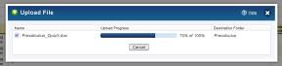 | - If the file is so small that the upload should only take a few seconds, display a green spinner while the file is uploading, rather than the full progress bar identified in this element.  - If the file will need more than a few seconds to upload, display the full progress bar interface.  - Display headers for Name, Upload Progress, and Destination Folder above the file that is being uploaded.  - The file name will not be clickable while being uploaded and should appear in black.  - The upload progress bar should track the percentage complete that the upload is. This number should be displayed to the right and the percentage of the bar filled should match the percentage displayed to the right.  - Once the upload process has been completed, the user should return to the destination folder of the file that was uploaded.  - Clicking the cancel button should delete the file that is being uploaded from the system and return the user to the destination folder of the file that was uploaded.  - The cancel button should be grayed out when the upload is nearly completed. Clicking the button at this time will not cancel the upload.
C-8 | Legal Text  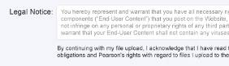 | - Display legal text within a text box. The text box should be 4 rows high.  - Users should not be able to change text within the box.  - Below the text box, display the text, “By continuing with my file upload, I acknowledge that I have read the Legal Notice and understand my obligations and Pearson's rights with regard to files I upload to the Website.”  - Inside of the box, display the following legal text:  You hereby represent and warrant that you have all necessary rights in and to all files and file components (“End-User Content”) that you post on the Website, and that such End-User Content will not infringe on any personal or proprietary rights of any third parties. You hereby represent and warrant that your End-User Content shall not contain any viruses or other contaminating or destructive devices, features or code of any kind; and that your End-User Content shall not contain any defamatory, indecent, offensive, tortuous, harassing or otherwise unlawful material or content.  You, and not Pearson, are entirely responsible for all End-User Content that you upload, post, email or otherwise transmit via the Website. Under no circumstances will Pearson be liable in any way for any errors, omissions, violation of third party rights or illegal conduct arising from said End-User Content.  You hereby authorize Pearson to make your End-User Content available via the Website to course instructor(s), administrator(s) and enrolled students to use in the manner, format or medium for which the file was provided. You shall have no claim or other recourse against Pearson for infringement of any proprietary right in End-User Content.  Pearson does not pre-screen End-User Content, but Pearson and its designees shall have the right (but not the obligation) in their sole discretion to monitor and refuse or remove any End-User Content available via the Website for any reasons it may deem appropriate (including but not limited to the reasons specified above) and/or to terminate your right of access to the Website to prevent further posting of prohibited End-User Content.  You acknowledge and agree that Pearson may preserve End-User Content after the end of the relevant course. Thereafter, Pearson shall not permit any further public access to the End-User Content on the Website, but reserves the right to retain the End-User Content indefinitely in the event of a potential violation of these terms or dispute pertaining to End-User Content. You acknowledge that Pearson may also disclose End-User Content in association with your contact information if required to do so by law or in the good faith belief that such preservation or disclosure is reasonably necessary to: (a) comply with legal process; (b) enforce the terms of service hereunder; (c) respond to claims that any End-User Content violates the rights of third-parties; or (d) protect the rights, property, or personal safety of Pearson, its users and the public.  Feel free to review the Subscription and End-User License Agreement containing the full legal notice to which you consented during registration at https://register.pearsoncmg.com/reg/include/license2.jsp.  (c) 2010 Pearson Education, Inc. All rights reserved.  v2 - last updated 27-April-2010
C-9 | Additional Info | - Below the legal agreement, display the following text, “Upload times can vary depending upon file size. Files of 6MB or larger may take several minutes to upload. To cancel the operation before upload is complete, click Cancel.”

File and Folder Management

Prototypes

New Folder
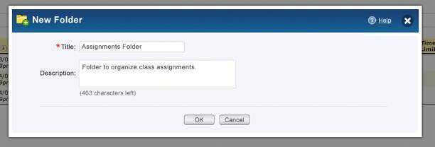

Delete a Folder
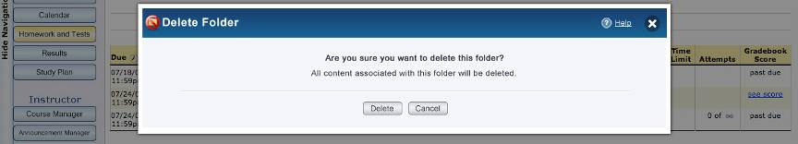

Delete a File
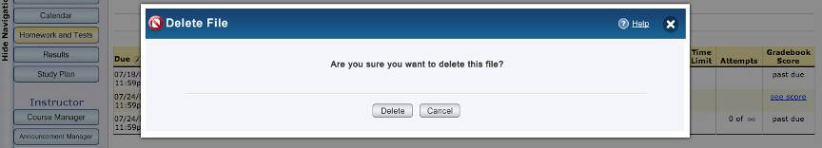

Copy a File or Folder
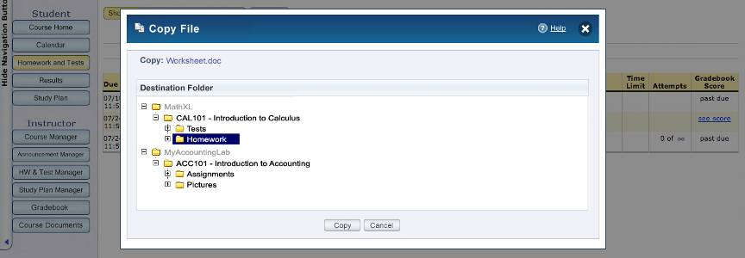

File Properties – Full Access

V1 - Documents
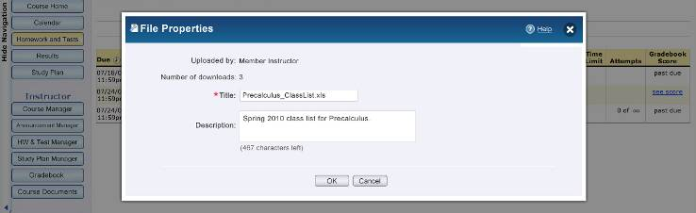

V2 – Media
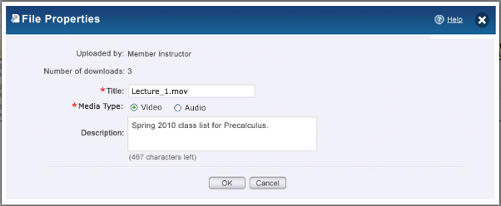

MEDIA: MP3 AWARENESS : VIDEO DISABLED
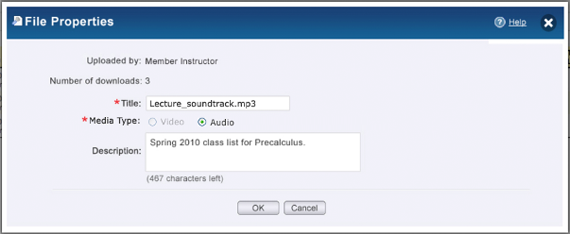

File Properties – Read Only Access
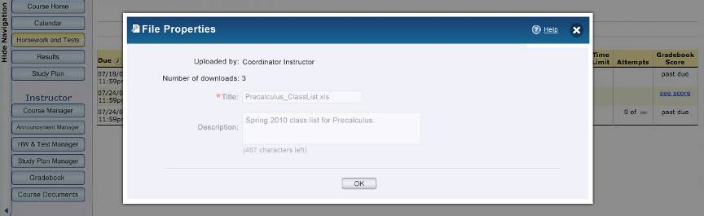

Folder Properties – Full Access
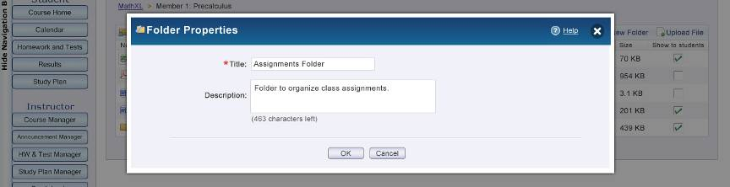

Folder Properties – Read-Only Access
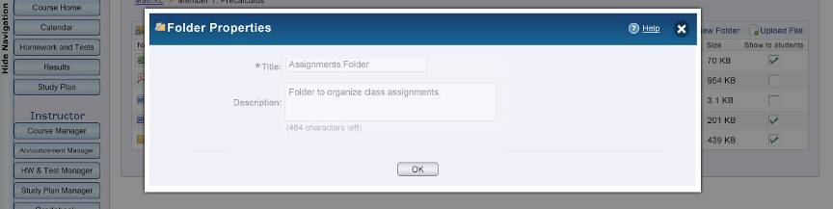

Elements
ID | Element | Behavior
D-1 | Title - Create | - By default, this field will be blank.  - Title should have a character limit of 42.  - This is a required field and should have a red asterisk next to it to indicate such.
D-2 | Description - Create  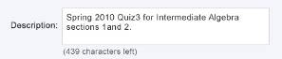 | - By default, this field will be blank.  - Description should have a character limit of 500. The number of characters left should decrease one by one after every character the user types.  - This is not a required field.
D-3 | Delete Text  Folder  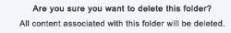  File | - If the user deletes a folder, display the text “Are you sure you want to delete this folder? All content associated with this folder will be deleted.”  - If the user deletes a file, display the text “Are you sure you want to delete this file?”
D-4 | Copy  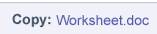 | - Display the name of the file or the folder.  - Clicking the file name will prompt the option to save or open the file.  - If the user is attempting to copy a folder rather than a file, the folder name should not be clickable and should be in black.
D-5 | Destination Folder  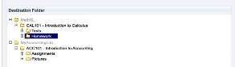 | - User must be able to copy a file or a folder to any of the following destinations: A folder they have created with the current course, a folder they have created in a different course in the same product (AKA “platform”), a folder they have created in a different course in a different product (AKA “platform”), any of their standard courses (e.g. Algebra 102 root level), or any of their member courses that have file upload permissions granted (e.g. Member Course Algebra 102 root level).  - Display a tree of destination folders. If the user has a subscription to 2 or more products, display the product name at the top of the hierarchy, all folders within that product below it, and the additional products the user has a subscription to below that.  - Display the product that the file or folder being copied originates from at the top of the tree. All other products should be displayed below in alphabetical order.  - If the user has a subscription to only 1 product, do not display the product name at the top of the tree.  - If the user is copying a folder, gray out that same folder name from the folder listing and do not allow the user to select it.  - Platform names should be grayed out and the user should not be allowed to select them.  - Expand by default all folders of the tree within the product that the file or folder being copied originates from. All other products should not be expanded by default.  - Folders that have yet to be expanded should include a plus sign and ones that have already been expanded should include a minus sign. If a folder contains no subfolders within it, there should not be a plus or minus sign.
D-6 | Ok and Cancel Buttons - Create  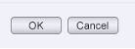 | - If the user clicks Cancel, and has not typed any characters into either field in the form, the user should be returned to the folder they were previously viewing.  - If the user clicks Cancel, and has added at least 1 character into either field in the form, they should be prompted, “Your folder has not yet been saved. Are you sure you want to cancel?” in an alertbox.  - Clicking Ok will submit the form and return the user to the folder they have just created.  - If the user has not entered a title, prompt the error message “Please enter a title and try again.” in an alertbox.  - If the user enters a title, and that title already exists for another folder within that level, display the message, “You have already uploaded a folder using this name. Would you like to create a second folder with the same name?” in an alertbox.  - If the user creates a folder within a coordinator course, that folder should also be created at the same destination within all member courses.  - The buttons should appear in gray. In previous designs, these buttons were blue.
D-7 | Uploaded By – Properties | - If the file is from a coordinator or member course, display this field. If the file is a standalone course, do not display this field.  - Do not display this field for folder properties.  - If the file was uploaded by a coordinator, display “Uploaded by: Coordinator Instructor”  - If the file was uploaded by a member, display “Uploaded by: Member Instructor”
D-8 | Number of Downloads - Properties  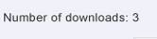 | - Display the count of the number of times the file has been downloaded by all users.  - Do not display this field for folder properties.
D-9 | Title – Properties  Active  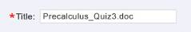  Inactive  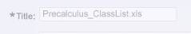 | - Display the title of the file or folder.  - Title should have a character limit of 42.  - This field is required and should have a red asterisk next to it to indicate such.  - If the user is a member instructor, and the file was uploaded by a coordinator instructor, the field should be in the inactive state and the user should not be able to edit it.  - If the course is a read only course, and the user is a member instructor, the field should be in the inactive state and the user should not be able to edit it.
D-10 | Description – Properties  Active  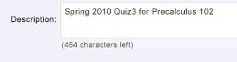  Inactive  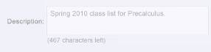 | - Display the description of the file or folder.  - Description should have a character limit of 500. The number of characters left should decrease one by one after every character the user types.  - This field is not required.  - If the user is a member instructor, and the file was uploaded by a coordinator instructor, the field should be in the inactive state and the user should not be able to edit it.  - If the course is a read only course, and the user is a member instructor, the field should be in the inactive state and the user should not be able to edit it.
D-11 | Ok and Cancel Buttons - Properties | - If the user is a member instructor, and the file was uploaded by a coordinator instructor, or if the course is a read only course, there should only be an OK button and no Cancel button.  - If the user clicks Cancel, and has not made any changes to the properties, the user should be returned to the folder the user was previously viewing.  - If the user clicks Cancel, and has made changes to the properties, they should be prompted, “If you cancel, you will lose your changes. Are you sure you want to cancel?” in an alertbox.  - Clicking Ok will return the user to the folder the user was previously viewing.  - If the user is a coordinator, a member editing a member file or folder, or an instructor of a standalone course, and they delete the title, prompt the error message “Please enter a title and try again.” in an alertbox.  - If the user is a coordinator, a member editing a member file or folder, or an instructor of a standalone course, and they change the title to an already existing title name, prompt the error message “You have already created a <file or folder, dependent on what they are viewing properties of> using this name. Please enter a different title.” in an alertbox. Both the actual file name and the title of the file name must be unique.  - If the user makes changes to a coordinator file within a coordinator course, those changes should also be reflected in the file within the member courses.  - The buttons should appear in gray. In previous designs, these buttons were blue.
D-12 | Delete – Delete and Cancel Buttons  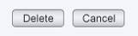 | - Clicking Cancel should return the user to the folder they were previously viewing.  - Clicking Delete will delete the file or folder and return the user to the folder they were previously viewing.  - If the user deletes a file or folder within a coordinator course, that file or folder should also be deleted within all the member courses.  - The buttons should appear in gray. In previous designs, these buttons were blue.  - When instructors delete a copied file or folder, only the reference to the file or folder is deleted. The file/folder is not removed until all references to it have been deleted.
D-13 | Copy – Copy and Cancel Buttons | - Clicking Cancel should return the user to the folder they were previously viewing; user should be asked to confirm that they want to cancel before they are returned to the folder they were previously viewing.  - Clicking Copy will copy the file or folder, and then return the user to the folder they have copied the file or folder from. The file tile will have “Copy of” added to it if it is being copied to a location in which a file of the same title already exists.  - When copying a file, the Show/Hide setting will not be retained.  - If the user is copying a folder, all files within the folder should be copied as well. All show/hide settings should additionally be copied.  - If the original file contains a description, the description should be copied as-is with no changes.  - If the size of the file is greater than the amount of space remaining on the user’s account, prompt the error message “You do not have enough free disk space to upload this file. To create more disk space, click Cancel, zip the file or delete unwanted files or folders, and try again.” in an alertbox.  - If a file has already been uploaded to the destination folder with the same title, prompt the error message “A file by this name already exists in that location. Are you sure you want to copy? Clicking OK will copy the file and add "Copy of" to its name.” in an alertbox. The buttons to be included within the prompt include “Copy” and “Cancel”  - If a folder has already been uploaded to the destination folder with the same title, prompt the error message “A folder by this name already exists in that location. Are you sure you want to copy? Clicking OK will copy the folder and add "Copy of" to its name.” in an alertbox. The buttons to be included within the prompt include “Copy” and “Cancel”  - If a file or folder has already been copied to the destination folder, append “Copy (2)” to the file name or folder name.  - If the user copies a file or folder within a coordinator course, that file or folder should also be copied within all the member courses.  - The buttons should appear in gray. In previous designs, these buttons were blue.
D-14 | Media File Type Indicator   | - The media file type indicator appears on the Properties page for media files.  - The media file type indicator displays the current setting for the media entry – audio or video – as it is stored by Kaltura  - Instructors with permission to edit the file properties can change the type from video to audio and vice-versa.  - If the user is a member instructor, and the file was uploaded by a coordinator instructor, the indicator should be in the inactive state and the user should not be able to edit it.
D-14 | Media File Type Indicator: MP3 Awareness   | - Users can indicate that a file they are uploading is an audio file. The mechanism used to indicate and audio file upload (e.g. radio buttons below the Title field in the Save form) only appears for media files that are not .mp3 files.  - Audio-only files display the default audio thumbnail. Audio files are still played using the video player.  - If no thumbnail is available because users incorrectly identified an audio file as a video file, show default icon so that a broken image icon does not appear.  - Users can update the audio/video indication in the Properties form  - MP3 files will always be Audio files. Users will not be able to change the indicator for an MP3 file from "audio"  - Recordings will always be Video files. Users should not be able to change the media type of a recorded file from "video"

Media File Management

Prototype

Initial State
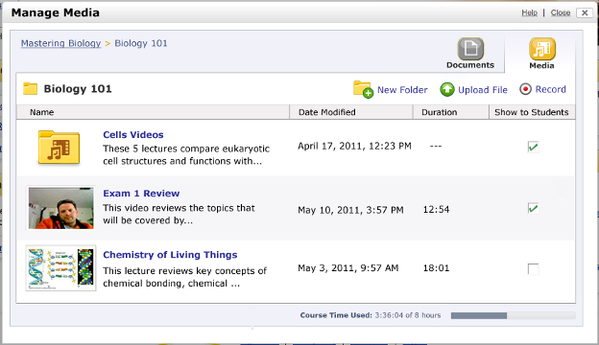

Elements
ID | Element | Behavior
F-i | Platform Menu | Same as Documents Elements 2.2 (B-1)
F-ii | Course Level View | Same as Documents Elements 2.2 (B-8)
F-1 | File and Folder Listing  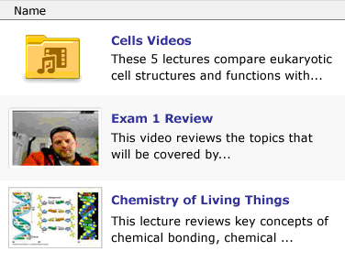 | - Instructors are able to view a list of their Media Files, as well as folders containing their media files. The list view displays the file Title, Thumbnail, Description, Date Modified, and Duration and the folder Title, Description, and Date Modified.  - Audio-only files display the default audio thumbnail. If no thumbnail is available because users incorrectly identified an audio file as a video file, show default icon so that a broken image icon does not appear.  - When a user hovers over the Name column header, hover text will appear: “The title of the file”  - Clicking the file name or the file thumbnail will launch the media player in a new window with the selected file loaded and ready to play. (See “Browser Playback” G-14 below)  - The focus of the new window should be set to the player widget automatically so that keyboard controls for the player are immediately available. Users can open multiple media files in multiple windows. Audio files are played with the video player.  The following is the same as the Document Elements 2.2 (B-9)  - When a user hovers over the Name header, rollover text will appear: “The title of the file”  - If a folder is hidden from students, but files within that folder are set to be shown, the files should not be able to be seen by students until the instructor decides to show the folder.  - Allow the user to sort by name, date modified, duration, and show to students by clicking the headers of the column. Display an arrow pointing up or down next to the column being sorted.  - By default, display any folders within the folder at the top of the list. These folders should be sorted alphabetically by title. If the user sorts by any of the available columns, folders should still remain on the top or bottom, depending on whether the field is being sorted ascending or descending.  - Sort settings for each folder remain sticky for the duration of the user’s session and for the next login.  - The “Show to students” column should not be visible to student users.  - If the user is an instructor of a read-only course, or is a student, and there are no files within the folder, display the message, “There is no content in this folder.”  - If the user is an instructor of a coordinator course, standalone course, or member course with read-write privileges, and there are no files within the folder, display the message, “There is no content in this folder. To add a new file, click 'Upload File'.”  - If the file upload service is unavailable, display the message, “This page is currently unavailable. Check back later to see if this page is available.”
F-1A | MEDIA ICONS  MEDIA FOLDER    VIDEO THUMBNAIL    VIDEO THUMBNAIL: THUMBNAIL UNAVAILABLE    VIDEO THUMBNAIL: VIDEO NOT AVAILABLE    AUDIO THUMBNAIL   | - NEW IMAGES
F-2 | Path | Same as Documents Elements 2.2 (B-4)
F-3 | New Folder | Same as Documents Elements 2.2 (B-5)
F-4 | Upload File | Same as Documents Elements 2.2 (B-6) - EXCEPT  - Upload file icon has rollover text, “Upload a prerecorded file to this folder.”  - If the course has surpassed the maximum quota duration, the Upload File link and icon will be disabled.
F-5 | Record  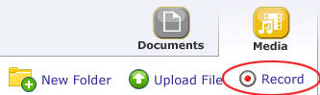 | - If a product does not have webcam recording enabled, the Record icon and link will not appear  - If a product has webcam recording enabled, the Record icon and link appear and Instructors can Record a lecture via a chosen web-cam  - Clicking this element will open the Kaltura Widget  - When a user hovers over the Record link, hover text will appear: “Record a video with your webcam”  - If the course has surpassed the maximum quota duration, the Record icon and link will be disabled.
F-6 | Date Modified | - Include the date modified of the file or folder.  - The date modified for a folder should be the date the most recent file within the folder was modified.  - On the column header, hover state of “The date that the file or folder was last modified.”  - Allow the user to sort by name, date modified, duration, and show to students by clicking the headers of the column. Display an arrow pointing up or down next to the column being sorted.
F-7 | Length  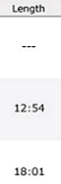 | - This column includes the length of the media file  - Time will be shown in hh:mm (00:00)  - For folders, do not calculate the size and instead display “-- -- -- --“  - On the column header, hover state of “The total duration of the file.”  - If the duration is not yet available, because the uploaded media file is still being transcoded, “Processing…” should appear until the screen is refreshed when the duration is available.  - Allow the user to sort by name, date modified, duration, and show to students by clicking the headers of the column. Display an arrow pointing up or down next to the column being sorted.
F-8 | Show to Students | Same as Documents Elements 2.2 (B-4)
F-9 | File and Folder Listing Hover Effect – Full Access  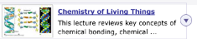  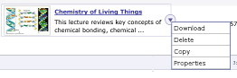  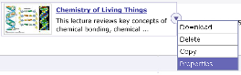 | - If the file or folder has been uploaded by a coordinator, and the coordinator is hovering over the file name or folder name, a cMenu should make available an arrow. Clicking this arrow should display the options to Download, Delete, Copy, or view Properties about the file.  - If the file or folder has been uploaded by a member, and the member is hovering over the file name or folder name, a cMenu should make available an arrow. Clicking this arrow should display the options to Download, Delete, Copy, or view Properties about the file.  - If the file or folder is a part of a standalone course, and the instructor is hovering over the file name or folder name, a cMenu should make available an arrow. Clicking this arrow should display the options to Download, Delete, Copy, or view Properties about the file.  - Clicking “Download” will prompt the users to save or open their file – or whatever the browser settings are configured to do for downloads.  - Selecting delete, copy, or properties is covered in File and Folder Management 4.2  - Hovering over other data within the row such as size, date modified, and show to students should not activate the hover effect.  - The cMenu feature should not appear for student users.  - List Hover Background Hex # 6767b6  - List Hover Background Text Hex # FFFFFF
F-10 | Space Capacity  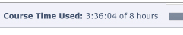 | - The time quota (in terms of time) is configurable by product and will be a soft limit (users will actually be able to upload up to an extra 5 minutes).  - When users are within 15 minutes of the quota, a warning message will appear: “You are within 15 minutes of your allotted course time. You may want to download files that you are not using and delete them to make more room before you record or upload a new file.”  - Allow the user to have XX hours of disk space per course by default.  - Display “Course Time Used: <hh:mm:00 used> of <xx> hours”  - The percent of the bar filled should match the percentage of space used.  - This feature should not be visible for student users.  - If the user is a member of a coordinator course, and the coordinator has given the member read-only access, this feature should not be visible  - Hover state of “You have used <hh:mm:ss used> of your allotted <XX> hours within the course.”
F-11 | Help | Same as Documents Elements 2.2 (B-16)
F-12 | Close | Same as Documents Elements 2.2 (B-17)
F-13 | Switch to Document Upload  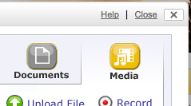  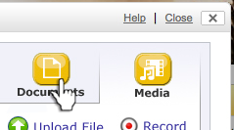 | - Instructors can toggle between Documents and Media  - Media element displays in “active” state  - Documents Element displays in “Off” state.  - On hover, Documents Element displays in “Over” state.  - When a user hovers over the Documents button, hover text will appear: “Browse and download documents”
F-14 | Browser Playback  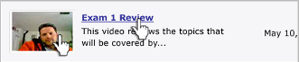 | - Instructors can view by clicking Thumbnail or title  - When a user hovers over the media Thumbnail or Title, hover text will appear: “Play file”  - If the recording or uploaded file is still processing and not yet ready for playback or download, a processing indicator will appear.  - The label of the download action in the context menu reads, "Processing download...," until the download version of the file is ready and available for download.  - If users click on "Processing download..." in the context menu before the file is ready for download, a message dialogue appears to let the user know that the file is not yet ready. (US35521)  - The thumbnail for a file that is not yet ready for playback indicates that the media is not yet available.  - If users click on the thumbnail or title of a media file that is not yet ready for playback, the player launches in a new window and displays a message saying that the file is not yet ready.

Upload Media File

Prototypes

Initial State: Media
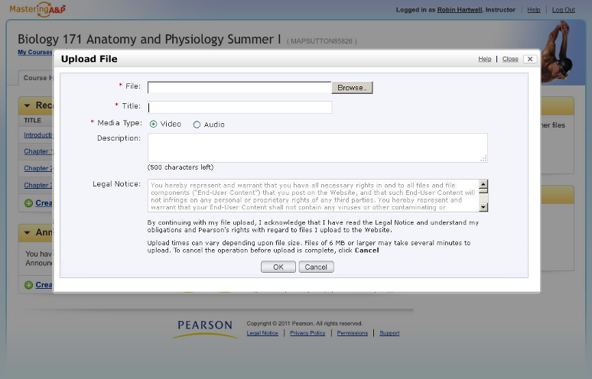

Uploading Progress Bar: Media RON – New Image with messaging for Large File Upload

NEED TO CREATE THESE SCREENS

Elements
ID | Element | Behavior
G-1 | Browse | Same as Upload Document File 3.2 (C-2)
G-2 | Title | Same as Upload Document File 3.2 (C-3)
G-3 | Description | Same as Upload Document File 3.2 (C-4) - EXCEPT  - Default text appears in the description file, which disappears when the field becomes active and the user starts typing. The default text is as follows:  - For Media Files: "Click to enter a description of your file for your students."  - The full description of a media file appears for students; it does not get cut off.
G-4 | Audio File Upload Indicator | - Users can indicate that a file they are uploading is a video or audio file using a radio button that is labeled: “Media Type”  - The radio button only appears for media files that are not .mp3 files. The radio button should not appear for .mp3 files.  - The radio button defaults to “video”
G-5 | Okay and Cancel Buttons | Same as Upload Document File 3.2 (C-6)
G-6 | File Upload Progress Bar  [RON – Need a mockup of the progress bar with the large file message]  Need to create these screens | Same as Upload Document File 3.2 (C-7) – EXCEPT  - If the file size is over 100 MB, an alert will appear on the media upload progress bar screen with the message “You are uploading a very large file. Files of this size can take 10 minutes or more to upload. To cancel the upload before it completes, click Cancel.”
G-7 | Legal Text | Same as Upload Document File 3.2 (C-8)
G-8 | Additional Info | Same as Upload Document File 3.2 (C-8)

Record File

Prototype

Initial State
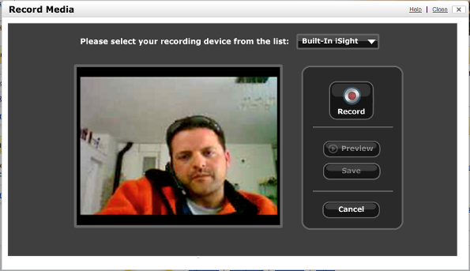

Elements
ID | Element | Behavior
H-1 | Initial State | - Some kind of visual indicator appears right when the Record page loads to let users know that the recorder is loading. (e.g. "Loading recorder...")  - The "Record" button on the record widget is disabled until the widget loads and a video source is detected. If no source is detected, the "Record" button remains unavailable, and a message appears:  - The recorder cannot detect a webcam or video camera. You will not be able to record a video. For more information on webcams, please search the Help for "Webcam."
H-2 | Controls: Selecting Device Element   | - The list is presented via a drop-down menu with a selection of recording devices.  - The recording device list is dynamically generated by the Kaltura Widget via device recognition  - If users have only one recording device, the drop-down selector and message to select a device from the list do not appear. This will be the behavior that all Mac users see, because the recorder always only detects one device on a Mac.  - When a user hovers over the device drop-down, rollover text will appear: “Select a recording device.”
H-3 | Controls: Start Record Behavior  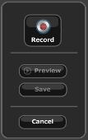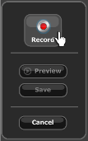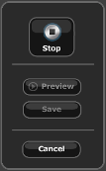 | - Clicking the Record button begins recording.  - If the Record button has been clicked and recording has begun, the button toggles to the Stop button.  - Before recording starts/stops, the Preview button is automatically disabled.  - Before recording starts/stops, the Save button is automatically disabled.  - When a user hovers over the Record button, rollover text will appear: “Start recording.”
H-4 | Controls: Stop Recording Behavior  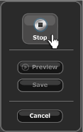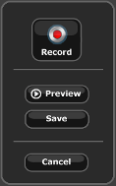 | - Clicking the Stop button stops recording  - Once the Stop button is clicked, the Record button becomes active again. If users click Record again without saving, a message appears: Would you like to record again without saving? Yes / No  - Once the Stop button is clicked, the Preview and Save buttons become active.  - When a user hovers over the Stop button, rollover text will appear: “Stop recording.”
H-6 | Controls: Preview  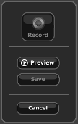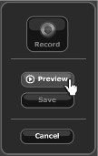 | - Clicking the Preview button plays the video the user just recorded  - If the Preview button has been clicked and playback has begun, the button toggles to the stop Preview button.  - When the Preview button has been clicked, the Record and Save buttons become disabled.  - When the Preview button has been clicked, the Cancel button remains active. When the user clicks the Cancel button, the user returns to the view files/folders view, and both the audio and video stop playing.  - When a user hovers over the Preview button, rollover text will appear: “Play preview of recorded file.”
H-7 | Controls – Stop Preview  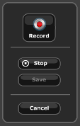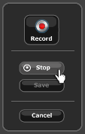 | - Clicking the stop Preview button stops recording  - Once the stop Preview button is clicked, the Record button becomes active again. If users click Record again without saving, a message appears: Would you like to record again without saving? Yes / No  - Once the stop Preview button is clicked, the Preview and Save buttons become active.  - When a user hovers over the Stop button, rollover text will appear: “Stop preview.”
H-7 | Controls: Save Recording  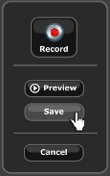 | - Clicking the Save button opens the Save Form.  - When a user hovers over the Save button, hover text appears: “Save recorded file.”
H-8 | Save Recording Form  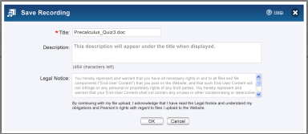 | - Instructors can save the file to the main directory or folder  - Users should not be able to save white space for a description. A description of only blank spaces will be deleted.  - The description field should not display the encoding of the text to users when the form is saved.  - Users should be able to enter and save 500 characters, including spaces, for a description for either a document or a media file. (There is a currently a defect logged against this: DE8131)  - Default text appears in the description file, which disappears when the field becomes active and the user starts typing. The default text is as follows: "Click to enter a description of your file for your students."  - If users delete all text in the Description, the default text appears.  - The default Description text should not appear to users in conjunction with a saved file. It should not appear in the View Media Files list for instructors or students and it should not appear in the Properties window for instructors  - The behavior of the description field for documents should be the same as the behavior of the description field for media.
H-9 | Controls: Cancel Button  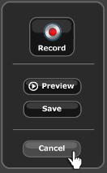 | - Clicking the Cancel button closes the Lightbox and returns user to main screen  - When a user hovers over the Cancel button, rollover text will appear: “Cancel recording and return to media files.”

Student View

Prototype

View Media

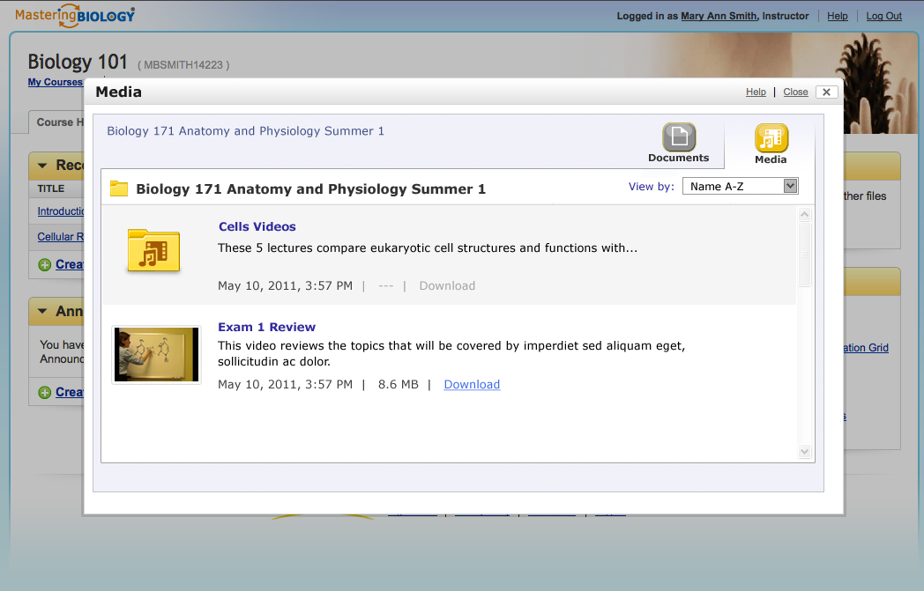

Elements
ID | Element | Behavior
I-1 | Platform Menu  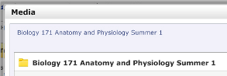 | - Students will only see the course they are currently viewing and not any additional courses or platforms. Therefore, students should always see the sans-menu version of the design shown in 2.1.9.
I-2 | Path | - Display the path to the folder the user is currently located in. If the user is not at the top level, an arrow should be displayed between each level.  - Clicking a folder at a different level than the one being currently viewed should link the user to that location. The current level should not be clickable.  - By default, when the user opens the tool, they should be taken to the folder containing the associated files of the course they are currently viewing.  - Students cannot click the root node of the path to navigate outside of their course.
I-3 | DOCUMENT File and Folder Listing | - Display the name, date modified and size in the Documents view  - When a student hovers over the Name column header, rollover text appears: “The title of the file”  - If an instructor has hidden a folder, but files within that folder are set to be shown, the files should not be able to be seen by students until the instructor decides to show the folder.  - Allow the user to sort by name, date modified and size by clicking the headers of the column. Display an arrow pointing up or down next to the column being sorted.  - By default, display any folders within the folder at the top of the list. These folders should be sorted alphabetically by title. If the user sorts by any of the available columns, folders should still remain on the top or bottom, depending on whether the field is being sorted ascending or descending. Sort settings for each folder remain sticky for the duration of the user’s session and for the next login.  - To the left of all files and folders, display an icon representing the type. .xls and .xlsx should display the Excel icon. .ppt and pptx should display the PowerPoint icon. .ai, .bmp, .gif, .jpg, .png, .psd, .tif should display the general image icon (top right corner). .pdf should display the acrobat icon. .flv, .fla, and .swf should display the flash icon. Folders should display the folder icon. .doc and .docx should display the word icon. All other supported file types (txt, avi, flv, rar, sit, sitx, tgz, zip, bok, vsd, dcr, accdb, html) should use the default icon on the bottom right. Movie file extensions will not be supported (mov, qt, rm, wmv)  - Clicking the file name will prompt the option to save or open the file.  - If there are no files within the folder, display the message, “There is no content in this folder.”  - If the file upload service is unavailable, display the message, “This page is currently unavailable. Check back later to see if this page is available.”
I-4 | MEDIA File and Folder Listing  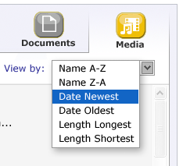 | - Display the name, thumbnail, description, date modified and duration in the Media view.  - The full description text for each file should appear. It should not be cut off.  - When a student hovers over the Name column header, rollover text appears: “The title of the file”  - If an instructor has hidden a folder, but files within that folder are set to be shown, the files should not be able to be seen by students until the instructor decides to show the folder.  - Allow users to sort by pre-defined options that are listed in a drop-down selector:  - Name A-Z  - Name Z-A  - Date Newest  - Date Oldest  - Length Longest  - Length Shortest  - By default, display any folders within the folder at the top of the list. These folders should be sorted alphabetically by title. If the user sorts by any of the available columns, folders should still remain on the top or bottom, depending on whether the field is being sorted ascending or descending. Sort settings for each folder remain sticky for the duration of the user’s session and for the next login.  - Clicking the file name or thumbnail will launch the media player in a new window with the selected file ready to play. See “Browse Playback” below (H-14).  - If there are no files within the folder, display the message, “There is no content in this folder.”  - If the file upload service is unavailable, display the message, “This page is currently unavailable. Check back later to see if this page is available.”
I-5 | Date Modified  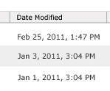 | - Include the date modified of the file or folder.  - The date modified for a folder should be the date the most recent file within the folder was modified.  - On the column header, hover state of “The date that the file or folder was last modified.”
I-6 | Size (Documents Only) | - Include the size of the file.  - For folders, do not calculate the size and instead display “-- -- -- --“  - On the column header, hover state of “The size of the file.”
I-7 | Length (Media Only)  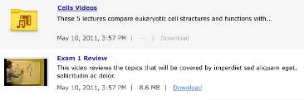 | - Include the size of the file.  - For folders, do not calculate the size and instead display “-- -- -- --“  - On the column header, hover state of “The size of the file.”
I-8 | Download (Media Only) | - A “Download” link appears for each available file.  - Students click the link to download an .mp4 version of the media file to save to their desktop.
I-9 | Help | Same as Documents Elements 2.2 (B-16)
I-10 | Close | Same as Documents Elements 2.2 (B-17)
I-11 | Header  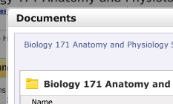 | - XL: Display a header containing the title “Course Documents” when in Documents View. Display a header containing the title “Course Media” when in Media View.  - Mastering: Display a header containing the title “View Documents” when in Documents View. Display a header containing the title “View Lectures” when in Media View.
I-12 | Switch to Media Upload  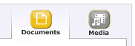  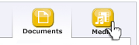 | - Students can toggle between Documents and Media.  - Documents element displays in “active” state  - Media Element displays in “Off” state.  - On hover, Media Element displays in “Over” state.  - When a user hovers over the Media button, rollover text appears: “Browse and play media files”
I-13 | Switch to Document Upload  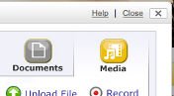  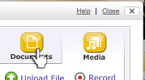 | - Students can toggle between Documents and Media  - Media element displays in “active” state  - Documents Element displays in “Off” state.  - On hover, Documents Element displays in “Over” state.  - When a user hovers over the Documents button, rollover text appears: “Browse and download documents”
I-14 | Browser Playback | - Students can view by clicking Thumbnail or title  - When a user hovers over the Thumbnail or Title, hover text appears: “Play file”  - If the recording or uploaded file is still processing and not yet ready for playback or download, a processing indicator will appear.  - The label of the download action in the context menu reads, "Processing download...," until the download version of the file is ready and available for download.  - If users click on "Processing download..." in the context menu before the file is ready for download, a message dialogue appears to let the user know that the file is not yet ready. (US35521)  - The thumbnail for a file that is not yet ready for playback indicates that the media is not yet available.  - If users click on the thumbnail or title of a media file that is not yet ready for playback, the player launches in a new window and displays a message saying that the file is not yet ready.

