Community Evaluator Control Panel (ECP) Functional Specification
Release 3.2

Version 3.4

RED = OPEN ISSUE
BLUE = MODIFICATION

Document Version History
Version | Date | Author(s) | Notes
1.0 | 2/28/2008 | Shelley McLaughlin | Initial Draft for Stakeholder Review
1.1 | 4/3/2008 | Shelley McLaughlin | Updated the number of attachments associated to a contribution from three to five
2.0 | 11/14/08 | Shelley McLaughlin | Updated to reflect the changes implemented to the UI presentation as part of the Community UI Refresh project. Changes limited to Interaction Diagrams
3.0 | 2/27/09 | Shelley McLaughlin | Updated to reflect the changes to be implemented as part of the Notification Requirements for Release 2.9
3.1 | 3/12/09 | Shelley McLaughlin | Initial Changes from the FS Review
3.2 | 3/27/09 | Shelley McLaughlin | Email subject lines and from email address added
3.3 | 4/17/09 | Shelley McLaughlin | Updated to include text changes defined in CR010949
3.4 | 4/24/09 | Shelley McLaughlin | Updated 4.1.3.5, 4.1.3.6, 4.1.4.5, 4.1.4.7 with additional clarification “If a community does not have custom login page, users without SSO sessions will be directed to the general community login page. If a community does have a custom login page, users will be taken there for authentication”
3.5 | 1/21/10 | Andy Trus | Updated to include new edit, view, and create a contribution pages.

Questions/Issues
ID | Status | Question/Issue | Resolution
1 | Closed | For the linking back to the community from an email capability, how do we need to handle this? I  - Provide a general login page for entering username/password needed? If Option A if selected, need the UX team to design this login view.  - Redirect users to the community’s login page f we redirect the user would the individual community login page need to be changed in order to support the direct access to the specific contribution after authentication? If so we need to provide a cookbook of sorts to the communities and update the sample login templates we are providing the communities. | For the initial release, a generic log in page will be used.

Table of Contents
1. Evaluator Control Panel (ECP) Multiple/Single Select Views for Contributions 4
1.1.1. Requirements 4
1.1.2. Interaction Diagram 4
1.1.3. Prototypes 4
1.1.4. Elements (Contributions Main Page) 8
2. Evaluator Control Panel (ECP) - View Contribution/Add and Delete Comments 16
2.1.1. Requirements 16
2.1.2. Interaction Diagram 16
2.1.3. Prototypes 16
2.1.4. Elements (View Contribution and Add/Delete Comments) 18
3. Evaluator Control Panel (ECP)-Create/ Edit Contributions 26
3.1.1. Requirements 26
3.1.2. Interaction Diagram 26
3.1.3. Prototypes 27
3.1.4. Elements Default View (Not Edit Mode) 27
3.1.5. Elements (Edit a Contribution Page) 40
4. ECP- Contribution Status Change Emails 50
4.1.1. Requirements 50
4.1.2. Prototypes 50
4.1.3. Elements (Approved Contribution Email) 50
4.1.4. Elements (Rejected Contribution Email) 52

Evaluator Control Panel (ECP) Multiple/Single Select Views for Contributions
NOTE: SOME SCREENSHOTS ARE BASED ON CKR AS THE EXAMPLE COMMUNITY. THE GENERALIZED CONTENT IS REPRESENTED IN THE DETAILED TEXT

Requirements
The Evaluator Control Panel (ECP) enables user with Evaluator and Administrators subscription roles to review all existing consortium contributions, process pending contributions for approval or denial, modify or update contributions and make contributions to the consortium content.

Interaction Diagram
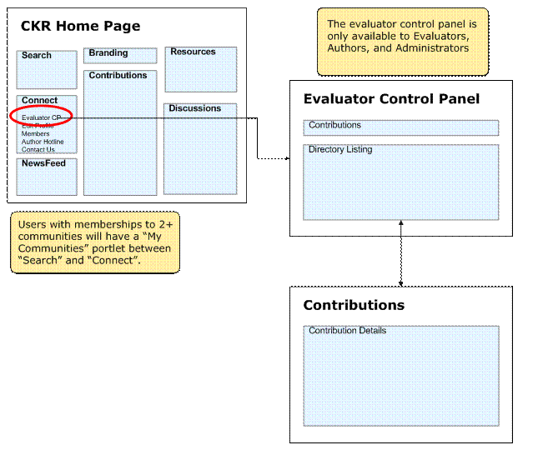

Prototypes
The following prototypes are typical views for the user roles indicated.

Evaluator and Administrator Contributions (Default – Nothing Selected)

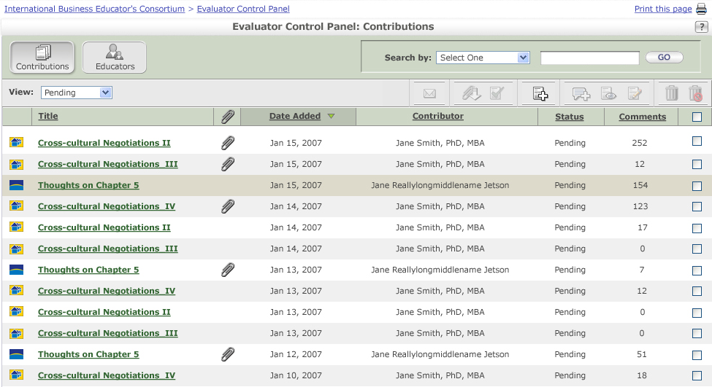

Evaluator and Administrator Contributions (Single Select View)

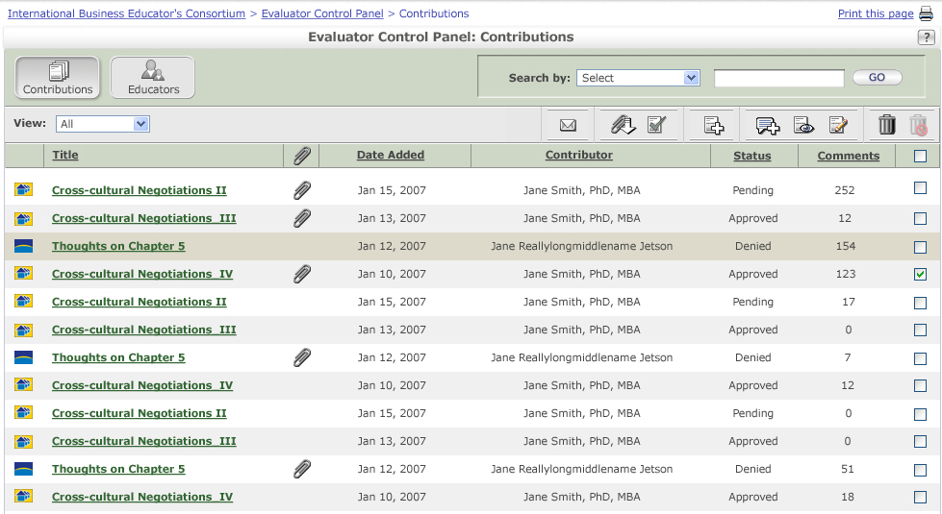

Evaluator and Administrator Contributions (Multiple Select View)

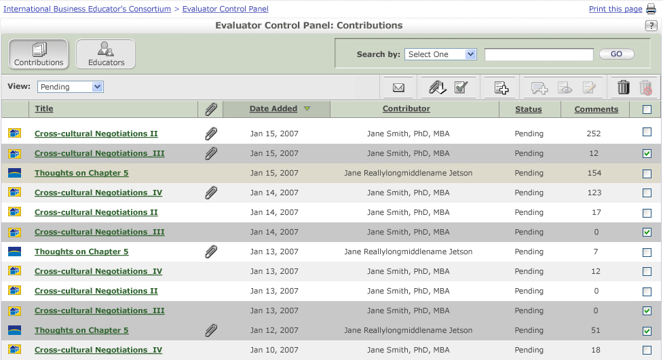

Evaluator and Administrator Contributions (Set Status Pop Up)

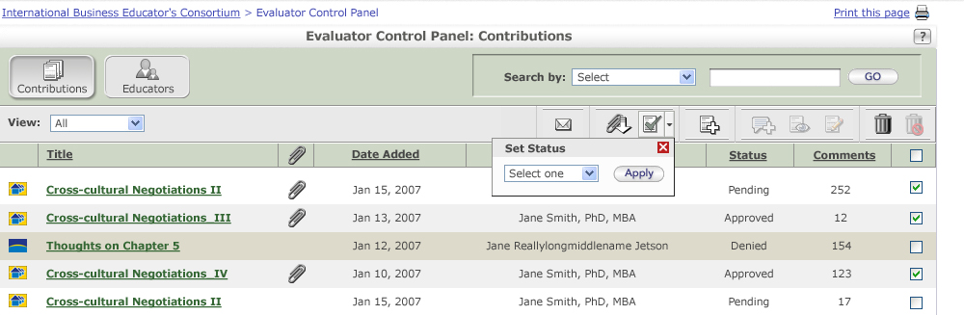

Evaluator and Administrator Contributions (Filtered View)

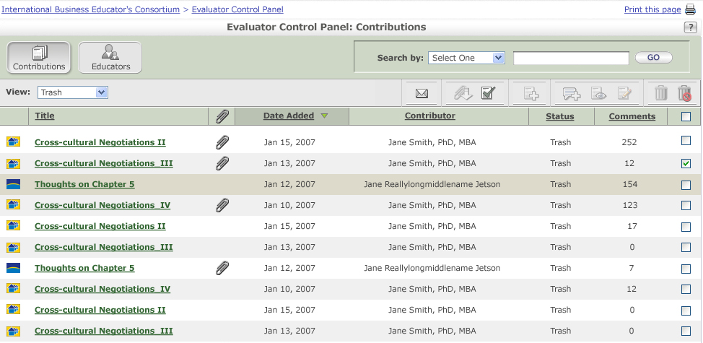

Elements (Contributions Main Page)
Note: All page elements will be displayed for all user types unless specifically noted otherwise.
ID | Sub Roles | Element | Behavior
1.1.4.1 | Roles =  Evaluator  Admin | Breadcrumb Navigation  COMMUNITY NAME> Evaluator Control Panel  Or if user has performed a search  COMMUNITY NAME> Evaluator Control Panel > Search Results | - Clicking COMMUNITY NAME takes the user back to the default view of the Community Tab  - Clicking the Evaluator Control Panel takes the user back to the default list view of the ECP
1.1.4.2 | Roles =  Evaluator  Admin | Evaluator Control Panel Help button | - This button shall link to the following in a secondary window constrained to 600x400:  - Link: (COMMUNITY BASE HELP URL)/ECP/ECP.htm  - The Help icon will be displayed within the portlet content rather than as an element of the Portal theme.
1.1.4.3 | Roles =  Evaluator  Admin | Evaluator Control Panel Print button | - This link and button shall open the browser’s print dialog box, and print the contents of the page in a reader-friendly format using CSS.  - Shall provide the ability to print the list view of all contributions.
1.1.4.4 | Roles =  Evaluator  Admin | Contributions button   | - Selected state  - Displays the default contribution list view (sorted by date – with most recent at the top)
1.1.4.5 | Roles =  Evaluator  Admin | Directory button   | - Takes the user to the Directory Default List View  - Note: The graphic for this image may change for Release 2.6 – time permitting.
1.1.4.6 | Roles =  Evaluator  Admin | Search by (drop-down) | - Shall provide a drop-down options menu that provides the ability for a user to access select one of the options.  - Default value is Select  - The values of the drop-down menu should be:  - Date Added (shall be default sorted by most recent)  - Contributor  - CONTRIBUTION TITLE LABEL  - Searching by Date Added returns all contributions matching the entered date  - Search by Contributor returns all contributions with contributor names (first or last) matching the search criteria  - Search by CONTRIBUTION TITLE LABEL returns all contributions with titles matching the search criteria  - Searches only this community. The ECP doesn’t not cross communities. To search or view contributions in another community the user must switch there entire context to that community.
1.1.4.7 | Roles =  Evaluator  Admin | Search by  If Contributor or Title Selected  If Date is Selected  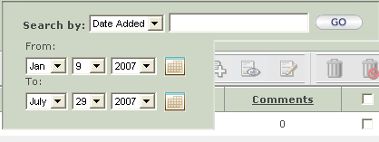 | - Shall support keyword searching.  - Text Field is not case sensitive  - If Date Range selected – will display a date picker for From and To dates with Month/Day/Year and calendar picking icon.  - If user selects a To date prior to the From Date – display error message in a pop-up  - If user selects an invalid date, display error message in a pop-up  - Text box will be disabled if the Date Added option is selected  - Search results will be returned with a case sensitive sort
1.1.4.8 | Roles =  Evaluator  Admin | Go button | - Initiates the full text search based on the selected search target (date, title, and contributor) and the key word entered.  - If a user clicks GO without specifying any search criteria then all Contributions will be returned.  - If the user has not selected what to search by (Title, Contributor, or Date, display the following message in a pop up when the user clicks Go. “Please select your Search By criteria.” The Ok button closes the popup and user can select a value from the search by dropdown.
1.1.4.9 | Roles =  Evaluator  Admin | Status (drop-down) | - Shall provide the ability for a user to select one of the following by which to filter the list view  - Pending (Default View selection for the list)  - All  - Approved  - Denied  - Trash  - Archived  - When All is selected, shall provide the ability for a user to view a list of “All” contributions to the consortium.  - Pending shall be the default status.  - Shall provide the ability for a user to view a list of all contributions in the consortium matching the selected status  - If the user is currently viewing search results and then chooses to filter using the View dropdown – the result set will be the original search results filtered by the selected view value.
1.1.4.10 | Roles =  Evaluator  Admin | Icon – Email Contributor(s) | - Rollover Text: Email Contributor(s)  - Shall provide the ability for the system to send an email message to the contributors of the selected contributions  - Enabled when one or more contributions are selected  - A Mail To will be used here. The user’s mail client will be launched when this is clicked with the email address of the contributor who submitted this contribution.
1.1.4.11 | Roles =  Evaluator  Admin | Icon – Download Contribution Attachments | - Rollover Text: Download Contribution Attachment(s)  - Shall provide the ability for a user to download contribution attachments.  - Enabled when one or more contributions is selected  - All attachments associated to the selected contribution(s) will be added into a single zip file for download to the user’s computer. User will specify the location of the zip file on local computer or chose standard Open Now option.  - Zip file will create one directory for each contribution selected to avoid file name collisions. The naming convention will be # - Contribution Title.
1.1.4.12 | Roles =  Evaluator  Admin | Icon - Set Contribution Status | - Rollover Text: Set Contribution Status  - Shall provide the ability for a user to change the status of one or more selected contributions. Displays Set Status pop up  - Enabled when one or more contributions is selected
1.1.4.13 | Roles =  Evaluator  Admin | 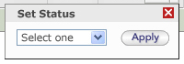 | - Shall provide the ability for a user to select a status from the dropdown list and click Apply to change the status of all selected contributions.  - List of supported statuses included in the dropdown are: Approved, Denied, Pending, Trash, Archive  - Statuses can be changed from any status to any status.  - Changing the status of a contribution from Any Status to Approved will trigger the Contribution Approved Email Message to be sent (See Section 4.1.3)  - Changing the status of a contribution from Any Status to Denied will trigger the Contribution Denied Email Message to be sent (See Section 4.1.4)
1.1.4.14 | Roles =  Evaluator  Admin | Icon – Make Contribution | - Rollover Text: Make a Contribution  - Shall open the Make a Contribution screen in the ECP. See Section 3.  - Icon is always Enabled on the Contribution List View
1.1.4.15 | Roles =  Evaluator  Admin | Icon: Adding a Comment | - Rollover Text: Add Contribution Comment  - Shall link the user to the view contribution page with Add Comments. Allows user to view all comments associated to the selected contribution and add an additional comment  - Icon will be enabled when only one contribution is selected.
1.1.4.16 | Roles =  Evaluator  Admin | Icon – Edit Contribution | - Rollover Text: Edit Contribution  - Shall provide the ability for a user to edit a contribution.  - Shall open the Edit Contribution view in the ECP. See Section 3.  - Icon will be Enabled when only one contribution is selected
1.1.4.17 | Roles =  Evaluator  Admin | Icon – View Contribution | - Rollover Text: View Contribution  - Shall provide the ability for a user to view the contribution.  - Opens a “View a Contribution” page in the ECP. See Section 2  - Icon will be Enabled when only one contribution is selected
1.1.4.18 | Roles =  Evaluator  Admin | Icon – Trash | - Rollover Text: Set Contribution Status to Trash  - Selecting the Trash icon will change all selected contributions to a status of “Trash  - Icon will be Enabled when one or more contributions is selected
1.1.4.19 | Roles =  Admin | “Empty the Trash” Icon  For Admins  For Non-Admins | - Rollover Text: Permanently Delete Contributions  - The Empty Trash icon will be selectable only be Administrators  - Icon will be enabled for the Admin if one or more contributions are selected.  - Selecting Empty Trash will permanently delete all selected contributions regardless of status. i.e. they could permanently delete something in archive status for example.  - Administrator will be prompted to confirm delete before emptying trash
1.1.4.20 | Roles =  Evaluator  Admin | Category Icon | - Displays the category icon set up for the category to which the contribution is associated. Categories and Category icons are defined via the community admin tool.
1.1.4.21 | Roles =  Evaluator  Admin | Title Column Header | - Column Header label shall display the CONTRIBUTION TITLE LABEL.  - Contains the name of the contribution title.  - Column Header shall provide the ability to sort in ascending or descending A-Z order.
1.1.4.22 | Roles =  Evaluator  Admin | Title of Contribution (link) | - Click a contribution title in the link Shall link to the “View Contribution Page” – See Section 2  - If contributed by an Evaluator or Admin the row will have a special treatment, of a middle gray highlighting  - List contains only contributions for this community. The ECP views do not cross communities.
1.1.4.23 | Roles =  Evaluator  Admin | Attachment Column Header | - Indicates if an attachment is provided with the contribution.
1.1.4.24 | Roles =  Evaluator  Admin | Date Added Column Header | - Shall display the date of the contribution.  - Column Header shall provide the ability to sort in ascending or descending order according to date.
1.1.4.25 | Roles =  Evaluator  Admin | Date Added | - Shall display the date of the contribution was added to the system
1.1.4.26 | Roles =  Evaluator  Admin | Contributor Column Header | - Shall display the full name of the user who created the listed contribution Last Name, First Name based on SMS data.  - Column Header shall provide the ability to sort in ascending or descending A-Z order.
1.1.4.27 | Roles =  Evaluator  Admin | Contributor Name  Last Name, First Name | - The user’s name will be sourced from SMS and will follow this display convention: Last, First
1.1.4.28 | Roles =  Evaluator  Admin | Status Column Header | - Shall display the current status of the contribution.  - Column Header shall provide the ability to sort in ascending or descending A-Z order.
1.1.4.29 | Roles =  Evaluator  Admin | Status Value | - Displays the current status of the contribution  - Valid Status Values include Pending, Approved, Denied, Archived, Trash
1.1.4.30 | Roles =  Evaluator  Admin | Number of Comments Column | - Contains the number of comments for a contribution  - Shall provide the ability to sort in ascending or descending numerical order.
1.1.4.31 | Roles =  Evaluator  Admin | Number of Comments | - Displays the current number of comments associated to the contribution
1.1.4.32 | Roles =  Evaluator  Admin | Check Box Column Header | - Contain a check box for selecting each contribution  - Selecting the column header causes all checkboxes to be selected on the current page view of the contributions.  - Deselecting the column header – unchecks all the checkboxes (Acts as a toggle)
1.1.4.33 | Roles =  Evaluator  Admin | Check Box (select/deselect) | - Provides the ability for the user to select one or more contributions to perform the associated icon actions on.  - Shall provide the ability to select or deselect the check box.  - Actions supported if single checkbox selected include Add Comment, Edit Contribution, View Contribution, Email Contributor, Make a Contribution, Download Attachment, Set Status, Trash, Empty Trash (if admin)  - Actions supported if multiple checkboxes selected Email Contributor(s), Make a Contribution, Download Attachments, Set Status, Trash, Empty Trash (if admin)  - If check box is selected then the row will be highlighted
1.1.4.34 | Roles =  Evaluator  Admin | Pagination  Example: | - Pagination shall be displayed if there are more than 10 contributions than the value selected.  - The “< Previous> link shall be displayed on all page sets except for the first  - <Clicking “< Previous” shall refresh the current page and display the previous set of contributions.  - The numbers 1-n shall be displayed, where n is the total number of page sets.  The number representing the currently viewed page set shall not be a link.  The number(s) representing the page set(s) not currently viewed shall be links to the respective page set(s).  - A “Next >” link shall be displayed on all page sets except for the last.  Clicking “Next >” shall refresh the current page and display the next set of contributions.
1.1.4.35 | Roles =  Evaluator  Admin | Show All/Paginate   | - Click the Show All link – removes the current contribution pagination and redisplays the view with all contributions listed.  - If user has filtered the view or reached the view from a search result these filters should be retained when clicking Show All. Should permit for example the ability to Show All items in a Trash state in a single list view.  - If Show All selected, the label will become Paginate

Confirmation Messages
Message | Message Displayed
Permanently Delete Contribution | Clicking the Delete Icon displays the following message.  Are you sure you wish to remove these contribution(s) from the system? [Cancel] [OK]  Cancel returns the user to the screen they were viewing  OK deleted the selected contribution or contribution(s) and refreshes the list view with the contributions removed
No Attachment To Download | Error Message displayed if selecting a single contribution for which to download an attachment and there is no attachment  “This action cannot be completed. The contribution you have chosen does not contain an attachment.” [OK]  OK – closes the Alert pop up.  Error Message if selecting multiple contributions for which to download attachments and one or more has no attachment.  “This action cannot be completed. One of the contributions you have chosen does not contain an attachment.”  OK – closes the Alert pop up
No Matching Search Results | Error Message to be displayed if no contributions match the entered search results. Text should state the following.  Your search criteria shows “0” results. To search again, please use the following guidelines:  - Check the spelling of all search terms  - Wildcards are not supported in the search; try another search term  - If searching by dates, consider expanding selected date range
No Matching Filter (View) Results | Error Message to be displayed if no contributions match the selected view filter  "There are currently no contributions with a status of ${viewStatus} in the system."
No Matching Filter and Search Results | Error Message to be displayed if no contributions match the selected view filter and the entered Search criteria combined.  "Your search results do not contain any contributions with a status of ${viewStatus}."

Evaluator Control Panel (ECP) - View Contribution/Add and Delete Comments
NOTE: ALL SCREENSHOTS ARE BASED ON CKR AS THE EXAMPLE COMMUNITY. THE GENERALIZED CONTENT IS REPRESENTED IN THE DETAILED TEXT

Requirements
The Evaluator Control Panel (ECP) enables user with Evaluator and Administrators roles to review all existing consortium contributions, process pending contributions for approval or denial, modify or update contributions and make contributions to the consortium content.

Interaction Diagram

Prototypes
The following prototypes are typical views for the user roles indicated.

Evaluator and Administrator (View Contribution & Add/Delete Comments)

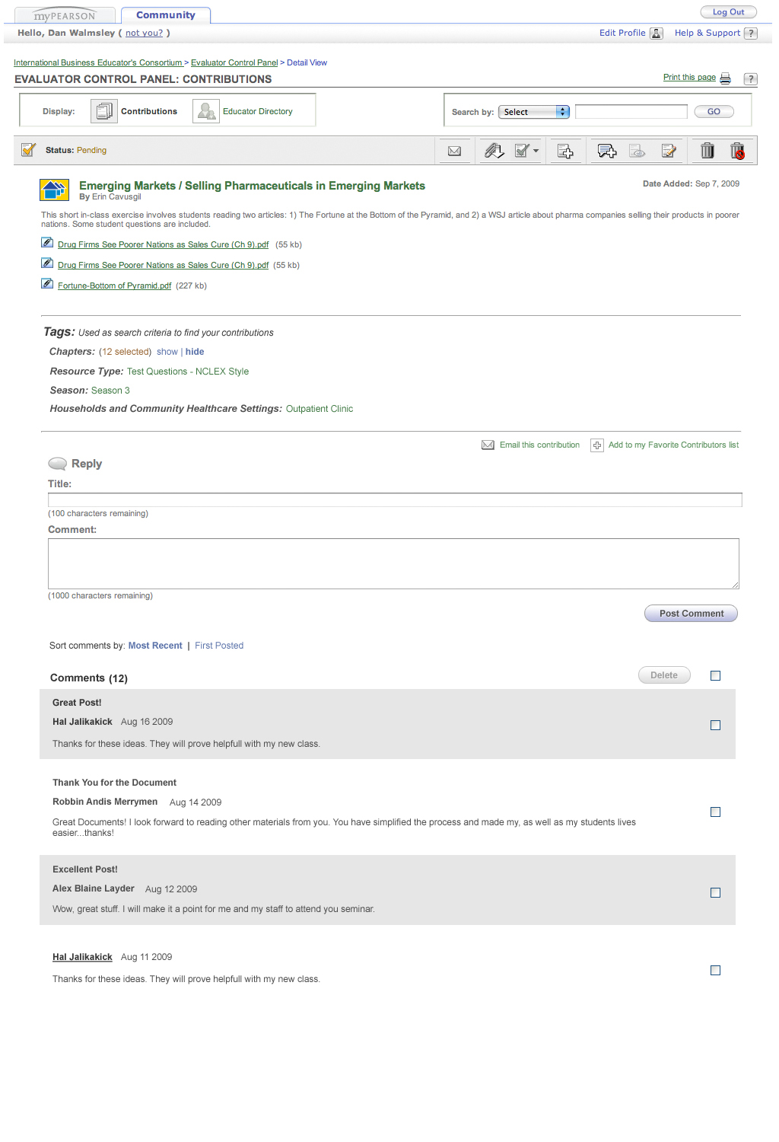

Elements (View Contribution and Add/Delete Comments)
Note: All page elements will be displayed for all user types unless specifically noted otherwise.
ID | Sub. Role | Element | Behavior
2.1.4.1 | Roles =  Evaluator  Admin | Breadcrumb Navigation  COMMUNITY NAME > Evaluator Control Panel > Detail View | - Clicking COMMUNITY NAME takes the user back to the default view of the Community Tab  - Clicking Evaluator Control Panel link takes the user back to the Default ECP Contribution View
2.1.4.2 | Roles =  Evaluator  Admin | Help button | - This button shall link to the following in a secondary window constrained to 600x400:  Link: (COMMUNITY BASE HELP URL)/ECP/ECP.htm  - The Help icon will be displayed within the portlet content rather than as an element of the Portal theme.
2.1.4.3 | Roles =  Evaluator  Admin | Print button | - This link and button shall open the browser’s print dialog box, and print the contents of the page in a reader-friendly format using CSS.  - Shall provide the ability to print the contribution being viewed
2.1.4.4 | Roles =  Evaluator  Admin | Contributions button | - Selected state
2.1.4.5 | Roles =  Evaluator  Admin | Educators button | - Takes the user to the Directory Default List View  - Note: The graphic for this image may change for Release 2.6 – time permitting.
2.1.4.6 | Roles =  Evaluator  Admin | Search by (drop-down) | - Shall provide a drop-down options menu that provides the ability to access select one of the options.  - Default value is Select  - The values of the drop-down menu should be:  - Date Added (Shall be default sorted by most recent) – This is a date range  - Contributor  - CONTRIBUTION TITLE LABEL  - Searching by Date Added returns all contributions matching the entered date  - Search by Contributor returns all contributions with contributor names (first or last) matching the search criteria  - Search by CONTRIBUTION TITLE LABEL returns all contributions with titles matching the search criteria  - Searches only this community. The ECP doesn’t not cross communities. To search or view contributions in another community the user must switch there entire context to that community.
2.1.4.7 | Roles =  Evaluator  Admin | Search by  If Contributor or Title Selected  If Date is Selected | - Shall support keyword searching.  - Text Field is not case sensitive  - If Date Range selected – will display a date picker for From and To dates with Month/Day/Year and calendar picking icon.  - If user selects a To date prior to the From Date – display error message in a pop-up  - If user selects an invalid date, display error message in a pop-up  - Text box will be disabled is search by Date Added is selected.  - Search results will be returned with a case sensitive sort
2.1.4.8 | Roles =  Evaluator  Admin | Go button | - Initiates the full text search based on the selected search target (date, title, and contributor) and the key word entered.  - List of nodes shall return – See Section 1.  - If the user has not selected what to search by (Title, Contributor, or Date) display the following message in a pop up when the user clicks Go. “Please select your Search By criteria.” The Ok button closes the popup and user can select a value from the search by dropdown.
2.1.4.9 | Roles =  Evaluator  Admin | Status | - Display the current contribution status  - Valid Statuses include Approved, Pending, Archived, Denied, Trash
2.1.4.10 | Roles =  Evaluator  Admin | Icon – Email Contributor(s) | - Rollover Text: Email Contributor(s)  - Shall provide the ability for the system to send an email message to the contributor of the contribution being viewed  - A Mail To will be used here. The user’s mail client will be launched when this is clicked with the list of email addresses corresponding to the contributors of the selected contributions.  - Icon is always enabled on this view
2.1.4.11 | Roles =  Evaluator  Admin | Icon – Download Contribution Attachments | - Rollover Text: Download Contribution Attachment(s)  - Shall provide the ability to download an attached artifacts associated to the contribution being viewed  - All attachments associated to the selected contribution will be added into a single zip file for download to the user’s computer. User will specify the location of the zip file on local computer or chose standard Open Now option.  - Icon is always enabled on this view when one or more attachment is present
2.1.4.12 | Roles =  Evaluator  Admin | Icon - Set Contribution Status | - Rollover Text: Set Contribution Status  - Shall provide the ability for a user to change the status of the selected contribution. Displays Set Status pop up  - Icon is always enabled on this view
1.1.4.13 | Roles =  Evaluator  Admin |  | - Shall provide the ability for a user to select a status from the dropdown list and click Apply to change the status of the contribution being viewed.  - List of supported statuses included in the dropdown are: Approved, Denied, Pending, Trash Archive  - Changing the status of a contribution from Any Status to Approved will trigger the Contribution Approved Email Message to be sent (See Section 4.1.3)  - Changing the status of a contribution from Any Status to Denied will trigger the Contribution Denied Email Message to be sent (See Section 4.1.4)
2.1.4.14 | Roles =  Evaluator  Admin | Icon – Make Contribution | - Rollover Text: Make a Contribution  - Shall open the Make a Contribution screen in the ECP. See Section 3.  - Icon is always enabled on this view
2.1.4.15 | Roles =  Evaluator  Admin | Icon: Adding a Comment | - Rollover Text: Add Contribution Comment  - Shall move the user to the Add Comment field anchor at the bottom of this view  - Icon is always enabled on this view
2.1.4.16 | Roles =  Evaluator  Admin | Icon – Edit Contribution | - Rollover Text: Edit Contribution  - Shall provide the ability for the user to edit a contribution.  - Shall open the Edit Contribution view in the ECP. See Section 3.  - Icon is always enabled on this view
2.1.4.17 | Roles =  Evaluator  Admin | Icon – View Contribution | - Rollover Text: View Contribution  - Icon will be disabled on this view
2.1.4.18 | Roles =  Evaluator  Admin | Icon – Trash | - Rollover Text: Set Contribution Status to Trash  - Selecting the Trash icon will change the contributions being viewed to a status of “Trash
2.1.4.19 | Roles =  Admin | “Empty the Trash” Icon  For Admins  For Non-Admins | - Rollover Text: Permanently Delete Contributions  - The Empty Trash icon will be selectable only be Administrators  - Icon will be enabled for the Admin if one or more contributions are selected.  - Selecting Empty Trash will permanently delete all selected contributions regardless of status. i.e. they could permanently delete something in archive status for example.  - Administrator will be prompted to confirm delete before emptying trash
2.1.4.20 | Roles =  Evaluator  Admin | Contribution Title | - Shall display the name of the contribution.
2.1.4.21 | Roles =  Evaluator  Admin | Contributor Name | - First and Last Name of the user who created the currently viewed contribution shall be displayed.
2.1.4.22 | Roles =  Evaluator  Admin | Date Added | - Label
2.1.4.23 | Roles =  Evaluator  Admin | Date | - Date the contribution being viewed was added to the system Month, DD, YYYY format.
2.1.4.24 | Roles =  Evaluator  Admin | Optional Element – Multi-level communities only  Book:  Example  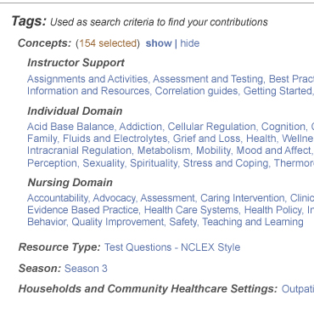 | - If the community has a multi-level taxonomy, then this field will display the name of the Multi-Level: Title node, above the Multi-Level Chapter Numeric or Multi-Level Chapter None node associated to this contribution. The names/values for these elements are defined in the admin tool.  - Display in parenthesis next to the field name label, “<number of selections> selected”  - By default, show all tags. Show should be bold and non-clickable while hide should be non-bold and clickable. Hovering over hide will display an underline.  - The visual treatment of show and hide should swap upon the other being clicked.  - Do not display the title of the level if there are no tags within it.  - Clicking a tag will initiate a search on that term and return all matching search results.  - Users will not be permitted to search by Multi-level: Titles in a multi-level taxonomy. They will be non-clickable.
2.1.4.25 | Roles =  Evaluator  Admin | Category Icon  Example Icon | - Displays the category icon set up for the category to which the contribution is associated. Categories and Category icons are defined via the community admin tool.
2.1.4.26 | Roles =  Evaluator  Admin | Single-level communities - Chapter Label and Value  Example: 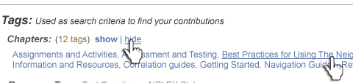 | - Displays the tags associated with the selected Contribution along with the field name label  - Display in parenthesis next to the field name label, “<number of selections> selected”  - By default, show all tags. Show should be bold and non-clickable while hide should be non-bold and clickable. Hovering over hide will display an underline.  - The visual treatment of show and hide should swap upon the other being clicked.  - Clicking a tag will initiate a search on that term and return all matching search results.
2.1.4.27 | Roles =  Evaluator  Admin | Chapter Item Value  Example | - Shall display the number of the chapter associated to this contribution. Shall NOT link to any additional information or view  - Shall derive this information from the information entered by the educator when they submitted the contribution.
2.1.4.28 | Roles =  Evaluator  Admin | TYPE Label | - Displays the TYPE Label defined in the community admin tool.  - Display under the Tags section of the page.
2.1.4.29 | Roles =  Evaluator  Admin | Type Item Value | - Shall display the type of contribution. Shall NOT link to any additional information or view  - Shall derive this information from the information entered by the user when they submitted the contribution.  - Display under the Tags section of the page.  - Clicking a tag will initiate a search on that term and return all matching search results.
2.1.4.30 | Roles =  Evaluator  Admin | CONTRIBUTION ATTRIBUTE 2 Label  Example | - Displays the CONTRIBUTION ATTRIBUTE 2 Label defined in the community admin tool.  - Display under the Tags section of the page.
2.1.4.31 | Roles =  Evaluator  Admin | Contribution Attribute 2 Item Value  Example | - Shall display the Contribution Attribute 2 value for the contribution, if it exists. Shall NOT link to any additional information or view.  - Shall derive this information from the information entered by the user when they submitted the contribution.  - Display under the Tags section of the page.  - Clicking a tag will initiate a search on that term and return all matching search results.
2.1.4.32 | Roles =  Evaluator  Admin | CONTRIBUTION ATTRIBUTE 2 Label  Example | - Displays the CONTRIBUTION ATTRIBUTE 2 Label defined in the community admin tool.  - Display under the Tags section of the page.
2.1.4.33 | Roles =  Evaluator  Admin | Contribution Attribute 2 Item Value  Example | - Shall display the CONTRIBUTION 2 value associated to the contribution, if it exists. Shall NOT link to any additional information or view.  - Shall derive this information from the information entered by the user when they submitted the contribution.  - Display under the Tags section of the page.  - Clicking a tag will initiate a search on that term and return all matching search results.
2.1.4.34 | Roles =  Evaluator  Admin | Description Text | - Shall display the contribution description for the selected contribution
2.1.4.35 | Roles =  Evaluator  Admin | Name of Attachments (link) | - Shall display a list of any attachments associated to the contribution.  - Shall provide the ability to download a single attached artifact by clicking on the attachment name  - Include the standard attachment icon and file size of the attachment
3.1.3.36 | Roles =  Evaluator  Admin | Suggested Article or Link | - Shall display the contribution Suggested Article or Link text, if it exists
2.1.4.37 | Roles =  Evaluator  Admin | Notes to the Contribution Reviewers: | - Shall display the Notes to the Reviewers entered by the contribution contributor
2.1.4.38 | Roles =  Evaluator  Admin | Comment Top | - Does not display if no comments exist for the selected contribution  - Displays “Comments (Number of Comments)” when at least one comment exists.
2.1.4.39 | Roles =  Evaluator  Admin | Reply | - This element is displayed above the title text field.
2.1.4.40 | Roles =  Evaluator  Admin | Delete (button)  Inactive  Active  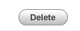 | - When clicked will delete all checked comments  - Disabled if no comments are checked  - User will be required to confirm the deletion of the selected comments  - View Contribution view is refreshed and newly deleted comments no longer appearing
2.1.4.41 | Roles =  Evaluator  Admin | Check box Header | - Checkbox column header
2.1.4.42 | Roles =  Evaluator  Admin | Check box | - Shall provide the ability to select or deselect the check box. One check box will display next to each existing comment  - Shall provide the ability for the user to select comment to be commented when the delete button is pressed with comments checked
2.1.4.43 | Roles =  Evaluator  Admin | Comment | - Display the comment title, comment text, comment author first name last name and the date the comment was submitted  - Information will be repeated for each comment associated with the contribution being viewed.  - Comments are ordered with most recent first  - If contributed by an Evaluator or Admin the Comment row will have special visual treatment
2.1.4.44 | Roles =  Evaluator  Admin | Add Comment Title text field | - Shall contain a field that will be used to enter the title of the comment.  - This is a required field. The system shall support ability to check that all required fields have been populated.  - The information entered in this field shall display in the Search results.  - Shall provide an error message if the user attempts to submit a comment without completing this field.  - The title field will be limited to 100 characters. User will not be permitted to exceed character count.
2.1.4.45 | Roles =  Evaluator  Admin | Add Comment - Comment text field | - This is a required field. Support ability to check that all required fields have been populated.  - Shall provide an error message if the user attempts to submit a contribution without completing this field.  - Up to 1000 characters will be allowed in the description. User will not be permitted to exceed character count.
2.1.4.46 | Roles =  Evaluator  Admin | Post (button)   | - Submits the new comment.  - View Contribution view is refreshed and newly added comment is now listed with other comments  - Comment is flagged for display as from the Review Team
2.1.4.47 | Roles =  Evaluator  Admin | Sort Contribution Comments | - Sort by Most Recent by default.  - Clicking First Posted should sort to show the oldest comment on top.  - The visual treatment of Most Recent and First Posted should swap upon the other being clicked.

Confirmation Messages
Message | Message Displayed
Permanently Delete Contribution | Same as above from list view.
Delete Comment Confirmation | Confirmation displays when delete comment(s) option is clicked  Are you sure you want to delete these comment(s)? [OK] [Cancel]  OK refreshes the view with the comments removed  Cancel closes the dialog box – user remains on the unchanged contribution view
Comment fields not complete | If user does not enter Comment Text and clicks Add Comment will display  You must enter a comment. [OK]  If user does not enter Comment Title and clicks Add Comment will display  You must enter a title. [OK]  If user does not enter Comment Title or Comment field and clicks Add Comment will display  Your must enter a title.  You must enter a comment. [OK]  If user enters too long a comment – Greater than 1000 characters the following error message will be displayed. Includes the number of characters entered by the user  Your comment is too long (#### characters). Please limit your comment to 1,000 characters. [OK]  In all cases OK returns the user to the view contribution view.

Evaluator Control Panel (ECP)-Create/ Edit Contributions
NOTE: SOME SCREENSHOTS ARE BASED ON CKR AS THE EXAMPLE COMMUNITY. THE GENERALIZED CONTENT IS REPRESENTED IN THE DETAILED TEXT

Requirements
The Evaluator Control Panel (ECP) enables user with Evaluator and Administrators roles to review all existing consortium contributions, process pending contributions for approval or denial, modify or update contributions and make contributions to the consortium content.

Interaction Diagram

Prototypes
The following prototypes are typical views for the user roles indicated.

Evaluator and Administrator (Create a Contribution View)
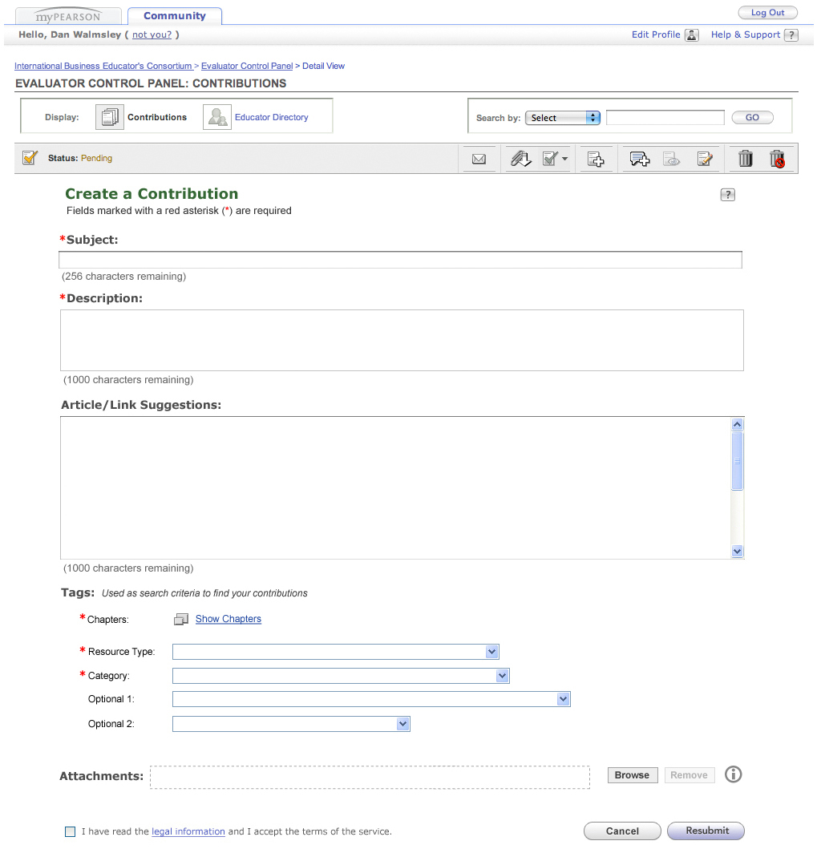

Elements Default View (Not Edit Mode)
Note: All page elements will be displayed for all user types unless specifically noted otherwise.
ID | Sub Role | Element | Behavior
3.1.4.1 | Roles =  Evaluator  Admin | Breadcrumb Navigation  COMMUNITY NAME> Evaluator Control Panel > Make a Contribution | - Clicking COMMUNITY NAME takes the user back to the default view of the Community Tab  - Click the Evaluator Control Panel link takes the user back to the default view of the Contributions List in the ECP
3.1.4.2 | Roles =  Evaluator  Admin | Help button | - This button shall link to the following in a secondary window constrained to 600x400:  Link: (COMMUNITY BASE HELP URL)/ECP/ECP.htm  - The Help icon will be displayed within the portlet content rather than as an element of the Portal theme.
3.1.4.4 | Roles =  Evaluator  Admin | Contributions button | - Selected
3.1.4.5 | Roles =  Evaluator  Admin | Directory button | - Disabled in Make Contribution View
3.1.4.6 | Roles =  Evaluator  Admin | Search by (drop-down – text field – Go button) | - Disabled on Make a Contribution View
3.1.4.7 | Roles =  Evaluator  Admin | View Filter | - Disabled on the Make a Contribution View
3.1.4.8 | Roles =  Evaluator  Admin | Action Icons  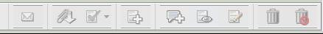 | - All the action icons are disabled on the Make a Contribution View: Email, Attachments, Status, Make Contribution, Add Community , View Contribution, Edit Contribution, Trash, Permanently Delete
3.1.4.9 | Roles =  Evaluator  Admin | Page Title  Example:   | - Title of the page
3.1.4.10 | Roles =  Evaluator  Admin | Instructional Text  Example:  Fields marked with a red asterisk (*) are required | - Instructional Text for the User
3.1.4.11 | Roles =  Evaluator  Admin | Contributor Information | Contributor information shall include the following personal information:  - Name (Required field – Data from SMS)  - Email Address (Required field – Data from SMS)  - Institution Affiliation (Required field – Data from SMS)  - Faculty Personal Homepage URL/Website
3.1.4.12 | Roles =  Evaluator  Admin | Name  Non-editable display text | - This is a required field. The system shall support ability to check that all required fields have been populated.  - Data shall populate with information from the SMS.  - The Name field will be created by concatenating the first and last name of the user as supplied by SMS
3.1.4.13 | Roles =  Evaluator  Admin | Email Address  Non-editable display text | - This is a required field. The system shall support ability to check that all required fields have been populated.  - Data shall populate with information from the SMS or if the user has a different address in the Directory for this community, the Directory address will be used.
3.1.4.14 | Roles =  Evaluator  Admin | Institution Affiliation  Non-editable display text | - This is a required field. The system shall support ability to check that all required fields have been populated.  - Data shall populate with information from the SMS.
3.1.4.15 | Roles =  Evaluator  Admin | Faculty Personal Homepage URL  Non-editable display text | - This is NOT a required field.  - This field will be populated if the user has a URL in the Directory for this community.  - This will not be editable from this view.  - If the user does not have a URL in their profile the view will display the text - Not Available
3.1.4.16 | Roles =  Evaluator  Admin | Contribution Metadata | Contribution Metadata shall include the following fields:  - CONTRIBUTION TITLE LABEL (Required field)  - Description (Required field)  - CHAPTER LABEL (Required field)  - TYPE LABEL (Required field)  - CONTRIBUTION ATTRIBUTE 1  - CONTRIBUTION ATTRIBUTE 1  - CATEGORY LABEL (Required field)
3.1.4.17 | Roles =  Evaluator  Admin | Subject Label & Field | - Field label will be pulled from the Community Admin Tool – Contribution Title Label field  - This is a required field. The system shall support ability to check that all required fields have been populated.  - The information entered in this field shall display in the Search results.  - Shall provide an error message if the user attempts to submit a contribution without completing this field.  - The title field will be limited to 256 characters. User will not be permitted to exceed character count. Character Count will be displayed below when the field is active.
3.1.4.18 | Roles =  Evaluator  Admin | Description Label & Field | - Field label will defaulted to description as a default community setting.  - This is a required field. Support ability to check that all required fields have been populated.  - The information entered in this field will display in the Search results.  - Shall provide an error message if the user attempts to submit a contribution without completing this field.  - Up to 256 characters will be allowed in the description. User will not be permitted to exceed character count. Character Count will be displayed below when the field is active.
3.1.4.19 | Roles =  Evaluator  Admin | Chapter Label | - Field label will be pulled from the Community Admin Tool – Chapter Label field  - This is a required field.  - Shall provide an error message if the user attempts to submit a contribution without completing this field.  - Clicking “Show <variable>” will launch a lightbox allowing the user to select the fields they would like. This lightbox is described in element 3.1.3.7.  - If the user has made at least 1 selection, display the number of selections in parenthesis, with the word “selected” after it.
3.1.4.19b | Roles =  Evaluator  Admin | Chapter Selection Box  Multi-Level Taxonomy Example  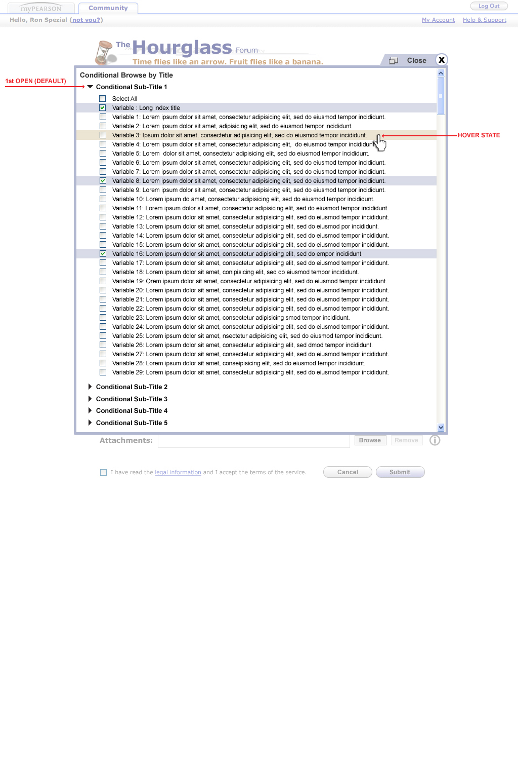  Single Book: Example CKR  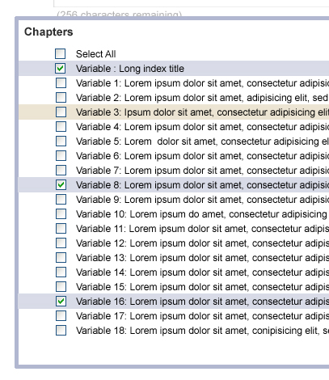 | Multi-Level Taxonomies  - Lightbox should have width of 830. Height should expand to fit contents up to maximum available height based on the browser's viewport  - The background color of the row should change to a blue gray (#d9dbe8) after it has been selected. If is subsequently unselected, the background color of the row should change back to white.  - The background color of the row should change to a light brown (#ebe4d2) when the user hovers over any part of it.  - Clicking anywhere on the row, not just the checkbox, should select the row. Clicking it again should unselect the row.  - Include Select All within each level. Clicking this will select all fields within that level. Clicking it a 2nd time will deselect all fields within that level. If the user clicks Select All, but deselects at least one field, uncheck the Select All field.  - Each level should be able to be expanded or collapsed separate from the other levels.  - Expand first level by default. Collapse all other levels by default.  - Display top-level field name on top (I.E. concepts) in bold.  - Clicking anywhere on the Close tab on the top-right corner will close the lightbox.  Single-Level Taxonomies  - Lightbox should have width of 830. Height should expand to fit contents up to maximum available height based on the browser's viewport  - The background color of the row should change to a blue gray (#d9dbe8) after it has been selected. If is subsequently unselected, the background color of the row should change back to white.  - The background color of the row should change to a light brown (#ebe4d2) when the user hovers over any part of it.  - Clicking anywhere on the row, not just the checkbox, should select the row. Clicking it again should unselect the row.  - Include Select All. Clicking this will select all fields. Clicking it a 2nd time will deselect all fields within that level. If the user clicks Select All, but deselects at least one field, uncheck the Select All field.  - Display top-level field name on top (I.E. book) in bold.  - Clicking anywhere on the Close tab on the top-right corner will close the lightbox.
3.1.4.20 | Roles =  Evaluator  Admin | Type Label & Dropdown | - Field label will be pulled from the Community Admin Tool – Type Label field  - Shall contain a drop-down menu to select one of the type items set up for this community via the admin tool. Type items will be listed in the order defined in the admin tool.  - Default option: Select a <TYPE LABEL>  - This is a required field. Support ability to check that all required fields have been populated.  - Shall provide an error message if the user attempts to submit a contribution without completing this field.
3.1.4.21 | Roles =  Evaluator  Admin | Contribution Attribution 1 Label & Dropdown (Example Region) | - Field label will be pulled from the Community Admin Tool – Contribution Attribute 1 Label field  - Shall contain a drop-down menu to select one of the Contribution Attribute 1 items set up for this community via the admin tool. Cont. Attribute items will be listed in the order defined in the admin tool.  - Default option: Select a <CONT ATTRIBUTE 1>  - This is an optional field
3.1.4.22 | Roles =  Evaluator  Admin | Contribution Attribute 2 Dropdown (Example Language) | - Shall contain a drop-down menu to select one of the Contribution Attribute 2 items set up for this community via the admin tool. Cont. Attribute items will be listed in the order defined in the admin tool.  - Default option: Select a Language  - This is an optional field.
3.1.4.23 | Roles =  Evaluator  Admin | Category Drop Down | - Label and Dropdown will always appear in the ECP.  - Field label will be pulled from the Community Admin Tool – Category Label field  - Shall contain a drop-down menu to select one of the Category items set up for this community via the admin tool. Type items will be listed in the order defined in the admin tool and filtered by the admin tool permissions.  - Default option: Select a <CATEGORY LABEL>  - This is a required field. Support ability to check that all required fields have been populated.  - Shall provide an error message if the user attempts to submit a contribution without completing this field..
3.1.4.24 | Default view of the Attachment Section  No Attachments  Multiple Attachments  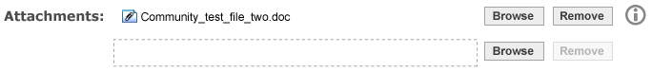
3.1.4.25 | Roles =  Evaluator  Admin | Information Icon   | - Clicking the I icon displays information on the support file types and the permitted file size allowed for upload.  - Clicking X closes the information display  - Text in window will state  Attachment Information  Multiple attachments can be added to your contribution. To add an attachment, click the Add Attachment button and then browse to the location of the desired file. Files will be uploaded when you submit your contribution. Files will be checked for size, file types and viruses.  Supported File Attachment Types <LIST FOR THIS COMMUNITY WILL BE PULLED FROM THE COMMUNITY ADMIN TOOL>  File Attachment Size: <FILE SIZE FOR THIS COMMUNITY WILL BE PULLED FROM THE COMMUNITY ADMIN TOOL>
3.1.4.26 | Roles =  Evaluator  Admin | Attachments | - Shall support the ability to restrict contribution to a pre-defined, but configurable set of file types.  - Shall provide an error message if user attempts to submit a file greater than the permitted size limit.  - Shall provide the ability to associate up to five file uploads with a single contribution.  - Shall support the ability to perform a virus check on all uploaded files. Must include support for single and multiple file upload scenarios.  - Shall support the ability to provide error handling and user messaging for a file upload failure due to a virus being detected in one or more of the files being uploaded. Note: This will occur asynchronously and will result the contribution being denied.  - This is an optional field.
3.1.4.27 | Roles =  Evaluator  Admin | Upload File text field  0 Files Uploaded  1 File Uploaded | - Should be placed to the right of the text, “Attachments”.  - This text field will work in conjunction with the Attachment Browse button.  - Shall display the local path to selected attachment selected using the Attachment Browse button.  - By default, this field will be blank  - This is not a required field.  - The presentation of the text field and associated browse button will visually differ on each browser. More on the visual difference by browser can be found here - http://www.456bereastreet.com/lab/styling-form-controls-revisited/file-select/
3.1.4.28 | Roles =  Evaluator  Admin | Attachment Browse button | - This button is implemented in conjunction with the Upload file text field (see 3.1.3.15 for more information)  - Should be placed to the right of the Upload File text field.  - Clicking this button will open a file-browser window showing files on the user’s computer.  - Selecting a file then affirming the selection will close the browse window. At which time the local path (relative to the user’s machine) of the file will be displayed in the Upload File text field.  - After a file has been chosen, another row should be automatically added below to allow for a user to add another attachment should they want to.
3.1.4.29 | Roles =  Evaluator  Admin | Remove Button  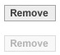 | - Should be placed to the right of the Browse button.  - Clicking this button will remove the entire row of the attachment. The row below the one removed should move up and take it’s place.  - This button should be inactive until a file has been added to the row.
3.1.4.30 | Roles =  Evaluator  Admin | Article or Link Suggestions | - Shall allow the user to provide a URL or text for a contribution (an article link, suggestions).  - Up to 5000 characters will be accepted User will not be permitted to exceed character count. Character Count will be displayed below when the field is active.
3.1.4.32 | Roles =  Evaluator  Admin | Legal Information checkbox and link | - Shall contain a check box for accepting the Pearson Legal Disclaimer.  - Shall not allow contributions to be submitted without acknowledgement from the user that it has been read (checkbox selected).  - Shall include “Use of 3rd party copyright materials”  - Link will open a 600x400 window that displays the text of the legal information.  - Shall provide an error message if user does not check box.
3.1.4.33 | Roles =  Evaluator  Admin | Cancel button | - Provide a pop-up caution message that confirms the user’s cancel action  - “Your contribution has not yet been saved. Are you sure you want to cancel?”  [OK] [Cancel]  - If the user selects OK, they will be returned to the default view of the ECP on the Contribution List
3.1.4.34 | Roles =  Evaluator  Admin | Submit button | - Starts the upload of the browsed to files  - Triggers virus and size check.  - If all error conditions are satisfied, a success message will be displayed to the user.  - If a Virus is encountered in one or more of the attached files, following the successful submit. The contribution status will be changed to Denied automatically by the system and the following statement will be added to the reviewer notes section:  - One or more of the files associated to your contribution contained a virus. The impacted files have been deleted and your contribution automatically denied by the system. If you wish, you may re-submit your contribution for consideration by clicking the Edit icon and adding a corrected version of the attachment. The following files were infected: <File Name(s)>

Error Condition | Message Displayed
File size exceeds limit, ZIP file and attempt to submit again | Provide an error message if user attempts to submit a file greater than the permitted size limit. Include user assistive text recommending they zip their contribution.  File exceeds size limit of <COMMUNITY SIZE LIMIT> MB. Please ZIP file and try again.  File that exceeded the size limit will be highlighted in the form as red.
Two files with the same name | Display the following error message when the user has attached two files with the same name to the contribution  There was an error uploading attachments.  Multiple files with the same name were filename specified. Please try to upload again. All files must have unique filenames.  Filename  The filename will be displayed in red
File not Found | Display the following error message when the file attached to a contribution can not be found  There was an error uploading attachments.  The following files were not found. Please try to upload again  Filename  The filename will be displayed in red
Complete all required fields | Provide error message if user attempts to submit a contribution without completing all required fields. Uncompleted fields should be marked in red.  “All fields in this form must be completed before we can process your request. Items in red are incomplete.”
Example:  Failure to Acknowledge Legal Agreement | Pop-up message: Shall not allow contributions to be submitted without acknowledgement from the user that it has been read (checkbox selected).  Please acknowledge the legal agreement by checking the box before continuing. [OK]
File type is not supported | Provide error messages if user attempts to submit a non-supported file type. File type unsupported. Please use only one of the following types: <LIST OF FILE TYPES PULLED FOR THIS PARTICULAR COMMUNITY>

Success Conditions
Success Condition
Example:  No errors are encountered | User shall see a ‘Success’ message that their contribution was received.  “Your contribution has been given the status of Approved. The contribution has been placed into the system and is ready for viewing by the community. Please select from the list below to continue.”  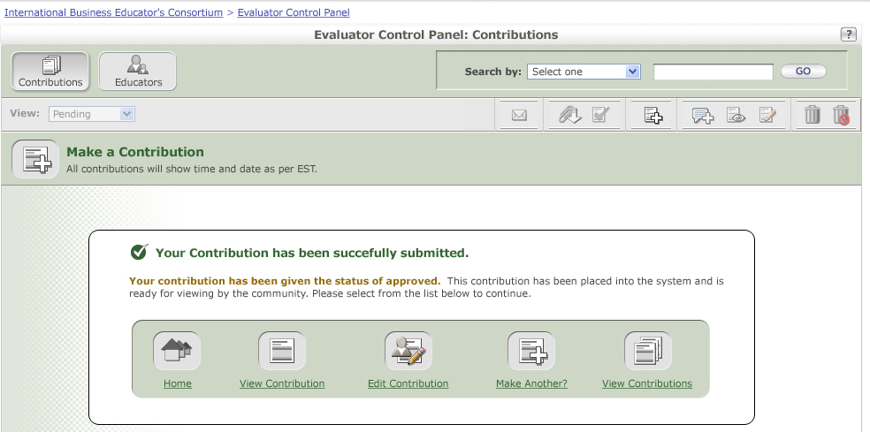  Home – links user to default Community Tab view  View Contribution – links user to the View Contribution screen for the contribution just added (within the ECP)  Edit Contribution – links user to the Edit Contribution screen for the contribution just edited (within the ECP)  Make Another – links user to the Make a Contribution view (within the ECP)  View Contributions – links user to the default view of the ECP Contribution portlet view.

Evaluator and Administrator (Edit a Contribution View – same if viewing their own contribution or another users)

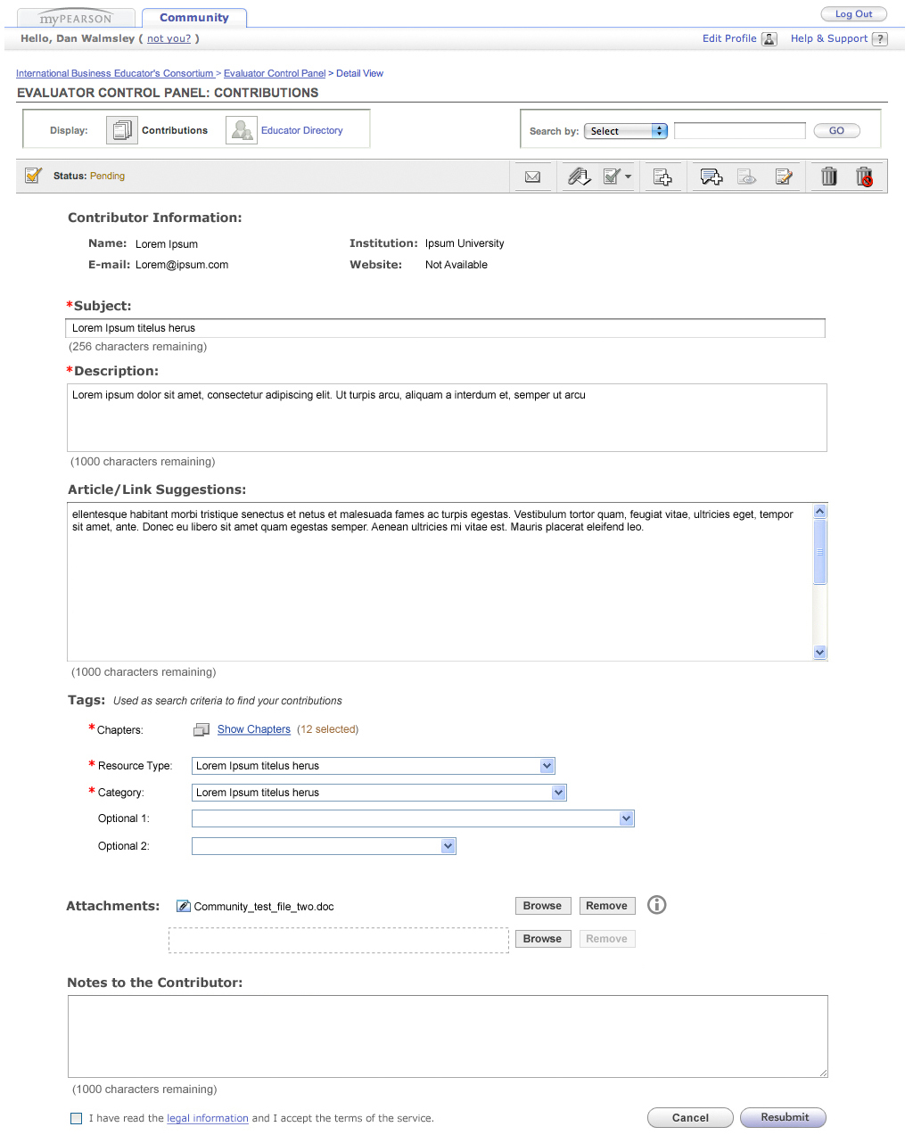

Elements (Edit a Contribution Page)
Note: All page elements will be displayed for all user types unless specifically noted otherwise.
ID | Sub Role | Element |  | Behavior
3.1.5,1 | Roles =  Evaluator  Admin | Breadcrumb Navigation  COMMUNITY NAME> Evaluator Control Panel > Edit Contribution |  | - Clicking COMMUNITY NAME the user back to the default view of the Community Tab  - Clicking the Evaluator Control Panel link takes the user back to the view from which they accessed the edit view – could be either a default list view or a set of search results.
3.1.5,2 | Roles =  Evaluator  Admin | Help button |  | - This button shall link to the following in a secondary window constrained to 600x400:  Link: (COMMUNITY BASE HELP URL)/ECP/ECP.htm  - The Help icon will be displayed within the portlet content rather than as an element of the Portal theme.
3.1.5.3 | Roles =  Evaluator  Admin | Contributions button |  | - Selected
3.1.5.4 | Roles =  Evaluator  Admin | Educators button |  | - Disabled on Edit Contribution
3.1.5.5 | Roles =  Evaluator  Admin | Search by (drop-down + text field+ Go button) |  | - Disabled on Edit Contribution View
3.1.5.6 | Roles =  Evaluator  Admin | Status  Example |  | - Display the current contribution status  - Valid Statuses include Approved, Pending, Archived, Denied, Trash
3.1.5.7 | Roles =  Evaluator  Admin | Icon Tool Bar |  | - All icons are disabled, except Trash  - Clicking Trash changes the status of the contribution to Trash and re-displays the Edit View with that contribution in trash status.  - “Any changes to the contribution have not yet been saved. Press the OK button to discard any changes and change the contribution status to Trash." [Ok] [Cancel]  - If contribution is already in a Trash status, the trash icon will be disabled.
3.1.5.8 | Roles =  Evaluator  Admin | Page Title  Example: |  | - Title/Subject of the contribution being edited.
3.1.5.9 | Roles =  Evaluator  Admin | Date Added |  | - Date Added Label
3.1.5.10 | Roles =  Evaluator  Admin | Date |  | - Displays the date of the displayed contribution.
3.1.5.11 | Roles =  Evaluator  Admin | Instructional Text  Example:  Fields marked with a red asterisk (*) are required |  | - Instructional Text for the User
3.1.5.12 | Roles =  Evaluator  Admin | Contributor Information  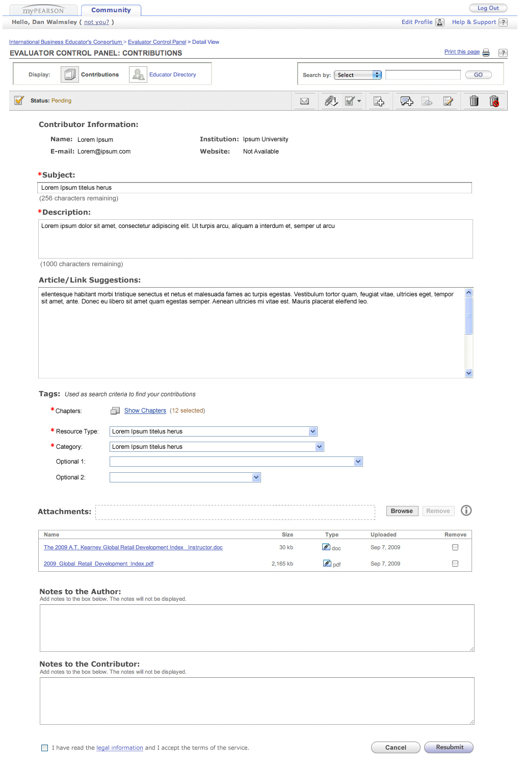 |  | Contributor information shall include the following personal information:  - Name (Required field – Data from SMS – This is the Name of the original contributor not the user editing the contribution in the control panel)  - Email Address (Required field – Data from SMS - This is the email of the original contributor not the user editing the contribution in the control panel)  - Institution Affiliation (Required field – Data from SMS)- This is the institution of the original contributor not the user editing the contribution in the control panel  - Faculty Personal Homepage URL/Website - This is the Name of the original contributor not the user editing the contribution in the control panel
3.1.5.13 | Roles =  Evaluator  Admin | Name  Non-editable display text |  | - This is a required field. The system shall support ability to check that all required fields have been populated.  - This is the Name of the original contributor not the user editing the contribution in the control panel
3.1.5.14 | Roles =  Evaluator  Admin | Email Address  Non-editable display text |  | - This is a required field. The system shall support ability to check that all required fields have been populated.  - This is the Email of the original contributor not the user editing the contribution in the control panel  - Data shall populate with information from the SMS or if the user has a different address in the Directory the address for this community will be used.
3.1.5.15 | Roles =  Evaluator  Admin | Institution Affiliation  Non-editable display text |  | - This is a required field. The system shall support ability to check that all required fields have been populated.  - This is the Institution of the original contributor not the user editing the contribution in the control panel  - Data shall populate with information from the SMS.
3.1.5.16 | Roles =  Evaluator  Admin | Faculty Personal Homepage URL |  | - This is NOT a required field.  - This is the Faculty URL of the original contributor not the user editing the contribution in the control panel  - This field will be populated if the user has a website in the Directory for this community.
3.1.5.17 | Roles =  Evaluator  Admin | Contribution Metadata |  | Contribution Metadata shall include the following fields:  - CONTRIBUTION TITLE LABEL (Required field)  - Description (Required field)  - CHAPTER LABEL (Required field)  - TYPE LABEL (Required field)  - CONTRIBUTION ATTRIBUTE 1 LABEL  - CONTRIBUTION ATTRIBUTE 2 LABEL  - CATEGORY (Required field)
3.1.5.18 | Roles =  Evaluator  Admin | Subject Label and Field |  | - Field label will be pulled from the Community Admin Tool – Contribution Title Label field  - In Edit Mode, this field will be pre-filled. The information entered in this field shall display in the Search results.  - This is a required field. The system shall support ability to check that all required fields have been populated.  - Shall provide an error message if the user attempts to submit a contribution without completing this field.  - The title field will be limited to 256 characters. User will not be permitted to exceed character count. Character Count will be displayed below when the field is active.
3.1.5.19 | Roles =  Evaluator  Admin | Description |  | - In Edit Mode, this field will be pre-filled.  - This is a required field. Support ability to check that all required fields have been populated.  - The information entered in this field will display in the Search results.  - Shall provide an error message if the user attempts to submit a contribution without completing this field.  - Up to 256 characters will be allowed in the description. User will not be permitted to exceed character count. Character Count will be displayed below when the field is active.
3.1.5.20 | Roles =  Evaluator  Admin | Chapter Label |  | - Field label will be pulled from the Community Admin Tool – Chapter Label field  - This is a required field.  - Shall provide an error message if the user attempts to submit a contribution without completing this field.  - Clicking “Show <variable>” will launch a lightbox allowing the user to select the fields they would like. This lightbox is described in element 3.1.3.7.  - If the user has made at least 1 selection, display the number of selections in parenthesis, with the word “selected” after it.
3.1.5.20b | Roles =  Evaluator  Admin | Chapter Selection Box  Multi-Level Taxonomy Example  Single Book: Example CKR |  | Multi-Level Taxonomies  - Lightbox should have width of 830. Height should expand to fit contents up to maximum available height based on the browser's viewport  - All fields previously selected should be shown as selected when loading the lightbox.  - The background color of the row should change to a blue gray (#d9dbe8) after it has been selected. If is subsequently unselected, the background color of the row should change back to white.  - The background color of the row should change to a light brown (#ebe4d2) when the user hovers over any part of it.  - Clicking anywhere on the row, not just the checkbox, should select the row. Clicking it again should unselect the row.  - Include Select All within each level. Clicking this will select all fields within that level. Clicking it a 2nd time will deselect all fields within that level. If the user clicks Select All, but deselects at least one field, uncheck the Select All field.  - Each level should be able to be expanded or collapsed separate from the other levels.  - Expand first level by default. Collapse all other levels by default.  - Display top-level field name on top (I.E. concepts) in bold.  - Clicking anywhere on the Close tab on the top-right corner will close the lightbox.  Single-Level Taxonomies  - Lightbox should have width of 830. Height should expand to fit contents up to maximum available height based on the browser's viewport  - All fields previously selected should be shown as selected when loading the lightbox.  - The background color of the row should change to a blue gray (#d9dbe8) after it has been selected. If is subsequently unselected, the background color of the row should change back to white.  - The background color of the row should change to a light brown (#ebe4d2) when the user hovers over any part of it.  - Clicking anywhere on the row, not just the checkbox, should select the row. Clicking it again should unselect the row.  - Include Select All. Clicking this will select all fields. Clicking it a 2nd time will deselect all fields within that level. If the user clicks Select All, but deselects at least one field, uncheck the Select All field.  - Display top-level field name on top (I.E. book) in bold.  - Clicking anywhere on the Close tab on the top-right corner will close the lightbox.
3.1.5.21 | Roles =  Evaluator  Admin | Type Label & Dropdown |  | - In Edit Mode, this field will be pre-filled.  - Field label will be pulled from the Community Admin Tool – Type Label field  - Shall contain a drop-down menu to select one of the type items set up for this community via the admin tool. Type items will be listed in the order defined in the admin tool.  - Default option: Select a <TYPE LABEL>  - This is a required field. Support ability to check that all required fields have been populated.  - Shall provide an error message if the user attempts to submit a contribution without completing this field.
3.1.5.22 | Roles =  Evaluator  Admin | Contribution Attribute 1 Label and Dropdown (Example Region) |  | - In Edit Mode, this field might or might not be pre-filled.  - Field label will be pulled from the Community Admin Tool – Contribution Attribute 1 Label field  - Shall contain a drop-down menu to select one of the Contribution Attribute 1 items set up for this community via the admin tool. Cont. Attribute items will be listed in the order defined in the admin tool.  - This is an optional field
3.1.5.23 | Roles =  Evaluator  Admin | Contribution Attribute 2 Label and Dropdown |  | - In Edit Mode, this field might or might not be pre-filled.  - Field label will be pulled from the Community Admin Tool – Contribution Attribute 2 Label field  - Shall contain a drop-down menu to select one of the Contribution Attribute 2 items set up for this community via the admin tool. Cont. Attribute items will be listed in the order defined in the admin tool.  - This is an optional field
3.1.5.24 | Roles =  Evaluator  Admin | Category Label & Dropdown |  | - In Edit Mode, if displayed this field will be pre-filled.  - Label and Dropdown will always appear in the ECP.  - Field label will be pulled from the Community Admin Tool – Category Label field  - Shall contain a drop-down menu to select one of the Category items set up for this community via the admin tool. Type items will be listed in the order defined in the admin tool and filtered by the admin tool permissions.  - Default option: Select a <CATEGORY LABEL>  - This is a required field. Support ability to check that all required fields have been populated.  - Shall provide an error message if the user attempts to submit a contribution without completing this field...
3.1.5.25
3.1.5.26 | Roles =  Evaluator  Admin |  | Information Icon | - Clicking the I icon displays information on the support file types and the permitted file size allowed for upload.  - Clicking X closes the information display  - Text in window will state  Attachment Information  Multiple attachments can be added to your contribution. To add an attachment, click the Add Attachment button and then browse to the location of the desired file. Files will be uploaded when you submit your contribution. Files will be checked for size, file types and viruses.  Supported File Attachment Types <LIST FOR THIS COMMUNITY WILL BE PULLED FROM THE COMMUNITY ADMIN TOOL>  File Attachment Size: <FILE SIZE FOR THIS COMMUNITY WILL BE PULLED FROM THE COMMUNITY ADMIN TOOL>
3.1.5.27 | Roles =  Evaluator  Admin |  | Attachments | - In Edit Mode, this field will be pre-filled (if any exist).  - Shall support the ability to restrict contribution to a pre-defined, but configurable set of file types.  - Shall provide an error message if user attempts to submit a file greater than the permitted size limit.  - Shall provide the ability to associate up to five file uploads with a single contribution.  - Shall support the ability to perform a virus check on all uploaded files. Must include support for single and multiple file upload scenarios.  - Shall support the ability to provide error handling and user messaging for a file upload failure due to a virus being detected in one or more of the files being uploaded. Note: This will occur asynchronously and will result the contribution being denied.  - This is an optional field.
3.1.5.28 | Roles =  Evaluator  Admin |  | Upload File text field  0 Files Uploaded  1 File Uploaded | - Should be placed to the right of the text, “Attachments”.  - This text field will work in conjunction with the Attachment Browse button.  - Shall display the local path to selected attachment selected using the Attachment Browse button.  - By default, this field will be blank  - This is not a required field.  The presentation of the text field and associated browse button will visually differ on each browser. More on the visual difference by browser can be found here - http://www.456bereastreet.com/lab/styling-form-controls-revisited/file-select/
3.1.5.29 | Roles =  Evaluator  Admin |  | Attachment Browse button | - This button is implemented in conjunction with the Upload file text field (see 3.1.3.15 for more information)  - Should be placed to the right of the Upload File text field.  - Clicking this button will open a file-browser window showing files on the user’s computer.  - Selecting a file then affirming the selection will close the browse window. At which time the local path (relative to the user’s machine) of the file will be displayed in the Upload File text field.  After a file has been chosen, another row should be automatically added below to allow for a user to add another attachment should they want to.
3.1.5.30 | Roles =  Evaluator  Admin |  | Remove Button | - Should be placed to the right of the Browse button.  - Clicking this button will remove the entire row of the attachment. The row below the one removed should move up and take it’s place.  - This button should be inactive until a file has been added to the row.
3.1.5.32 | Roles =  Evaluator  Admin |  | Attachment Name link | - When in editing mode, a link to each uploaded file shall be provided.  - Clicking this link will result in a browser save-as window.
3.1.5.33 | Roles =  Evaluator  Admin |  | Size display text | - In Edit Mode, this field will be pre-filled if attachment exist  - Shows the attachment size in kb
3.1.5.34 | Roles =  Evaluator  Admin |  | Type and attachment Icon | - In Edit Mode, this field will be pre-filled if an attachment exists  - Shows the file attachment icon and textually using an abbreviation for the file type.
3.1.5.35 | Roles =  Evaluator  Admin |  | Uploaded date | - In Edit Mode, this field will be pre-filled if an attachment exists  - Date when the attachment was uploaded.
3.1.5.37 | Roles =  Evaluator  Admin |  | Article or Link Suggestions | - In Edit Mode, this field may or may not be pre-filled  - Shall allow the user to provide a URL or text for a contribution (an article link, suggestions).  - Up to 5000 characters will be accepted. User will not be permitted to exceed character count. Character Count will be displayed below when the field is active.
3.1.5.39 | Roles =  Evaluator  Admin |  | Notes to the Contributor | - Shall allow the user to enter text that will be made available to the reviewers and the original contributor.  - Up to 1000 characters will be accepted. User will not be permitted to exceed character count. Character Count will be displayed below when the field is active.
3.1.5.40 | Roles =  Evaluator  Admin |  | Legal Information checkbox and link | - Shall contain a check box for accepting the Pearson Legal Disclaimer.  - Shall not allow contributions to be submitted without acknowledgement from the user that it has been read (checkbox selected).  - Shall include “Use of 3rd party copyright materials”  - Link will open a 600x400 window that displays the text of the legal information.
3.1.5.41 | Roles =  Evaluator  Admin |  | Cancel button | - Provide a pop-up caution message that confirms the user’s action:  Your contribution has not been saved. Are you sure you want to cancel? [OK] [Cancel]  - If the user cancels, they will be returned to the page -1 click of the Make a Contribution page.
3.1.5.42 | Roles =  Evaluator  Admin |  | Resubmit button | - This button will only be available in Edit mode.  - Starts the upload of the browsed to files  - Triggers virus and size check.  - If all error conditions are satisfied, a success message will be displayed to the user.  - Contribution Status will remain whatever it is currently set to – DOES NOT GO BACK TO A PENDING STATE.  - If a Virus is encountered in one or more of the attached files, following the successful submit. The contribution status will be changed to Denied automatically by the system and the following statement will be added to the reviewer notes section:  “One or more of the files associated to your contribution contained a virus. The impacted files have been deleted and your contribution automatically denied by the system. If you wish, you may re-submit your contribution for consideration by clicking the Edit icon and adding a corrected version of the attachment. The following files were infected: <File Name(s)>”

Error Conditions
Same as Add Contribution

Confirmation Messages
Message | Message Displayed
Set Contribution to Trash Status | Prompts user to confirm delete of contribution – UI Text:  “Any changes to the contribution have not yet been saved. Press the OK button to discard any changes and change the contribution status to Trash." [Ok] [Cancel]  Cancel -returns the user to the edit view closing the prompt  OK – Changes the status to Trash and redisplays the Edit View

Success Conditions
Success Condition
No errors are encountered | User shall see a ‘Success’ message that their contribution was received.  “Your Contribution has been successfully updated. Please select from the list below to continue.”  Home – links user to default Community Tab view  View Contribution – links user to the View Contribution screen for the contribution just added (within the ECP)  Edit Contribution – links user to the Edit Contribution screen for the contribution just edited (within the ECP)  Make Another – links user to the Make a Contribution view (within the ECP)  View Contributions – links user to the default view of the ECP Contribution portlet view.

ECP- Contribution Status Change Emails

Requirements
Changing the status of a contribution via the ECP from Any State to Approved or from Any State to Denied will trigger the sending of an email to the Contribution Contributor.

Prototypes
The following prototypes are typical emails with styling

Contribution Approved Email

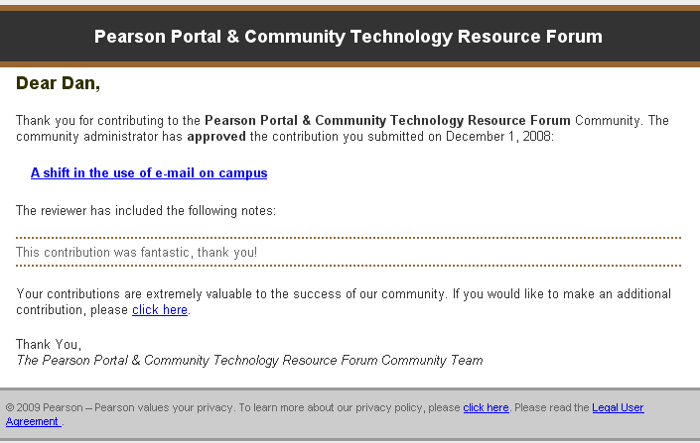

Elements (Approved Contribution Email)
ID | Element | Behavior
4.1.3.0a | Subject Line | Your contribution status for <Community Name>
4.1.3.ob | From Email Address | <PEARSON CONTACT EMAIL ADDRES> for this community. If the community has more than one contact email address, the first will just be used.
4.1.3.1 | Community Name   | Community Name will be displayed at the top of the email
4.1.3.2 | User First Name | The email will be addressed Dear <UserFirstName>,  User first name will be pulled from the user’s SMS data
4.1.3.3 | Community Name | The community name as specified in the community admin tool will be included in the text of the first paragraph.  “Thank you for contributing to the <COMMUNITY NAME> Community.”  as well as the closing of the email  “Thank You,  The <COMMUNITY NAME> Team”
4.1.3.4 | Submit Date | The contribution Submit date will be included in the text of the first paragraph.  “The community administrator has approved the contribution you submitted on <SUBMITDATE>”  Date will be formatted as Month Day, Year (e.g. December 1, 2008)
4.1.3.5 | Contribution Title/Subject | The contribution title/subject will be included in the text of email.  Clicking the contribution title will navigate the user to the community and to that specific contribution. If the user has an existing SSO session they can access the community and contribution directly. If no SSO session exists they will be prompted to authenticate, before accessing the contribution/community.  If a community does not have custom login page, users without SSO sessions will be directed to the general community login page. If a community does have a custom login page, users will be taken there for authentication
4.1.3.5b | Notes to the Contributor | Conditional – Displayed only is there are Reviewer notes to the Contributor  “The reviewer has included in the following notes”  Any text entered into the Notes to the Contributor field will be displayed in the email after the static text for the following reason.
4.1.3.6 | Link to access the community | A link to access the community and make additional contributions will be provided  Clicking the click here link will navigate the user to the default view of that community. If the user has an existing SSO session they can access the community and contribution directly. If no SSO session exists they will be prompted to authenticate.  If a community does not have custom login page, users without SSO sessions will be directed to the general community login page. If a community does have a custom login page, users will be taken there for authentication
4.1.3.7 | Privacy Policy | The click here link for the privacy policy will link to the URL - https://register.pearsoncmg.com/w3c/privacy.htm
4.1.3.7a | End User Legal Agreement | https://register.pearsoncmg.com/reg/include/license2.jsp
4.1.3.8 | Copyright Year | Copyright should be current year.  This should be a configurable property or calculated value to avoid yearly CRs to update the copy right

Contribution Rejected Email

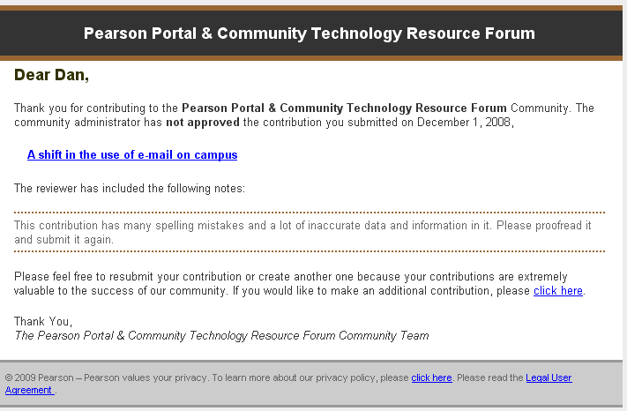

(See revised text below for the closing paragraph)

Elements (Rejected Contribution Email)
ID | Element | Behavior
4.1.4.0a | Subject | Your contribution status for <Community Name>
4.1.4.0b | From | <PEARSON CONTACT EMAIL ADDRES> for this community. If the community has more than one contact email address, the first will just be used.
4.1.4.1 | Community Name Header | Community Name will be displayed at the top of the email
4.1.4.2 | User First Name | The email will be addressed Dear <UserFirstName>,  User first name will be pulled from the users SMS data
4.1.4.3 | Community Name | The community name will be included in the text of the first paragraph.  “Thank you for contributing to the <COMMUNITY NAME> Community.”  as well as the closing of the email  “Thank You,  The <COMMUNITY NAME> Team”
4.1.4.4 | Submit Date | The contribution Submit date will be included in the text of the first paragraph.  “The community administrator has not approved the contribution you submitted on <SUBMITDATE>.”  Date will be formatted as Month Day, Year (e.g. December 1, 2008)
4.1.4.5 | Contribution Title/Subject | The contribution title/subject will be included in the text of email.  Clicking the contribution title will navigate the user to the community and to that specific contribution. If the user has an existing SSO session they can access the community and contribution directly. If no SSO session exists they will be prompted to authenticate, before accessing the contribution/community  If a community does not have custom login page, users without SSO sessions will be directed to the general community login page. If a community does have a custom login page, users will be taken there for authentication
4.1.4.6 | Notes to the Contributor | Conditional – Displayed only is there are Reviewer notes to the Contributor  “The reviewer has included in the following notes”  Any text entered into the Notes to the Contributor field will be displayed in the email after the static text for the following reason.
4.1.4.7 | Link to access the community | Text to be displayed:  “Please feel free to resubmit your contribution or create a new one. Your contributions are extremely valuable to the success of our community. If you would like to make a new contribution, please click here”  A link to access the community and make additional contributions will be provided  Clicking the click here link will navigate the user to the default view of that community. If the user has an existing SSO session they can access the community and contribution directly. If no SSO session exists they will be prompted to authenticate  If a community does not have custom login page, users without SSO sessions will be directed to the general community login page. If a community does have a custom login page, users will be taken there for authentication
4.1.4.9 | Privacy Policy | The click here link for the privacy policy will link to the URL - https://register.pearsoncmg.com/w3c/privacy.htm
4.1.4.10 | End User Legal Agreement | https://register.pearsoncmg.com/reg/include/license2.jsp
4.1.4.11 | Copyright Year | Copyright should be current year.  This should be a configurable property or calculated value to avoid yearly CRs to update the copy right

